Sanjana Parmar

December 3, 2021

**Association of Cancer Incidence and Hazardous Waste Disposal in New York State (2010)**

**Problem Statement:**

Sites, where hazardous waste is disposed of, have an adverse impact on human health. There are environmental factors associated with cancer risks such as air pollution, water pollution and soil contamination. Studies have shown that improperly stored or damaged containers of hazardous waste can expose individuals to toxic elements through the contamination of water, soil or even the food chain [1]. The ecological data is not sufficient to establish a causal relationship between hazardous waste disposal sites and cancer incidence, since there is no measurement of the type of exposure and length of residence of a person in that area. However, studies have shown clear and consistent patterns between the presence of hazardous waste sites and elevated cancer rates [2].

New York state has seen a steady increase in the number of people diagnosed with cancer each year. On average, each year, about 115,000 New Yorkers receive a cancer diagnosis and near 35,000 people on average lose their lives to cancer, making it the second leading cause of death in the state. The burden of cancer is disproportionately distributed with the cancer rates differing amongst people from different socio-economic backgrounds [3].

This study is done to establish an association between sites that have bulk storage of hazardous waste and incidences of cancer in New York state. We consider three different types of bulk storage facilities namely Petroleum Bulk Storage, Chemical Bulk Storage and Major Oil Bulk Storage. These facilities are required by the law to safely manage the waste they generate, so as to ensure that no damage is caused to the environment and the community. The Environment Protection Agency (EPA) and New York State Conservation Department (NYSDEC) are tasked with inspecting these facilities every year to ensure that these facilities follow proper laws and guidelines [4].

In the current methodology, the EPA and NSYDEC find out about a violation only after an initial inspection. With as many as 60,000 facilities in the state of New York, these organizations often lack sufficient resources to inspect every single one of these facilities. This study aims to examine the cancer incidences at a county level, as an indicator of potentially serious violations by these facilities.

**Methodology / Approach:**

Hazardous waste sites are identified through the data from New York State GIS inventory. This KMZ file contains the point location for facilities with Chemical, Oil and Petroleum bulk storage. This data is then used on ArcGIS Pro, to map the location of the three different types of bulk storage facilities.

The Cancer incidence data at a county level for New York state was sourced from a publicly available data set generated by researchers from the University of Albany, and the New York State Department of Health. This data is used in conjunction with the shapefiles for the counties acquired from the New York State government data catalogue.

Finally, the ACS data was utilized to determine the percentage of the population below the poverty level in these counties. The data provides information about the income across demographic attributes like race, age, gender etc.

The objective of this study is to overlay the data points from the Bulk Storage Facilities data and the Cancer incidence data, to establish an associative relationship between counties with high hazardous waste storage facilities and the incidence of cancer rates in that county, during the period of 2010. Furthermore, this is compared with the data that indicates the percentage of the population having income below the poverty line, to ascertain the disparity in cancer incidences across economic groups.

**Results:**

Studies have shown that there exist disparities in how environmental issues affect communities of poor economic backgrounds. Hazardous waste sites tend to be concentrated in areas that have a significant minority population, living below the poverty level. The studies indicate the need for measures of government policies, industry practices and community empowerment to ensure fairness in the siting process [5].

Figure 1 represents a choropleth map of the population with income below the poverty line at a county level. The top 5 counties with the highest population below the poverty line are represented by Kings County (GeoID: 36047), Bronx County (GeoID: 36005), Queens County (GeoID: 36081), New York County (GeoID: 36061) and Erie County (GeoID: 36029). These counties (represented in dark pink) account for 61% of the population living below the poverty line in New York State. The same can be observed in the chart in Figure 2

**Figure 1.** New York State Population under Poverty Line  
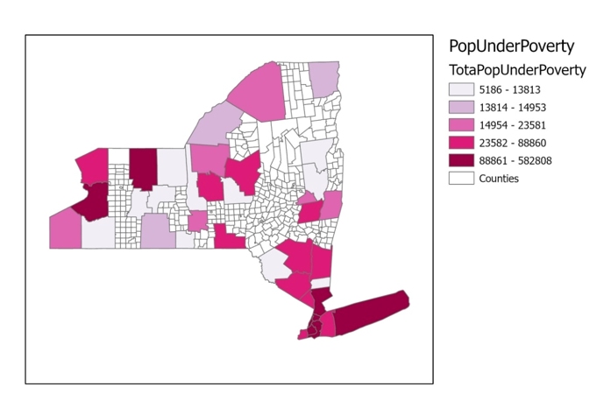

**Figure 2:** Top 10 counties by population under poverty line  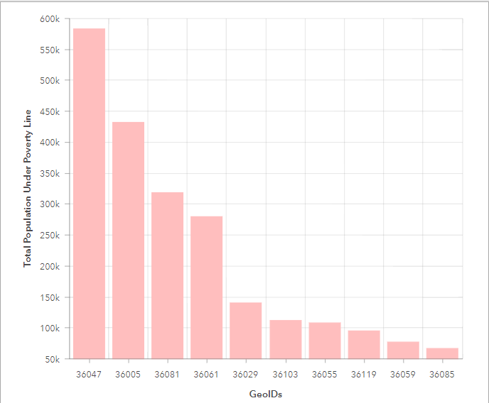

Figure 3 represents the choropleth map of total cancer incidences reported at a county level for 2010. The top 5 counties with the highest cancer incidences are Kings County (GeoID: 36047), Queens County (GeoID: 36081), Suffolk County (GeoID: 36103), Nassau County (GeoID: 36059) and New York County (GeoID: 36061).

**Figure 3.** New York State Cancer Incidence  
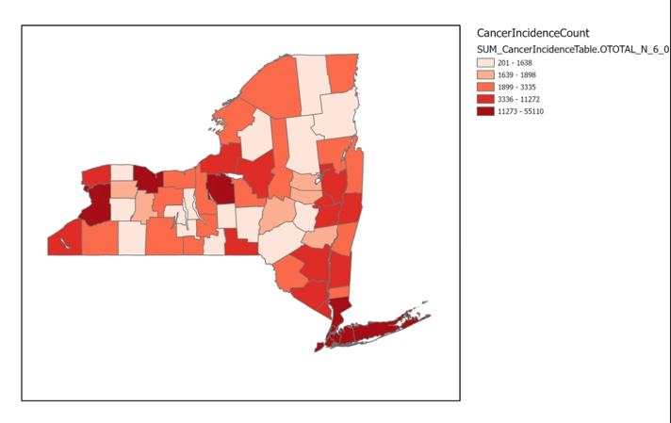

**Figure 4:** Counties with top cancer incidence in New York State for 2010  
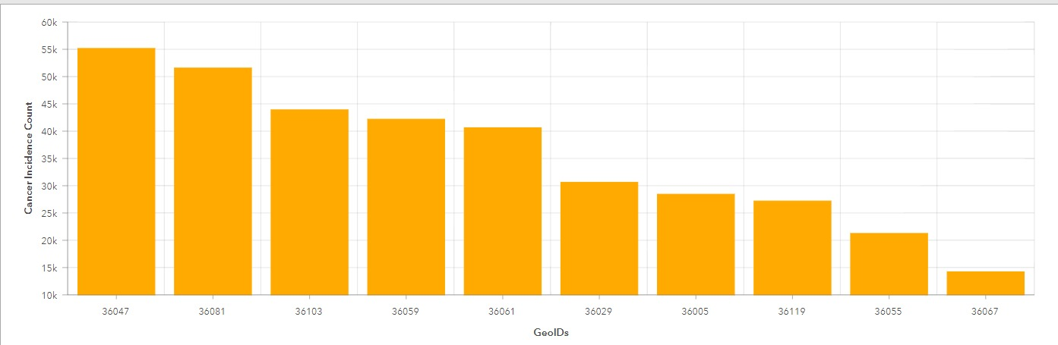

Figure 5 represents the distribution of Major Oil Bulk Storage Facilities, overlaid on the choropleth map of cancer incidences. There is a significant concentration of these facilities in the southeast region of the state, which also has higher cancer incidences. This region also represents the counties with the most number of people living below the poverty line as observed from Figure 6

**Figure 5.** New York State Cancer Incidence and Major Oil Storage Facilities  
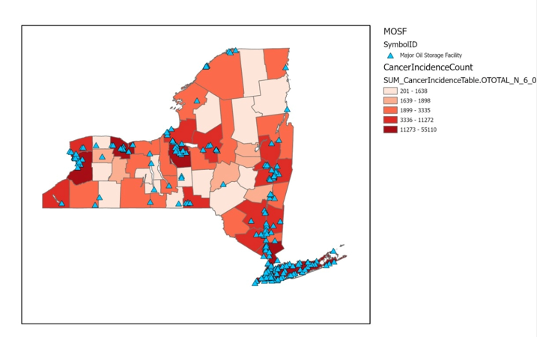

**Figure 6.** New York State Population below Poverty and Major Oil Storage Facilities  
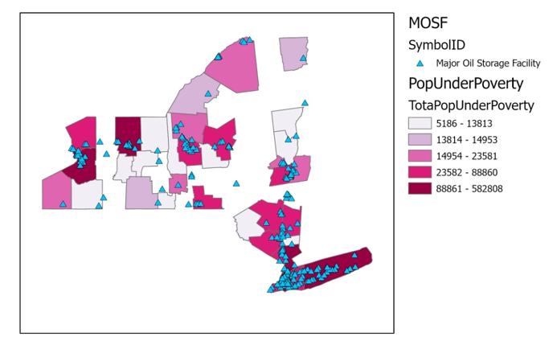

Figure 7 represents the distribution of Chemical Bulk Storage facilities overlaid on the choropleth map of cancer incidences. These facilities are highly concentrated in the southeast and northwest regions of the state, coinciding with counties with high cancer incidences, and a high population under the poverty line, as observed in figure 8.

**Figure 7.** New York State Cancer Incidence and Chemical Bulk Storage Facilities  
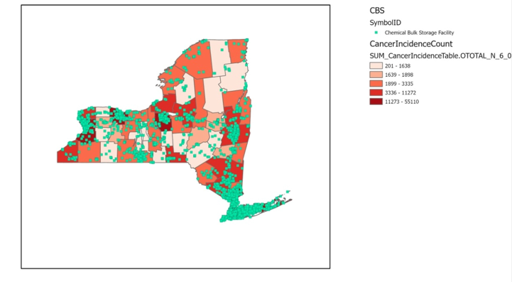  
  
  
  
  
  
  
  
  
  
  
  
  
  
  
  
  
  
**Figure 8.** New York State Population below Poverty line and Chemical Bulk Storage Facilities  
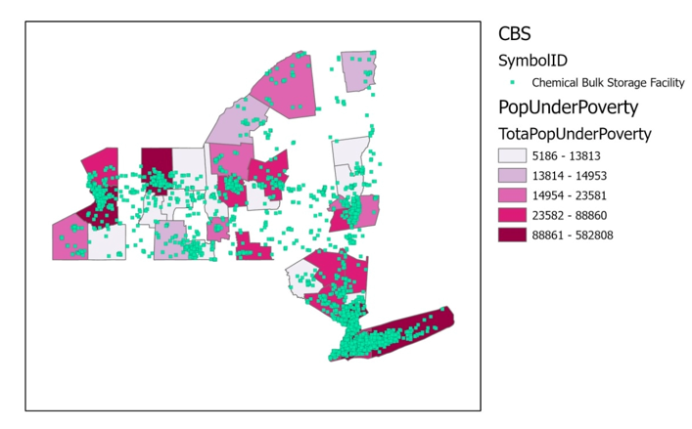

The high density of Petroleum Storage Facilities across the state, as seen in Figure 9, indicates no clear correlation between facility citing and cancer incidences.

**Figure 9:** New York State Cancer Incidences and Petroleum Bulk Storage Facilities.   
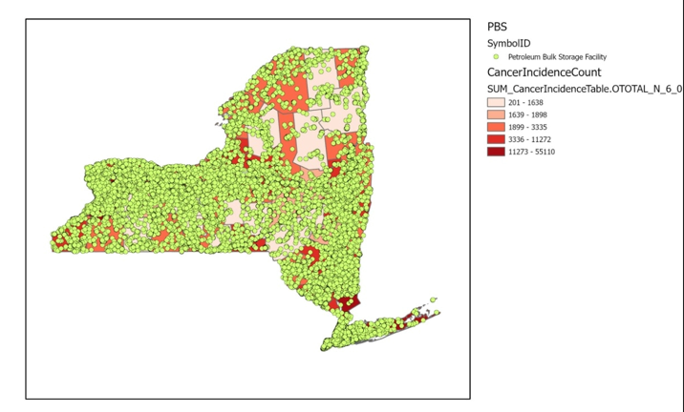

**Caveats / Future Work:**

* The data used to determine the income level and population living below the poverty line is incomplete, as the data is missing for 18 counties. Since all three files namely Cancer Data, County Shape file, and Poverty Line file, all had different versions of the GeoID, we had to extract the most common versions so that we can add joins.
* The population data for people living below the poverty line is not normalized to the total population of the counties
* We do not have the county names for each County GeoID because of the same problem mentioned in the first point.

**Conclusion:**

We observe in these maps that high cancer incidence counts are in counties that have clusters of Chemical, Petroleum and Major Oil Bulk Storage Facilities. This can be observed by switching on and off the different layers. We also see that there is a higher count of Population under the Poverty Line in the same counties. So the people residing in these communities also don’t have the access to resources to remedy their situations. We believe both these data sets should be used in deciding which facilities should be inspected every year.

**Data Sources:**

* “NYS GIS Clearinghouse - NYS Dept. of Environmental Conservation (DEC) - Bulk Storage Sites in New York State.” Accessed November 15, 2021.<https://gis.ny.gov/gisdata/inventories/details.cfm?DSID=1253>.
* “New York State Cancer Data - Boscoe F, Thomas T, Kulldorff M. Public domain small-area cancer incidence data for New York State, 2005-2009.” Accessed December 01,2021  
  <https://www.satscan.org/datasets/nyscancer/>

**References:**

[1] Alexander Kirpich and Emily Leary, “Superfund Locations and Potential Associations with Cancer Incidence in Florida,” *Statistics and Public Policy* 4, no. 1 (January 1, 2017): 1–9,<https://doi.org/10.1080/2330443X.2016.1267599>.

[2] Mary P. Harmon and Kathryn Coe, “Cancer Mortality in U.S. Counties with Hazardous Waste Sites,” *Population and Environment* 14, no. 5 (May 1993): 463–80,<https://doi.org/10.1007/BF01261111>.

[3] “Snapshot of Cancer in New York” (New York Department of Health, 2017),<https://www.health.ny.gov/statistics/cancer/registry/pdf/snapshot.pdf>.

[4] OECA US EPA, “Hazardous Waste Compliance Monitoring,” Overviews and Factsheets, July 30, 2013,<https://www.epa.gov/compliance/hazardous-waste-compliance-monitoring>.

[5] Paul Mohai and Robin Saha, “Which Came First, People or Pollution? Assessing the Disparate Siting and Post-Siting Demographic Change Hypotheses of Environmental Injustice,” *Environmental Research Letters* 10, no. 11 (November 1, 2015): 115008,<https://doi.org/10.1088/1748-9326/10/11/115008>.