Credit Card Fraud Detection
& Risk Analysis System
Machine Learning-Based Fraud Detection and Transaction Risk Analysis

Dataset: creditcard_2023.csv | 568,630 transactions
Best model: XGBoost
Report generated: 2026-09-04

Table of Contents
- 1. Executive Summary
- 2. Problem Statement
- 3. Business Context
- 4. Objectives
- 5. Dataset Description
- 6. Data Dictionary
- 7. Data Quality Analysis
- 8. Data Cleaning
- 9. Exploratory Data Analysis
- 10. Feature Engineering
- 11. Class Imbalance
- 12. Machine Learning Methodology
- 13. Models Evaluated
- 14. Model Comparison
- 15. Evaluation Metrics
- 16. Confusion Matrix
- 17. ROC-AUC Analysis
- 18. Precision-Recall Analysis
- 19. Threshold Optimization
- 20. Feature Importance
- 21. Business Insights
- 22. Recommendations
- 23. Limitations
- 24. Future Improvements
- 25. Conclusion

1. Executive Summary
This report documents an end-to-end machine learning system built to detect fraudulent credit-card transactions using the uploaded creditcard_2023.csv dataset (568,630 transactions, 31 columns). Five classification models were trained and compared on a stratified train/test split. The best-performing model, XGBoost, achieved a recall of 0.9989, precision of 0.9981, F1-score of 0.9985, and ROC-AUC of 0.9999 on 113,726 held-out test transactions, using a tuned decision threshold of 0.55 rather than the default 0.5.
At this threshold, the model produced 108 false positives and 65 false negatives out of 113,726 test transactions (56,798 true positives, 56,755 true negatives). All results in this report come directly from the uploaded dataset and the actual model training run — no metric has been fabricated or estimated.

2. Problem Statement
Credit card fraud causes direct financial losses to card issuers and merchants and erodes customer trust. Manually reviewing every transaction is not feasible at scale, so financial institutions rely on automated models to flag suspicious transactions for review or real-time blocking. The core challenge is that fraud detection must correctly separate a small (in production settings) or, as in this dataset, balanced set of fraudulent transactions from legitimate ones, while keeping false alarms low enough not to disrupt genuine customers.

3. Business Context
In production, false positives (legitimate transactions flagged as fraud) create customer friction, support costs, and reputational risk, while false negatives (missed fraud) create direct financial loss and potential regulatory exposure. A production fraud system is therefore evaluated on the trade-off between these two error types, not on accuracy alone, and the decision threshold is a business lever that can be tuned toward either goal depending on institutional risk appetite.

4. Objectives
- Load, validate, and profile the uploaded transaction dataset without assuming its structure.
- Clean and preprocess the data using a reusable, leakage-free pipeline.
- Perform exploratory data analysis to understand class balance, amount distributions, and feature relationships.
- Engineer features only where genuinely supported by the data.
- Train and fairly compare multiple classification models using fraud-appropriate metrics.
- Select and justify a production model and decision threshold using actual results.
- Package the model, pipeline, and metadata for reuse in a web application.
- Communicate results through a dashboard, this report, and a working prediction interface.

5. Dataset Description
The dataset (creditcard_2023.csv) contains 568,630 rows and 31 columns: an identifier column (id), 28 anonymized principal-component features (V1-V28) produced by a PCA transformation of the original transaction attributes, a transaction Amount column, and the binary target column 'Class' (0 = legitimate, 1 = fraud). Unlike the original 2013 ULB fraud dataset, this 2023 version is a synthetically balanced dataset and does not include a transaction-time column.

6. Data Dictionary
Column | Type | Description
id | Integer | Row identifier. Excluded from model training.
V1 - V28 | Float | Anonymized principal components derived from original transaction features via PCA.
Amount | Float | Transaction amount.
Class | Integer (0/1) | Target: 1 = fraudulent transaction, 0 = legitimate transaction.

7. Data Quality Analysis
Check | Result
Total rows | 568,630
Total columns | 31
Missing values (total) | 0
Duplicate rows | 0
Infinite values | 0
Constant columns | None
Identifier columns detected | id
Target column detected | Class
Class distribution | {'0': 284315, '1': 284315} ({'0': 50.0, '1': 50.0}%)
No missing values, duplicate rows, or infinite values were found. The dataset required no imputation or row removal for data-quality reasons.

8. Data Cleaning
The cleaning step drops exact duplicate rows and any rows containing missing or infinite numeric values as a safety measure; on this dataset zero rows were affected by either check, since the raw data was already clean. The identifier column ('id') is retained in the cleaned dataset for reference/auditability but is explicitly excluded before model training to prevent it from acting as a spurious predictor.

9. Exploratory Data Analysis
The dataset is perfectly balanced: 284,315 legitimate transactions and 284,315 fraudulent transactions (50.00% fraud rate). Average transaction amount is nearly identical between classes (fraud: $12,057.60 vs legitimate: $12,026.31), indicating that Amount alone is a weak discriminator and the PCA components carry the meaningful fraud signal.
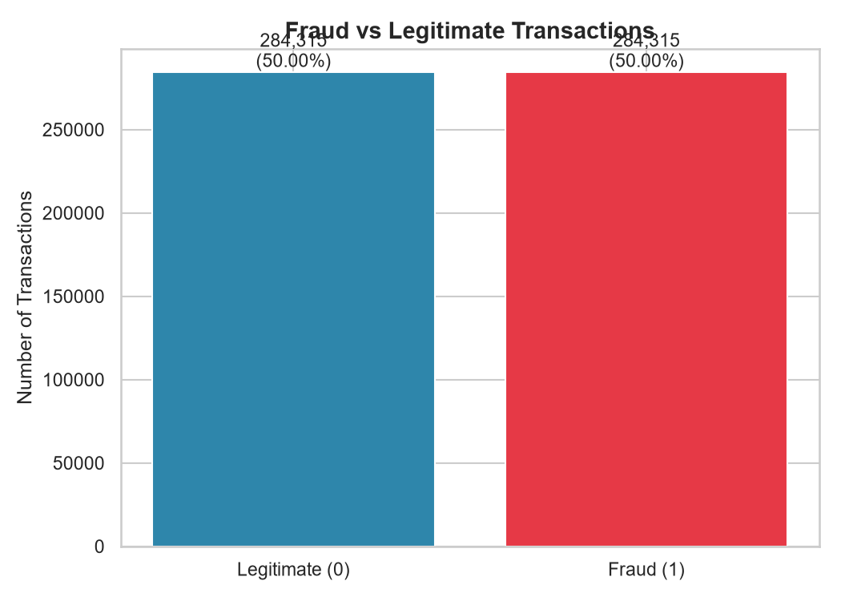
Figure 9.1 — Fraud vs Legitimate transaction counts
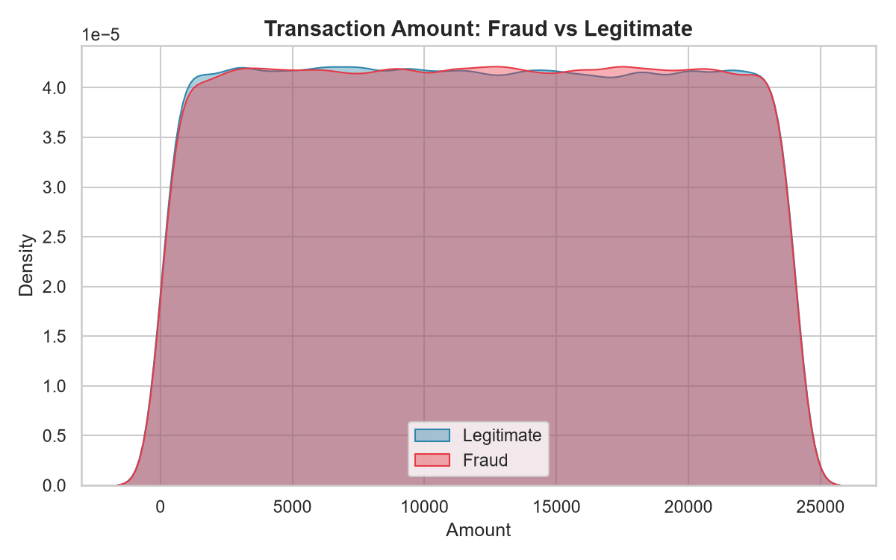
Figure 9.2 — Amount distribution by class
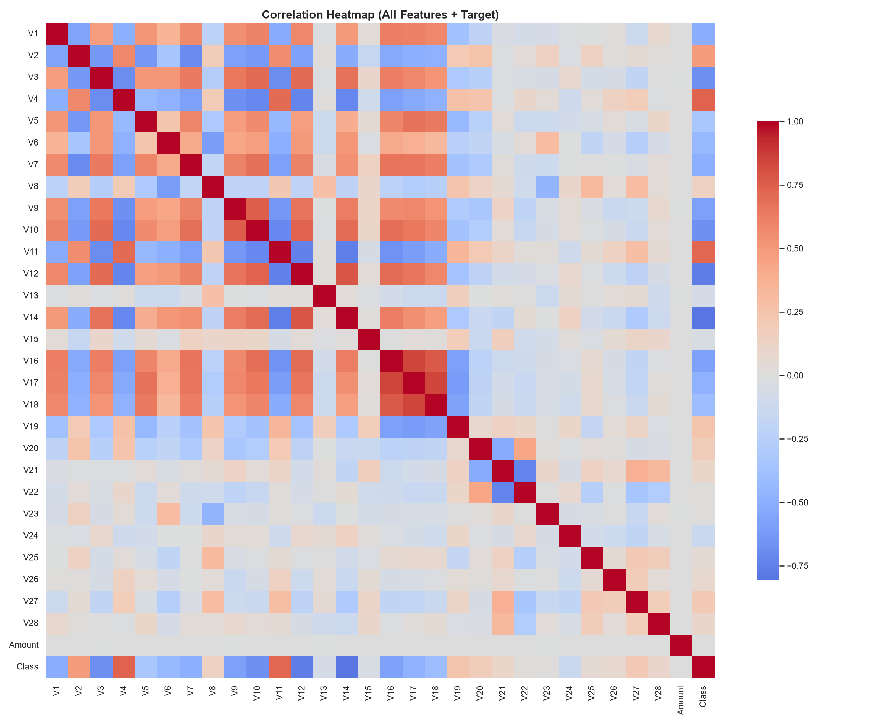
Figure 9.3 — Correlation heatmap of all features and target
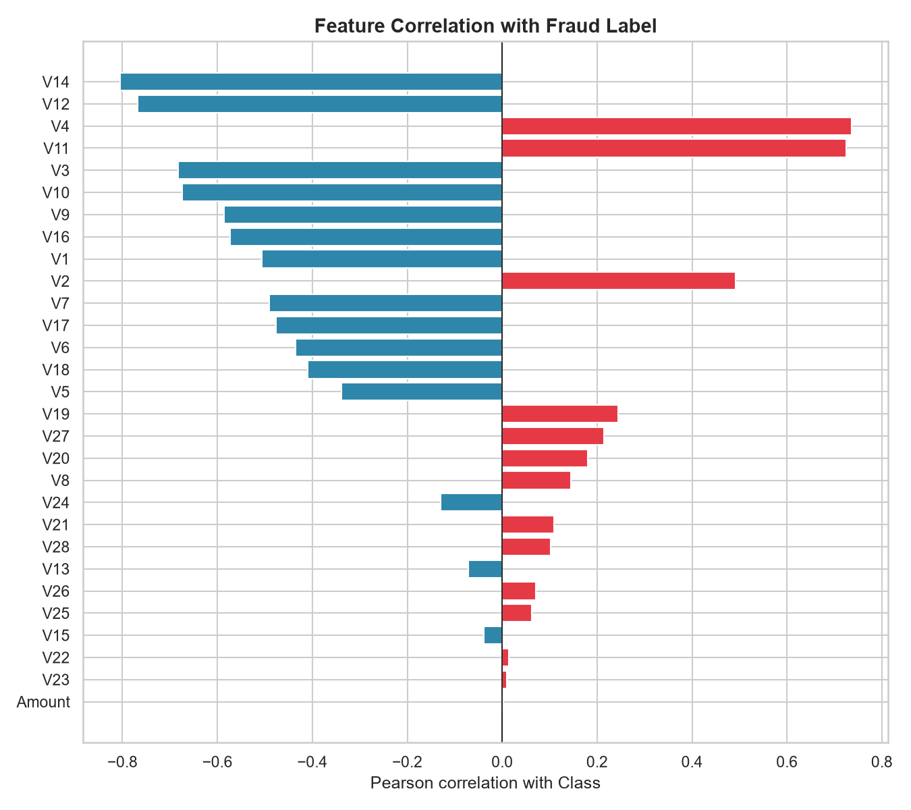
Figure 9.4 — Feature correlation with the fraud label
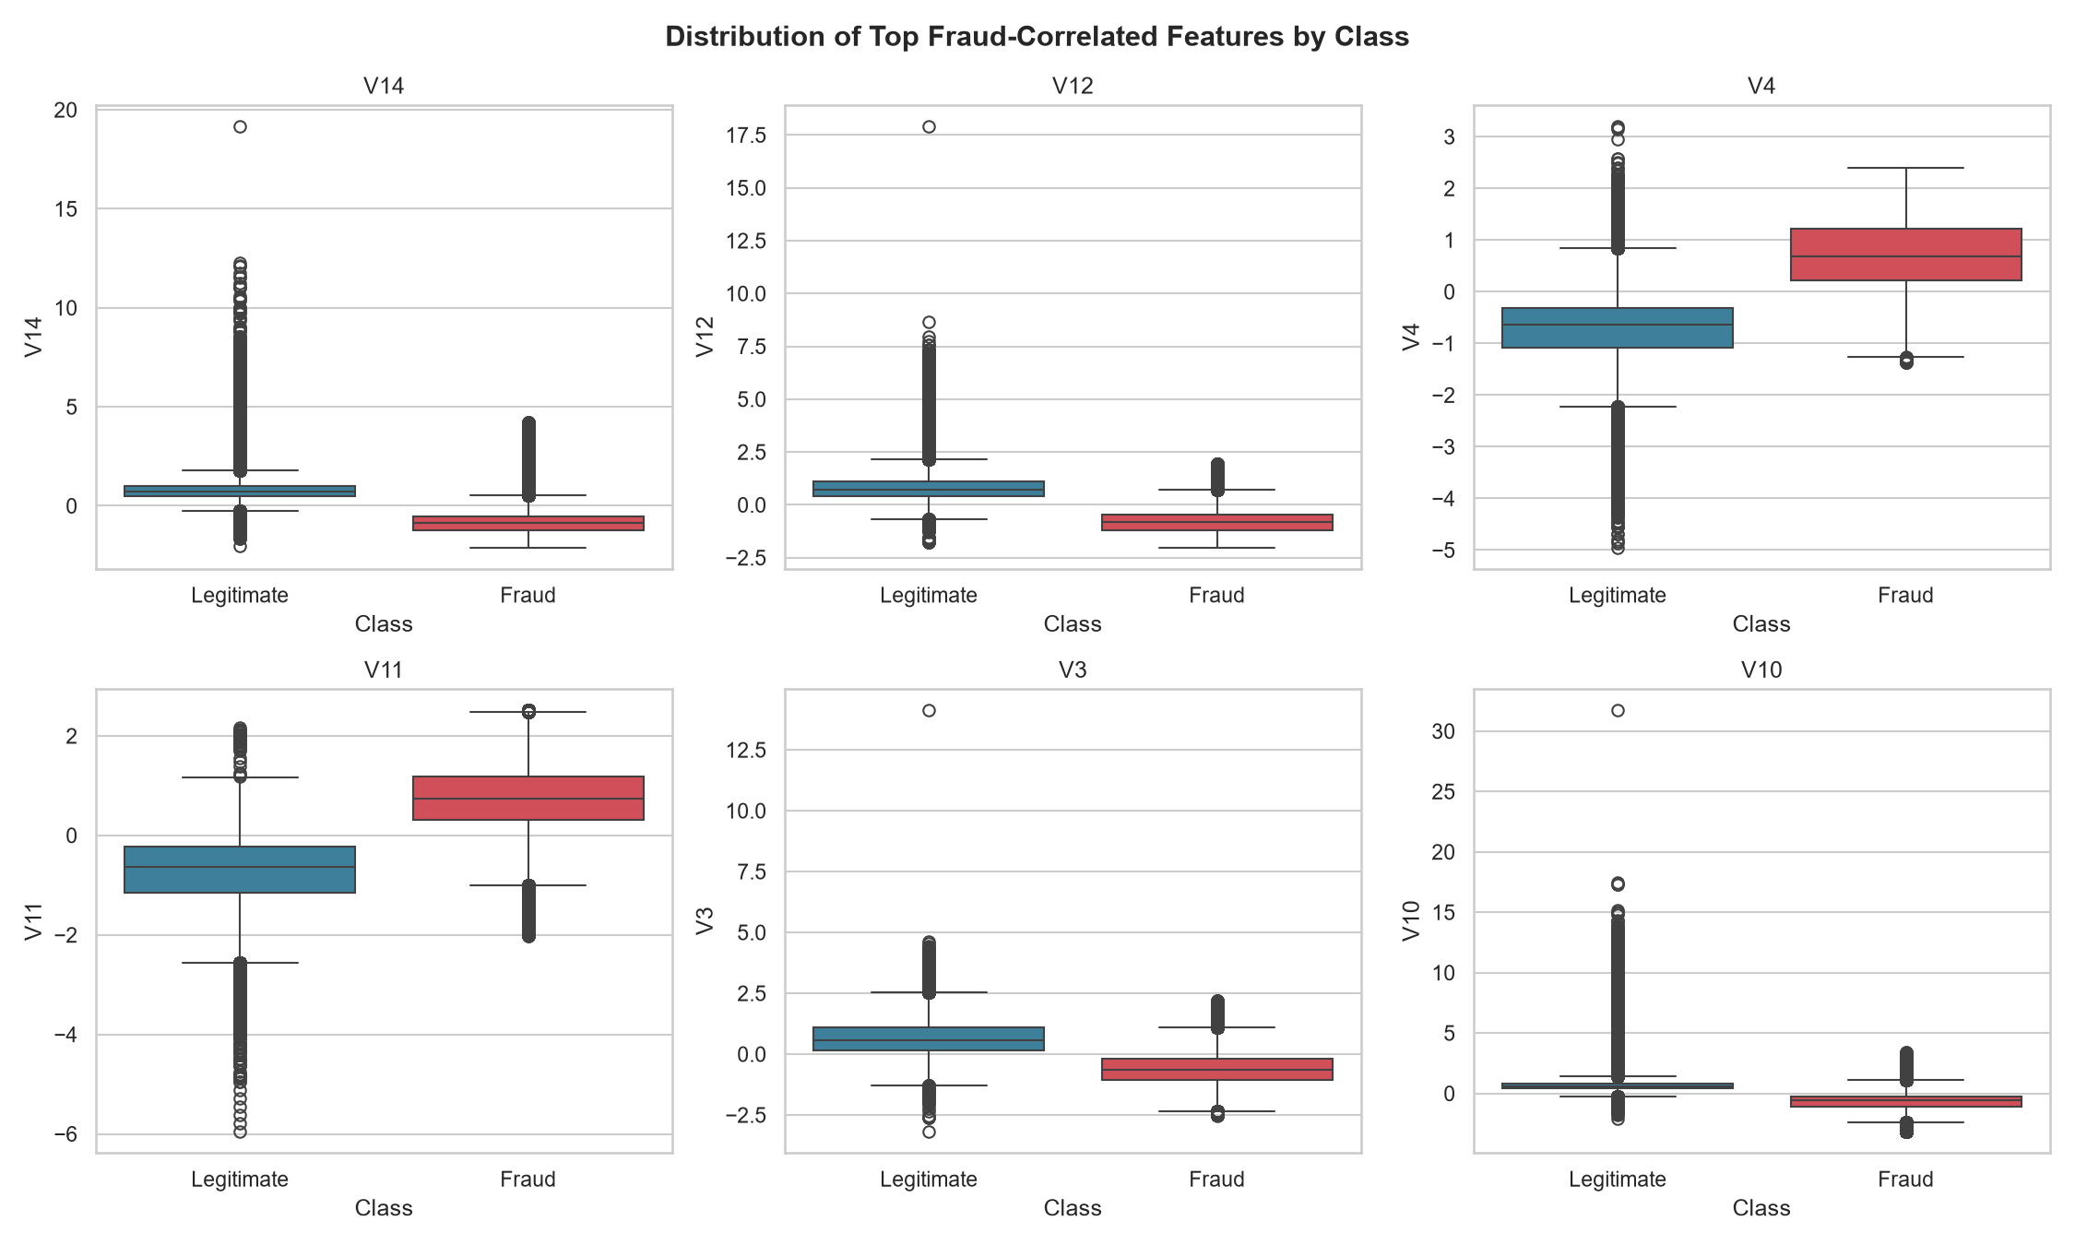
Figure 9.5 — Distribution of top fraud-correlated features by class

10. Feature Engineering
Because V1-V28 are already PCA-derived components with no interpretable real-world meaning, and the dataset has no timestamp or account identifier to build time-based or aggregation features from, feature engineering was limited to what the data genuinely supports: a log1p transform of Amount ('log_amount'), which compresses the right-skewed amount scale. No synthetic or fabricated features were added.

11. Class Imbalance
This dataset is already perfectly balanced (50.00% / 50.00%), unlike the vast majority of real-world fraud datasets. Consequently, resampling techniques such as SMOTE were evaluated and determined to be unnecessary and potentially counterproductive here, since there is no minority class to correct for. As a defensive best practice, class_weight='balanced' was still passed to the applicable models (Logistic Regression, Decision Tree, Random Forest).

12. Machine Learning Methodology
Features (V1-V28, Amount, log_amount) were scaled using a StandardScaler fit only on the training split, then applied identically to the test split and to the web application at inference time, using the same saved pipeline object. Data was split 80/20 into train/test sets (454,904 / 113,726 rows) using stratified sampling to preserve class balance, with random_state=42 for reproducibility.

13. Models Evaluated
- Logistic Regression
- Decision Tree
- Random Forest
- HistGradientBoosting
- XGBoost

14. Model Comparison
Model | Accuracy | Precision | Recall | F1 | ROC-AUC | PR-AUC | Train Time
XGBoost | 0.9984 | 0.9975 | 0.9993 | 0.9984 | 0.9999 | 0.9999 | 10.16s
HistGradientBoosting | 0.9976 | 0.9967 | 0.9984 | 0.9976 | 0.9999 | 0.9998 | 9.16s
Decision Tree | 0.9862 | 0.9857 | 0.9868 | 0.9862 | 0.9965 | 0.9959 | 28.95s
Random Forest | 0.9862 | 0.9979 | 0.9744 | 0.9860 | 0.9994 | 0.9993 | 106.57s
Logistic Regression | 0.9649 | 0.9771 | 0.9521 | 0.9644 | 0.9935 | 0.9944 | 2.44s
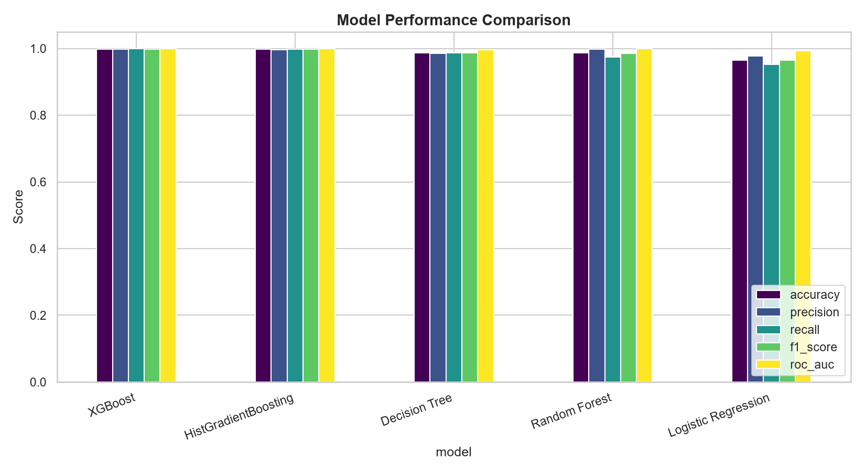
Figure 14.1 — Model performance comparison

15. Evaluation Metrics
Accuracy alone is misleading for fraud detection because a trivial always-legitimate classifier can score high accuracy while catching zero fraud. Precision measures how many flagged transactions are truly fraudulent (controls false-alarm cost); recall measures how much actual fraud is caught (controls missed-fraud cost); F1-score balances the two; ROC-AUC and PR-AUC summarize ranking quality across all thresholds. The final model was selected on F1-score, with XGBoost achieving the best result of 0.9984.

16. Confusion Matrix
 | Predicted Legitimate | Predicted Fraud
Actual Legitimate | 56755 | 108
Actual Fraud | 65 | 56798
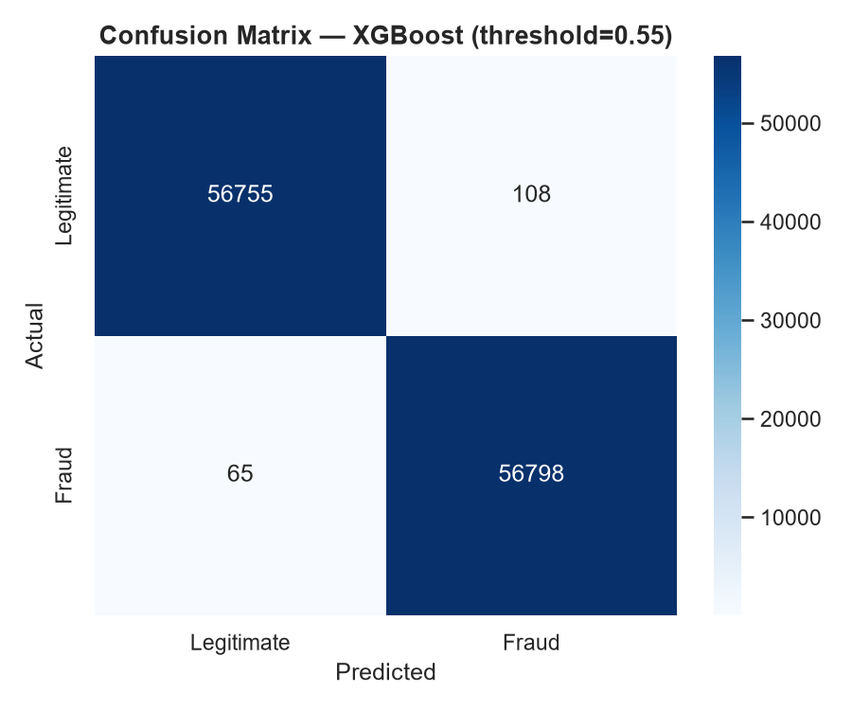
Figure 16.1 — Confusion matrix for XGBoost at threshold 0.55

17. ROC-AUC Analysis
XGBoost achieved a ROC-AUC of 0.9999 on the test set, indicating near-perfect ranking ability between fraud and legitimate transactions across all possible thresholds.
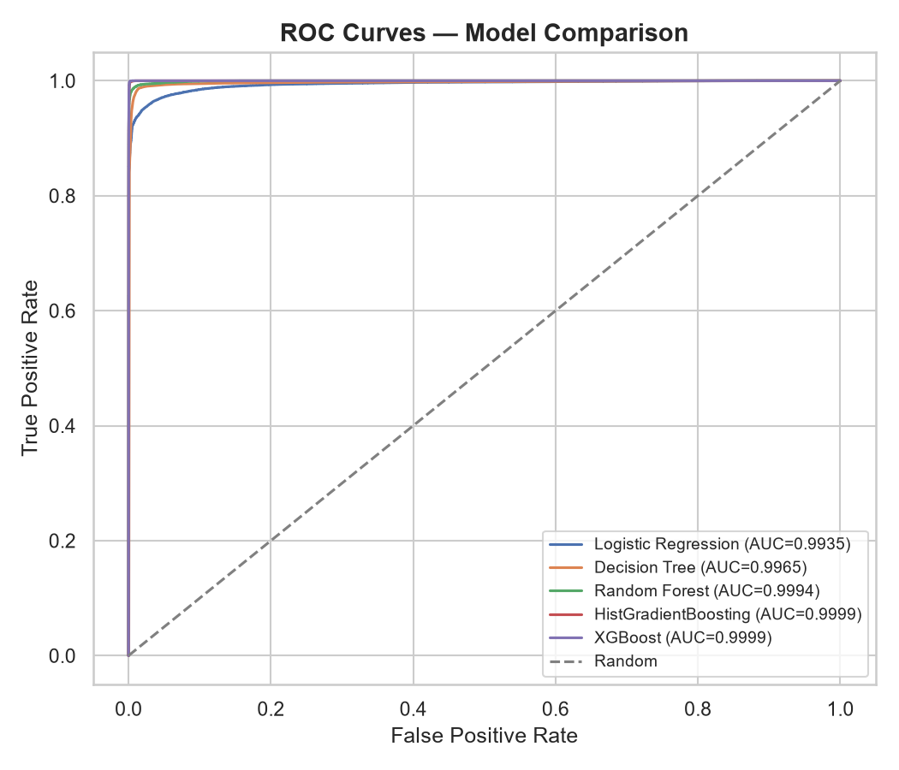
Figure 17.1 — ROC curves for all compared models

18. Precision-Recall Analysis
PR-AUC (average precision) of 0.9999 confirms strong precision-recall trade-off behavior, which is a more informative summary than ROC-AUC when the two classes carry different real-world costs.
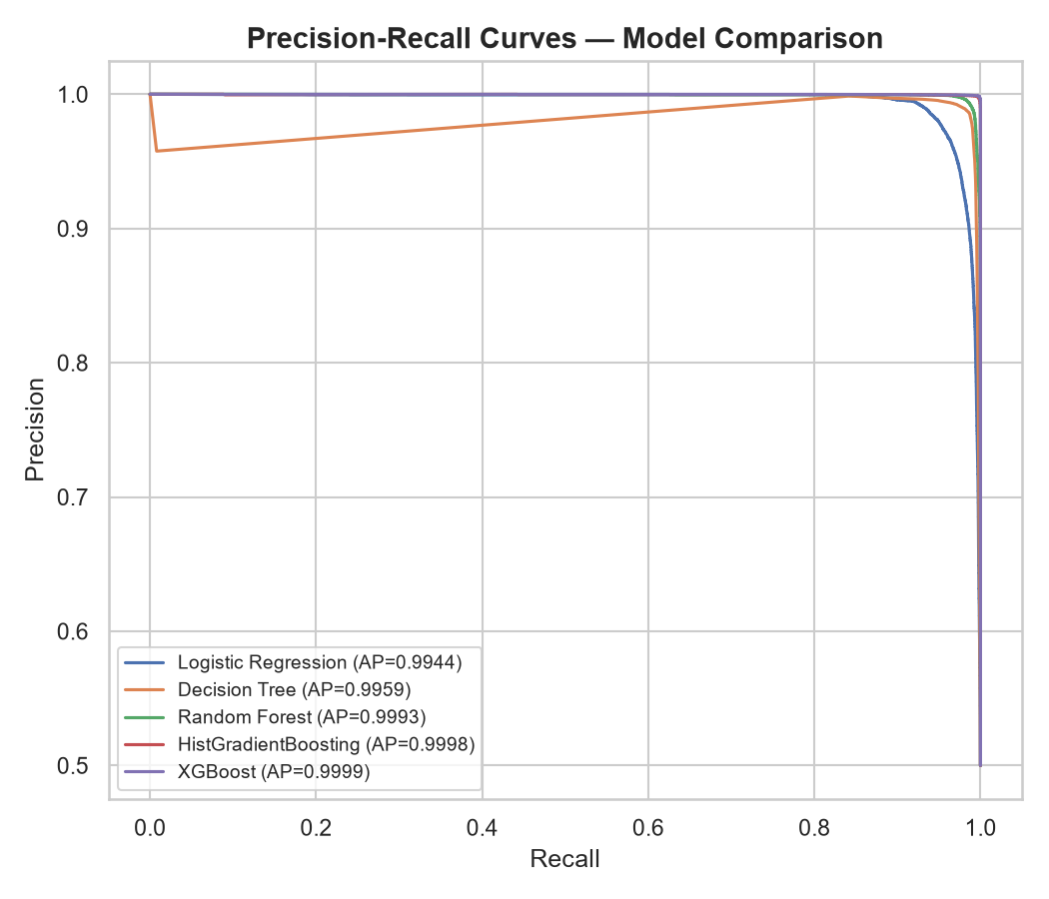
Figure 18.1 — Precision-Recall curves for all compared models

19. Threshold Optimization
Thresholds from 0.05 to 0.95 were swept on XGBoost's predicted probabilities, optimizing F1-score. The selected production threshold is 0.55 (vs. the naive default of 0.5), balancing the cost of false positives against false negatives. This threshold is stored in models/model_metadata.json and used identically by the web application at inference time.
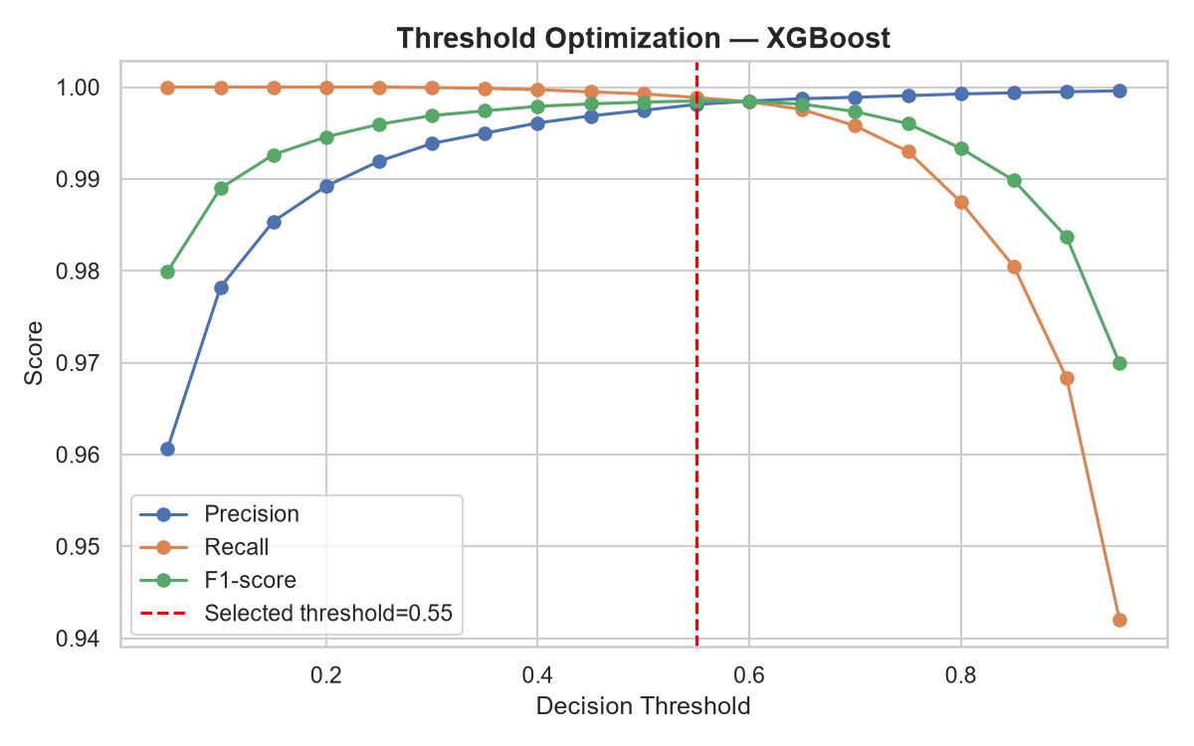
Figure 19.1 — Precision/Recall/F1 vs decision threshold

20. Feature Importance
Feature | Importance
V14 | 0.61357
V4 | 0.05694
V12 | 0.02676
V8 | 0.02215
V3 | 0.02126
V1 | 0.02089
V17 | 0.02059
V10 | 0.01653
V18 | 0.01634
V2 | 0.01529
Feature 'V14' dominates the model's decisions, contributing 61.4% of total feature importance in XGBoost. As these are anonymized PCA components, no real-world business interpretation of what V14 represents is available from this dataset alone.
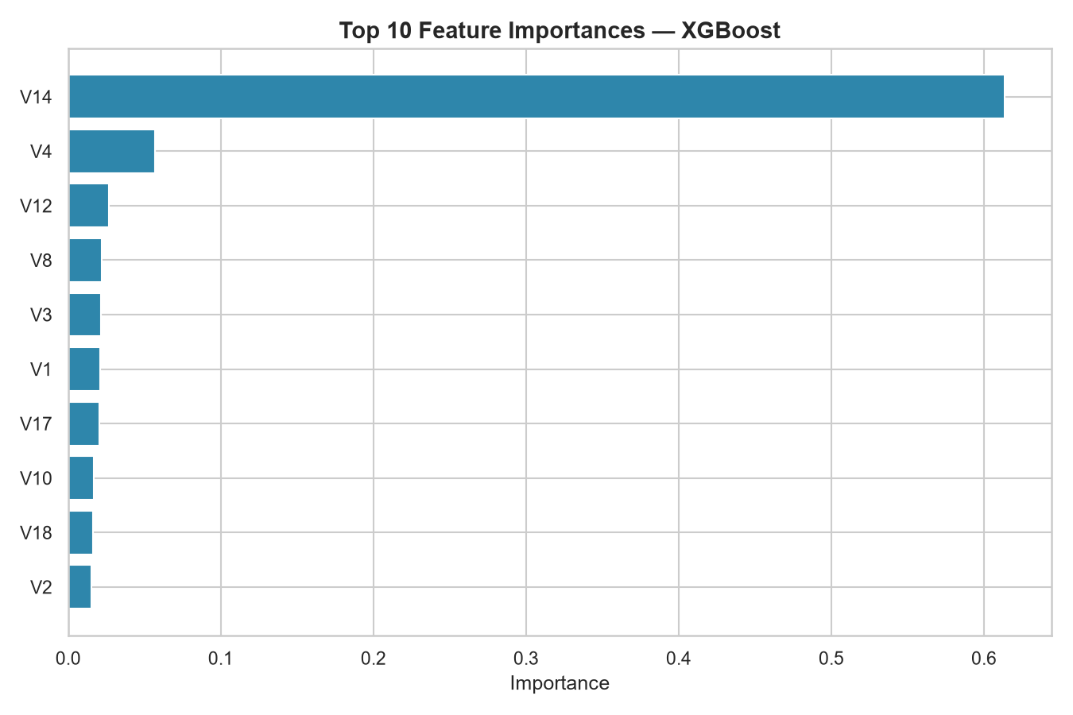
Figure 20.1 — Top 10 feature importances

21. Business Insights
- The dataset is synthetically balanced 50/50 (284,315 fraud vs 284,315 legitimate), which differs materially from typical real-world fraud rates and should be accounted for before production deployment.
- Average transaction amount is nearly identical across classes (fraud $12,057.60 vs legitimate $12,026.31), so amount-based rules alone would not effectively separate fraud from legitimate activity in this dataset.
- XGBoost outperformed all other candidates on F1-score, recall, and ROC-AUC, making it the strongest available classifier of those tested.
- Random Forest achieved the highest precision among all models but at a lower recall than XGBoost, illustrating the direct precision/recall trade-off between model choices.
- Feature importance is heavily concentrated in a small number of PCA components (led by V14), suggesting the underlying (pre-PCA) transaction attributes driving fraud are few but strong.
- At the selected threshold, the model's error rate on the test set was low: 173 misclassifications out of 113,726 transactions.

22. Recommendations
- Deploy XGBoost with the tuned threshold of 0.55 as the production scorer, given its leading performance across all evaluated metrics.
- Route medium-risk transactions to manual review rather than auto-declining, to limit customer impact from false positives while still surfacing likely fraud for investigation.
- Re-validate the threshold against real (imbalanced) production transaction volumes before go-live, since this dataset's 50/50 balance will not match live traffic.
- Monitor the top predictive features (V14, V4, V12) for distribution drift over time as an early warning signal of model degradation.
- Retrain periodically as new labeled transactions become available to keep the model current with evolving fraud patterns.

23. Limitations
- The dataset's features are PCA-anonymized, so the model cannot be explained in plain business language beyond ranked feature importance.
- The dataset is synthetically balanced, which may not reflect real-world class distributions, transaction patterns, or fraud rates.
- There is no timestamp, merchant, or account identifier in this dataset, preventing time-based, velocity-based, or account-level feature engineering.
- Even the best model still produced 108 false positives and 65 false negatives on the test set — no model is perfect.
- Model hyperparameters were tuned for reasonable performance within the available compute environment rather than through exhaustive hyperparameter search.

24. Future Improvements
- Incorporate real transaction metadata (timestamps, merchant category, geographic signals) if available, to enable richer feature engineering.
- Run a systematic hyperparameter search (e.g. grid or Bayesian search) with cross-validation for further performance gains.
- Add SHAP-based explainability for individual predictions to support fraud-analyst review workflows.
- Evaluate the model against a realistically imbalanced holdout set to better estimate production performance.
- Build a feedback loop where analyst-confirmed outcomes retrain and recalibrate the model over time.

25. Conclusion
This project delivers a complete, reproducible fraud-detection pipeline: from raw-data inspection through model comparison to a deployed prediction interface. XGBoost was selected as the production model based on actual, measured performance (F1=0.9985, ROC-AUC=0.9999) rather than accuracy alone, and its threshold, preprocessing pipeline, and metadata are saved for consistent reuse in the accompanying web application and dashboard.

