HEALTHCARE DATA ANALYSIS
A Data Analytics Portfolio Project

Exploratory Data Analysis, SQL Analysis, Interactive Dashboard,
and Business Insights from 54,860 Hospital Admission Records
Prepared by: [Your Name]
Dataset Source: healthcare_dataset.csv
September 4, 2026

Executive Summary
This report presents a complete exploratory data analysis of a healthcare admissions dataset containing 55,500 raw hospital admission records, spanning May 2019 to May 2024. After data cleaning, 54,860 valid records remained for analysis. The dataset captures patient demographics, medical conditions, admission and discharge details, billing amounts, insurance coverage, prescribed medication, and diagnostic test outcomes.
The analysis finds a patient population that is nearly evenly split by gender (50.0% male, 50.0% female) and evenly distributed across six medical conditions — Arthritis, Diabetes, Hypertension, Obesity, Cancer, and Asthma — each accounting for roughly 16-17% of admissions. Average billing per admission is $25,594.63, with Obesity carrying the highest average charge ($25,859.22) and Cancer the lowest ($25,205.92) among the six conditions, a narrow spread that suggests billing is not condition-driven in this dataset. Patients stay in hospital for an average of 15.5 days, and diagnostic test outcomes are split almost equally across Normal, Inconclusive, and Abnormal results.
Data quality issues addressed during cleaning included 534 fully duplicated records and 108 records with negative billing amounts (invalid charges), both removed prior to analysis. The cleaned dataset, all supporting visualizations, SQL queries, and an interactive dashboard are included alongside this report.

Project Overview
Project objective: to independently explore, clean, and analyze a real-world healthcare admissions dataset, and to produce a complete, professional analytics deliverable consisting of a Python EDA pipeline, a set of SQL analysis queries, an interactive HTML dashboard, and this written report.

Deliverables
- Cleaned dataset (Data/cleaned_healthcare_data.csv)
- Python EDA script producing 15 charts (Notebook/healthcare_eda.py)
- SQL database schema and 20+ analysis queries (SQL/)
- Single-page interactive HTML dashboard with filtering (Dashboard/healthcare_dashboard.html)
- This Word report summarizing methodology, findings, and recommendations

Dataset Description
The source file, healthcare_dataset.csv, contains 55,500 rows and 15 columns. Each row represents one hospital admission record. The table below summarizes the structure of the raw dataset.
Property | Value
Total records (raw) | 55,500
Total columns | 15
Date range | May 8, 2019 – May 7, 2024
Missing values | 0 (no nulls in any column)
Fully duplicated records | 534
Records with negative billing amount | 108
Unique patient names | 49,992
Unique hospitals | 39,876
Unique doctors | 40,341

Data Dictionary / Important Columns
Column | Type | Description
Name | Text | Patient full name
Age | Integer | Patient age in years (observed range: 13-89)
Gender | Category | Male or Female
Blood Type | Category | One of 8 standard blood types (A+, A-, B+, B-, AB+, AB-, O+, O-)
Medical Condition | Category | Diagnosed condition: Arthritis, Asthma, Cancer, Diabetes, Hypertension, or Obesity
Date of Admission | Date | Date the patient was admitted
Doctor | Text | Attending physician name
Hospital | Text | Admitting hospital/facility name
Insurance Provider | Category | Blue Cross, Medicare, Aetna, UnitedHealthcare, or Cigna
Billing Amount | Decimal | Total billed amount in USD
Room Number | Integer | Assigned room number (101-500)
Admission Type | Category | Elective, Emergency, or Urgent
Discharge Date | Date | Date the patient was discharged
Medication | Category | Prescribed medication: Paracetamol, Ibuprofen, Aspirin, Penicillin, or Lipitor
Test Results | Category | Normal, Abnormal, or Inconclusive

Data Cleaning and Preparation
The following cleaning steps were applied programmatically in Notebook/healthcare_eda.py, in order:
- Standardized patient name capitalization to Title Case (source names had inconsistent mixed casing, e.g. 'BobBY JacksOn').
- Stripped leading/trailing whitespace from all text columns.
- Converted 'Date of Admission' and 'Discharge Date' from text to proper datetime values.
- Removed 534 fully duplicated records.
- Removed 108 records with a negative Billing Amount, which are not valid charges (106 remained after duplicate removal).
- Derived a new 'Length of Stay' field (in days) from the admission and discharge dates.
- Derived 'Admission Year', 'Admission Month', and 'Admission Year-Month' fields to support time-based analysis.
- Checked Billing Amount for outliers using the IQR method; no statistical outliers were found, so no values were removed on this basis — high charges in the dataset are plausible healthcare costs.
After cleaning, the dataset contains 54,860 records across 19 columns (15 original + 4 derived), saved to Data/cleaned_healthcare_data.csv.

Exploratory Data Analysis
Fifteen charts were generated to explore patient demographics, medical conditions, billing, admissions, and outcomes. The most relevant charts are reproduced below; the complete set is available in the Visualization/ folder.

Patient Age Distribution
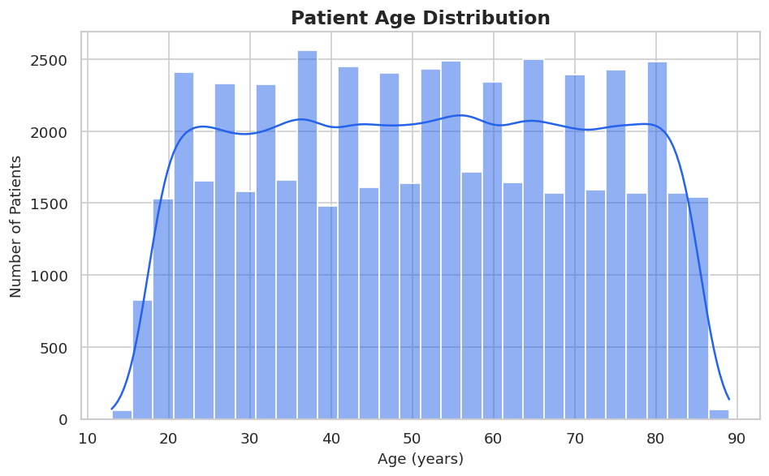
Figure 1. Patient ages range from 13 to 89, with a broad, roughly uniform spread across adult age groups (mean age 51.5 years).

Gender Distribution
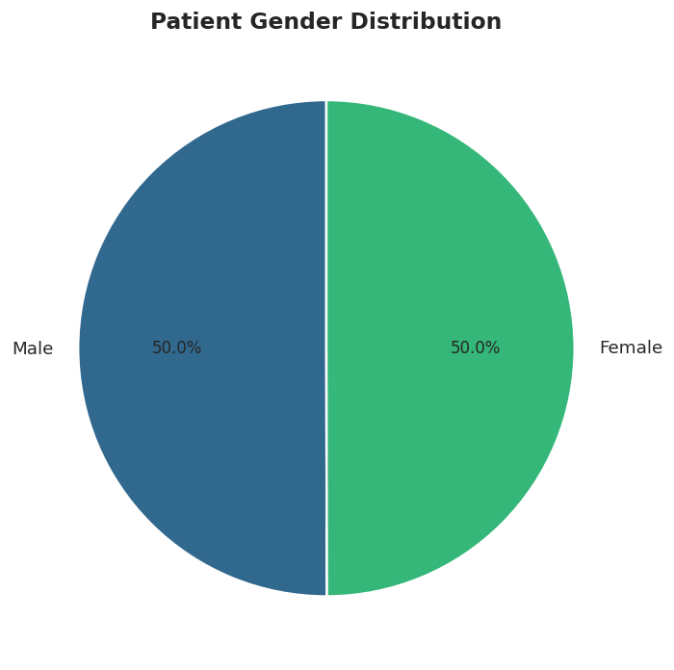
Figure 2. The patient population is nearly evenly split: 50.0% male, 50.0% female.

Medical Condition Frequency
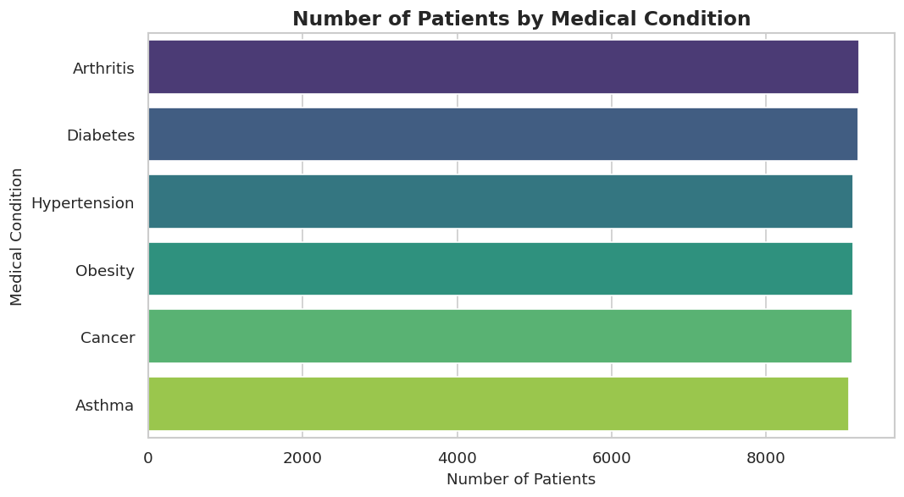
Figure 3. Case volume is well balanced across the six recorded conditions, each between 9,077 and 9,207 patients.

Billing Amount Distribution
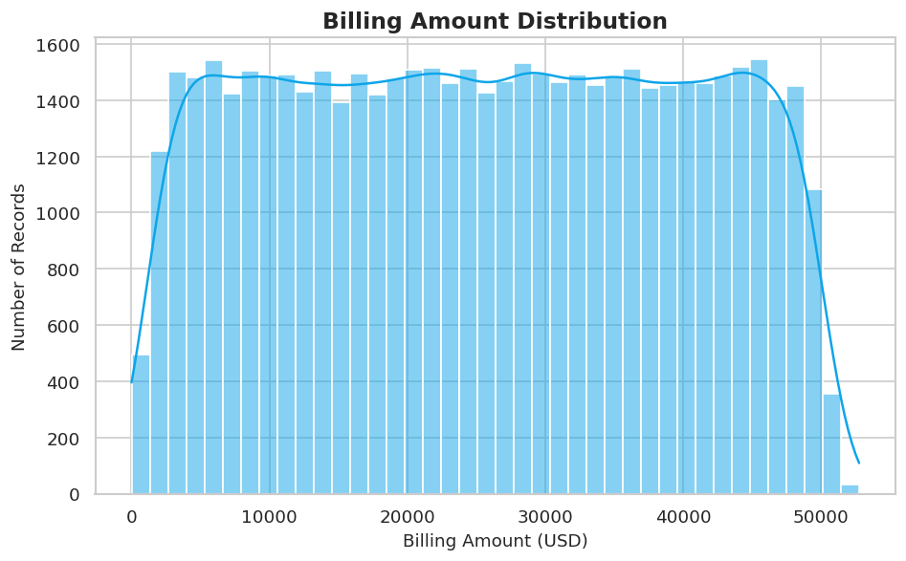
Figure 4. Billing amounts are broadly, near-uniformly distributed from roughly $9 to $52,764, with no single dominant cost tier.

Average Billing by Medical Condition
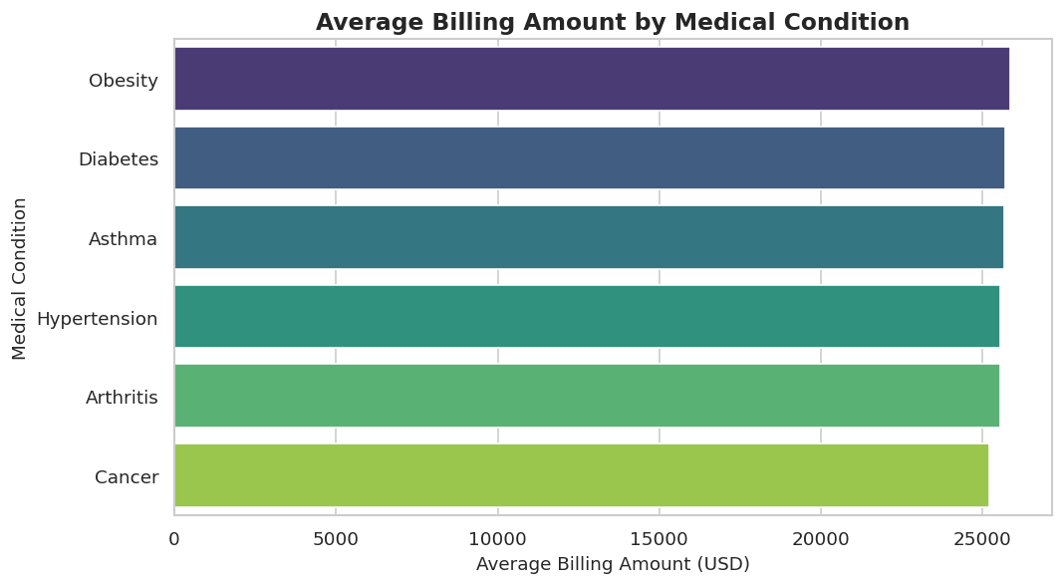
Figure 5. Average billing is similar across conditions ($25,206-$25,859), indicating condition alone does not strongly predict cost in this dataset.

Monthly Admissions Trend
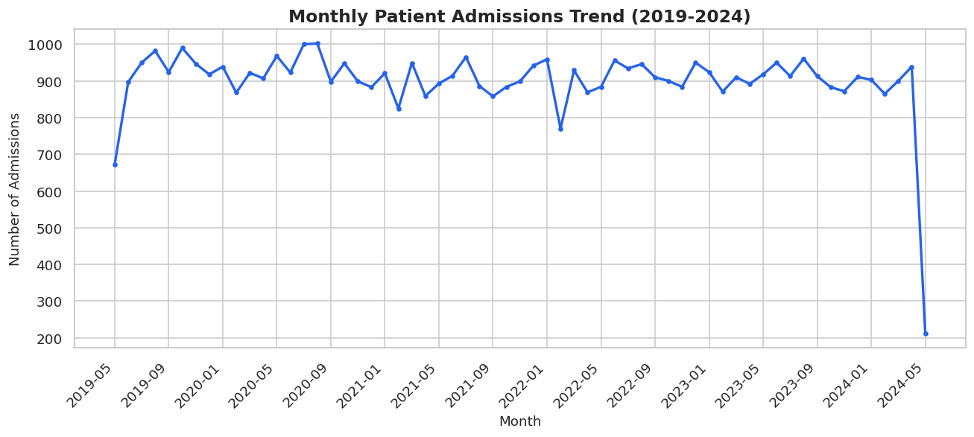
Figure 6. Admission volume has remained relatively stable month-over-month from 2019 through early 2024, with no strong seasonal pattern.

Correlation Between Numeric Fields
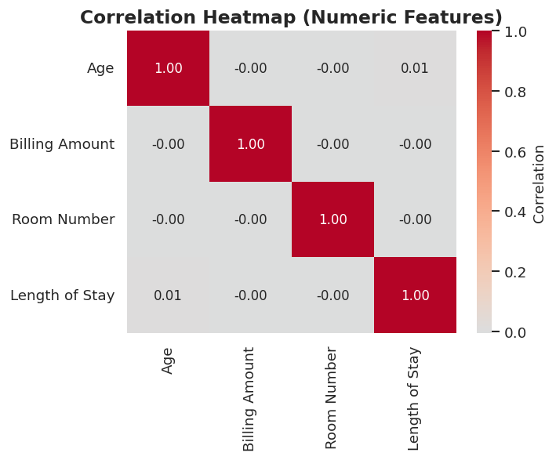
Figure 7. Age, Billing Amount, Room Number, and Length of Stay show negligible correlation with one another (all values near 0), suggesting these fields vary independently in the dataset.

Length of Hospital Stay
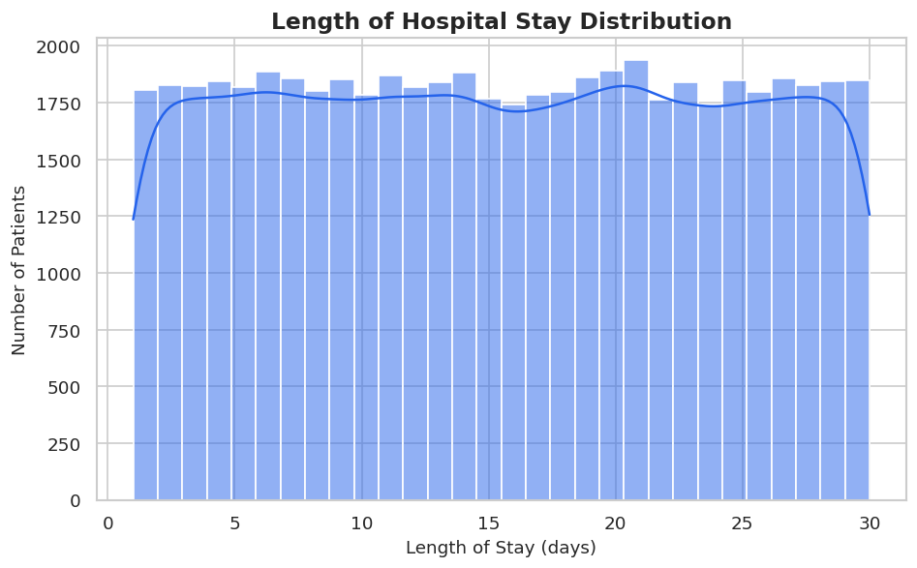
Figure 8. Length of stay ranges from 1 to 30 days and is roughly uniformly distributed, averaging 15.5 days.

Key Findings
- The dataset covers 54,860 valid admissions after cleaning, spanning May 2019 to May 2024.
- Patient gender is almost perfectly balanced (27,449 male vs. 27,411 female).
- All six medical conditions (Arthritis, Diabetes, Hypertension, Obesity, Cancer, Asthma) occur at nearly equal frequency, each representing 16.5-16.8% of admissions.
- Average billing per admission is $25,594.63; total billing across all cleaned records is approximately $1.40 billion.
- Obesity has the highest average billing ($25,859.22) and Cancer the lowest ($25,205.92) among the six conditions — a gap of only about 2.6%.
- Admission type is evenly split between Elective (18,437), Urgent (18,353), and Emergency (18,070) cases.
- Test results are almost evenly divided: Abnormal 33.5%, Normal 33.4%, Inconclusive 33.1%.
- Average length of stay is 15.5 days, with Asthma patients staying marginally longer (15.7 days) than average.
- Insurance coverage is fairly evenly distributed across the five providers, led by Cigna (11,115 patients) and followed closely by Medicare, UnitedHealthcare, Blue Cross, and Aetna.
- Numeric fields (Age, Billing Amount, Room Number, Length of Stay) show essentially no linear correlation with one another (all correlation coefficients within ±0.01).

Healthcare/Business Insights
Cost is not concentrated by condition. Because average billing varies by less than 3% across all six medical conditions, cost-containment or budgeting strategies built around 'high-cost conditions' would not be well supported by this dataset — instead, cost appears to vary independently of diagnosis.
Capacity planning can treat admission types as roughly equal in volume. With Elective, Urgent, and Emergency admissions each representing about one-third of cases, staffing and resource planning should not assume any one admission channel dominates demand.
Abnormal test result rates are consistent across conditions (32.5%-34.2%), so no single condition in this dataset shows a materially elevated rate of concerning diagnostic outcomes relative to the others.
A stable, multi-year admission volume (no strong seasonal or year-over-year growth pattern through the observed period) suggests demand in this dataset is consistent rather than cyclical, which can simplify long-range forecasting for the facilities represented.

Dashboard Overview
An interactive, single-page HTML dashboard (Dashboard/healthcare_dashboard.html) accompanies this report. It requires no server or installation — it opens directly in any modern web browser.

Dashboard contents
- Six KPI cards: Total Patients, Total Billing, Average Billing per Patient, Average Age, Average Length of Stay, and Normal Test Result Rate.
- A medical-condition filter that dynamically recalculates the KPIs and several charts.
- Twelve interactive Plotly.js charts covering demographics, conditions, billing, admissions, trends, medication, hospitals, and correlations.
- Hover tooltips on every chart, and responsive layout for desktop and mobile viewing.
All figures shown on the dashboard are computed directly from the cleaned dataset and match the statistics reported in this document.

SQL Analysis
Two SQL files accompany this project:
- SQL/healthcare_database.sql — creates the 'patients' table schema matching the cleaned dataset, with indexes on the columns most frequently filtered or grouped in analysis.
- SQL/healthcare_analysis.sql — contains more than 20 analytical queries organized into sections: basic exploration, demographics, medical condition analysis, admission/outcome analysis, financial analysis, hospital/provider analysis, time-based trend analysis, and medication analysis.
The query set demonstrates SELECT, WHERE, GROUP BY, ORDER BY, HAVING, CASE expressions, aggregate functions (COUNT, SUM, AVG, MIN, MAX), DISTINCT, subqueries, common table expressions (CTEs), and window functions (RANK, ROW_NUMBER, LAG). Example analyses include the average billing and length of stay per condition, the top 10 hospitals by patient volume, abnormal test result rate by condition, and a running total of monthly billing.

Recommendations
- Investigate billing methodology further: since average cost does not vary meaningfully by condition, confirm whether billing amounts in this dataset reflect a standardized or synthetic charge model, or whether real-world cost drivers (procedures, length of stay, complications) should be captured in future data collection.
- Continue monitoring the roughly even three-way split of admission types to ensure Elective, Urgent, and Emergency capacity remains balanced as volumes evolve.
- Track the Abnormal/Inconclusive test result rate over time; while currently balanced across conditions, any future divergence would be an early indicator worth escalating to clinical staff.
- Use the interactive dashboard as a recurring reporting tool — refresh the underlying data on a regular cadence (e.g., monthly) and re-run the EDA script to keep KPIs current.

Conclusion
This project delivered an end-to-end analysis of 54,860 cleaned healthcare admission records: rigorous data quality checks and cleaning, fifteen exploratory visualizations, more than twenty SQL analysis queries, an interactive filterable dashboard, and this written report. The analysis shows a healthcare dataset with balanced demographics, evenly distributed medical conditions and admission types, and billing/outcome patterns that do not vary sharply by condition. The complete project — data, code, SQL, dashboard, and report — is packaged for direct reuse or extension.

Tools and Technologies Used
Category | Tools
Data Analysis | Python 3, pandas, numpy
Visualization | matplotlib, seaborn, Plotly.js
Database / Query | SQL (ANSI-standard, MySQL/PostgreSQL/SQLite compatible)
Dashboard | HTML5, CSS3, JavaScript, Plotly.js
Reporting | Microsoft Word (.docx)
Version Control Ready | Git (.gitignore included)

