ScamShield AI
AI-Powered Scam & Fraud Message Detection System — Project Report
Training date: 2026-09-07T07:34:08

Abstract
Cyber-enabled financial fraud conducted in Hinglish (Hindi-English code-mixed) phone calls and messages is a large and growing problem in India. This project builds ScamShield AI, an end-to-end machine-learning system that classifies a free-text message as SAFE, SUSPICIOUS, or SCAM/FRAUD. The system combines a leakage-safe data pipeline, a TF-IDF + handcrafted-feature NLP representation, a five-model comparison, and a separate rule-based explainability layer, delivered through a Flask web dashboard.

Introduction
Scam calls and messages impersonating banks, delivery couriers, police, and government agencies are widespread and frequently exploit urgency, authority, and fear (e.g. 'digital arrest' scams). Detecting these automatically from raw text can help users and platforms flag risky messages before harm occurs.

Problem Statement
Given an arbitrary text message, automatically assess how likely it is to be a scam, explain why, and recommend an action — without relying on metadata that would not be available for a real user-submitted message.

Objectives
- Build a leakage-safe, reproducible data pipeline from the raw dataset to trained artifacts.
- Engineer text features suitable for Hinglish/code-mixed content.
- Compare multiple model families appropriate for high-dimensional sparse text.
- Select a final model using a criterion that accounts for the asymmetric cost of false negatives.
- Provide human-readable explanations separate from the statistical prediction.
- Ship a working, tested web application.

Existing System
Most consumer-facing scam protection today relies on manual user vigilance, telecom-operator caller-ID/spam tagging, or platform-level keyword filters that are easy to evade and offer no explanation to the end user. Few widely-available tools are tuned for Hinglish text specifically.

Proposed System
ScamShield AI ingests raw message text, extracts a combined TF-IDF (word + character n-gram) and handcrafted numeric feature representation, and applies a trained classifier calibrated to output a scam probability. That probability is bucketed into a three-tier SAFE/SUSPICIOUS/SCAM risk system, and a separate rule-based layer surfaces plain-language indicators (urgency, financial requests, authority impersonation, blackmail language, URLs, phone numbers, currency mentions).

Dataset Description
Source file: India_Cyber_Scam_Hinglish_Dataset.csv — 10000 rows, 8 columns: text, label, scam_category, caller_type, audio_duration, urgency_level, contains_blackmail, language_style.
Important data-quality finding: the raw file contains only 743 distinct message strings, each duplicated many times with different simulated call metadata to reach 10,000 rows. Allowing identical strings into both the train and test split would let a model memorise exact text rather than generalise, silently inflating every metric. The cleaning pipeline therefore deduplicates on message text before splitting.
After cleaning: 743 distinct messages remain (label distribution: {"0":110,"1":633}), split into 594 training and 149 test messages (stratified 80/20).
Only the 'text' column is used as a model input feature. scam_category, caller_type, audio_duration, urgency_level, and contains_blackmail describe how a call was categorised after the fact and would not be available for an arbitrary user-submitted message, so they are used only for exploratory analysis, never as training features. The constant language_style column (100% 'hinglish') was dropped as uninformative.

Data Preprocessing
- Removed exact duplicate rows and empty/whitespace-only messages.
- Normalised whitespace and stripped stray HTML-like tags.
- Deduplicated on message text to prevent train/test leakage (see above).
- Preserved case, digits, punctuation, URLs, and currency symbols through cleaning, since these are predictive signals for scam detection rather than noise to discard.
- Applied lightweight lowercasing + whitespace normalisation immediately before TF-IDF vectorisation only (the same function is reused identically at inference time).

Exploratory Data Analysis
Full EDA — class distribution, message length/word count distributions, most frequent words per class, urgency-level and blackmail-flag cross-tabulations, and the template-duplication finding above — is in notebooks/scam_message_detection_eda.ipynb, executed end-to-end with real outputs.
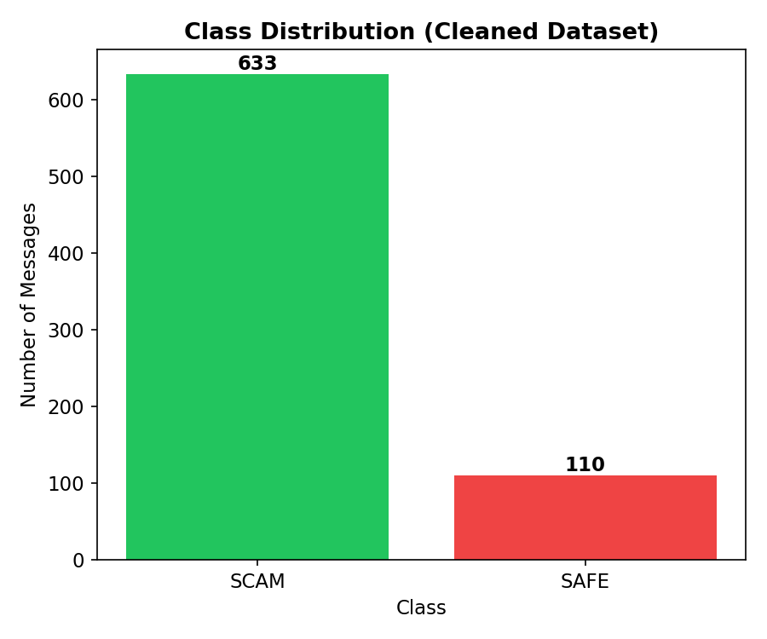
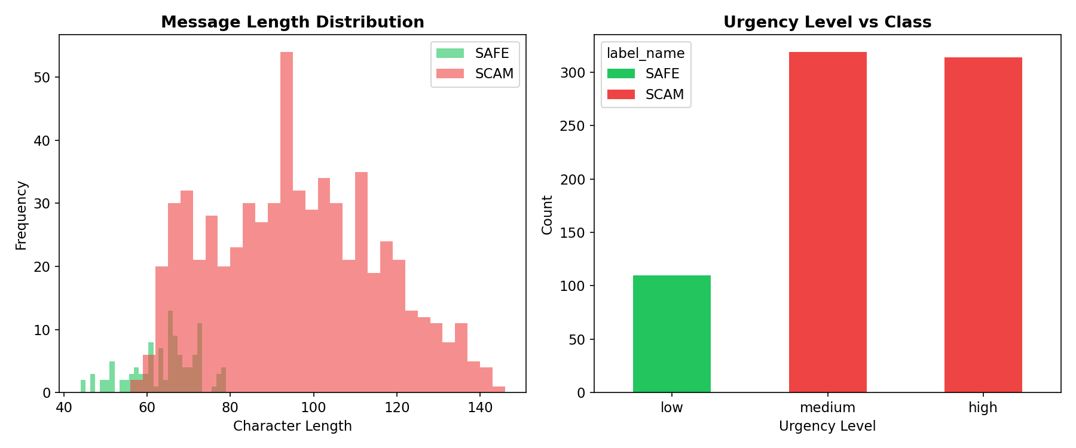

Feature Engineering
Three feature blocks are combined into a single sparse matrix:
- TF-IDF word n-grams (1-2 grams, max_features=8000, sublinear TF).
- TF-IDF character n-grams (3-5 grams, char_wb, max_features=8000) — robust to Hinglish spelling variation.
- Handcrafted numeric features: length, word/digit counts, uppercase ratio, exclamation/question counts, URL/phone/currency pattern counts, special-character count, average word length, and keyword-group hit-counts (urgency, financial, account/security, authority-impersonation, blackmail).
The numeric block is scaled with MaxAbsScaler to stay compatible with the sparse TF-IDF blocks. All transformers are fit on the training split only and pickled for reuse at inference time.

Machine Learning Models
Five models appropriate for high-dimensional sparse text were trained and compared using 5-fold stratified cross-validation (macro F1) plus held-out test evaluation:
- Logistic Regression (class_weight=balanced)
- Linear SVM (calibrated via CalibratedClassifierCV for probability outputs)
- Multinomial Naive Bayes
- Random Forest (class_weight=balanced_subsample)
- XGBoost

Model Evaluation
Final model: Logistic Regression. Selection criterion: macro F1 as the primary metric, with scam-class recall as an explicit tie-breaker, since a missed scam (false negative) is more costly than a false alarm on a safe message.
Metric | Value (Best Model) | Notes
Accuracy | 100.00% | Held-out test set
Macro F1 | 1.0000 | Primary selection criterion
Scam-class Recall | 100.00% | Tie-break criterion (false negatives)
Scam-class Precision | 100.00%
ROC-AUC | 1.0000
PR-AUC | 1.0000
5-fold CV Macro F1 | 1.0000 ± 0.0000 | Training set only

Comparison across all five candidate models on the held-out test set:
Model | Accuracy | Macro F1 | Scam Recall | ROC-AUC
Logistic Regression | 100.00% | 1.0000 | 100.00% | 1.0000
Linear SVM | 100.00% | 1.0000 | 100.00% | 1.0000
Multinomial Naive Bayes | 100.00% | 1.0000 | 100.00% | 1.0000
Random Forest | 100.00% | 1.0000 | 100.00% | 1.0000
XGBoost | 100.00% | 1.0000 | 100.00% | 1.0000

Results
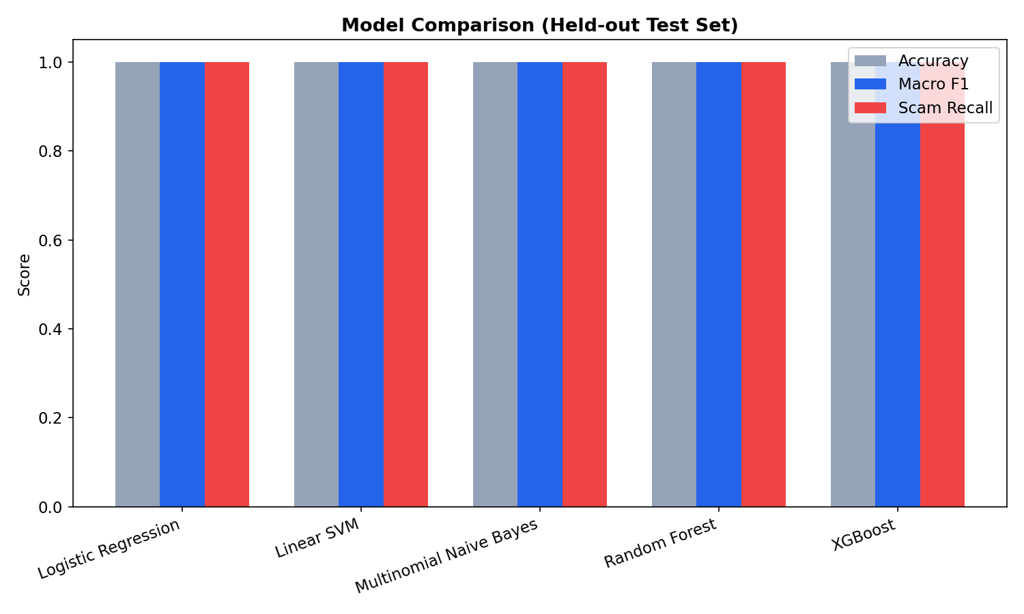
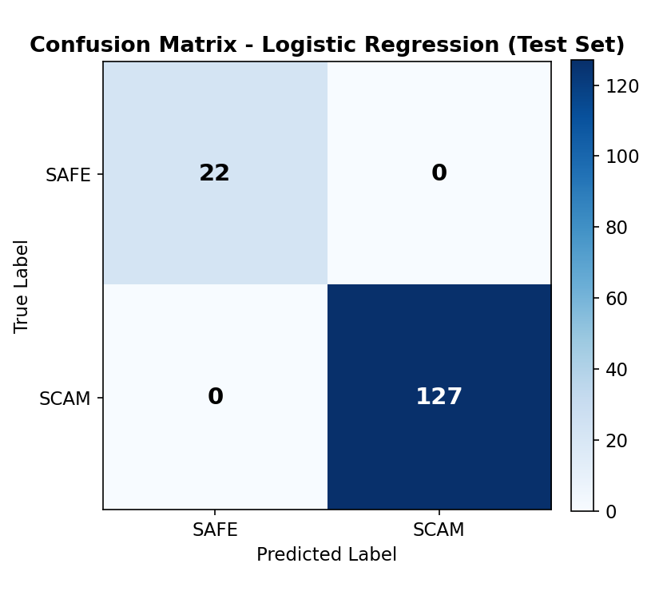
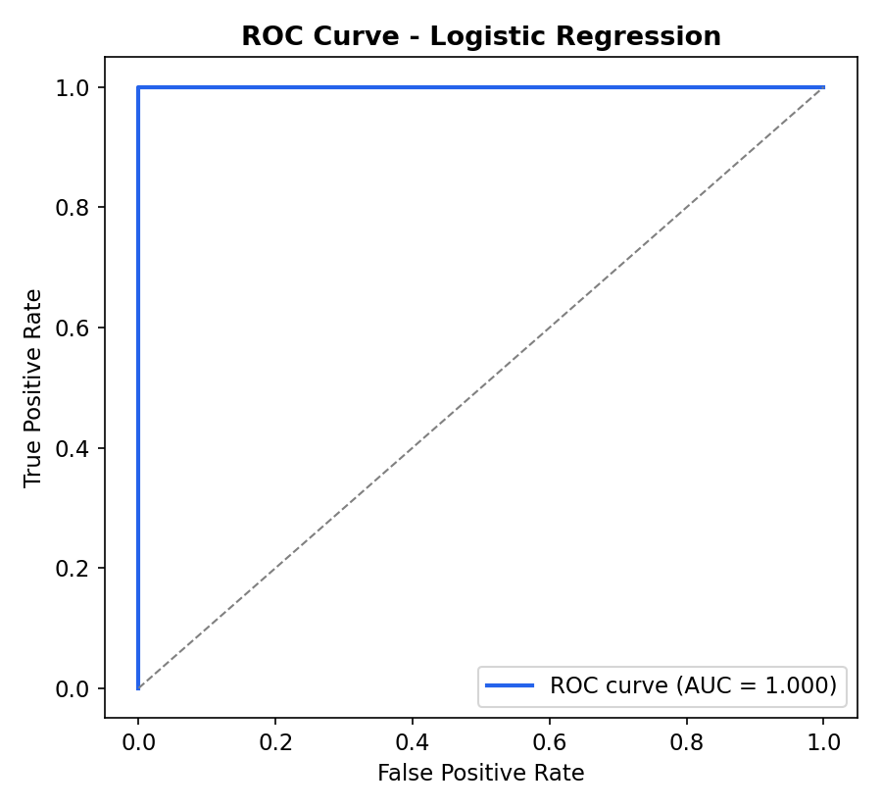
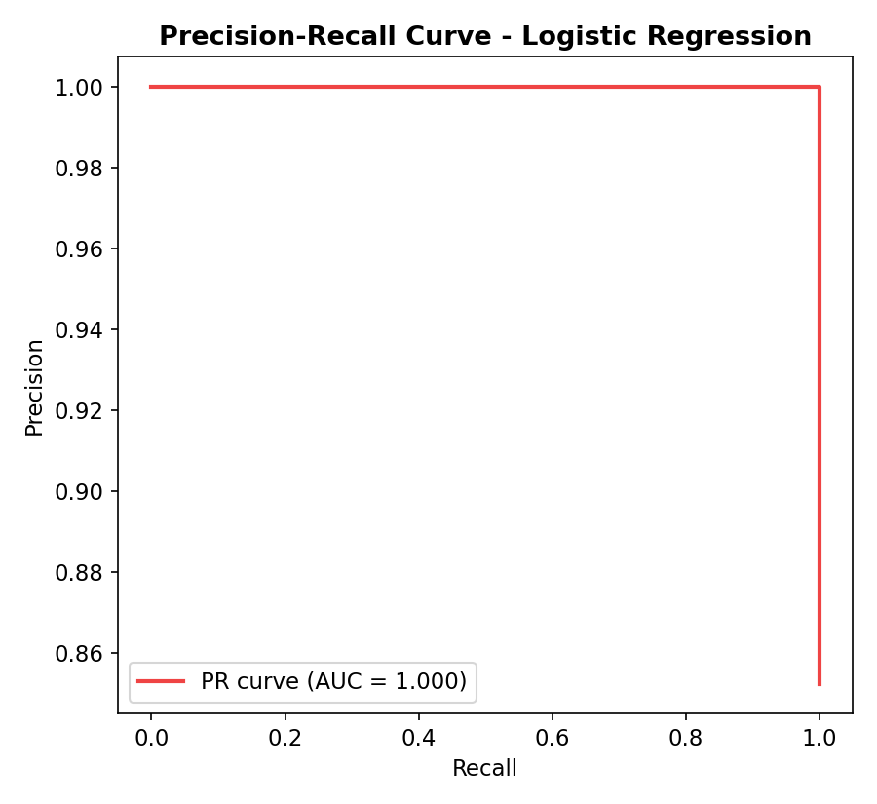
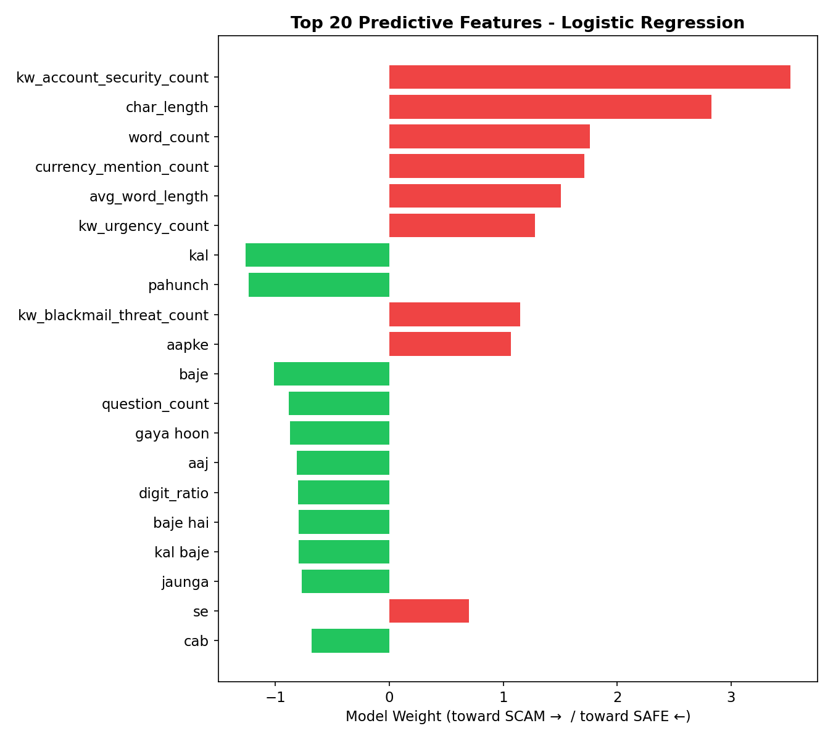

System Architecture
Modular pipeline: data/ (raw + processed) -> src/ (loading, cleaning, preprocessing, feature engineering, training, evaluation, prediction) -> models/ (persisted artifacts + metadata) -> app/ (Flask dashboard consuming the exact same prediction module used in training/testing) -> visualizations/ and reports/ generated directly from real results. run.py is the single entry point (--train / --test / --serve / --all).

Application Screens
The dashboard provides: a message analyzer with a live risk meter and detected-indicators panel; a model & dataset stats panel; a session-scoped prediction history; and an analytics section with the charts shown above, all served from a single Flask app with a REST prediction API (POST /api/predict).

Prediction Workflow
- User submits message text via the dashboard or POST /api/predict.
- Server-side validation: non-empty, string type, length capped at 3,000 characters.
- Text passed through the identical preprocessing + feature pipeline used in training.
- Model outputs a calibrated scam probability, bucketed into a SAFE/SUSPICIOUS/SCAM risk tier.
- Rule-based indicator detector runs independently on the raw text for explanation.
- Response returns prediction, probability, confidence, indicators, and a recommended action.

Limitations
- Small, template-generated training data: after leakage-safe deduplication, only 743 distinct messages (110 SAFE / 633 SCAM) were available.
- Near-perfect in-dataset metrics reflect the dataset's templated simplicity, not a guarantee against real-world adversarial scams with novel phrasing — see the notebook's out-of-distribution error-analysis section.
- The explainability keyword lists are tuned for Hinglish/English and would need extension for other languages.
- This is a decision-support tool, not a guarantee of detection; users should always independently verify suspicious requests for money, OTPs, or personal information.

Future Scope
- Incorporate a larger, real-world, continuously updated dataset of user-reported messages.
- Add active learning / periodic retraining as new scam patterns emerge.
- Extend explainability keyword coverage to additional Indian languages.
- Add multi-class scam-category prediction alongside the risk tier.

Conclusion
ScamShield AI demonstrates a complete, honestly-evaluated NLP pipeline for Hinglish scam-message detection: a leakage-safe data pipeline, a combined TF-IDF + handcrafted-feature representation, a principled multi-model comparison favouring recall on the costly class, a model-vs-heuristic explainability split, and a working, tested web application. The project's main caveat — a small, templated source dataset — is treated as a documented limitation rather than hidden behind inflated claims.

References
1. Dataset: India_Cyber_Scam_Hinglish_Dataset.csv (provided dataset).
2. scikit-learn documentation, https://scikit-learn.org
3. XGBoost documentation, https://xgboost.readthedocs.io
4. National Cyber Crime Reporting Portal, https://cybercrime.gov.in

