***Citi Bridge Program 2020***

*Cummins College Of Engineering For Women, Pune.*

*Clearing Feed Generation.*

**Table no. 5 :**

**Mentor:**

Jaidev Anoop

**Students:**

Jui Bangali

Sanjana Rao

Meenal Sadani

Kshitija Choudhari

Vaishnavi Kale

**Project Overview :**

Generate the feed file towards clearing system in a specific format based on the input transactions to the system.

**What is clearing**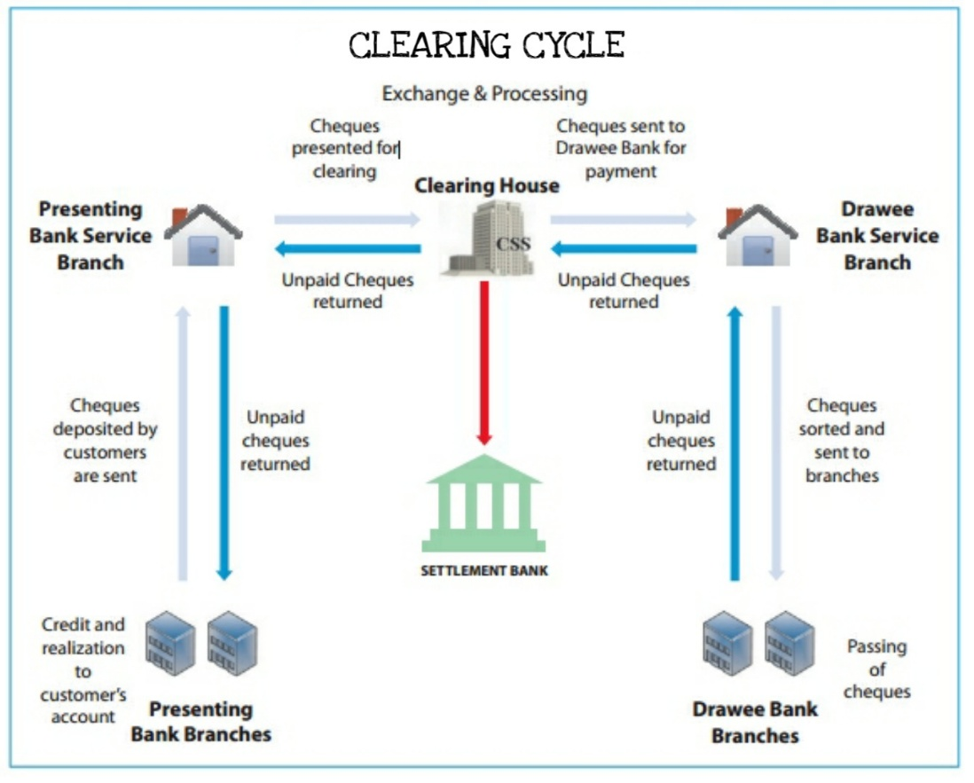

**Functional Requirements:**

1. User Uploads the input transaction file

2. In this uploaded file we have fields like Transaction Reference, validate date, Payer name, Payer account, payer name, payee account and amount.

3. Validations such as naming convention, record length, number of fields within the record, if all the fields within the record are filled, date format etc. Are performed on this file.

4. Once the validation is done, the successful entries which passed the validations will be downloaded in file format, through correct ID. The failed transaction entries will be displayed on the table format on the screen.

**Work Flow:**

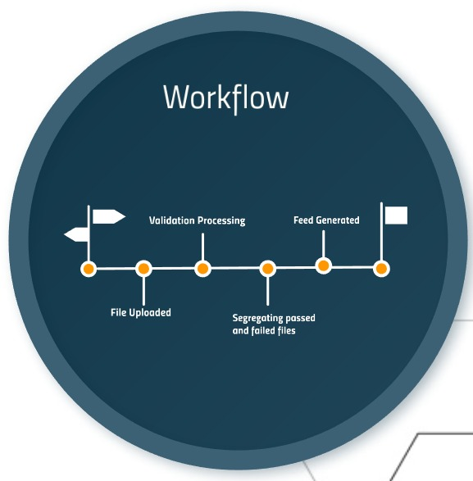

**Technologies Used:**

1. For the Backend we used Spring-tool-Suite, Java and Maven.
2. For the Frontend, we used Angular, CSS, HTML, Bootstrap.

**Assumptions:**

1. A single user is uploading a single file.

**Future Scope:**

1. The system can be further extended using SQL or MongoDB database.
2. System upgrade for Single user – Multiple Input and Multiple user – Multiple Input can also be implemented.

**Screenshots of working flow of program:**

1. Register Page:

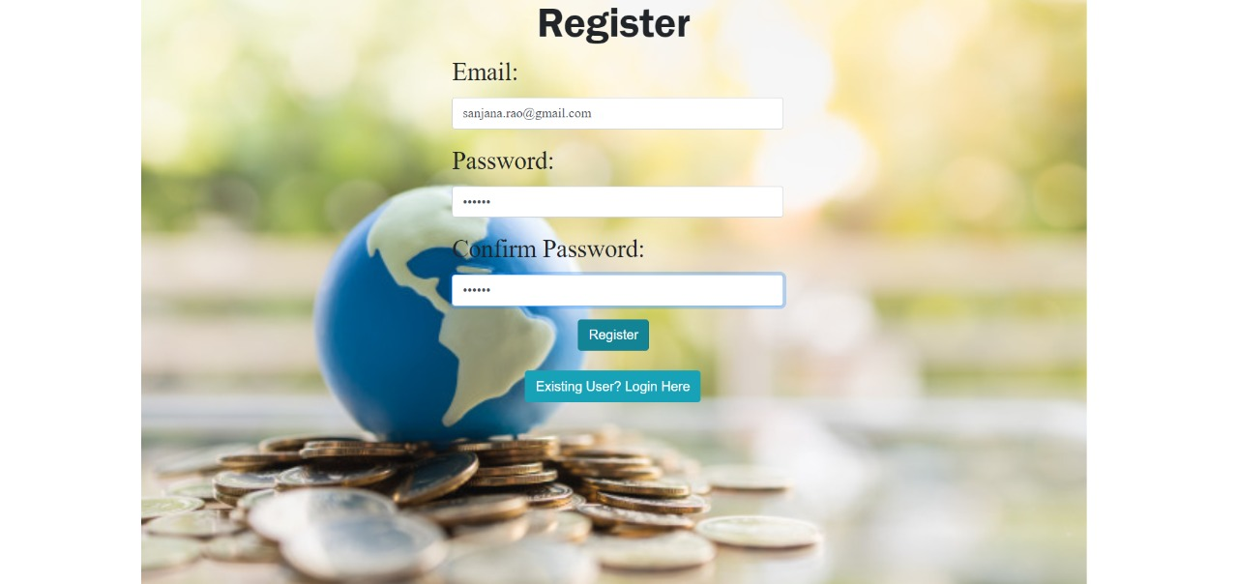

1. Login:



1. Upload File: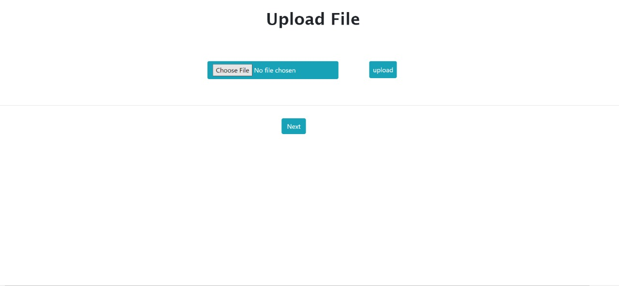
2. File Selection:

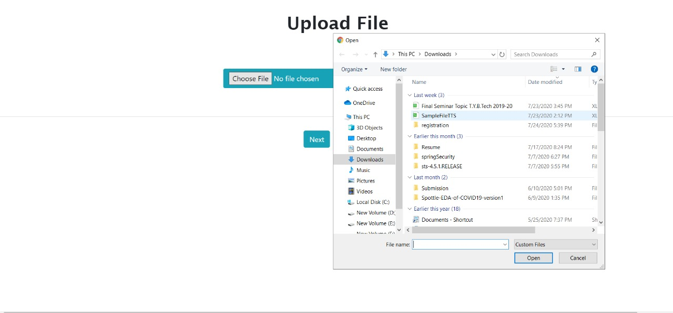

1. Upload Successful:

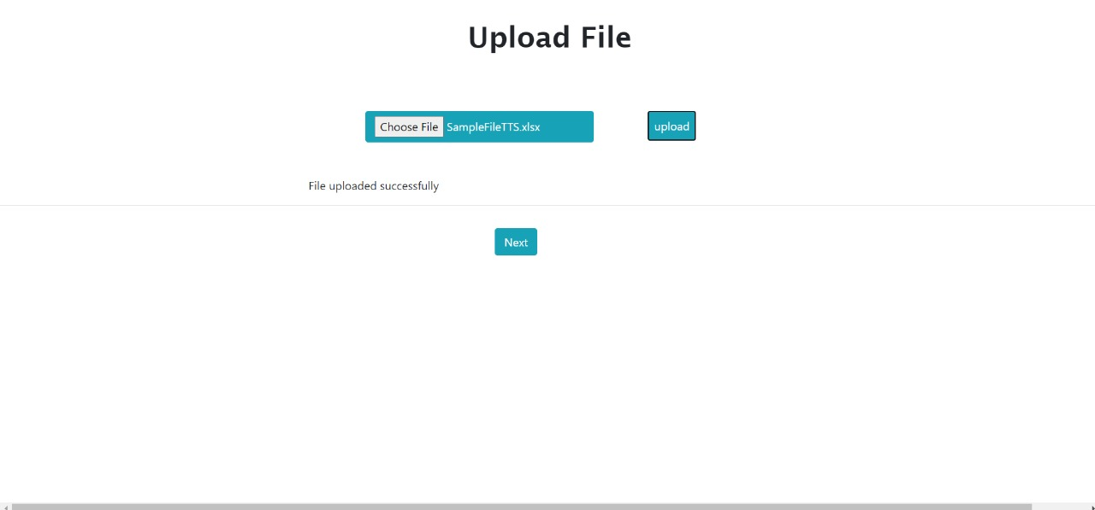

1. Correct transaction-file Download and Failed transaction-table Display:

