|  |  |  |  |  |  |
| --- | --- | --- | --- | --- | --- |
|  |  | | | | |
|  | |  | | | |
| Project: | | Personal Tutoring Services  CSE 5325 – Fall 2023  Project Management | | | |
| Module: | | COCOMO | | | |
| Deliverable: | | COCOMO Estimate Report | | | |
| Version: | | | [1.0] | Date: | [11/09/2023] |

Prepared by: Sanjana Reddy Thigulla

1002142811

TABLE OF CONTENTS

1. Introduction 2

2. Estimating Factors 3

2.1 Source of Lines of Code 3

2.2 Scale Drivers 3

2.3 Cost Drivers 4

3 Project Final Timeline and Cost Structure 8

4. Conclusion and Recommendation 12

Appendices 13

# 1. **Introduction**

The main objective of this project is to implement a website and develop a  
corresponding web application for personal tutoring services which can be accessed using PC/Smartphone/Tablet. This project plan aims to provide a comprehensive estimation of the project cost for the "Personal Tutoring Service - PTS" using the COCOMO II (Constructive Cost Model) methodology. This estimation report provides to a comprehensive overview of the budget and resource allocation needs for the project, integrating COCOMO tools, scale drivers, and cost factors, aims. It will be a valuable guideline for understanding the financial requirements and resource distribution of this project.

The report thoroughly explores the project's scope, timelines, team structure, cost breakdown, risk assessment, and security concerns. It accentuates the importance of managing configurations and integrating security protocols to guarantee data authenticity during the development phase. Furthermore, it emphasizes the necessity of meticulous planning and documentation to facilitate efficient project management.

The successful implementation of the proposed cost estimation and management strategies, as outlined in this report, will be instrumental in ensuring the timely delivery of the "Personal Tutoring Service - PTS" project, while meeting the desired quality standards and client expectations. By adhering to the recommended guidelines and addressing the key considerations highlighted in this report, the project can effectively navigate the challenges and complexities inherent in software project management, thereby achieving the desired objectives and deliverables.

# 2. Estimating Factors

## 2.1 Source of Lines of Code

The following is the number of lines of code delivered as part of this project, A justification for the total amount of LOC is provided.

|  |  |
| --- | --- |
| **SLOC | Source Lines Of Code** | Value Chosen: 5000 |
| Justification: The estimate of 5000 lines of code has been allocated for the overall development of the core functionalities of this project. This covers the implementation of key components such as user management, session scheduling, and database integration. This allocation caters to essential backend functionalities, ensuring a secure platform and aligning with the project's scope and objectives. | |

## 2.2 Scale Drivers

The following is the list of scale drivers, the values applicable to this project and a justification for each value chosen:

|  |  |
| --- | --- |
| **PREC | Precendentedness** | Value Chosen: nominal - Somewhat Unpreceded |
| Justification: "Somewhat Unprecedented" is chosen because the project involves some aspects that are new or challenging, requiring a minimum level of expertise during various stages of the software development process. Although the project draws on existing knowledge, the inclusion of complex features, demands a certain level of skill that hasn't been fully experienced before in this particular context. | |

|  |  |
| --- | --- |
| **FLEX | Development Flexibility** | Value Chosen: high - general conformity |
| Justification: a "High" value is chosen because of the client's preference for adherence to specific guidelines and goals, emphasizing a strong need for flexibility within the project framework to accommodate potential modifications and adapt to evolving requirements. | |

|  |  |
| --- | --- |
| **RESL |** **Architecture/Risk Resolution** | Value Chosen: high (75%) |
| Justification: The "High" value (75%) for Architecture/Risk Resolution indicates the team's strong ability to handle technical challenges and manage potential risks effectively. With their solid architecture resolution skills and proactive risk management approach, the team is well-prepared to tackle any issues that might arise during the project, ensuring smooth progress and effective problem-solving. | |

|  |  |
| --- | --- |
| **TEAM | Team Cohesion** | Value Chosen: **Highly cooperative** |
| Justification: Despite the team's limited field experience, their cohesive nature, developed over years of collaboration, demonstrates a highly cooperative spirit. The team's effective resolution of conflicts and adherence to established work guidelines underscores their strong collaborative dynamics, justifying the assignment of a "Highly Cooperative" value. | |

|  |  |
| --- | --- |
| **PMAT | Process Maturity** | Value Chosen: **SEI CMM LEVEL 4** |
| Justification: Choosing SEI CMM Level 4 indicates that the team is experienced in structured software development processes. It reflects their ability to follow established methods, leading to consistent and dependable project outcomes. | |

## 2.3 Cost Drivers

The following is the list of cost drivers, the values applicable to this project and a justification for each value chosen:

|  |  |
| --- | --- |
| **ACAP | Analyst Capability** | Value Chosen: Very High |
| Justification: The analysts involved in this project possess extensive capabilities, demonstrating exceptional skills and expertise that exceed the average standards. Their proficiency in understanding complex requirements, conducting thorough analysis, and delivering precise solutions showcases their high level of competence, contributing significantly to the project's success and efficient cost management. | |

|  |  |
| --- | --- |
| **APEX - Applications Experience** | Value Chosen: Nominal |
| Justification: The team has an average level of experience with this type of application, indicating a standard level of familiarity and understanding. While not exceptionally high, their moderate level of expertise allows for adequate project execution and contributes to maintaining reasonable cost management. | |

|  |  |
| --- | --- |
| **PCAP - Programmer Capability** | Value Chosen: High |
| Justification: The programmers involved in the project demonstrate a strong level of capability, showcasing a notable skill set and proficiency that surpasses the average standards. Their ability to comprehend complex programming requirements and deliver effective solutions contributes significantly to the project's success, ensuring efficient implementation and cost management. | |

|  |  |
| --- | --- |
| **PLEX - Platform Experience** | Value Chosen: High |
| Justification: The team's moderate three-year experience with the target platform demonstrates a strong understanding of the hardware and software infrastructure. While not the highest level of experience, their familiarity enables efficient platform utilization, contributing to effective project implementation and cost management. | |

|  |  |
| --- | --- |
| **LTEX - Language and Tool Experience** | Value Chosen: Very High |
| Justification: With six years of extensive experience in the relevant languages and tools, the team exhibits profound expertise and a deep understanding of these resources. Their prolonged exposure and comprehensive knowledge significantly contribute to the project's success, ensuring efficient implementation and cost-effective management. | |

|  |  |
| --- | --- |
| **PCON - Personnel Continuity** | Value Chosen: Nominal |
| Justification: With a moderate 12% annual turnover rate, the organization maintains a reasonable level of personnel continuity, fostering a stable work environment and ensuring consistency within the project team. This continuity significantly contributes to effective project execution and cost management. | |

|  |  |
| --- | --- |
| **TOOL - Use of Software Tools** | Value Chosen: High |
| Justification: The team will utilize advanced software tools that are well-integrated, facilitating efficient project management and development. This choice enhances productivity and contributes to effective cost management during the project. | |

|  |  |
| --- | --- |
| **SITE - Multisite Development** | Value Chosen: High |
| Justification: The team is situated in the same city or metro area and uses high-speed electronic communication for collaboration. This setup allows for effective communication and coordination, contributing to efficient project management and cost control. | |

|  |  |
| --- | --- |
| **SCED - Development Schedule** | Value Chosen: Nominal |
| Justification: The project follows the standard schedule, ensuring a balanced approach to time management without incurring extra costs. | |

|  |  |
| --- | --- |
| **TIME - Execution Time Constraint** | Value Chosen: High |
| Justification: The software will utilize a significant portion of the available execution time, indicating a notable constraint on CPU usage. This emphasizes the need for efficient resource management, ensuring optimal performance while utilizing a substantial portion of the available resources, leading to effective time management and cost control. | |

|  |  |
| --- | --- |
| **STOR - Main Storage Constraint** | Value Chosen: High |
| Justification: The software will utilize a significant portion of the available main memory, indicating a notable constraint on storage usage. This emphasizes the need for efficient memory management and signifies the project's emphasis on optimizing storage usage, ensuring effective performance and cost control. | |

|  |  |
| --- | --- |
| **PVOL - Platform Volatility** | Value Chosen: Nominal |
| Justification: The platform undergoes regular updates every 6 months for major changes and every 2 weeks for minor changes. This moderate level of volatility ensures a balanced approach to software adaptation, contributing to manageable development costs. | |

|  |  |
| --- | --- |
| **RELY - Required Reliability** | Value Chosen: High |
| Justification: Software failure would lead to substantial financial losses, highlighting the critical need for robust and stable software. Effective risk management and high-quality assurance measures are necessary to prevent such financial consequences. | |

|  |  |
| --- | --- |
| **DATA – Database size** | Value Chosen: Nominal |
| Justification: The data required for testing the software falls within the standard range, ensuring a moderate testing effort without excessive burden. This allows for effective software evaluation and manageable testing processes. | |

|  |  |
| --- | --- |
| **CPLX - Product Complexity** | Value Chosen: High |
| Justification: The software involves complex code and intricate numerical analysis, highlighting the need for a comprehensive approach to managing the product's complexity. | |

|  |  |
| --- | --- |
| **RUSE - Required Reusability** | Value Chosen: Nominal |
| Justification: The software components are being developed for reuse across the project, indicating a standard level of reusability. This implies a moderate approach to reusability, balancing the benefits of potential cost savings with the costs associated with designing for reuse. | |

|  |  |
| --- | --- |
| **DOCU - Documentation match to life-cycle needs** | Value Chosen: Nominal |
| Justification: The documentation created is appropriate for the project's life-cycle needs, ensuring an optimal level of information without unnecessary overhead. This approach contributes to efficient project execution and cost management. | |

# 3 Project Final Timeline and Cost Structure

Previous Cost, Work and Duration (from assignment #2)

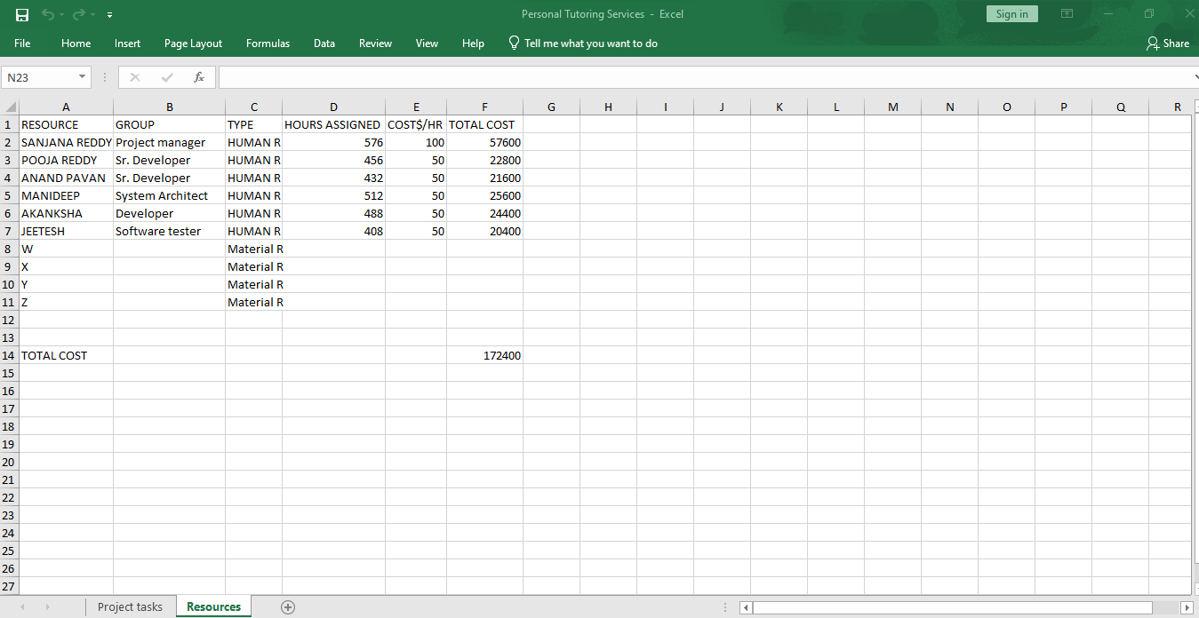

New Schedule (Duration)

|  |  |
| --- | --- |
| **Task** | **Duration** |
| Requirements | 11 days |
| Design | 11 days |
| Build (Front/ Back end) | 15 days |
| Mobile Application Back end | 12days |
| Mobile Application Frontend | 11 days |
| Quality Assurance | 14 days |

COCOMO estimated costs

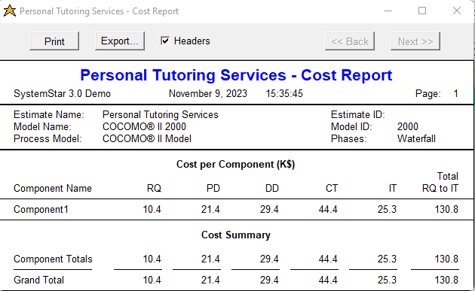

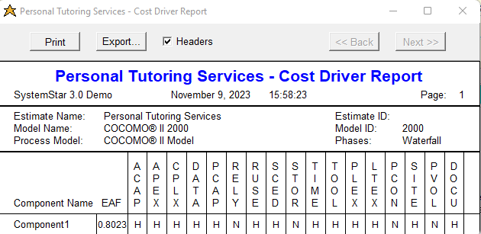

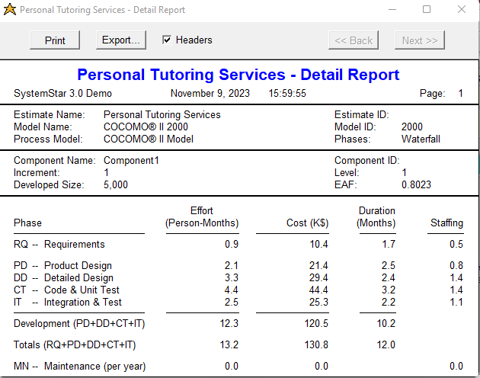

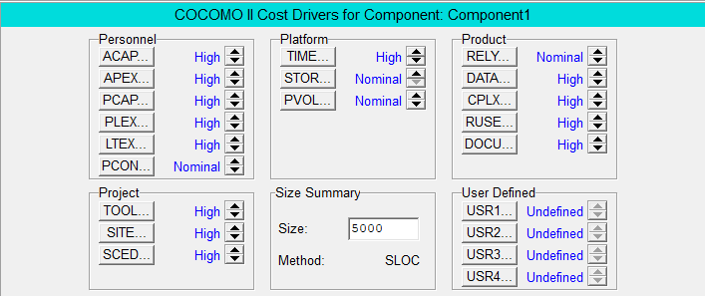

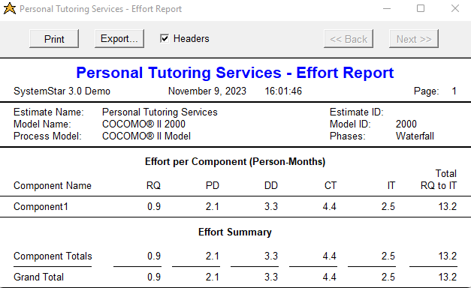

**Estimated Costs :**

|  |  |  |
| --- | --- | --- |
| **RESOURCE** | **Monthly** | **3 Months** |
| Senior Developer 1 | $5000 | $15000 |
| Senior Developer 2 | $5000 | $15000 |
| System Architect | $5000 | $15000 |
| developer | $5000 | $15000 |
| Software Tester | $5000 | $15000 |
| Manager | $10,000 | $30,000 |
|  | **Total** | $105,000 |

| Non-Human Resources | Cost for 3-Month Duration |
| --- | --- |
| Software Licenses | $800 |
| Cloud Computing Services | $500 |
| Security Software | $300 |
| Testing Tools | $200 |
| Project Management Tool | $100 |
| Total | $1900 |

# 4. Conclusion and Recommendation

In conclusion, the COCOMO estimation process provided valuable insights into the cost structure and resource requirements of the project. By offering a more detailed evaluation and accounting for previously overlooked factors, COCOMO's refined estimates support the project's continuation. Adhering to these estimates is crucial for successful implementation within the set timeline and budget, ensuring the delivery of a high-quality tutoring service platform.

The comprehensive analysis conducted through COCOMO has provided a realistic understanding of the project's details, enabling informed decision-making and better planning. To ensure successful execution, it is vital to follow the suggested cost allocations and resource utilization meticulously. With effective management and careful oversight, the project is well-equipped to achieve its goals and deliver an exceptional tutoring service platform.

# Appendices

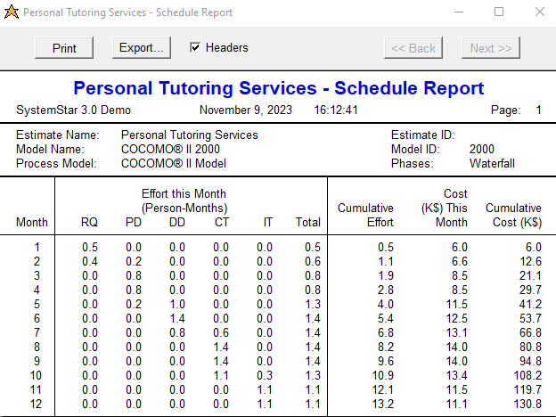

References :

* <https://link.springer.com/article/10.1007/s41870-018-0083-6>
* Boehm B et al (2000) Software cost estimation with COCOMO II. Prentice Hall PTR, New Jersey, p 07458
* <https://www.researchgate.net/publication/228600814_Cost_estimation_with_COCOMO_II>