**USER STORY DOCUMENTATION-LINUX**

**USER STORY 1:** Create user /home/modak.

**DESCRIPTION:**

a.change home directory /opt/modak

b. uid and gid for the user modak

c.change username and primary group for the user modak to MODAK

d.uid and gid should be same

**Explanation:**

**Created user /home/modak**

* Used useradd to add the user
* Then checked whether user added or not in the /etc/passwd directory.

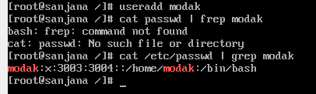

### **Changed home directory /opt/modak**

* Changed the home directory using usermod
* **Syntax: usermod -d directory user**
* Then checked whether it changed or not.



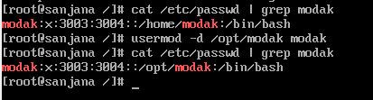

**uid and gid for the user modak**

* Used id command to get uid and gid of user
* **Syntax: id user_name**



**Changed username and primary group for the user modak to MODAK**

* We can change username and primary group using usermod
* **Syntax:usermod –g groupname username**
* **Syntax:usermod –l newname oldname**

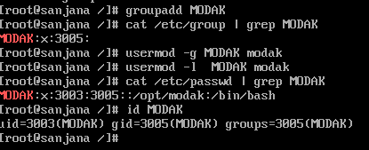



**Changed uid and gid of MODAK (uid and gid should be same)**

* Changed userid using usermod
* Changed gid using groupmod
* Then checked by using id command

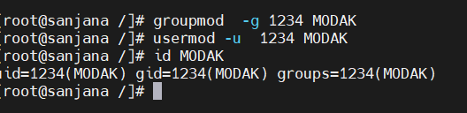

**USER STORY 2:** Create a file system and mount, unmount it.

**DESCRIPTION:**

* Create a file system then mount it.
* Add the file system in /etc/fstab file. without editing fstab file remove and unmount filesystem and then restart.

**Created a harddisk:**

* Goto settings.

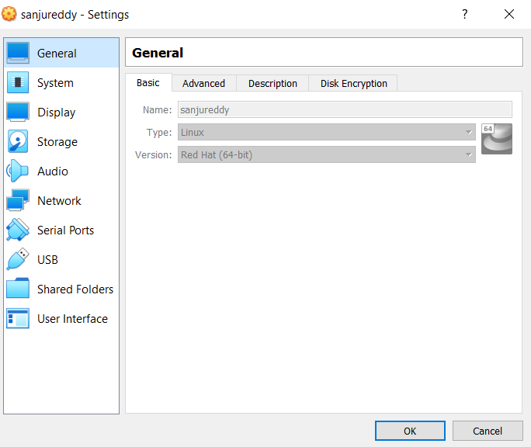

* Goto storage.

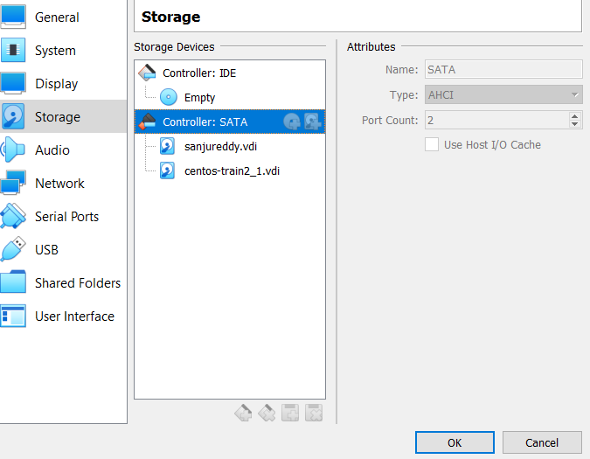

* Create new harddisk .
* Check whether new harddisk created or not.
  + Use fdisk -l to view partition tables of all attached devices in our syatem.
  + **Syntax: fdisk -l**

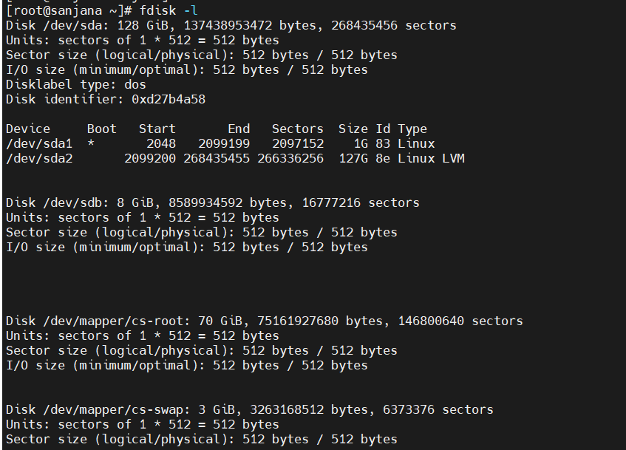

**Created a fileSystem.**

* Used mkfs to create a filesystem
* **syntax: mkfs -t[type] target_device**



* checked whether new filesystem is created or not uisng df command
* **syntax: df -h**

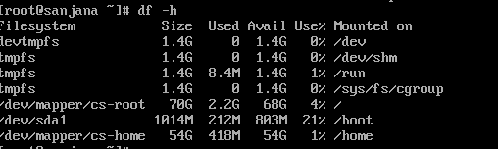

**Created a directory:**

* Used mkdir command to create a direcotry.
* **Syntax: mkdir directory_name**



* Checked whether directory created or not.

**Mounted the filesystem.**

* Used mount command to mount the filesystem.
* **Syntax:mount device_name directory_name**
* Checked whether mounted or not using lsblk command.

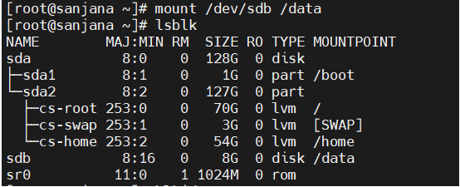

**Added the filesystem in /etc/fstab.**

* Step-1: Get the uid of filesystem.
  + Used the blkid command to get the uid of filesystem.

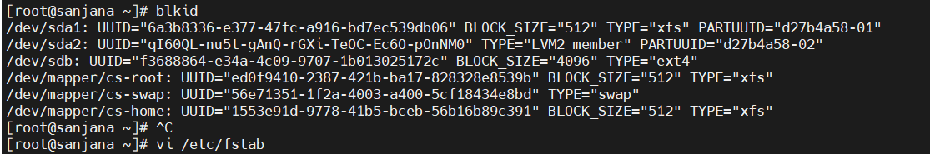

* Step-2: Added the created filesystem in /etc/fstab.
  + Open the /etc/fstab in vi editor
  + Then added the filesystem in the same format as other filesystems.

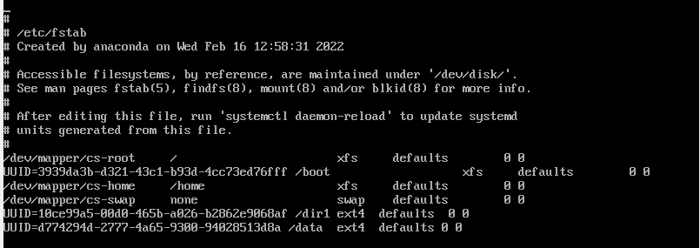

**Checked whether filesystem added into /etc/fstab.**

* Opened the /etc/fstab using cat command to see content present in it.
* **Syntax: cat /etc/fstab**

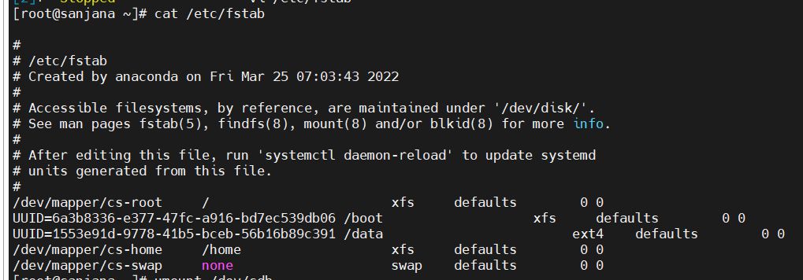

**Unmount the filesystem:**

* Unmounted the filesystem using umount command.
* **Syntax: umount filesystem**



* Checked whether unmounted or not using lsblk command.
  + before unmounting

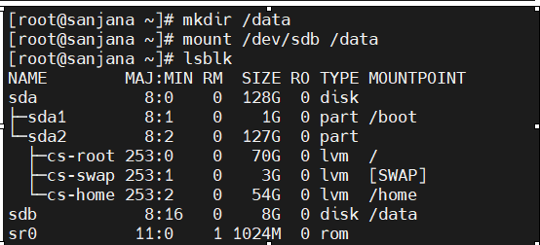

* + After unmounting

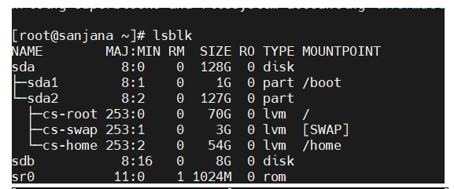

**Reboot the System:**

* By using systemctl command reboot the system
* **Syntax: Systemctl reboot**



**Result:**

* After rebooting the system , the system entered into the emergency mode.

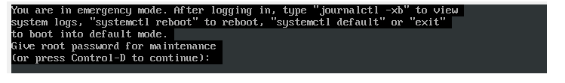

* If you want your system not to enter into emergency mode , removed the added filesystem in /etc/fstab.

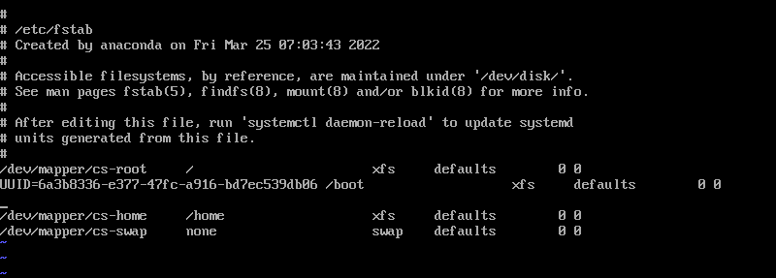

* Then again rebooted the system and checked whether the system entered into emergency mode or not.
* The system doesn't entered into emergency mode.

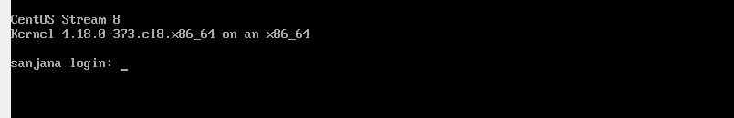

**USER STORY 3:** Write a script in Linux to get an alert when the disk size reaches 90%

**DESCRIPTION:**

* Write a script in Linux to get an alert when the disk size reaches 90%

**Installing mailx:**

* Before installing mailx, updated all installed packages that are available in this repository.
* **Syntax: yum -y update**



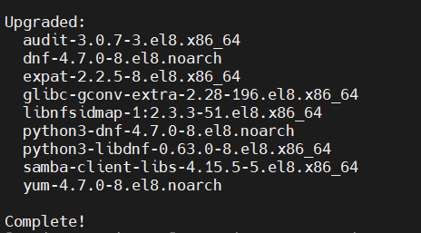

* Installed the mailx using yum command.
* **Syntax: yum install -y mailx**



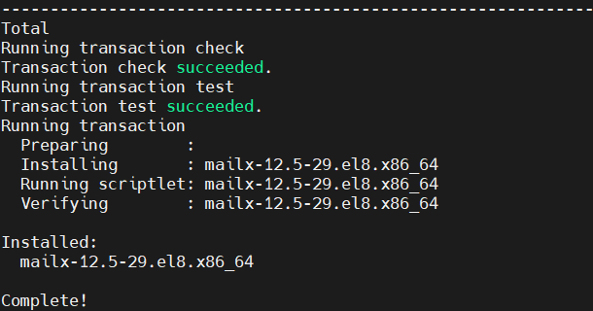

**Set an external SMTP Server to relay E-Mails:**

* opened /etc/mail.rc file using vi editor.
* **Syntax:vi /etc/mail.rc**



* Edited the /etc/mail.rc file with following code.

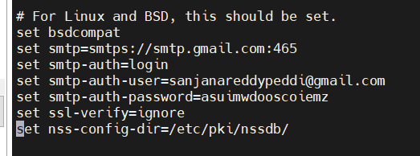

* The connection to SMTP server is established.

**Write script to send alert mail.**

* Opened the file using vi editor.



* Wrote script to send alert mail.

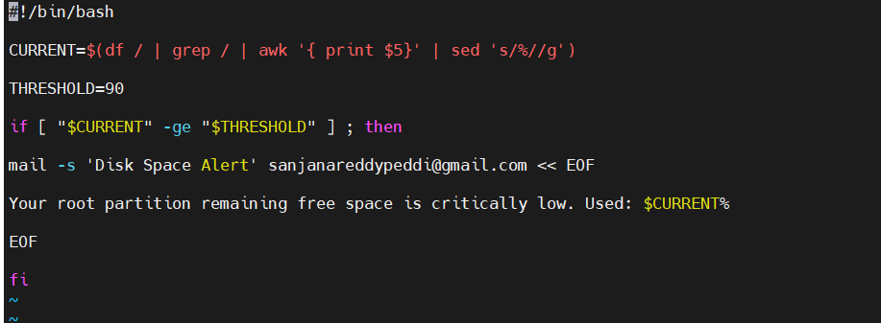

**Result:**

* Executed the check_disk.sh



* As memory not extended threshold 90, so mail was not prompted.
* Changed the threshold to 1, so got mail as follow.

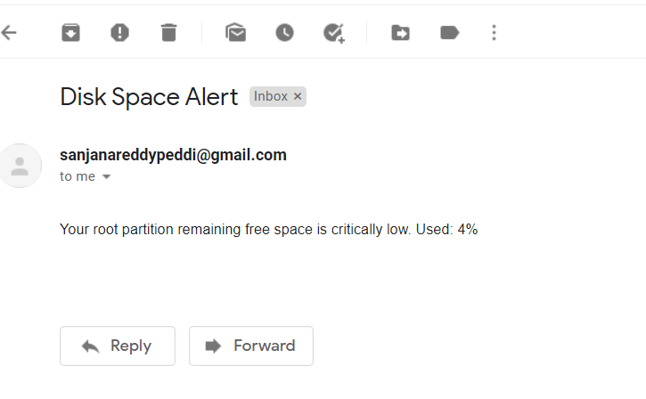

**Automated the script execution :**

* Created a crontab to execute the script file for every minute.



**Result:**

* Got mails for every minute.

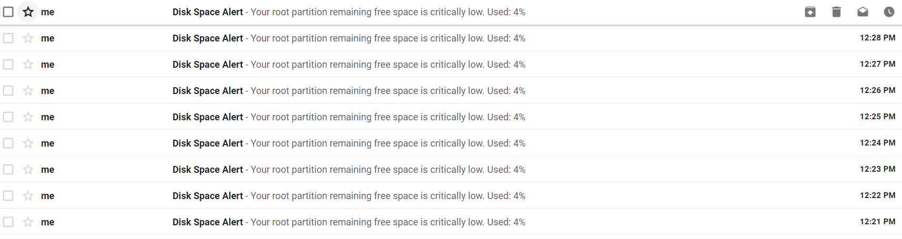

**USER STORY 4:** Resetting root password

**DESCRIPTION:**

* Resetting root password of a VM using kernel.

**Explanation:**

**Reboot the system:**

* Used the systemctl command to reboot the system.
* **Syntax: systemctl reboot.**

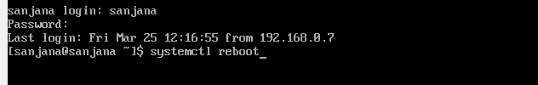

**Interrupt boot process:**

* While booting process is going on press 'esc'
* Use the arrows to highlight the line that starts with kernel or Linux.
* **Press 'E' :**It will go to end of line.
* **Then add rd.break**.
* Adding rd.break to the end of the line with kernel parameters in Grub stops the start up process before the regular root filesystem is mounted.

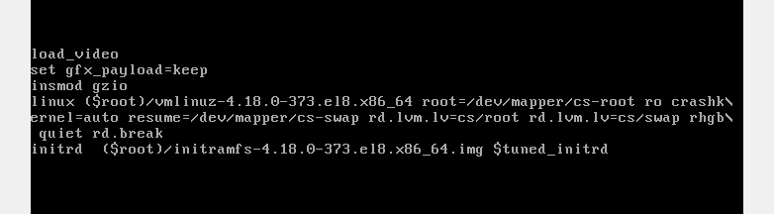

**Remount the sysroot directory:**

* Initially the sysroot directory is in read only mode, changed it to read and write mode.
* **Syntax: mount -o remount,rw /sysroot**
* Then changed the root directory.
* **syntax: chroot /sysroot**
* The chroot /sysroot command means: "start a new shell in such a way that for that shell the /sysroot directory will appear as /."



**Changed the password:**

* Used passwd command to change the root passwd .
* **Syntax: passwd**

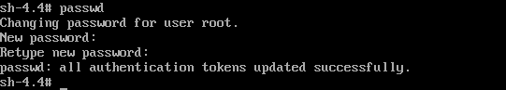

* Then execute the command touch /.autorelabel
* The touch /.autorelabel command creates a hidden file named .autorelabel under the root directory. On the next boot, the SELinux subsystem will detect this file, and then relabel all of the files on that system with the correct SELinux(Secured-enhanced linux) contexts.

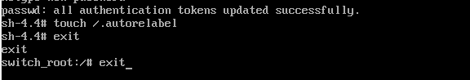

**USER STORY 6:** Create an ext4 file system on a new logical volume of 100MB called lv_ext4.

**DESCRIPTION:**

* Create an ext4 file system on a new logical volume of 100MB called lv_ext4. Mount it permanently under the /ext4 directory. Copy the files previously created into this new space.

**Explanation:**

**Created a physical volume:**

* A physical volume is a storage device or partition.
* Created a physical volume using 'pvcreate'.

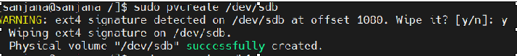

* Checked whether physical volume created or not uisng 'pvdisplay'

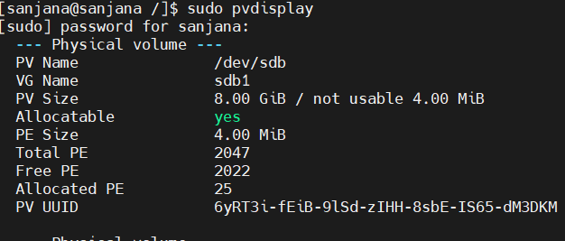

**Created a volume group:**

* Volume group is the highest level of abstraction.
* created the logical volume using 'vgcreate'.

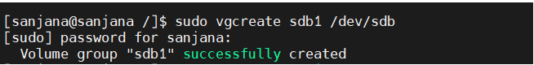

**Created a logical volume of 100MB:**

* Logical volumes are block devices which are created from the physical extents present in the same volume group.
* Created the logical volume of 100MB using 'lvcreate'.



* Checked whether logical volume created or not uisng 'lsblk'.

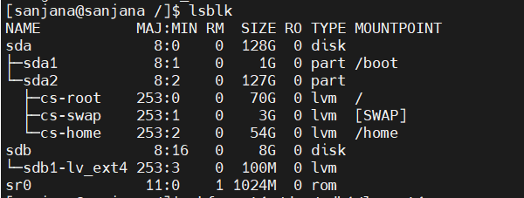

**Created the filesystem:**

* Used 'mkfs' command to create a filesystem.
* **Syntax : mkfs.[fs type] [target device]**
* It format a disk into specific filesystem.

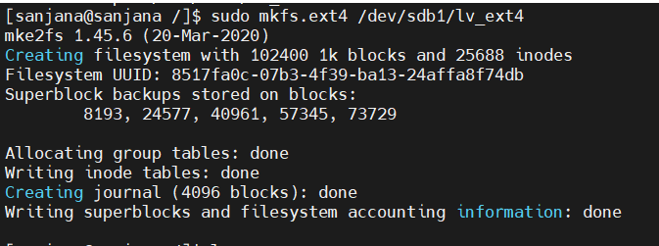

**Mounted the filesystem:**

* Created a directory using mkdir command.



* Used mount command to mount the filesystem.
* **Syntax:mount device_name directory_name**
* Checked whether mounted or not using lsblk command.



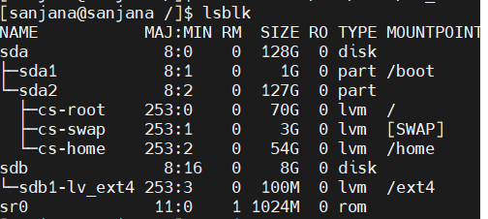

**Added the filesystem in /etc/fstab.**

* Step-1: Get the uid of filesystem.
  + Used the blkid command to get the uid of filesystem.

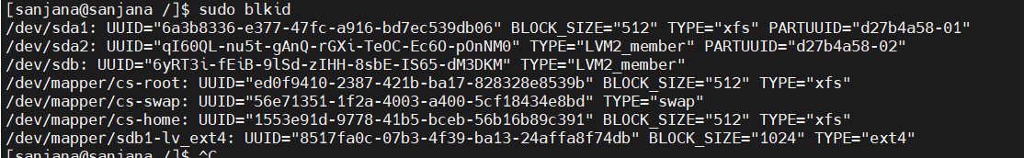

* Step-2: Added the created filesystem in /etc/fstab.
  + Open the /etc/fstab in vi editor
  + Then added the filesystem in the same format as other filesystems.



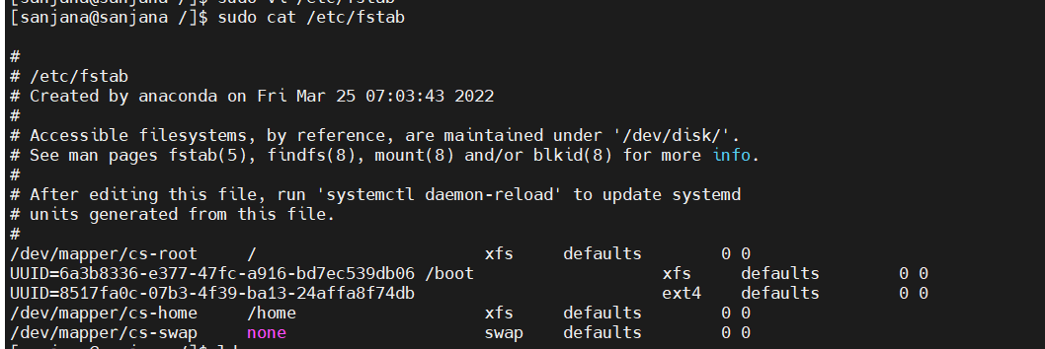

**Copied the files previously created into this new space:**

* Copied the files previously created using 'cp' command.
* **Syntax: cp source_file destination**



* cp '-p' option is used to preserve the properties and attributes of a file.

**Checked whether files copied or not:**

* Used ls command to check whether files or copied or not.

