Google Maps AI - Agentic Trip Planning (Google ADK, Maps MCP, FastAPI, Next.js) - AI-Powered Travel & Road Trip Planner

Project Description:
Planning a road trip often means juggling maps, review sites, and itinerary notes across many tabs, and generic advice rarely reflects a traveler’s route, budget, and interests. Google Maps AI is a full-stack travel planning web application in which a conversational AI assistant understands trip requests, retrieves real place and route data through Google Maps tools, and produces personalized day-by-day itineraries that users can save and edit. The platform includes an Authentication & Onboarding module, which provides secure sign-up, sign-in, and password reset with protected routes and stores each traveler’s preferences; an AI Trip Planner, which offers a split-view chat and map interface that turns natural-language requests into structured, editable itineraries; and an ADK Agent & Maps MCP module, which uses a Google ADK agent to select Google Maps MCP tools for places and routes and return verified, structured results.

Utilizing the Google Agent Development Kit (ADK) to plan each request and Google Maps MCP to retrieve real data, Google Maps AI takes every stop’s reason for recommendation and every route detail from tool results rather than letting the AI invent them. Built with a Next.js, React, and Tailwind CSS frontend and a FastAPI and Pydantic backend that stores data in PostgreSQL, the platform layers in an Interactive Map & Explore module, a Trip Management module with server-side ownership checks, and a Profile & Settings module, empowering travelers to plan, refine, and save road trips in one place. When Google Maps credentials are unavailable, the application shows a clearly labeled demo mode instead of presenting sample data as live information.

Scenarios
Scenario 1: A traveler wants a three-day road trip from Hyderabad to Hampi with historical places, good restaurants, and budget-friendly stops. After signing up and setting travel preferences during onboarding, the user types the request into the planner. The Google ADK agent extracts the trip details, asks follow-up questions if essential information is missing, and calls Google Maps MCP tools to find places and routes. The results appear as an itinerary beside an interactive map, with each stop’s reason for recommendation and the route details taken directly from the tool results rather than invented by the AI.

Scenario 2: Reviewing the generated plan, the same traveler decides it should cost less and asks the assistant to make it more affordable and to replace one of the stops. Rather than starting over, the user refines the plan conversationally, and the itinerary and map update to reflect the change. Satisfied with the result, the traveler saves the trip to their account, where it can later be edited, duplicated, or deleted, and where server-side ownership checks ensure that only its owner can access it.

Scenario 3: On a deployment where Google Maps credentials are unavailable, such as a demonstration before API keys are configured, the application does not quietly fall back to made-up results. Instead, it shows a clearly labeled demo mode, so a reviewer can see exactly how the planner behaves while understanding that the places and routes on screen are sample data rather than live Google Maps information.

Technical Architecture:
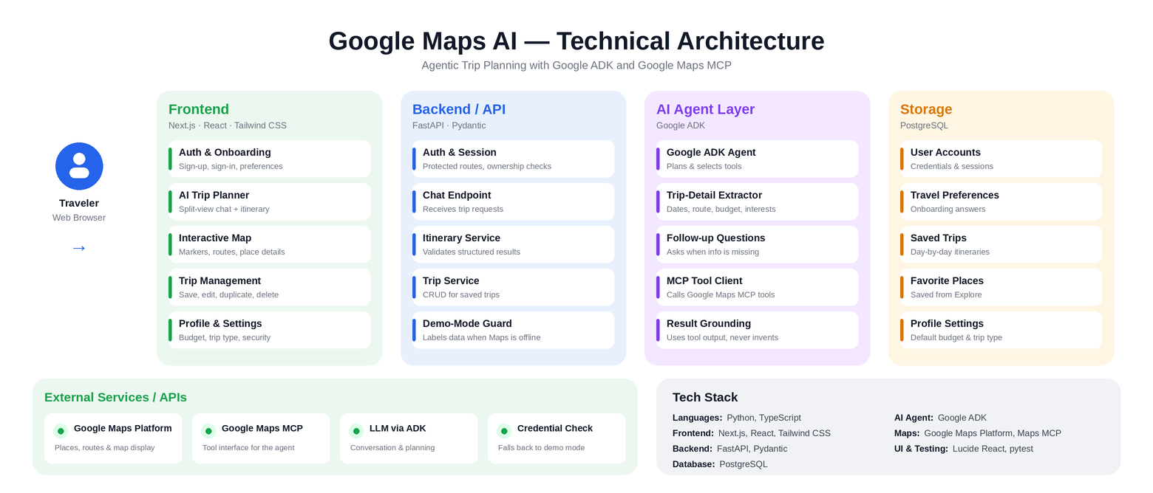
Description: Google Maps AI follows a modular four-layer architecture built for grounded, tool-driven trip planning. A Next.js frontend renders the authentication and onboarding screens, the split-view chat and map planner, the explore map, trip management, and profile settings. A FastAPI application layer validates requests with Pydantic, enforces protected routes and server-side ownership checks, passes trip requests to the agent layer, and returns structured itineraries. The Google ADK agent extracts trip details, asks follow-up questions when essential information is missing, and calls Google Maps MCP tools to retrieve places and routes, so that recommendations and route details come from tool results. User accounts, travel preferences, saved trips, favorite places, and profile settings are persisted in PostgreSQL.

Pre-requisites:
- Python Programming Proficiency: Python Documentation
- TypeScript Fundamentals: TypeScript Documentation
- Next.js & React Framework Knowledge: Next.js Documentation
- Tailwind CSS Styling: Tailwind CSS Documentation
- FastAPI & Pydantic Framework Knowledge: FastAPI Documentation
- PostgreSQL & Relational Database Basics: PostgreSQL Documentation
- AI Agent Concepts (Google ADK): ADK Documentation
- Model Context Protocol (MCP) Concepts: MCP Documentation
- Google Maps Platform & Maps MCP: Maps Platform Documentation
- Testing with pytest: pytest Documentation
- Version Control with Git: Git Documentation

Project Workflow:

Milestone 1: Requirements, Maps Access & Tech-Stack Setup
- Activity 1.1: Define sample trip scenarios, the details the agent must extract, and the structured itinerary and database models.
- Activity 1.2: Research and select the agent framework, Google Maps MCP tools, and supporting stack for grounded place and route data.
- Activity 1.3: Define the architecture of the application, detailing interactions between the frontend, backend, ADK agent, and Maps MCP tools.
- Activity 1.4: Set up the development environment, installing necessary libraries and dependencies for FastAPI, Google ADK, PostgreSQL access, and Next.js.

Milestone 2: Core Functionalities Development
- Activity 2.1: Develop the ADK Agent & Maps MCP integration that turns trip requests into verified, structured results.
- Activity 2.2: Develop Authentication & Onboarding with protected routes and stored travel preferences.
- Activity 2.3: Implement Trip Management and the Interactive Map & Explore features.

Milestone 3: Backend & API Serving Development
- Activity 3.1: Write the main backend application logic, establishing functions for trip planning, refinement, saving, and ownership checks.

Milestone 4: Frontend Development
- Activity 4.1: Design and develop the Next.js user interface, including onboarding, the split-view planner, and profile screens.
- Activity 4.2: Create dynamic components to render itineraries, map markers, route summaries, saved trips, and the demo-mode notice based on backend responses.

Milestone 5: Deployment
- Activity 5.1: Prepare the application for local deployment by configuring the backend and frontend environments.
- Activity 5.2: Test all modules end-to-end locally, then build and verify the production deployment.
Conclusion

Milestone 1: Requirements, Maps Access & Tech-Stack Setup
In this milestone, we focus on defining what Google Maps AI must do and selecting the agent and Maps tooling that will power it. This involves collecting representative trip requests, researching how a Google ADK agent works with Google Maps MCP tools, and ensuring the final design aligns with the application’s goal of itineraries grounded in real place and route data.

Activity 1.1: Define Trip Scenarios and the Data Model
Before the agent can be built, Google Maps AI needs a clear picture of the trip requests it must handle and the structured results it must return.
- Step 1 — Collect Sample Trip Requests: Compile a set of natural-language requests (e.g. a three-day Hyderabad to Hampi road trip with historical places, good restaurants, and budget-friendly stops) covering different durations, budgets, and interests.
- Step 2 — Identify Required Trip Details: List the details the agent must extract from a request, and decide which are essential enough to trigger a follow-up question when they are missing.
- Step 3 — Design the Itinerary Schema: Define a structured, editable format for days, stops, each stop’s reason for recommendation, and route details, expressed as Pydantic models.
- Step 4 — Plan the Database Entities: Define the PostgreSQL entities for users, travel preferences, trips, and favorite places, including the owner of every trip so ownership can be checked on the server.

Activity 1.2: Research and Select the Agent & Maps Tool Stack
Here are the things that needed to be researched to select the best agent and Maps stack for the project:
- Understand the Project Requirements: Review the need for conversational trip understanding alongside real, verifiable place and route data.
- Explore Candidate Architectures: Evaluate how a Google ADK agent selecting Google Maps MCP tools compares with calling Maps services directly from application code.
- Evaluate Tool Coverage: Confirm that the available Maps MCP tools cover the place search and route information needed to build day-by-day itineraries.
- Select the Optimal Stack: Choose a Google ADK agent with Google Maps MCP tools, a FastAPI and Pydantic backend, a Next.js frontend, and PostgreSQL storage, so that results stay grounded in tool output and the system remains maintainable.

Activity 1.3: Define the Architecture of the Application
- Draft an Architectural Diagram: Create a visual representation of the application architecture, including the Next.js frontend, FastAPI backend, ADK agent layer, Maps MCP tools, and PostgreSQL database.
- Detail Frontend Functionality: Outline how a traveler signs up, sets preferences, chats with the planner, views the itinerary beside the map, and saves, edits, duplicates, or deletes trips.
- Outline Backend Responsibilities: Specify how the backend authenticates users, validates requests, calls the agent, enforces ownership checks, and stores trips.
- Describe Agent Integration Points: Define how the backend invokes the ADK agent, how the agent selects Maps MCP tools, how structured results flow back to the frontend, and how demo mode is flagged when Maps credentials are unavailable.

Activity 1.4: Set Up the Development Environment
- Install Python and Node.js: Ensure Python 3.10+ is installed for the backend and the agent, and a current Node.js release for the Next.js frontend.

Create a Virtual Environment: Set up a virtual environment using venv to isolate backend dependencies:
D:\projects\googlemapsai\backend> python -m venv myenv
D:\projects\googlemapsai\backend> "d:\projects\googlemapsai\backend\myenv\Scripts\activate"
(myenv) D:\projects\googlemapsai\backend> pip install -r requirements.txt
Install Backend & Agent Libraries: Install FastAPI, Pydantic, Google ADK, a PostgreSQL driver, and pytest:
(myenv) D:\projects\googlemapsai\backend> pip install fastapi uvicorn pydantic google-adk "psycopg[binary]" pytest
Install Frontend Libraries: Create the Next.js project with TypeScript and Tailwind CSS, then add the icon library:
D:\projects\googlemapsai> npx create-next-app@latest frontend --typescript --tailwind
D:\projects\googlemapsai\frontend> npm install lucide-react
- Set Up Application Structure: Create the project directory structure, including folders for the backend (app/, agent/, tests/) and the frontend (app/, components/, lib/).

Milestone 2: Core Functionalities Development

Activity 2.1: Develop the ADK Agent & Maps MCP Integration
Implement the agent that turns a natural-language trip request into verified, structured results.
- Trip Detail Extraction: Extract the origin, destination, trip length, budget, and interests from the user’s request and stored travel preferences.
- Follow-up Questions: Ask the user a clarifying question only when essential information is missing, instead of guessing.
- MCP Tool Selection: Connect the ADK agent to Google Maps MCP tools and let it select the right tools for finding places and routes.
- Grounded Results: Return structured results in which each stop’s reason for recommendation and the route details are taken from the tool results rather than invented by the AI.

Activity 2.2: Develop Authentication & Onboarding
- Sign-up, Sign-in & Password Reset: Provide secure account creation, sign-in, and password reset flows.
- Protected Routes: Restrict planner, trip, and profile pages and their API endpoints to signed-in users.
- Onboarding Preferences: Collect and store travel preferences, such as trip type, budget, and interests, during the onboarding flow.

Activity 2.3: Implement Trip Management & Map Features
- Save and Edit Trips: Store generated itineraries in PostgreSQL and allow them to be edited after saving.
- Duplicate and Delete Trips: Let users copy a trip as a starting point for a new plan or remove trips they no longer need.
- Ownership Checks: Verify on the server that the signed-in user owns a trip before it is read, edited, duplicated, or deleted.
- Place Search & Favorites: Support place search, markers, route summaries, and place details on the map, with save-to-favorites for discovered places.

A simplified trip-planning function looks like this:
def plan_trip(user_id, message, history):
details = extract_trip_details(message, history)
missing = find_missing_details(details)
if missing:
return ask_follow_up(missing)

if not maps_credentials_available():
return build_demo_itinerary(details) # flagged demo_mode=True

results = agent.run_maps_tools(details) # places + routes via Maps MCP
itinerary = build_itinerary(details, results)
return validate_itinerary(itinerary) # Pydantic model

Milestone 3: Backend & API Serving Development
Milestone 3 focuses on creating and refining the core application logic that serves as the backbone of Google Maps AI. In this milestone, you’ll wire up each feature’s functionality, establish reliable planning and saving behavior, and test each function end-to-end.

Activity 3.1: Writing the Main Backend Application Logic
- Define the Core Functions: Establish functions for Google Maps AI’s key operations, each serving a distinct purpose:
  - extract_trip_details() — parses a natural-language request into structured trip details
  - plan_trip() — runs the ADK agent, calls Maps MCP tools, and returns a structured itinerary
  - refine_trip() — applies conversational changes such as a lower budget or a replaced stop
  - save_trip() — stores an itinerary in PostgreSQL under the signed-in user
  - check_trip_owner() — confirms the user owns a trip before it is read, edited, duplicated, or deleted

Load Configuration at Startup: Read the Maps credentials and database settings from the environment once when the application starts, and turn on demo mode when Maps credentials are unavailable:
MAPS_API_KEY = os.getenv("MAPS_API_KEY")
DEMO_MODE = MAPS_API_KEY is None
- Set Up Handlers for Each Feature: Implement Pydantic input validation for every request and return structured results for every function.
- Validate and Return Responses: Ensure every response includes the fields the frontend expects — itinerary days, stops with reasons, route details, and a demo-mode flag — before returning it.

Milestone 4: Frontend Development
Milestone 4 focuses on developing a clean, travel-oriented interface for Google Maps AI. This involves designing the Next.js application and wiring up dynamic components for onboarding, the split-view chat and map planner, trip management, and profile settings.

Activity 4.1: Designing and Developing the User Interface
- Set Up the Base App Structure: Build the sign-in and onboarding screens and the main application shell with navigation across Planner, Explore, My Trips, and Profile & Settings, with protected pages.
- Design a Clean Travel Theme: Implement a light, high-contrast Tailwind CSS theme with Lucide React icons, using a distinct amber notice style for demo mode.
- Build the Split-View Planner: Place the chat panel beside the itinerary and interactive map so travelers can read and refine the plan without leaving the page.
- Create Separate UI Components for Each Module: Onboarding form, chat panel, itinerary editor, map and place-details panel, trip cards, and the profile and security forms.

Activity 4.2: Creating Dynamic Content Rendering
- Fetch and Render Itineraries: On submitting a request, call the planner endpoint and render the day-by-day itinerary with each stop’s reason for recommendation.
- Render Map Markers and Route Summaries: Display stops as markers on Google Maps with route summaries and place details taken from the backend response.
- Support Conversational Refinement: Send follow-up requests, such as making the plan more affordable or replacing a stop, and update the itinerary and map with the new result.
- Render Saved Trips and Favorites: Populate My Trips and the favorites list from the account’s saved data, with edit, duplicate, and delete actions.
- Surface the Demo-Mode Notice: Display a clearly labeled demo-mode banner whenever a response is flagged as sample data.

Milestone 5: Deployment
In Milestone 5, the focus is on deploying Google Maps AI — first locally to verify correct operation, then as a production build. This involves configuring the backend and frontend environments, running the full test suite, and launching the application for real-world use.

Activity 5.1: Preparing the Application for Local Deployment
Create and activate a virtual environment, then install all required backend dependencies from requirements.txt:
D:\projects\googlemapsai\backend> python -m venv myenv
D:\projects\googlemapsai\backend> "d:\projects\googlemapsai\backend\myenv\Scripts\activate"
(myenv) D:\projects\googlemapsai\backend> pip install -r requirements.txt
Install the frontend dependencies:
D:\projects\googlemapsai\frontend> npm install
- Configure Environment Variables: Create a .env file for configuration such as the Google Maps credentials, the PostgreSQL connection string, and the authentication secret.

Activity 5.2: Local Testing and Verification
Start the backend and the frontend locally using:
(myenv) D:\projects\googlemapsai\backend> uvicorn app.main:app --reload
D:\projects\googlemapsai\frontend> npm run dev
- End-to-End Verification: Test sign-up, onboarding, the planner, conversational refinement, saving, editing, duplicating, and deleting trips, Explore favorites, and profile settings, and run the pytest suite to confirm the backend behaves correctly.
- Demo-Mode Check: Remove the Maps credentials and confirm that the clearly labeled demo mode appears instead of sample data being shown as live information.

Activity 5.3: Production Build and Deployment
Build and start the frontend for production:
D:\projects\googlemapsai\frontend> npm run build
D:\projects\googlemapsai\frontend> npm run start
Run the backend without auto-reload:
(myenv) D:\projects\googlemapsai\backend> uvicorn app.main:app --host 0.0.0.0 --port 8000
- Important Notes: Disable debug and auto-reload in production, keep Maps credentials and secrets in environment variables outside source control, restrict the Maps API key to the application, serve the site over HTTPS, and back up the PostgreSQL database regularly.

Exploring the Website’s Web Pages:
The following pages are illustrative wireframe mockups of the Google Maps AI web application, showing the intended layout and flow ahead of full frontend development. All places, routes, and names shown are sample data.

Sign In Page:

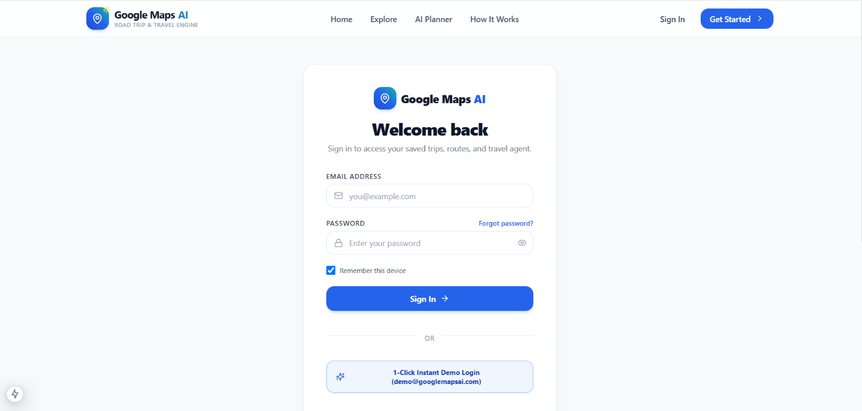

The entry point to Google Maps AI. A centered card displays the application logo, name, and tagline, with tabs to sign in or create an account. Users sign in with an email and password, and a “Forgot password?” link starts the password reset flow. All other pages are protected routes that require a signed-in user.

Onboarding Page:

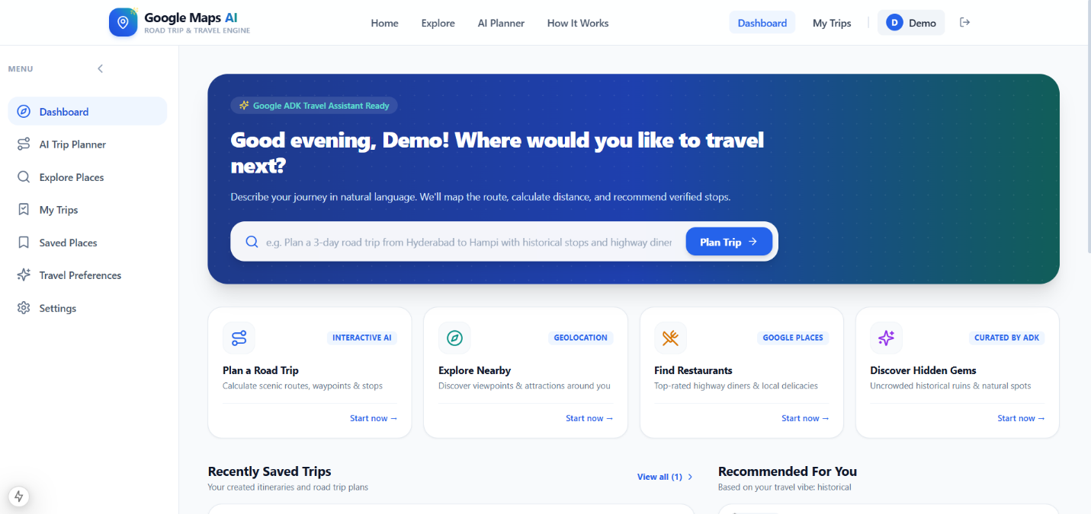

Shown to new travelers after sign-up. A short, step-by-step flow, with a progress bar, collects the preferred trip type, default budget, interests, and travel pace. These choices are stored on the user’s profile and give the planner sensible defaults for future requests.

AI Trip Planner Page:

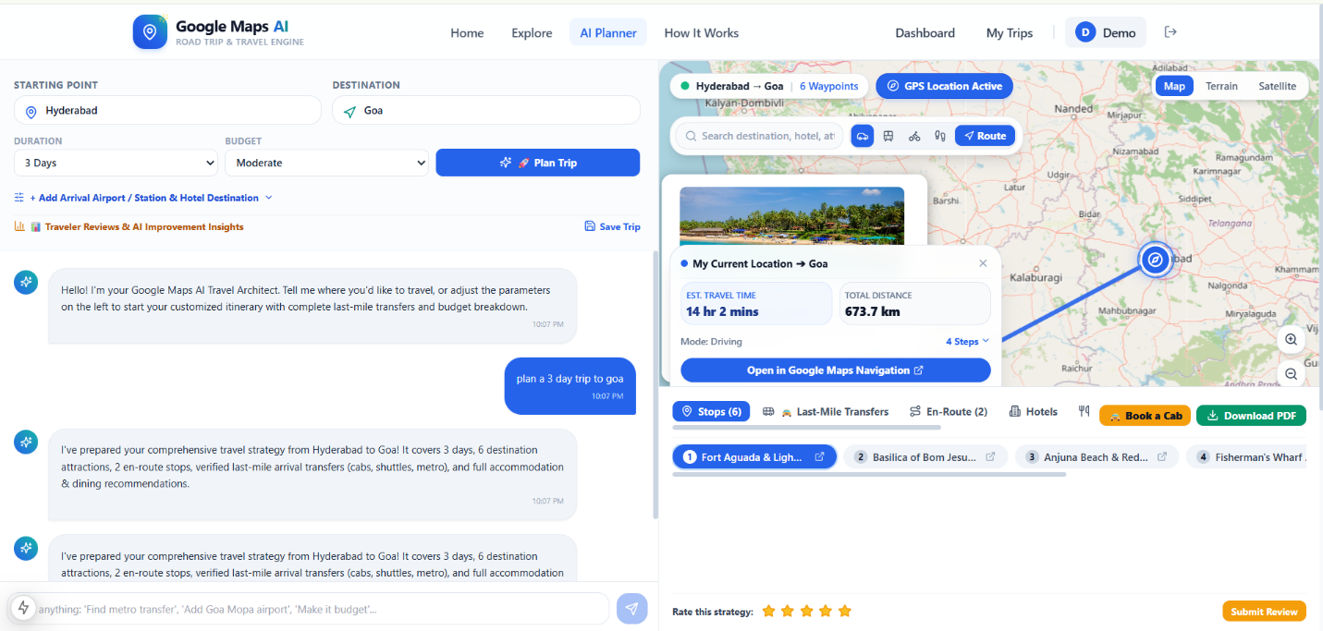
The main workspace of the application. A split-view layout places the conversational assistant on the left and the generated itinerary beside an interactive map on the right. The traveler types a trip request, follows any clarifying questions, and sees day-by-day stops with the reason each was recommended and the route details taken from Maps tool results. Follow-up messages such as “Make it more affordable” refine the plan, and the Save Trip button stores it to the account.

When Google Maps credentials are unavailable, the same page opens with a prominent demo-mode banner stating that the places and routes shown are sample data, so illustrative content is never mistaken for live information.

Interactive Map & Explore Page:

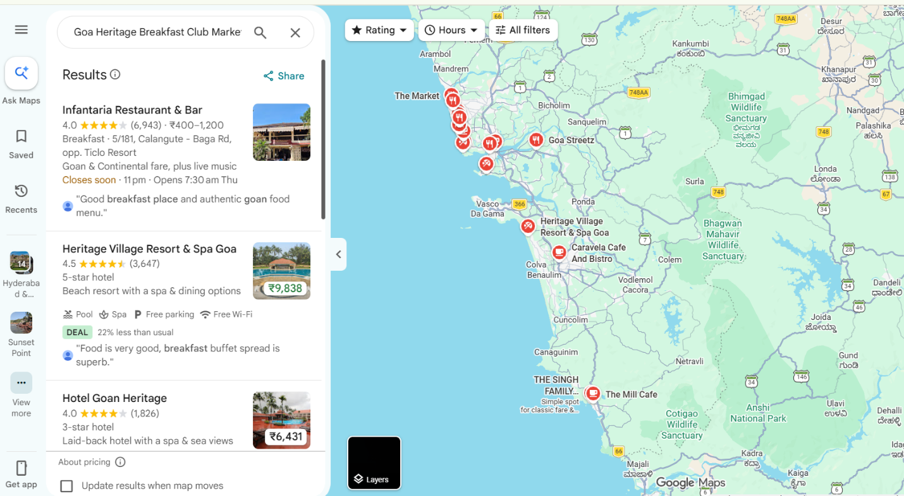

A full-width Google Map for discovering places independently of a trip. The search bar and category filters surface places as markers, route summaries appear on the map, and selecting a marker opens a detail panel with the place’s information. From the panel, a traveler can save the place to favorites or add it to a trip.

My Trips Page:

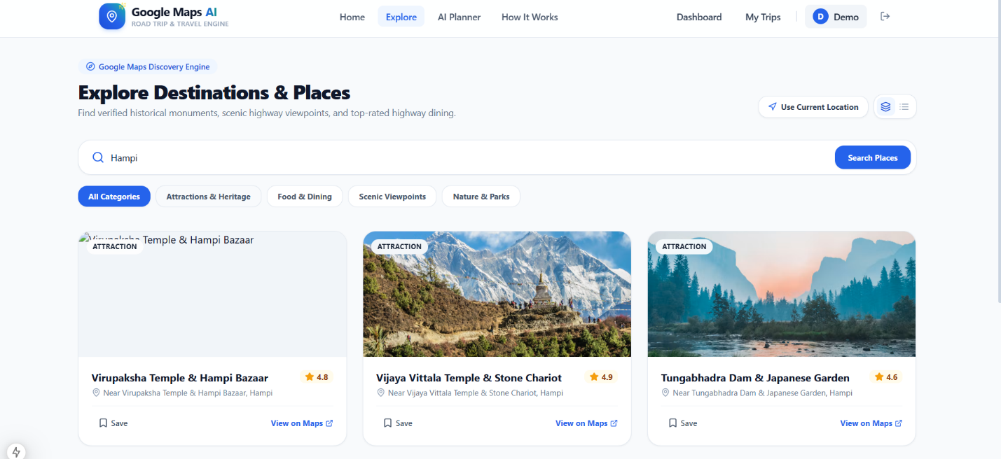
The trip management page. Each saved itinerary appears as a card with a route preview, trip details, and its days. Travelers can open, edit, duplicate, or delete a trip, and the server checks ownership on every action so that users only ever see their own trips.

Profile & Settings Page:

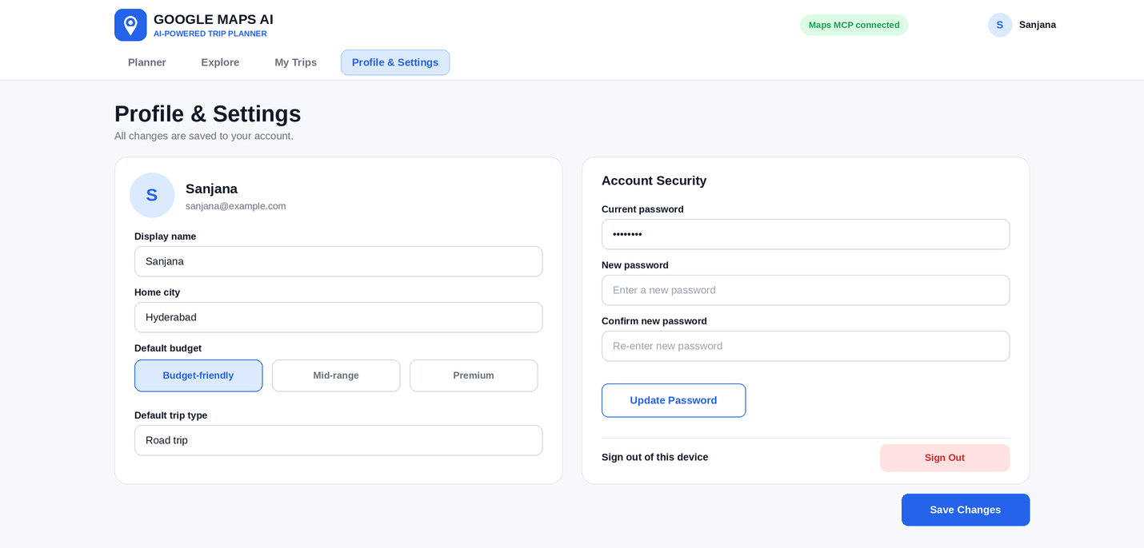
The account page. The left panel maintains the user profile together with the default budget and trip type used by the planner, while the right panel provides account security options such as changing the password and signing out. All changes are persisted to the account when the user selects Save Changes.

Conclusion:
Google Maps AI is a full-stack travel planning platform built with a Google ADK agent, Google Maps MCP tools, a FastAPI backend, and a Next.js frontend that brings clarity and speed to road trip planning. It turns natural-language requests into personalized, day-by-day itineraries whose stops and routes come from real Maps tool results rather than AI invention, while an interactive map, conversational refinement, and saved trips keep the traveler in control. The project, which spanned requirements and stack selection, core agent and account features, backend development, frontend development, and deployment, highlights how a tool-grounded agent paired with a clear, transparent interface can make trip planning faster without sacrificing trust, including a clearly labeled demo mode when live Maps data is unavailable.

Looking ahead, Google Maps AI offers significant opportunities for expansion, such as supporting multi-city and multi-traveler trips, adding collaborative trip sharing, integrating budget tracking and booking links alongside itineraries, and layering in offline access for saved plans. By refining its agent tooling and broadening the range of Maps data it can draw on, the platform is well-positioned to evolve from a road trip planner into a comprehensive AI-assisted travel companion for individual travelers and groups alike.

