Research-to-Action Agent: Autonomous Research, Verification & Roadmap Generation – LangGraph – RAG – LLM Agents

Project Description:
The Research-to-Action Agent tackles a common gap in self-directed learning and professional research — research produces large amounts of information, but that information rarely turns into a clear, trustworthy plan. The platform includes a Goal Understanding & Research Planning module, which interprets the user’s objective and breaks it into focused research questions; a Source Collection & Information Extraction pipeline, which gathers current material through web and search APIs and pulls out structured facts; and an Evidence Comparison & Source Verification module, which cross-checks claims across sources and scores their credibility before anything is accepted.

Utilizing a LangGraph-orchestrated workflow with LangChain tool wrappers and an LLM API, the Research-to-Action Agent stores extracted knowledge in a FAISS/ChromaDB vector store and uses Retrieval-Augmented Generation (RAG) so that every synthesized insight is grounded in retrieved evidence rather than generated from memory. Built with Python and a FastAPI backend, and fronted by a lightweight Streamlit dashboard, the platform adds Knowledge Synthesis, Roadmap Generation, and Research Report Generation modules that turn verified findings into a prioritized execution roadmap and a cited research report — empowering students, professionals, and researchers to move from a question to a concrete plan of action.

Scenarios
Scenario 1: Arjun, a final-year engineering student, asks the agent: “What GenAI skills should I learn to become an AI engineer in 2027?” The agent restates the goal, drafts a research plan with six focused questions, and collects current job descriptions, industry reports, and course syllabi through web and search APIs. After extracting the skills each source mentions, it identifies the ones that appear most consistently — such as LLM APIs, RAG, agent frameworks, and deployment — and produces a structured, phase-by-phase learning roadmap he can start following the same day.

Scenario 2: During evidence comparison, the agent finds that sources disagree on whether fine-tuning is essential for entry-level roles. Rather than silently picking a side, it flags the conflict, checks the credibility of each source, and lowers the confidence of that claim. The final roadmap lists fine-tuning as an optional stretch topic and shows which sources support each view — illustrating how evidence comparison and source verification prevent the agent from presenting an uncertain claim as settled fact.

Scenario 3: A career-services mentor at the same institute opens the Report & History page to review the research her students have run over the past month. She reopens a saved report, checks the cited sources behind each roadmap phase, and reruns the same question with the Deep research setting after a new batch of job postings appears — keeping the roadmap current without anyone starting the research from scratch.

Technical Architecture:
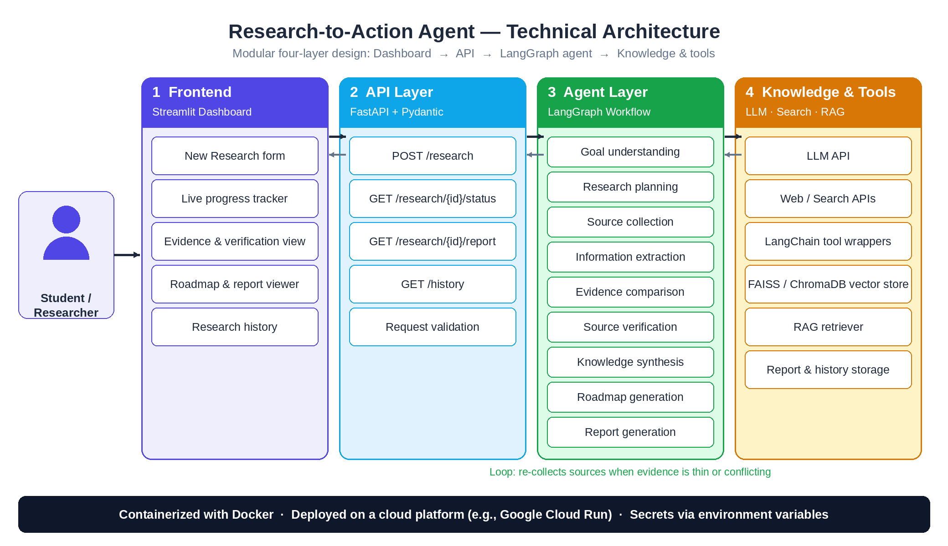

Description: The Research-to-Action Agent follows a modular four-layer architecture built for transparent, evidence-grounded research. A Streamlit-based frontend renders the research request form, live progress tracker, evidence and verification view, roadmap viewer, and research history. A FastAPI application layer validates requests with Pydantic, starts agent runs, and exposes endpoints for status, reports, and history. The core of the system is a LangGraph workflow in which each stage — goal understanding, research planning, source collection, information extraction, evidence comparison, source verification, knowledge synthesis, roadmap generation, and report generation — is a node that reads and updates a shared research state, with a conditional loop that sends the agent back to collect more sources when evidence is thin or conflicting. The agent calls an LLM API and web/search APIs through LangChain tools and stores extracted knowledge in a FAISS/ChromaDB vector store for RAG retrieval, while reports and run history are persisted and the entire stack is containerized with Docker for cloud deployment.

Pre-requisites:
- Python Programming Proficiency: Python Documentation
- LangGraph & Agent Workflows: LangGraph Documentation
- LangChain & LLM API Basics: LangChain Documentation
- RAG Concepts: LangChain RAG Tutorial
- Vector Databases (FAISS / ChromaDB): FAISS Documentation | ChromaDB Documentation
- FastAPI Framework Knowledge: FastAPI Documentation
- Streamlit Dashboard Basics: Streamlit Documentation
- Prompt Engineering for LLMs: Prompt Engineering Guide
- Version Control with Git: Git Documentation

Project Workflow:

Milestone 1: Problem Definition and Tool Selection
- Activity 1.1: Define the research goal, scope, and success criteria using the benchmark question on GenAI skills for 2027.
- Activity 1.2: Research and select the appropriate LLM API, web/search API, and vector store (FAISS or ChromaDB) for the agent.
- Activity 1.3: Define the architecture of the application, detailing interactions between the dashboard, API, agent workflow, and knowledge layers.
- Activity 1.4: Set up the development environment, installing necessary libraries and dependencies for LangGraph, LangChain, FastAPI, and Streamlit.

Milestone 2: Core Research Agent Development
- Activity 2.1: Develop the Goal Understanding & Research Planning nodes that turn a question into a structured research plan.
- Activity 2.2: Develop the Source Collection & Information Extraction nodes using web/search APIs and structured LLM extraction.
- Activity 2.3: Implement Evidence Comparison & Source Verification to cross-check claims and score source credibility.
- Activity 2.4: Implement Knowledge Synthesis, Roadmap Generation, and Research Report Generation using RAG.

Milestone 3: Agent Orchestration & Backend Development
- Activity 3.1: Write the main backend application logic, assembling the LangGraph workflow and exposing it through FastAPI endpoints.

Milestone 4: Dashboard (Frontend) Development
- Activity 4.1: Design and develop the Streamlit dashboard UI, including the research request form and progress tracker.
- Activity 4.2: Create dynamic components to render evidence, roadmaps, reports, and history based on backend responses.

Milestone 5: Deployment
- Activity 5.1: Prepare the application for local deployment by configuring the backend environment and API keys.
- Activity 5.2: Test the application locally, verifying all modules end-to-end with the benchmark question.
- Activity 5.3: Containerize the application with Docker and deploy it to a cloud platform.
Conclusion

Milestone 1: Problem Definition and Tool Selection
In this milestone, we focus on defining a clear research problem and selecting the right tools for the Research-to-Action Agent. This involves understanding what the agent must produce, evaluating language-model, search, and vector-store options, and ensuring the final choices support the application’s goal of verified, evidence-grounded research.

Activity 1.1: Define the Research Goal and Scope
Before any code is written, the Research-to-Action Agent needs a precise definition of what a successful research run looks like.
- Step 1 — Define the Target Use Case: Use the question “What GenAI skills should I learn to become an AI engineer in 2027?” as the primary test case, and add two or three further topics (for example, a data-engineering roadmap) to check that the agent generalizes.
- Step 2 — Specify the Outputs: Define the three deliverables: verified findings with source references, a phase-by-phase execution roadmap, and a structured research report.
- Step 3 — Identify Source Types: Decide which sources the agent should collect — job postings, industry reports, official documentation, course syllabi, and reputable technical articles.
- Step 4 — Set Success Criteria: Define how a run is judged: coverage of key skills, the number of independent sources behind each claim, citation completeness, and manual review of roadmap usefulness.

Activity 1.2: Research and Select the Appropriate Tools
Here are the things that needed to be researched to select the best stack for the project:
- Understand the Project Requirements: Review the agent’s need for multi-step reasoning, live web access, grounded synthesis, and traceable citations.
- Explore Candidate Components: Evaluate LLM APIs, web/search APIs, and vector stores (FAISS and ChromaDB) for the retrieval layer.
- Evaluate Orchestration Options: Compare LangGraph with simple LangChain chains for stateful workflows that need loops and conditional routing.
- Select the Optimal Stack: Choose LangGraph for orchestration, LangChain for tool and retriever wrappers, an LLM API for reasoning and extraction, a search API for source collection, and FAISS or ChromaDB for RAG — served through FastAPI.

Activity 1.3: Define the Architecture of the Application
- Draft an Architectural Diagram: Create a visual representation of the application architecture, including the Streamlit frontend, FastAPI backend, LangGraph agent, and knowledge layer.
- Detail Frontend Functionality: Outline how a user submits a research goal, watches progress, reviews verified evidence, and downloads the roadmap and report.
- Outline Backend Responsibilities: Specify how the backend validates requests, runs the LangGraph workflow, tracks run status, and stores reports and history.
- Describe Agent Integration Points: Define the shared research state passed between nodes and how each node calls the LLM, search tools, and vector store.

Activity 1.4: Set Up the Development Environment
- Install Python: Ensure Python 3.10+ is installed for the agent and the application backend.

Create a Virtual Environment: Set up a virtual environment using venv to isolate project dependencies:
D:\projects> python -m venv myenv
D:\projects> "d:\projects\myenv\Scripts\activate"
(myenv) D:\projects> pip install -r requirements.txt
Install Agent and RAG Libraries: Install LangGraph, LangChain, and the vector stores, plus your chosen LLM provider’s LangChain integration (for example, langchain-openai or langchain-anthropic):
(myenv) D:\projects> pip install langgraph langchain langchain-community faiss-cpu chromadb
Install API and Dashboard Libraries:
(myenv) D:\projects> pip install fastapi uvicorn pydantic streamlit python-dotenv
- Set Up Application Structure: Create the project directory structure, including folders for the API (api/), agent nodes (agent/), the dashboard (dashboard/), data and vector stores (data/), and utility functions (utils/).

Milestone 2: Core Research Agent Development

Activity 2.1: Develop the Goal Understanding & Research Planning Nodes
Implement the nodes that turn a plain-language question into a structured research plan.
- Goal Parsing: Use the LLM with a structured output schema to extract the topic, desired outcome, time frame (for example, 2027), and user context.
- Clarification Check: Detect when essential details, such as current skill level, are missing and ask a short follow-up question before research begins.
- Research Question Generation: Break the goal into focused sub-questions (for example, “Which GenAI skills do job postings request most often?”) and assign source types and search queries to each.

Activity 2.2: Develop Source Collection & Information Extraction
- Search & Collection: Run the planned queries through the web/search API, then fetch and clean page content, removing duplicates and low-quality pages.
- Structured Extraction: Prompt the LLM to extract skills, tools, requirements, and publication dates from each source into a fixed Pydantic schema.
- Chunking & Indexing: Split documents into chunks, create embeddings, and store them with source metadata in the FAISS/ChromaDB vector store.

Activity 2.3: Implement Evidence Comparison & Source Verification
- Cross-Source Comparison: Group similar claims across sources and count how many independent sources support each one.
- Conflict Detection: Flag claims on which sources disagree and record which sources hold each position.
- Credibility Scoring: Score each source using signals such as publisher type, recency, and corroboration, then lower or drop findings that rest on weak sources.
- Re-Research Loop: When evidence is thin or conflicting, route the workflow back to Source Collection for targeted additional searches, with a cap on the number of loops.

Activity 2.4: Implement Knowledge Synthesis, Roadmap & Report Generation
- Knowledge Synthesis (RAG): Use the retriever to pull verified evidence for each research question and have the LLM merge it into consistent, citation-backed insights.
- Roadmap Generation: Convert the prioritized skills into phases with durations, learning objectives, and suggested resources, ordering topics by dependency and strength of evidence.
- Research Report Generation: Assemble the executive summary, key findings, conflicts, roadmap, and source list into a structured report.
A simplified LangGraph workflow definition looks like this:
from langgraph.graph import StateGraph, START, END

graph = StateGraph(ResearchState)

graph.add_node("understand_goal", understand_goal)
graph.add_node("plan_research", plan_research)
graph.add_node("collect_sources", collect_sources)
graph.add_node("extract_info", extract_info)
graph.add_node("compare_evidence", compare_evidence)
graph.add_node("verify_sources", verify_sources)
graph.add_node("synthesize", synthesize)
graph.add_node("build_roadmap", build_roadmap)
graph.add_node("write_report", write_report)

graph.add_edge(START, "understand_goal")
graph.add_edge("understand_goal", "plan_research")
graph.add_edge("plan_research", "collect_sources")
graph.add_edge("collect_sources", "extract_info")
graph.add_edge("extract_info", "compare_evidence")
graph.add_edge("compare_evidence", "verify_sources")

graph.add_conditional_edges(
"verify_sources", needs_more_evidence,
{"more": "collect_sources", "done": "synthesize"})

graph.add_edge("synthesize", "build_roadmap")
graph.add_edge("build_roadmap", "write_report")
graph.add_edge("write_report", END)

agent = graph.compile()

Milestone 3: Agent Orchestration & Backend Development
Milestone 3 focuses on assembling the individual nodes into one reliable workflow and exposing it as an API that serves the dashboard. In this milestone, you’ll wire up the shared state, connect the nodes through LangGraph, and test the workflow end-to-end.

Activity 3.1: Writing the Main Backend Application Logic
- Define the Core Functions: Establish functions for the agent’s key operations, each serving a distinct purpose:
  - understand_goal() — parses the user’s question into a structured goal
  - plan_research() — generates research questions and search queries
  - collect_sources() — runs searches and fetches page content
  - extract_info() — extracts structured facts and indexes chunks in the vector store
  - compare_evidence() — groups claims across sources and flags conflicts
  - verify_sources() — scores source credibility and decides whether more research is needed
  - synthesize(), build_roadmap(), write_report() — produce the cited insights, execution roadmap, and final report
Define the Shared Research State: Every node reads from and writes to a single typed state object that travels through the workflow:
class ResearchState(TypedDict):
goal: str
questions: list[str]
sources: list[dict]
claims: list[dict]
verified: list[dict]
roadmap: dict
report: str
iterations: int
Load the Vector Store at Startup: Open the persisted vector store once when the application starts, avoiding repeated initialization per request:
vectorstore = Chroma(persist_directory="data/chroma", embedding_function=embeddings)
retriever = vectorstore.as_retriever(search_kwargs={"k": 6})
- Set Up Endpoints for Each Feature: Implement POST /research to start a run, GET /research/{id}/status for progress, GET /research/{id}/report for the final output, and GET /history for past runs, with Pydantic validation on every request.
- Validate and Return Responses: Ensure every response includes the fields the dashboard expects — run status, verified findings with sources, roadmap, report, and timestamp — before returning it.

Milestone 4: Dashboard (Frontend) Development
Milestone 4 focuses on developing a clear, easy-to-follow interface for the Research-to-Action Agent. This involves designing a Streamlit dashboard and wiring up dynamic components for submitting research goals, tracking progress, reviewing evidence, and viewing roadmaps and reports.

Activity 4.1: Designing and Developing the User Interface
- Set Up the Base App Structure: Build the main dashboard shell with navigation across New Research, Research Progress, Evidence & Verification, Roadmap, and Report & History.
- Design a Clean Research Theme: Implement a light, high-contrast theme with clear typography, using color-coded status tags (green for Verified, amber for Needs Review, red for Conflict).
- Build the Research Request Component: Allow the user to type a research goal, add optional context, choose a research depth, and set the maximum number of sources.
- Create Separate UI Components for Each Module: Progress tracker, evidence table, roadmap phase cards, report viewer, and research-history list.

Activity 4.2: Creating Dynamic Content Rendering
- Fetch and Render Run Status: On clicking “Start Research,” call the API and poll the status endpoint to update the stage tracker, counters, and activity log.
- Render Evidence & Verification: Populate the evidence table with each claim, the number of supporting sources, credibility rating, and status.
- Render the Roadmap & Report: Display roadmap phases with their topics and priorities, show the report preview, and provide a download option.
- Surface Conflict Alerts: Display a “Needs Review” or “Conflict” notice whenever a finding’s support or credibility falls below a set threshold.

Milestone 5: Deployment
In Milestone 5, the focus is on deploying the Research-to-Action Agent — first locally to verify correct operation, then to a cloud platform for wider access. This involves configuring the environment, containerizing the app, and launching it for real-world use.

Activity 5.1: Preparing the Application for Local Deployment
Create and activate a virtual environment, then install all required dependencies from requirements.txt:
D:\projects> python -m venv myenv
D:\projects> "d:\projects\myenv\Scripts\activate"
(myenv) D:\projects> pip install -r requirements.txt
- Configure Environment Variables: Create a .env file for configuration such as the LLM and search API keys, model name, and vector store path.

Activity 5.2: Local Testing and Verification
Start the FastAPI backend and the Streamlit dashboard locally using:
(myenv) D:\projects> uvicorn api.main:app --reload
(myenv) D:\projects> streamlit run dashboard/app.py
- End-to-End Verification: Run the benchmark question and confirm that every stage completes, evidence is verified, and the roadmap, report, and history render correctly across all pages.

Activity 5.3: Production Build and Deployment
Containerize the application with Docker:
FROM python:3.10-slim
WORKDIR /app
COPY . .
RUN pip install -r requirements.txt
EXPOSE 8080
CMD ["uvicorn", "api.main:app", "--host", "0.0.0.0", "--port", "8080"]
Deploy the dashboard as a second service by repeating the build with the start command streamlit run dashboard/app.py --server.port=8080. Then deploy the container to a cloud platform (Google Cloud Run is shown as an example):
gcloud run deploy research-agent --source . --region <your-region>
- Important Notes: Disable debug/auto-reload in production, keep API keys in a secret manager rather than in code, set limits on maximum sources and loop iterations to control cost, cache search results, and periodically refresh stored research as new sources appear.

Exploring the Website’s Web Pages:
The following pages are illustrative wireframe mockups of the Research-to-Action Agent dashboard, showing the intended layout and flow ahead of full frontend development. All values shown are sample data for illustration only.

New Research Page:

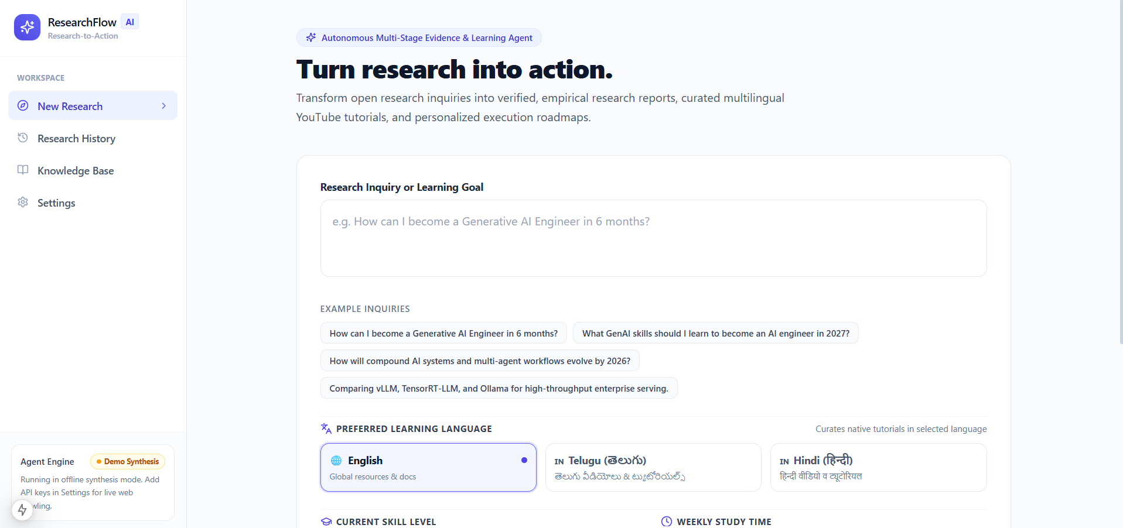

The entry point to the Research-to-Action Agent. A form lets the user type a research goal in plain language — here, “What GenAI skills should I learn to become an AI engineer in 2027?” — add optional context such as experience level and weekly time, choose a research depth (Quick, Standard, or Deep), and set the maximum number of sources. A “Start Research” button launches the agent, while a side panel lists recent research runs with their status.

Research Progress Page:

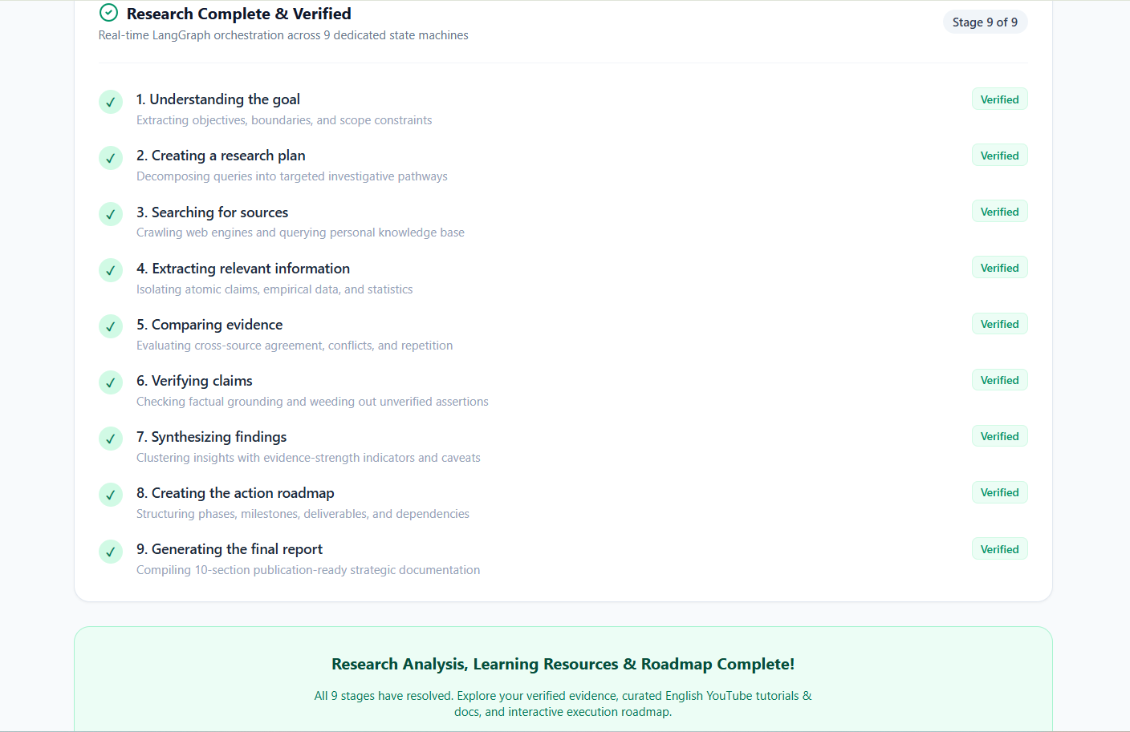
Opened as soon as a run starts, this page shows the LangGraph workflow stage by stage, marking completed steps and highlighting the one currently running. Summary counters report sources collected, claims extracted, and conflicts flagged, while an agent activity log records each action so the user can see exactly what the agent is doing.

Evidence & Source Verification Page:
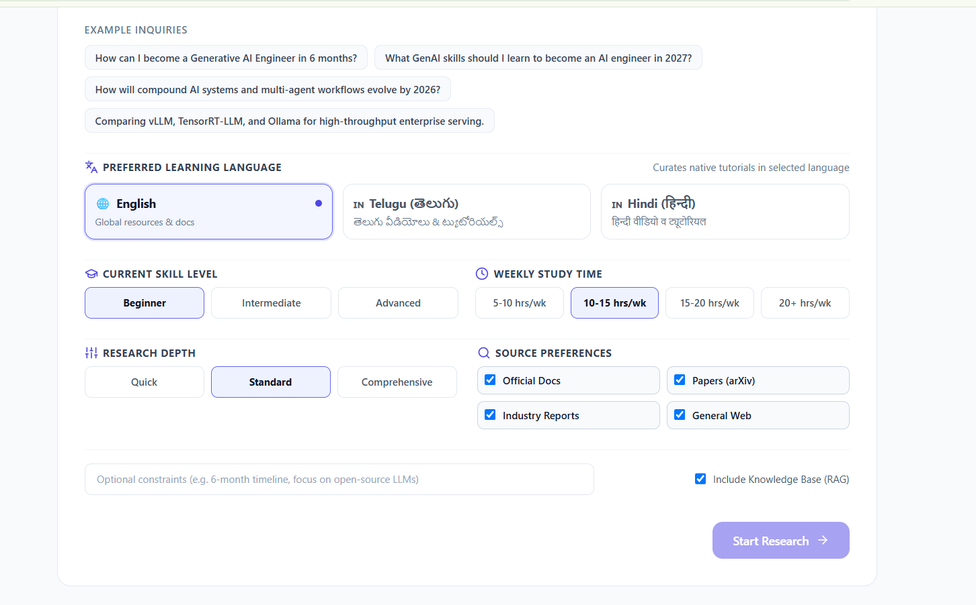
This page surfaces the verification output. Each extracted claim is listed with the number of sources that support it, a credibility rating, and a color-coded status — Verified, Needs Review, or Conflict. A source-credibility chart summarizes the quality of the evidence base, and a conflict panel explains disagreements between sources, such as differing views on whether fine-tuning is essential.

Roadmap Page:
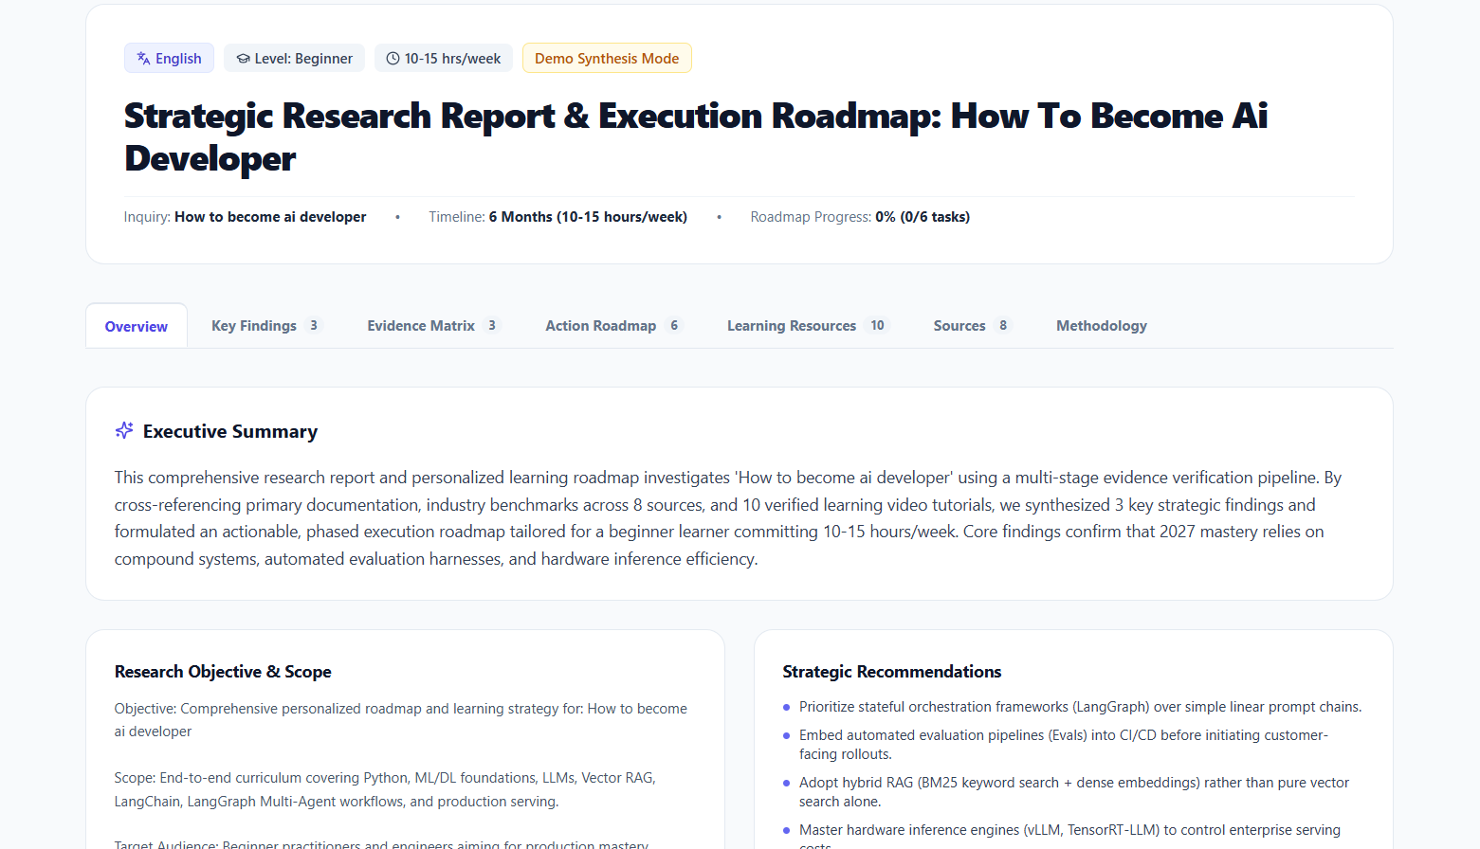
The Roadmap page turns verified findings into an execution plan. Skills are grouped into time-boxed phases — Foundations, RAG Systems, AI Agents, and Production — each with a checklist of topics and a priority tag, followed by a capstone project that combines the skills into a portfolio-ready deliverable.

Report & History Page:
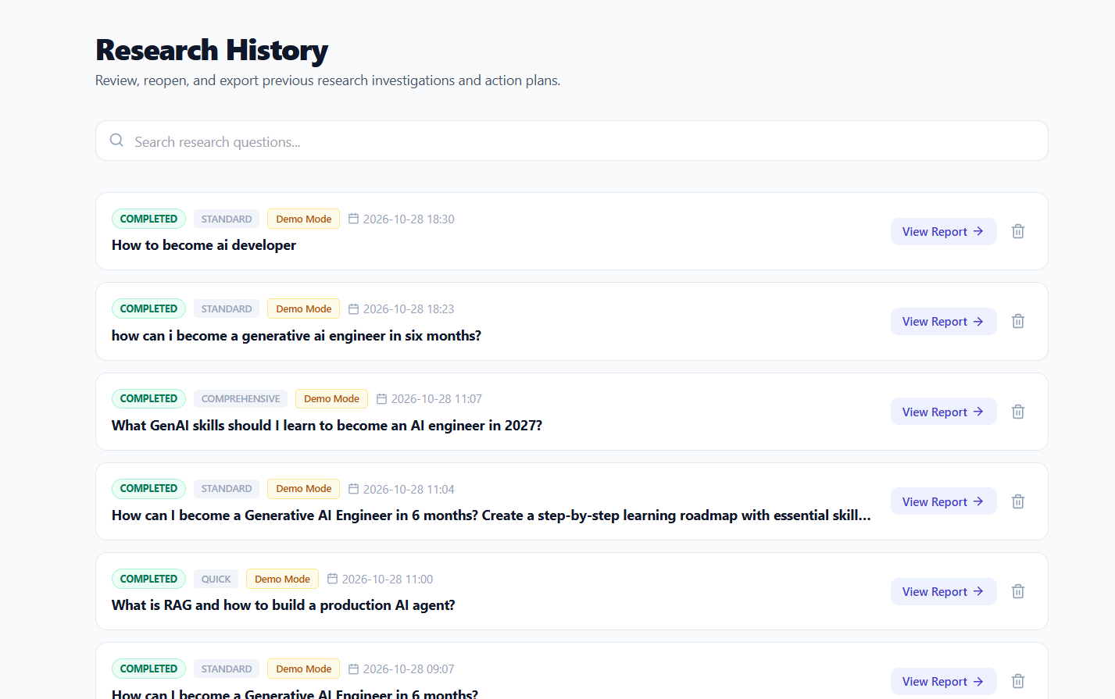
The hub for final outputs and past work. The report preview shows the executive summary, key findings, and source summary with a download button, while the history panel lists earlier research runs so users can reopen a report or rerun a topic with fresh sources.

Conclusion:
The Research-to-Action Agent is an autonomous research platform built with a LangGraph workflow, LangChain tooling, an LLM API, and a RAG knowledge layer, served through FastAPI and a Streamlit dashboard. It takes a plain-language goal, plans and runs its own research, cross-checks claims across sources, and converts only verified findings into a prioritized execution roadmap and a cited research report. The project, which spanned problem definition, core agent development, backend orchestration, dashboard development, and deployment, highlights how pairing retrieval-grounded synthesis with explicit evidence comparison and source verification can turn information overload into trustworthy, actionable plans.

Looking ahead, the Research-to-Action Agent offers significant opportunities for expansion, such as adding human-in-the-loop checkpoints where users approve the research plan before sources are collected, supporting private document uploads alongside web research, tracking progress against the roadmap with periodic re-research as the field changes, evaluating output quality with automated benchmarks, and extending the agent to other domains such as career planning, market research, and literature review. By refining its verification logic and broadening its tool set, the platform is well-positioned to evolve from a single-topic research assistant into a general-purpose personal research-to-action companion.

