DASHBOARD Page 1 – MUSIC PERFORMANCE OVERVIEW
Requirements:
- Identify the artist with the highest number of streams.
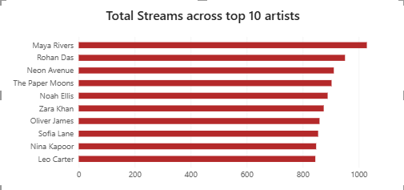
- The chart displays the total number of streams for the top 10 most popular artists.
- Maya Rivers leads the group as the highest-streamed artist, reaching over 1,000 streams.
- Display the top 10 artists based on total revenue
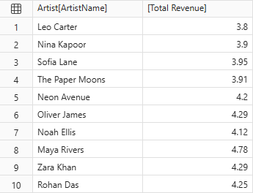
- Compare the revenue generated by different genres
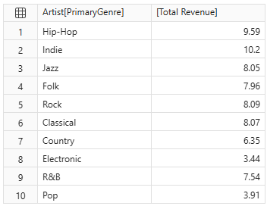

- Identify the album with the highest listening activity
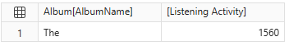
- Analyse monthly stream trends
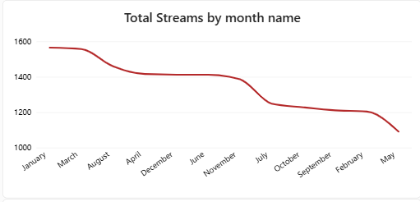
- This line chart shows the total number of streams sorted by month name from highest to lowest volume.
- January and March see the highest streaming activity, peaking near 1,600 streams.
- May records the lowest streaming activity, dropping close to 1,100 streams.
- The chart reveals a clear downward trend from the highest-performing month to the lowest-performing month.
- Compare the revenue between 2024 and 2025
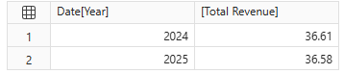

DASHBOARD Page 2 – Listener Behaviour and Revenue Analysis
Requirements:
- Determine which subscription type generates the highest total revenue.
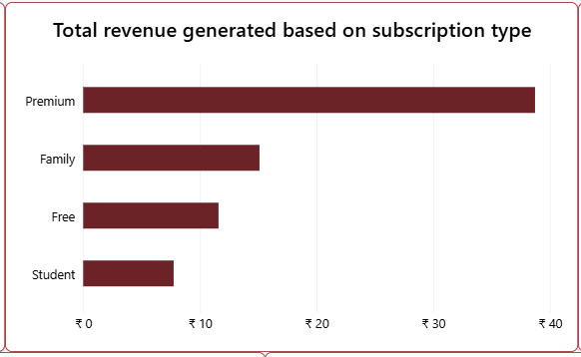
- This horizontal bar chart shows the total revenue generated based on different subscription types.
- Premium subscriptions generate the highest amount of revenue by a significant margin, reaching nearly ₹40.
- Overall, the Premium tier is the dominant financial driver for the platform

- Compare the average revenue per record for each subscription type.
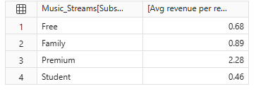
- Identify which device accounts for the most streaming activity.
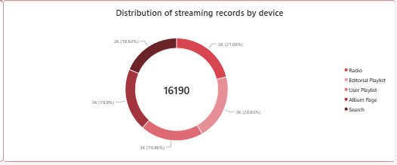
- This donut chart illustrates the distribution of 16,190 total streaming records across five primary sources.
- Radio accounts for the largest share of listening records at 21.06%.
- Editorial Playlist follows closely behind as the second most popular source at 20.65%.
- User Playlist and Album Page capture very similar shares of the activity, making up 19.81% and 19.86% respectively.
- Overall, streaming activity is remarkably well-balanced, with all five sources distributed nearly evenly around roughly 19% to 21% each.

- Compare listening behaviour across countries
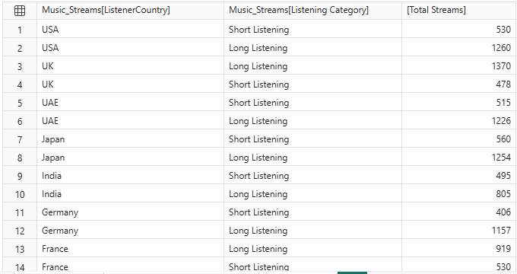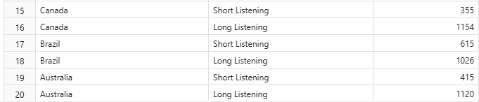

- Find which playlist source has the highest number of streams.
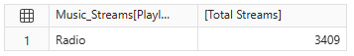
- Compare completed and not-completed records.
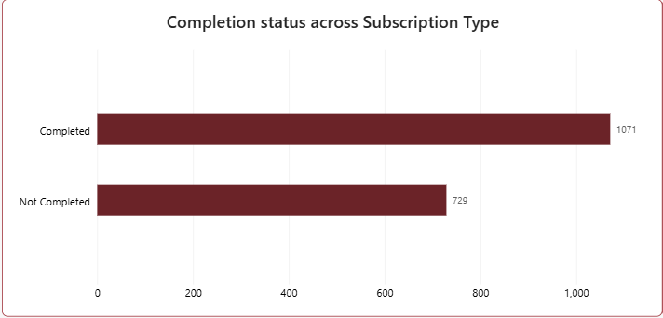

- Analyse the relationship between Skip Count and Rating.
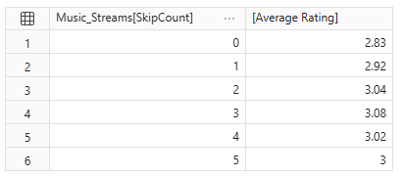

- Compare revenue growth with the previous year

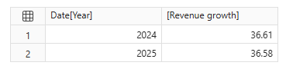

- Identify artists or albums with high streams but relatively low revenue.


