ShopNest Store
Power BI Capstone — Dashboard Report

Introduction :-

This report documents the Power BI dashboard built for the ShopNest Store Capstone Project. The dashboard was developed using a retail e-commerce dataset comprising nine related tables: orders, order items, order payments, order reviews, products, customers, sellers, product category translations, and geolocation.
The dataset was cleaned and modeled in Power BI, with a dedicated date table, calculated columns, and DAX measures built to support eight required business analysis questions. All eight visuals are consolidated onto a single dashboard page, supported by three interactive slicers (Year, State, and Product Category) and 4 KPI summary cards (Total Sales, Total Orders, Total Revenue, Delayed Orders), along with a drill through page for detailed order-level analysis.
The following sections address each of the eight required questions in turn, presenting the question statement, the corresponding visualization from the dashboard, and an explanation of the key insights and findings.

Dashboard Overview : -

- Eight visualizations
- KPI cards
- Slicers
- Are presented together on a single Power BI report page "Main Dashboard" as required.
- The following sections detail each question individually with its corresponding visual.

Question 1: Top Categories by Total Price
Question Statement:
Identify and visually represent the top 10 product categories by total sales.
Visualization:

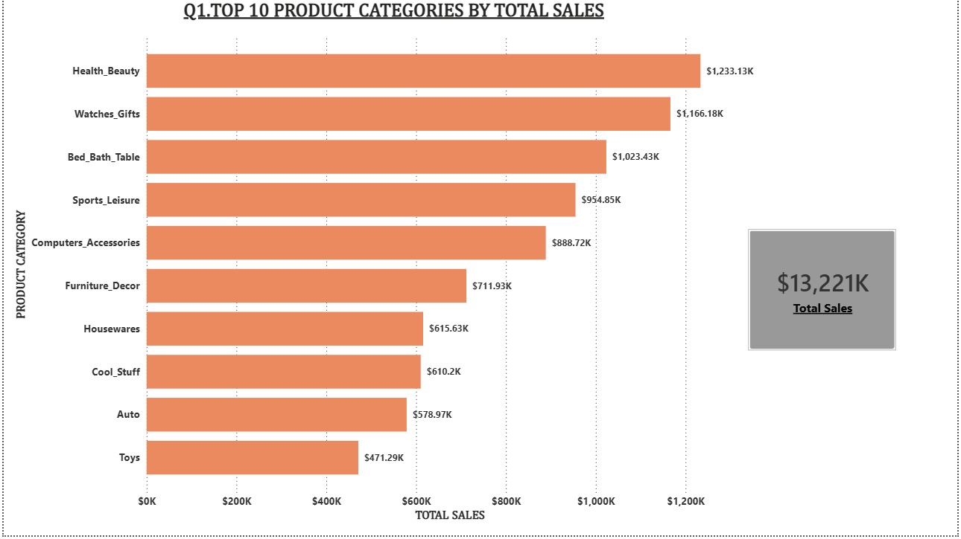

Explanation:

- This horizontal bar chart ranks ShopNest Store's product categories by total sales revenue
- Where total revenue is calculated as the sum of item prices for all delivered orders
- filtered to show only the top 10 by value.
- Health_Beauty , Watches_Gifts and Bed_Bath_Table these top three categories alone account for a substantial share of the $13,221K in total sales shown on the accompanying KPI card.
- Sports_Leisure and Computers_Accessories round out the top five, both exceeding $880K.
- The remaining categories in the top 10 range between roughly $470K and $712K, showing a fairly gradual decline rather than a single dominant category — this is a healthy, diversified sales base rather than dependence on one product line.

Question 2: Delayed Orders Analysis
Question Statement:
Determine the number of delayed orders in each category. An order is considered delayed if the actual delivery date is later than the estimated delivery date.
Visualization:
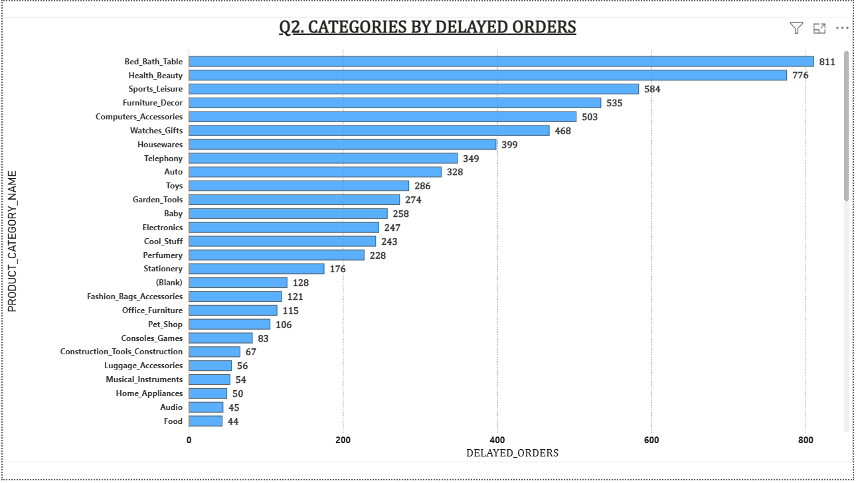
Explanation:
- An order is classified as "Delayed" using a calculated Delivery Status column:
- if the actual delivery date (order_delivered_customer_date) falls after the estimated delivery date (order_estimated_delivery_date), the order is flagged as delayed.
- This chart shows the full breakdown of delayed order counts across every product category (not just a top-10 subset), satisfying the requirement to show delays "in each category."
- Bed_Bath_Table has the highest number of delayed orders at 811, followed closely by Health_Beauty at 776 and Sports_Leisure at 584.
- These are the same categories that lead in total sales (Q1) — which makes sense, since categories with higher order volume naturally accumulate more delayed orders in absolute terms.
- A small number of order line items (128) fall under a Blank category, representing products whose category could not be matched during data cleaning; this has been retained transparently rather than hidden.
- At the lower end, categories such as Audio (45) and Food (44) show minimal delivery issues, though this is partly a function of their overall lower order volume rather than necessarily better logistics performance.

Question 3: Monthly Comparison of Delayed and On-Time Orders
Question Statement:
Create a dynamic visual that compares the number of delayed orders to the number of orders received earlier for each month. Utilize the drillthrough cross-report feature to provide a detailed analysis of late and on-time deliveries.
Visualization:
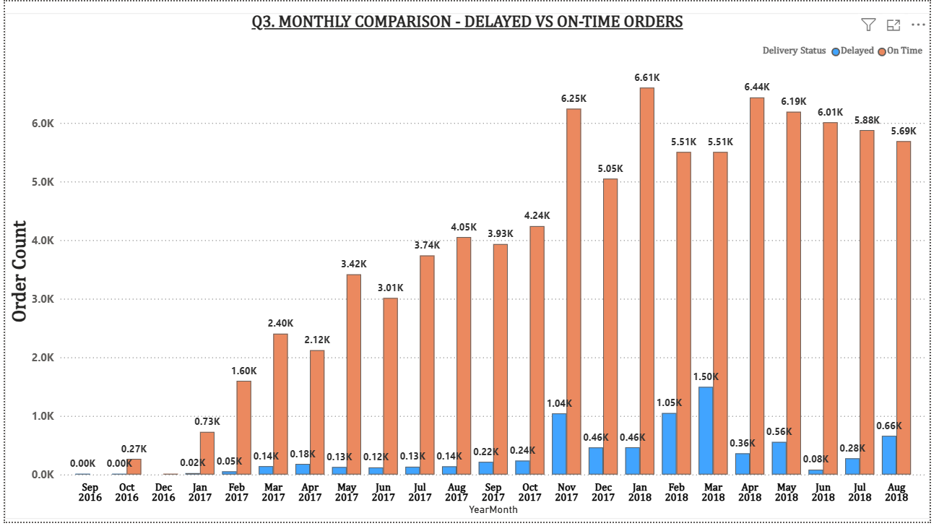
Explanation:
- This clustered column chart compares On-Time orders against Delayed orders for every month in the dataset, from September 2016 through August 2018,
- using the order's purchase month as the time axis. On-Time orders are shown in orange and Delayed orders in blue.
- The chart clearly shows overall business growth over the period:
- On-Time order volume climbs from under 300 orders per month in late 2016 to a peak of 6,610 orders in January 2018.
- Delayed orders remain a consistently small share of the total in most months, but show a visible spike in November 2017 (1,040 delayed orders) and again in March 2018 (1,500 delayed orders) — both worth flagging as potential periods of operational strain, possibly linked to seasonal demand surges (e.g. Black Friday in November).

- A drillthrough page ("Order Detail") was built and linked to this chart via the YearMonth field.
- Right-clicking any bar and selecting Drillthrough navigates to a dedicated page showing the individual order records (order ID, customer state, purchase date, delivery dates, and delivery status) for that specific month, filtered automatically. This allows a user to move from the high-level monthly trend directly to the underlying order-level detail behind any spike or dip in the chart.
Drill through Feature:-
- A dedicated drill through page ("Order Detail") was configured with Year Month set as the drill through field.
- Right-clicking any month's bar on the chart above and selecting "Drill through" navigates to this page, automatically filtered to show individual order records for the selected month — including order ID, customer state, purchase date, delivery dates, and delivery status.
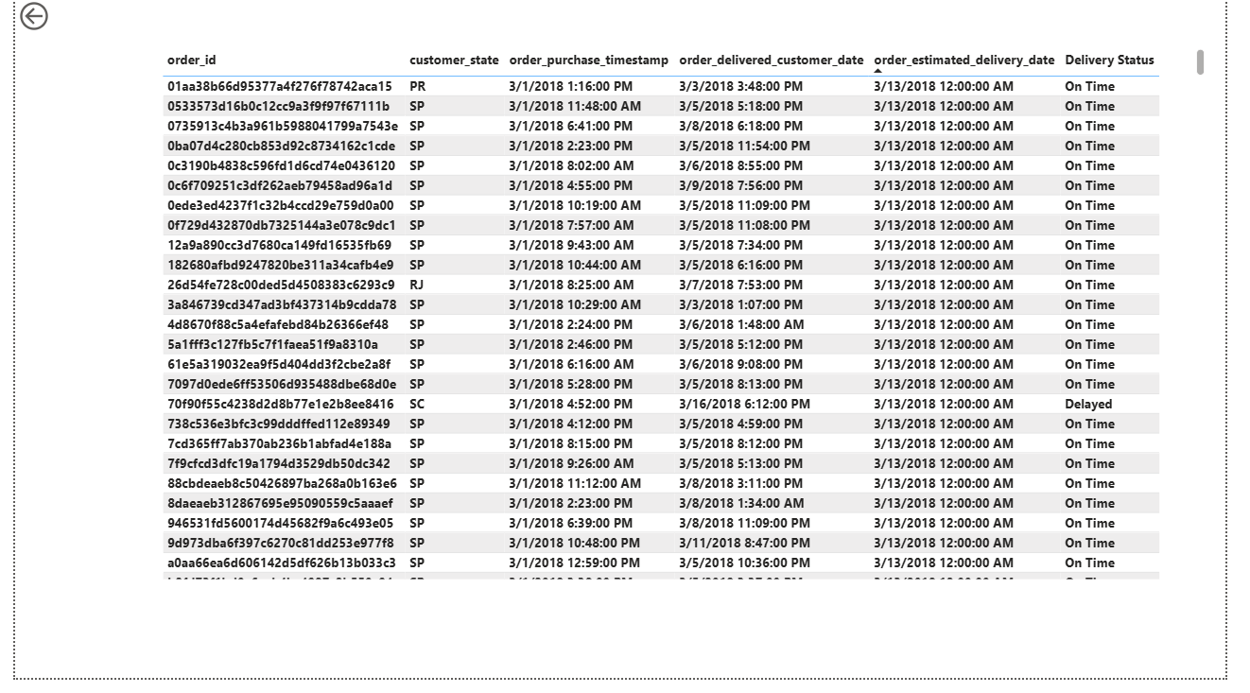

- The screenshot above shows the result of drilling through from the March 2018 bar:
- The page automatically filters to show only orders purchased in March 2018, with each row's Delivery Status clearly visible (e.g., order 70f90f55c4238d2d8b77e1e2b8ee8416 from Santa Catarina (SC) is flagged as Delayed, having been delivered on 3/16/2018 against an estimated date of 3/13/2018).
- The back-navigation arrow (top-left) allows the user to return to the main dashboard.

Question 4: Payment Method Analysis
Question Statement:
Analyze the most frequently used payment methods by customers using a visually appealing representation, such as a pie chart or other suitable visuals.
Visualization:
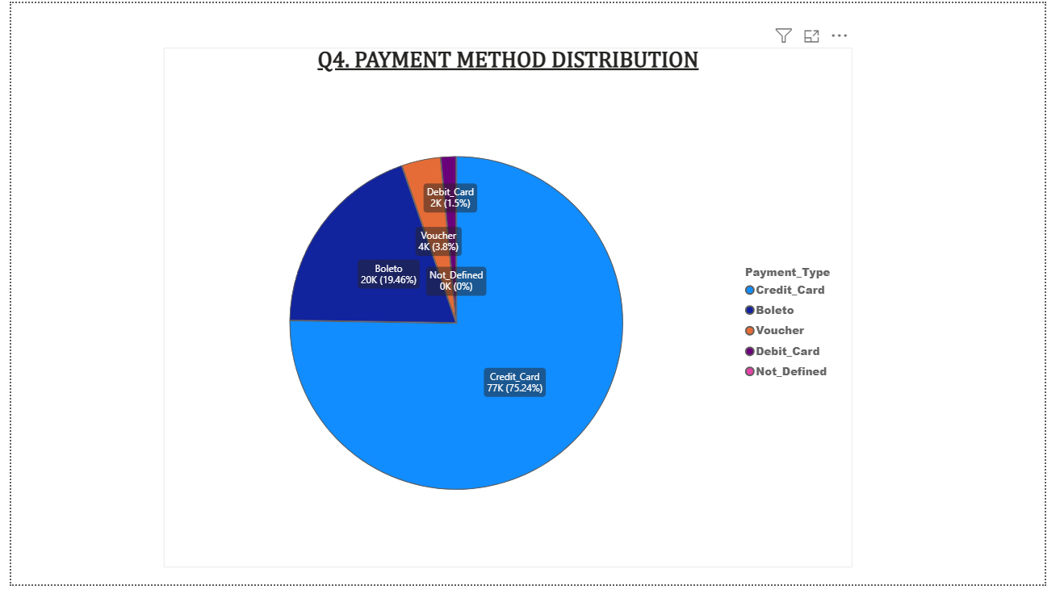
Explanation:
This pie chart shows the distribution of payment methods used across all customer orders.
- Credit_Card is most popular method, used in 75.24% of all payments (approximately 77,000 orders) — more than three times the combined share of every other payment method.
- Boleto (a common Brazilian bank-slip payment method) is the second most used at 19.46% (roughly 20,000 orders), followed by much smaller shares for Voucher (3.8%)
- Debit_Card (1.5%). A small residual category,
- Not_Defined, accounts for a negligible number of transactions.

This finding has a direct business implication: since three-quarters of all revenue flows through credit card payments, ensuring a smooth, reliable credit card checkout experience should be the top priority for reducing cart abandonment or payment failures.

Question 5: Product Rating Analysis
Question Statement:
Determine the top 10 highest-rated products and the bottom 10 lowest-rated products using a bar or column chart.
Visualization:
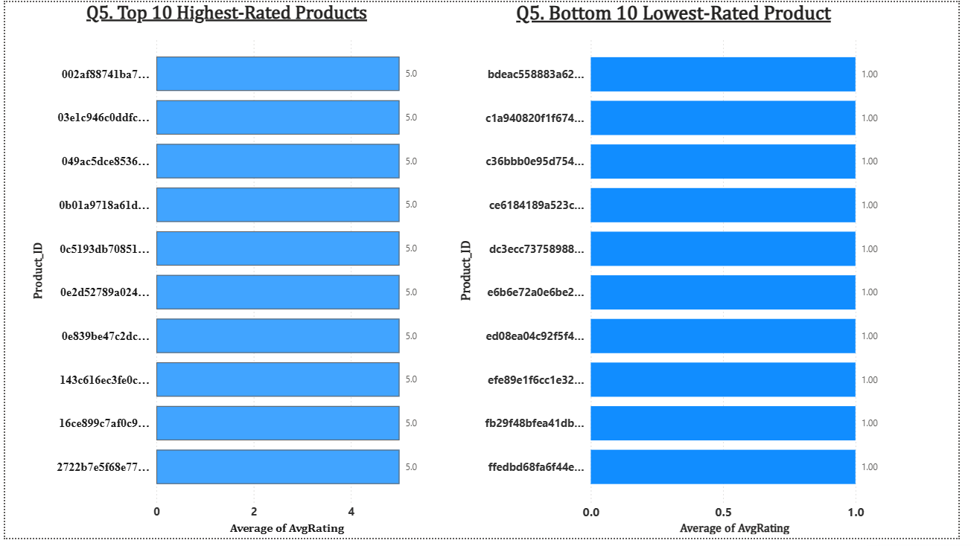
Explanation:
- Two side-by-side bar charts show the top 10 highest-rated and bottom 10 lowest-rated individual products, based on the average customer review score (1-5 scale) for each product, restricted to products with a minimum of 5 reviews so that ratings reflect a meaningful sample size rather than a single review.
- The Top 10 chart (left) shows 10 products that each achieved a perfect average rating of 5.0 across at least 5 customer reviews — genuinely consistent, excellent customer satisfaction rather than a statistical fluke from a single review.
- The Bottom 10 chart (right) shows 10 products that each averaged a rating of exactly 1.0 across at least 5 reviews — indicating a real, repeated pattern of customer dissatisfaction for these specific items, and a clear candidate list for quality review or removal from the catalog.
Product IDs are shown rather than product names, as the source dataset does not include a separate product name/description field — only category and physical attributes (weight, dimensions) are available at the product level.

Question 6: State-wise Sales Analysis
Question Statement:
Identify and visually represent states with high and low sales, providing a clear understanding of regional sales performance.
Visualization:
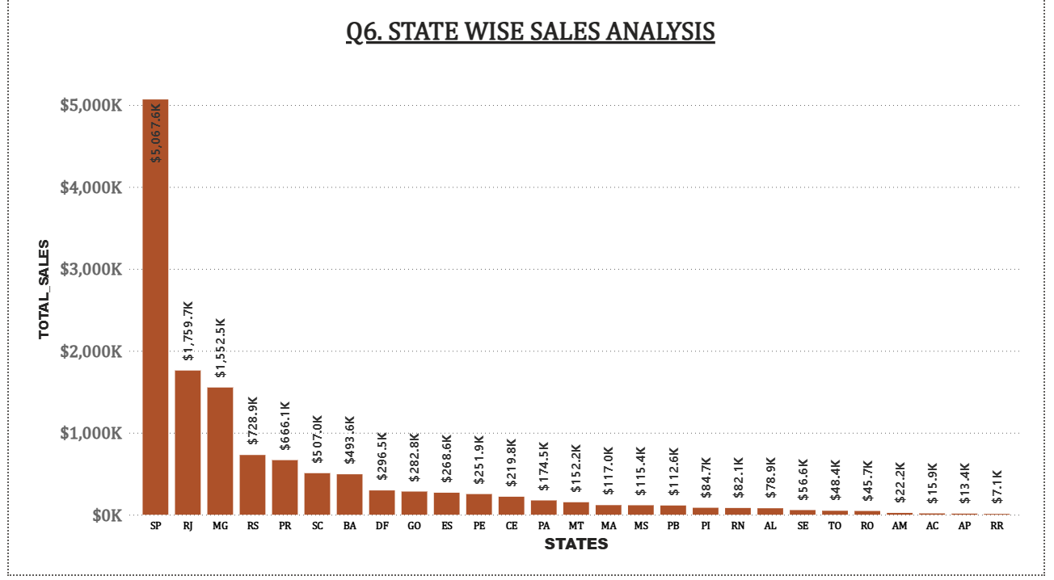

Explanation:
- This bar chart ranks all Brazilian states by total sales, from highest to lowest, based on the customer's state on each order.
- São Paulo (SP) is by far the highest-performing state, generating $5,067.6K in total sales — nearly three times the next closest state, Rio de Janeiro (RJ) at $1,759.7K. Minas Gerais (MG) follows at $1,552.5K.
- Top three states represent the core of ShopNest Store's customer base, consistent with them being Brazil's most populous and economically active states.
- At the opposite end, states such as Amapa (AP) and Roraima (RR) show minimal sales, at $13.4K and $7.1K respectively — reflecting these states' small, remote populations rather than any operational shortfall. This regional concentration suggests that logistics and marketing investment concentrated in the Southeast region (SP, RJ, MG) would yield the strongest returns, while the lowest-performing states may not justify significant dedicated investment given their market size.

Question 7: Seasonal Sales Patterns
Question Statement:
Investigate and visualize any seasonal patterns (Quarterly) or trends in sales data over the course of the year.
Visualization:
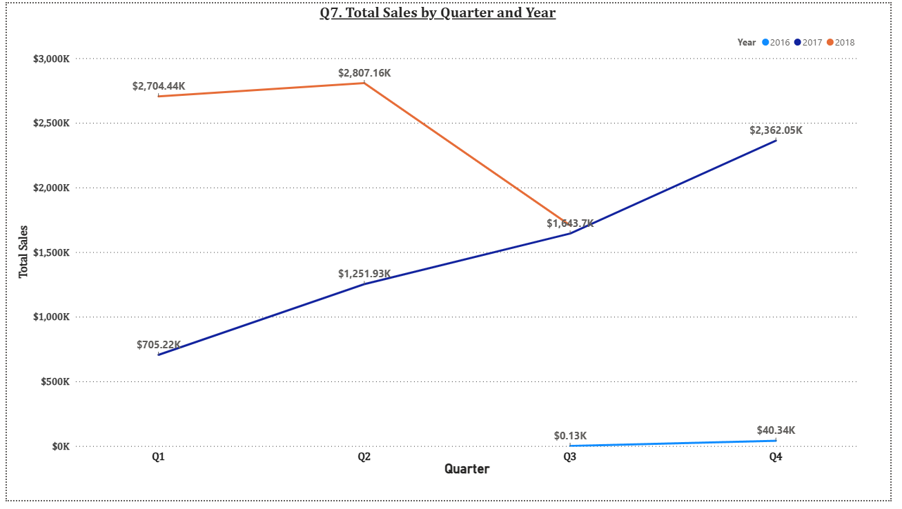
Explanation:
- This line chart tracks total sales by quarter, with a separate line for each year (2016, 2017, 2018), allowing quarter-to-quarter comparison across years to identify any repeating seasonal pattern.
- 2017 (dark blue) is the only complete year in the dataset and shows a clear, steady upward trend across all four quarters, from $705.22K in Q1 to $2,362.05K in Q4 — a genuine within-year growth trend rather than a seasonal dip-and-recover pattern.
- 2016 (light blue) only contains data from Q3-Q4, and 2018 (orange) only contains data through Q3, both reflecting the actual boundaries of the source dataset rather than a data quality issue. Because only one full year (2017) is available, a definitive repeating seasonal pattern (e.g., a consistent Q4 holiday spike across multiple years) cannot be confirmed from this dataset.
- What the data does clearly show is an overall growth trend in sales from late 2016 through mid-2018, which is the trend component explicitly permitted by the question's "or trends" wording.

Question 8: Revenue Analysis
Question Statement:
Determine the total revenue generated by ShopNest Store and analyze how it changes over time (Yearly). Represent this information through suitable visuals to highlight trends and patterns.
Visualization:
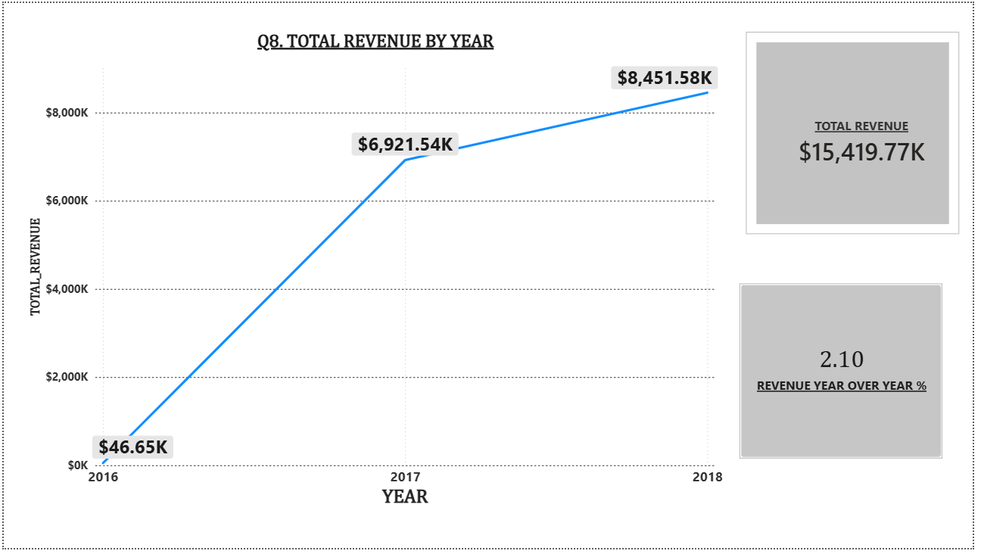
Explanation:
Total revenue (defined as total product sales plus freight/shipping charges) generated by ShopNest Store across the full dataset is $15,419.77K (approximately R$15.42 million), shown in the summary card alongside the yearly trend line.
Broken down by year, revenue grew from just $46.65K in 2016 (a partial year, covering only September-December) to $6,921.54K in 2017 (the only complete year in the dataset), and further to $8,451.58K in 2018 — though 2018 data only extends through August, so this figure represents roughly eight months rather than a full year.
Because 2018 is a partial year, the revenue already recorded ($8,451.58K) exceeding the full 12 months of 2017 ($6,921.54K) is a strong positive signal for the business, even though it should not be read as a simple year-over-year percentage without accounting for the incomplete year. This consistent upward trajectory across all three years indicates strong, sustained business growth for ShopNest Store over the period covered by the dataset.

Conclusion
The ShopNest Store Power BI dashboard successfully addresses all eight required business analysis questions through a combination of bar charts, column charts, line charts, a pie chart, and an interactive table, all consolidated onto a single dashboard page with supporting KPI cards, slicers, and a drill through page.
Key overall findings include: Health_Beauty, Watches_Gifts, and Bed_Bath_Table are the strongest-selling categories; Sao Paulo (SP) dominates regional sales; Credit_Card is the overwhelmingly preferred payment method; and the business shows strong, consistent revenue growth from 2016 through 2018, reaching a total of $15.42 million in revenue across the dataset's timeframe.

