Autoencoder for MNIST
1. Task Description
This research focuses on developing and training a convolutional autoencoder to learn a compressed, low-dimensional representation (latent space) of the MNIST handwritten digit dataset. Autoencoders are artificial neural networks that learn to recreate their input. It has two major parts:
- An encoder that transforms the input data into a latent space.
- A decoder that converts the latent space representation back to the original data space in order to recover the input.

For the MNIST dataset, the autoencoder takes a 28x28 grayscale digit picture, compresses it into a smaller, meaningful 32-dimensional numerical vector (the latent vector), and then decompresses it back into an image that is quite similar to the original. This technique encourages the network to learn key characteristics and patterns within the digits, resulting in effective unsupervised feature learning and dimensionality reduction. Following reconstruction, the learnt latent space is examined to better understand how the network organizes and displays the digit input.

2. Architecture: Building the Encoder-Decoder Pipeline
The autoencoder's concept is implemented in PyTorch as a neural network module with convolutional and linear layers carefully placed to handle picture data. It has a symmetric "hourglass" shape, with the encoder gradually downsampling and the decoder gradually increasing.
2.1. Encoder: Compressing the Visual Information
The encoder converts an image's raw pixel data into a dense, numerical latent vector. It employs a series of convolutional layers, followed by flattening and a linear layer.

- Input Image (1x28x28): The technique begins with a single-channel (grayscale) image of 28 pixels by 28 pixels.
- nn.Conv2d(in_channels=1, out_channels=16, kernel_size=3, stride=2, padding=1):
  - Purpose: This is the initial convolutional layer. Its purpose is to extract low-level features (such as edges and corners) from the input image.
  - in_channels=1: It accepts a single grayscale channel as input.
  - out_channels=16: It creates 16 separate feature maps.
  - kernel_size=3: The sliding window (filter) measures 3x3 pixels.
  - stride=2: The filter moves two pixels at a time, reducing spatial dimensions in half.
  - padding=1: Adds a one-pixel border to assist preserve edge information.
  - Output Dimensions: The 1x28x28 image is converted into a 16x14x14 feature map.
- nn.ReLU() :
  - Purpose: An activation function that is applied to each element. It introduces a nonlinearity.
- nn.Conv2d(in_channels=16, out_channels=32, kernel_size=3, stride=2, padding=1):
  - Purpose: This second convolutional layer learns more advanced characteristics.
  - in_channels=16: It takes 16 feature maps as input.
  - out_channels=32: Creates 32 new feature maps.
  - stride=2: This again reduces the feature map to half its original size.
  - Output Dimensions: The 16x14x14 feature map expands to a 32x7x7 feature map.
- nn.ReLU(): Another ReLU activation to account for nonlinearity.
- nn.Flatten():
  - Purpose: The 3D feature map (32 channels, 7 heights, and 7 widths) is converted to a single 1D vector.
  - Output Dimensions: The 32x7x7 feature map is flattened into a vector with dimensions 32 * 7 * 7 = 1568.
- nn.Linear(32 * 7 * 7, self.code_size):
  - Purpose : This layer reduces the high-dimensional features from the convolutional layers to a compact, low-dimensional latent vector. It acts as the "bottleneck" in the autoencoder design, limiting the quantity of data sent from the encoder to the decoder. This limitation requires the network to develop meaningful and efficient representations.
2.2. Decoder: Reconstructing from the Compressed Code
The decoder takes the latent vector and tries to reverse the encoding process, reconstructing the original image. It employs linear layers and transposed convolutional layers.
- nn.Linear(32 * 7 * 7, self.code_size):
  - Purpose: This linear layer returns the latent vector to the size required to create a 3D feature map (1568 items).
- nn.ReLU(): Activation function.
- nn.Unflatten(dim=1, unflattened_size=(32, 7, 7)):
  - Purpose: This is the inverse of flatten(). It converts a 1D vector with 1568 elements back into a 3D feature map.
  - Output Dimensions: A 32x7x7 feature map.
- nn.ConvTranspose2d(in_channels=32, out_channels=16, kernel_size=3, stride=2, padding=1, output_padding=1):
  - Purpose: This is the first transposed convolutional layer, which is responsible for upsampling.
  - in_channels=32: Takes all 32 channels.
  - out_channels=16: creates 16 new feature maps.
  - stride=2: The feature map is upscaled by a factor of 2.
  - output_padding=1: Ensures that the output dimensions precisely match the desired upsampled size (14x14).
  - Output Dimensions: A 16x14x14 feature map.
- nn.ReLU(): Activation function.
- nn.ConvTranspose2d(in_channels=16, out_channels=1, kernel_size=3, stride=2, padding=1, output_padding=1):
  - Purpose: The last transposed convolutional layer. It returns the feature map to its original image dimensions by upsampling.
  - in_channels=16: Takes the 16 feature maps.
  - out_channels=1: Creates a single channel (grayscale reconstructed image).
  - stride=2: Upsamples to 28x28.
  - output_padding=1: Ensures that the output size is precisely 28x28.
  - Output Dimensions: A 1x28x28 reconstructed picture.
- nn.Tanh():
  - Purpose: This is the ultimate activation function. Tanh compresses its input values to the range [-1,1]. This is crucial because our input photographs were adjusted to exactly this range.
This symmetrical design is highly effective for image data.

3. Training Strategy
The autoencoder was trained using a normal supervised learning paradigm in which the input is used to generate the desired output.
- Dataset Preparation:
  - The MNIST dataset was loaded via torchvision.datasets.MNIST.
  - The images were changed using transforms. ToTensor() translates to PyTorch tensors and transformations. Normalize((0.5,), (0.5,)) (sets the pixel values to [-1, 1]). This normalization matches the Tanh activation in the decoder.
  - DataLoader instances were created for both training (shuffle=True, batch_size=64) and testing (64).
- Device Allocation: The model and data were sent to the available computational device (cuda if available, otherwise CPU).
- Loss Function: Mean Squared Error (MSE) Loss (nn.MSELoss()) was selected.
- Optimizer: The Adam optimizer (torch.optim.Adam) was used, with a learning rate (lr) of 1e-3 (opt_step_size).
- Training Loop:
  - The training comprised of epoch_total (20) iterations.
  - The model was trained in each epoch using the train() mode.
  - For each batch:
      - Images were transferred to the device_type.
      - A forward pass resulted in rebuilt images.
      - The MSE loss was calculated.
      - Optimizer gradients were zeroed using optimizer_engine.zero_grad().
      - Gradients were computed by a backward pass using batch_loss.backward().
      - The optimizer updated the weights (optimizer_engine.step()).
  - The batch loss was accumulated.
  - Progression was printed every 100 batches and at the conclusion of each era.
- Loss Visualization: The average training loss per epoch was measured and graphed.
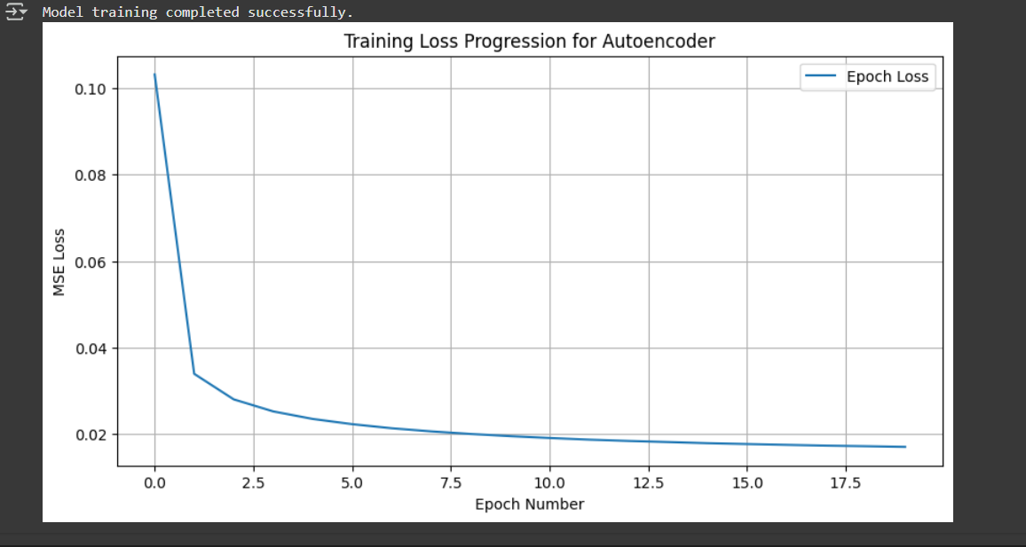
4. Performance
The performance of the autoencoder was assessed both quantitatively and qualitatively.
Quantitative Performance:
- Training Loss: The training loss curve decreased consistently during the 20 epochs. The average training loss converged to roughly 0.0170
- Test Reconstruction Loss: After training, the model was evaluated on an unknown test dataset. The average test reconstruction loss was 0.0171, which is very low and close to training loss, indicating high generalization.

Qualitative Performance:
- Image Reconstruction Quality:
  - Visual comparison of reconstructed images with originals showed good consistency. The autoencoder accurately recreated the distinguishing characteristics of handwritten digits.
  - The reconstructed versions maintained fundamental properties, indicating successful information capture.
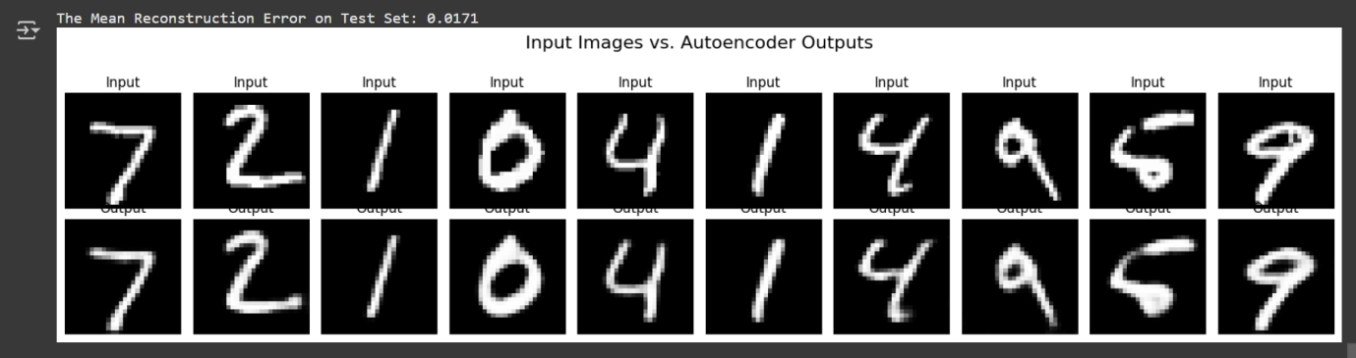
- Latent Space Analysis:
  - t-SNE Visualization: A t-SNE plot of latent vectors derived from a subset of the test dataset revealed that the autoencoder successfully arranged the digits in the latent space. Clusters belonging to different digit classes (0-9) were visible, indicating that the latent space is semantically meaningful and that the autoencoder instinctively learned to distinguish between multiple digit categories, even without explicit class labels during training. Digits from the same class tend to gather together, whereas digits from different classes are typically separated, indicating good feature extraction.
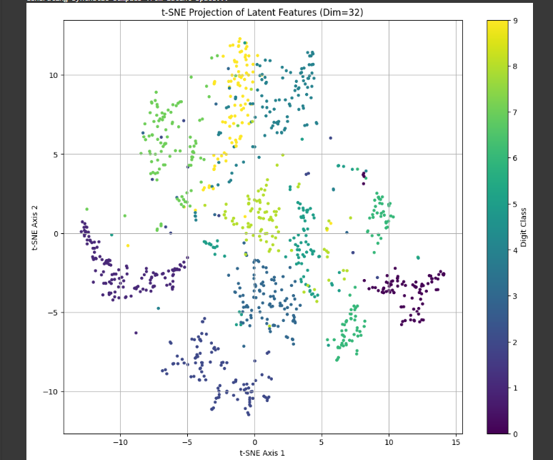
  - Generation from Random Latent Vectors: Because the compressed_vector_size (32) is less than or equal to 64, the notebook generated images by decoding random latent vectors (sampled using the mean and standard deviation of the learnt latent distribution). The created images contained recognized digit-like patterns, demonstrating the autoencoder's capacity to capture the underlying data distribution and produce fresh examples.

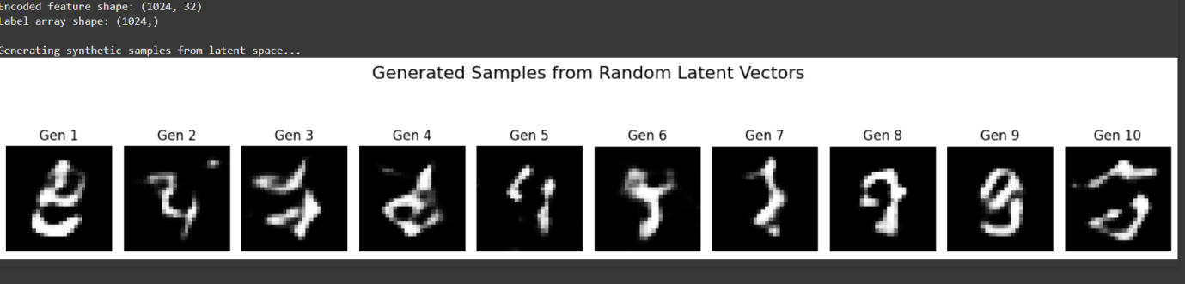

Conclusion
In conclusion, the autoencoder performed well in learning a compact representation of MNIST digits. It had minimal reconstruction error on both the training (0.0170) and test (0.0171) sets, created high-quality reconstructed images, and displayed the ability to generate convincing digit-like representations from its learned latent space. The commented-out t-SNE portion indicates that explicit display of latent space clustering was not included in this execution's output.
Refrences
Lecture notes and lab- week 6
Lecture notes and lab- week 5
Stackoverflow

