Book Store Management System
Database Design Document
By S.Sanjana (E25AI141)
(Bsc. Computer Science with AI)

Introduction:
The Bookstore Management System is a database-driven application designed to automate the operations of a bookstore. The system enables customers to browse, search, and purchase books, track their orders, record payments, and maintain personalized reading shelves. On the administrative side, it allows staff to manage book inventory, monitor stock levels, and generate sales reports.
This document presents the first-week deliverable of the project, describing the system's core objectives, functional scope, and the underlying database design, including the Entity-Relationship (ER) model, entity attributes, and relationships between entities.

Objective:
The primary objective of the Bookstore Management System is to design and implement a reliable, well-structured database that supports the complete lifecycle of bookstore operations — from customer registration to order fulfillment and reporting. Specific objectives include:
- To provide a secure and convenient platform for customers to register, log in, and manage their accounts.
- To maintain a comprehensive catalog of books with details such as author, category, and ISBN.
- To enable customers to search, filter, and locate books easily based on multiple criteria.
- To support a shopping cart and order placement mechanism with order status tracking.
- To accurately record payments and update stock levels automatically after each purchase.
- To allow customers to review books and organize their reading through personal shelves.

Functions Used:
The system supports the following core functions and operations on the data:
- Customer registration and login — creating and authenticating customer accounts.
- Book details management — adding, updating, and removing book records in the catalog.
- Search books by title, author, category, or ISBN.
- Add books to cart — temporary selection of books before checkout.
- Place orders and track order status — from order creation through delivery.
- Payment recording — capturing payment details against each order.
- Stock and inventory update — automatic adjustment of stock quantity after a purchase.
- Admin reports — generating reports such as total sales and low-stock book alerts.
- Add and view book reviews — customers can rate and comment on books.
- Maintain private reading shelves — categorizing books as Interested in Reading, Currently Reading, Completed, or Need to Read.

ER Model / Diagram Used:
The Entity-Relationship model for the Bookstore Management System consists of nine core entities: Customer, Book, Author, Category, Order, Order_Item, Payment, Review, and Reading_List (Shelf). The Order_Item entity acts as an associative (junction) entity resolving the many-to-many relationship between Order and Book. The diagram below illustrates the entities and their relationshpis.

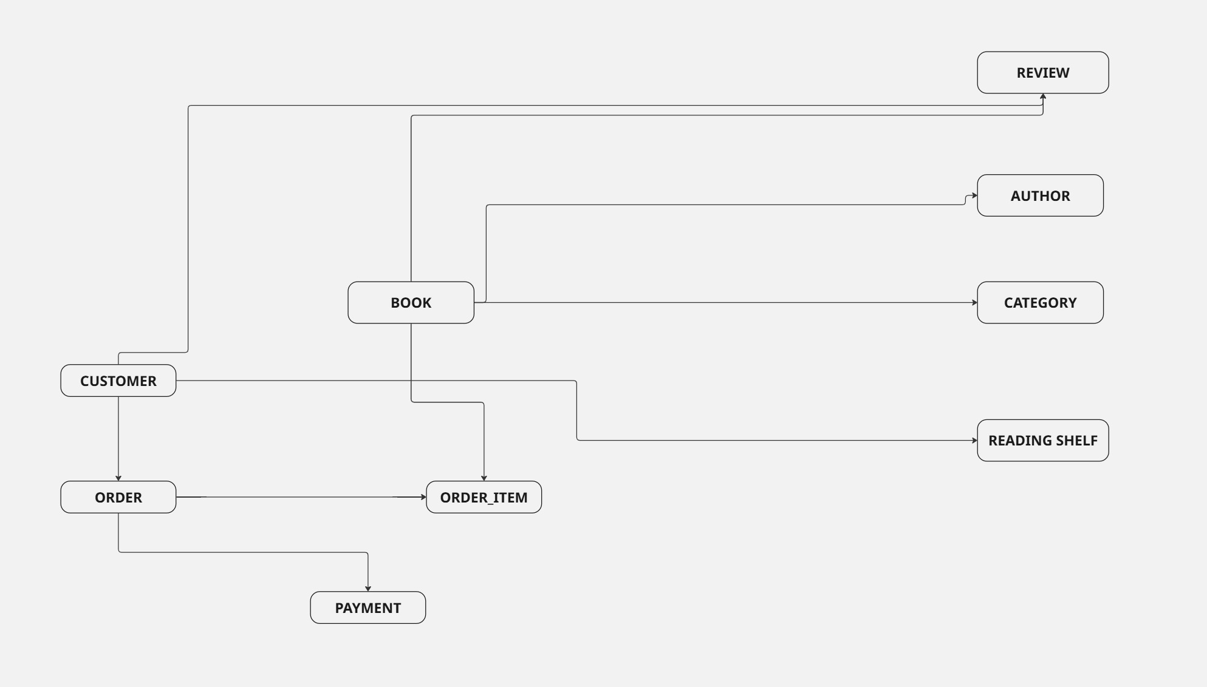

Attributes Used:
Customer:
Attribute | Description
Customer_ID (PK) | Unique identifier for each customer
Name | Full name of the customer
Email | Customer's email address, used for login
Phone | Contact number
Address | Delivery/billing address
Password | Encrypted login credential

Book:
Attribute | Description
Book_ID (PK) | Unique identifier for each book
Title | Title of the book
Author | Author name (linked to Author entity)
ISBN | International Standard Book Number
Category_ID (FK) | Reference to the book's category
Publisher | Publishing house name
Price | Selling price of the book
Stock_Quantity | Number of copies available in stock
Description | Short summary or blurb of the book

Author:
Attribute | Description
Author_ID (PK) | Unique identifier for each author
Author_Name | Full name of the author
Biography | Short biography of the author

Category:
Attribute | Description
Category_ID (PK) | Unique identifier for each category
Category_Name | Name of the book category, e.g. Fiction, Non-Fiction

Order:
Attribute | Description
Order_ID (PK) | Unique identifier for each order
Customer_ID (FK) | Reference to the customer who placed the order
Order_Date | Date the order was placed
Total_Amount | Total value of the order
Order_Status | Current status, e.g. Pending, Shipped, Delivered
Order_Item_ID (PK) | Unique identifier for each order line item
Order_ID (FK) | Reference to the parent order
Book_ID (FK) | Reference to the purchased book
Quantity | Number of copies of the book ordered
Unit_Price | Price of the book at the time of order

Payment:
Attribute | Description
Payment_ID (PK) | Unique identifier for each payment
Order_ID (FK) | Reference to the associated order
Payment_Date | Date the payment was made
Amount | Amount paid
Payment_Method | Mode of payment, e.g. Card, UPI, Cash on Delivery
Payment_Status | Status of the payment, e.g. Success, Pending, Failed

Review:
Attribute | Description
Review_ID (PK) | Unique identifier for each review
Customer_ID (FK) | Reference to the customer who wrote the review
Book_ID (FK) | Reference to the reviewed book
Rating | Numeric rating given to the book
Comment | Textual review comment
Review_Date | Date the review was submitted

Reading Shelf:
Attribute | Description
Shelf_ID (PK) | Unique identifier for each shelf entry
Customer_ID (FK) | Reference to the customer who owns the shelf entry
Book_ID (FK) | Reference to the book added to the shelf
Shelf_Status | Status such as Interested in Reading, Currently Reading, Completed, Need to Read
Added_Date | Date the book was added to the shelf

Relationships Used:
The relationships between entities capture how data in the Bookstore Management System is connected. The table below summarizes each relationship along with its cardinality.

Relationship | Cardinality | Description
Customer places Order | 1 : N | A customer can place many orders; each order belongs to one customer.
Order contains Book | M : N (via Order_Item) | An order can contain many books, and a book can appear in many orders. Resolved through the Order_Item associative entity.
Book belongs to Category | N : 1 | Each book belongs to one category; a category can have many books.
Book has Review | 1 : N | A book can receive many reviews; each review is for one book.
Customer writes Review | 1 : N | A customer can write many reviews; each review is written by one customer.
Customer maintains Reading_List / Shelf | 1 : N | A customer can have many books across their reading shelves.
Book appears in Reading_List / Shelf | 1 : N | A book can appear in many customers' reading shelves.
Order has Payment | 1 : 1 | Each order is associated with one payment record.

Conclusion:
The Bookstore Management System's database design provides a solid foundation for managing customers, books, orders, payments, reviews, and personalized reading shelves. By organizing data into well-defined entities with clear relationships — including the use of an associative entity to resolve the many-to-many relationship between orders and books — the design ensures data integrity, avoids redundancy, and supports efficient retrieval of information.
This first-week document establishes the conceptual groundwork for the project. Subsequent phases will build on this ER model to develop the logical schema, physical database, and the application layer that implements the functions described above, such as book search, cart management, order tracking, and administrative reporting.

