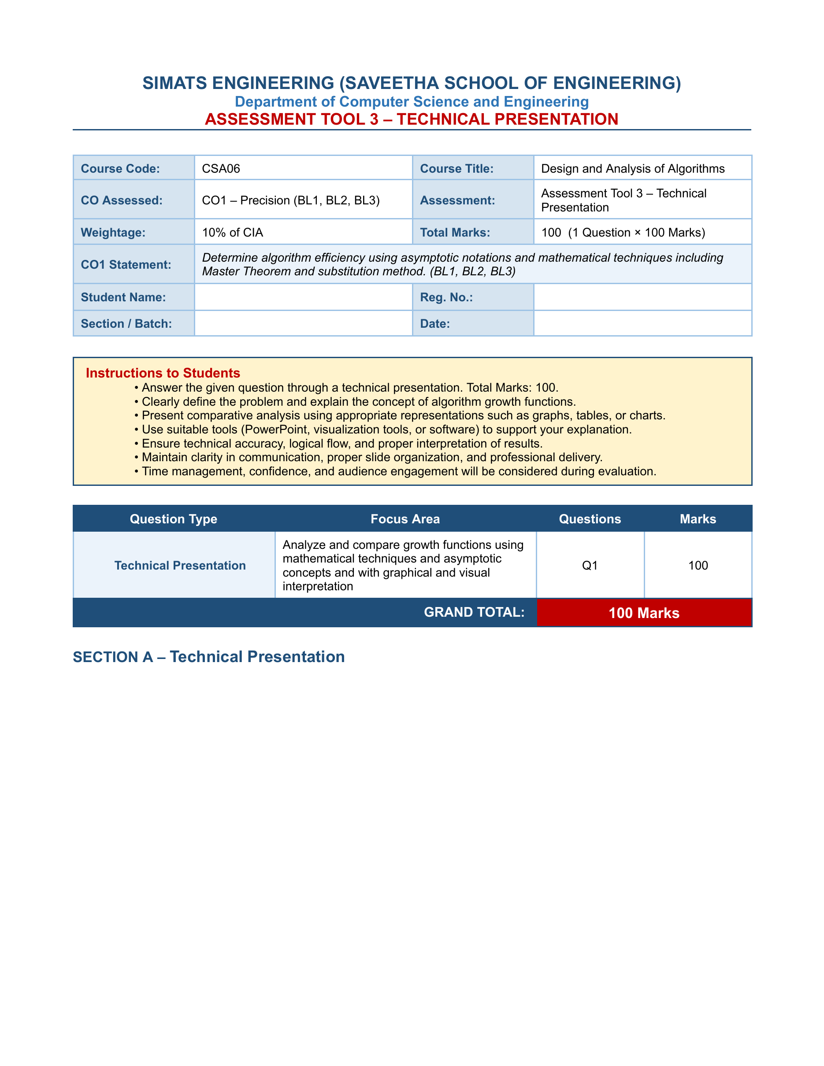

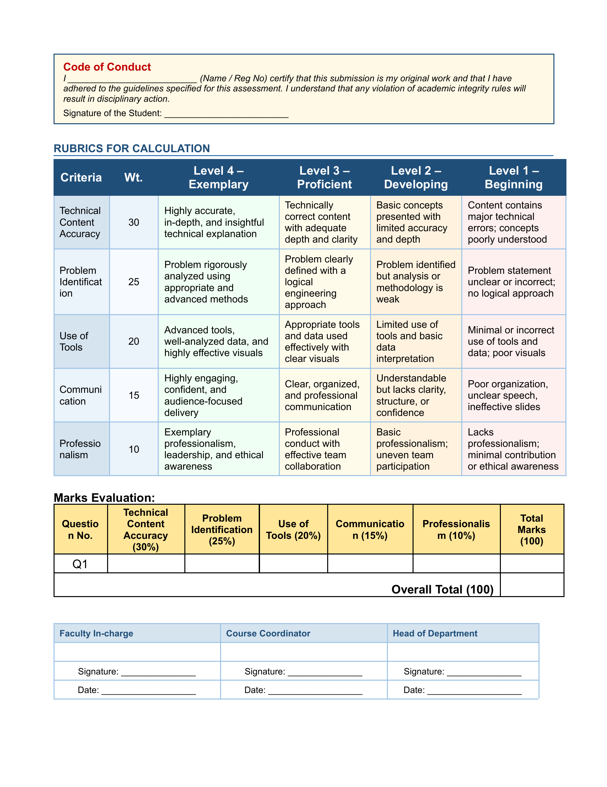

SIMATS ENGINEERING
ASSESSMENT TOOL 3 - TECHNICAL PRESENTATION
ASSIGNED QUESTION NO. 37
Space Complexity of Recursive vs Iterative Methods
Compare space complexity of recursive and iterative approaches for a problem. Clearly define stack usage and memory requirements. Apply asymptotic notation for both methods. Use diagrams to represent memory usage. Interpret trade-offs and justify preferred approach.
TECHNICAL PRESENTATION - PHOTOGRAPH
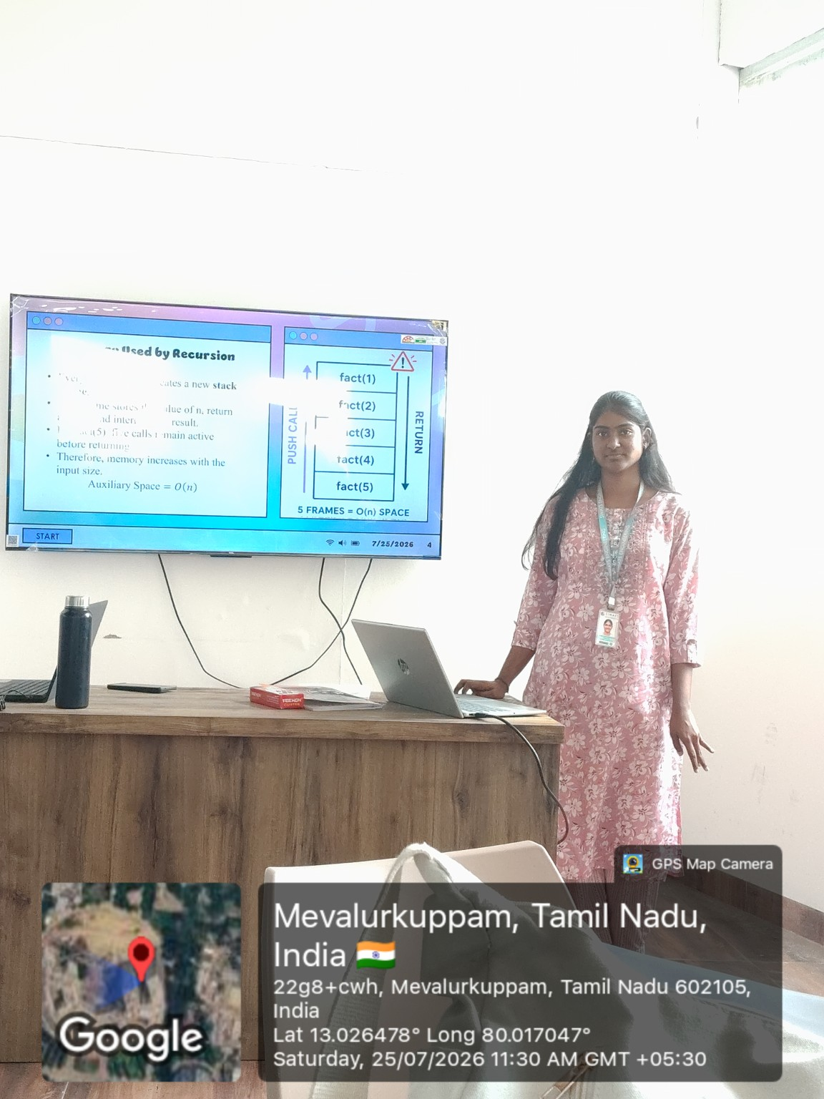
V Sanjana | Register No. 192571005 | 25-07-2026

