**Clouds, Grids and Virtualization**

**Cloud Computing Coursework**

**Name: Sanjana Prakash**

**Student ID: 001200662**

**Date: 30-November-2022**

**Course Leader: Dr Catherine Tonry**

Table of Contents

Parallel processing using cloud computing 3

Introduction and Benefits 3

Comparison 5

Cost Analysis 9

Recommendation 11

Reference: 12

# Parallel processing using cloud computing

## Introduction and Benefits to cloud computing

**Understanding cloud computing:**

Conventionally, if the companies had to develop any application, then they had to gather a plethora of hardware, namely servers, firewalls, operating systems with licenses, routers, databases, switches, and a lot more. By this, we can understand that there is a lot of capital investment which should be made to gather the hardware. In addition to this, investment must be made to maintain this hardware, namely human or manpower payroll, electricity, heating, ventilation, and investment in licenses. These are nothing but the operational costs.

With conventional computing, the CAPEx and OPEx are sky high. The mid ranged companies or startups are too from the scope to sink money onto the plethora of hardware and licenses.

The best option is to opt for cloud computing where they can run all the resources. They can position the resources namely storage, servers, software’s, databases, AI and the respective analytics to cloud. Cloud is a massive data center which is generally maintained by cloud providers like Amazon, Microsoft and even google. They ensure the flexibility of the resources by which you can easily scale the instances as and when required. They also keep an eye on the quickest possible way of delivery of resources.

By the usage of cloud, the CAPEx and OPEx will decrease exponentially as when only must pay for the services consumed.

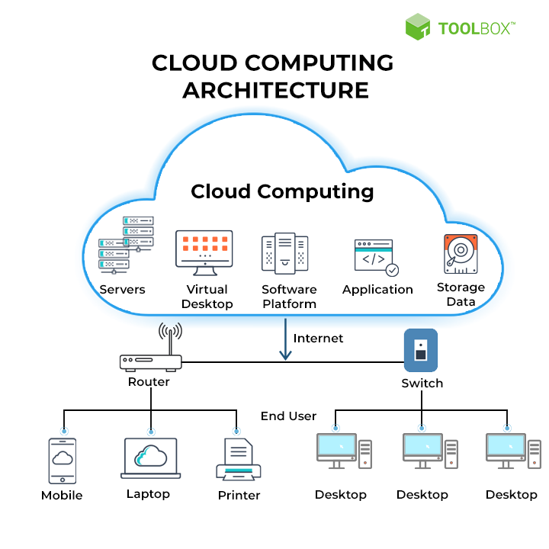

**Benefits:**

1. Cost Effective

* The cloud infrastructure can be scaled based on one’s requirement and can pay only for the used resources. It’s like paying as you use services. It is also termed as consumption based paying model as there is no need to pay any cost in advance for the hardware of computing resources. It is more like hardware renting.
* One need not invest and manage the infrastructure which is expensive.
* It offers the flexibility to pay for auxiliary resources when they are really required.
* One can eliminate the burden of paying for resources when not in use.
* Cloud computing also helps in prediction of cost. The cost of discrete resources and services is intimated. So, you can foretell the expenditure in the given billing period for your expected usage.

1. Scalability and Elasticity

* One can escalate or diminish the resources or services depending on demand.
* In on-premises, if we need to maintain the scalability of our infrastructure, then we need to acquire plenty of infrastructure.
* In cloud, scalability is done on demand

Types:

**Horizontal Scaling**

* Process of incrementing servers consecutively as single business unit.

Let’s look at an example.

Consider an e-commerce website. It will have a clump of webservers behind the load balancer. Normally, the webservers will be managing loads from the production environment, current traffic.

Let’s assume there is a black Friday sale going on. It will result in inflation in traffic swiftly. Since the cloud is elastic in nature the provider will allocate more instances to handle the traffic and when traffic begins to normalize the provider deallocates the additional resources to minimize the cost.

**Vertical Scaling**

* Incrementing resources to the set of servers which already exist is called vertical scaling.
* Consider if we have 4 GB of memory but you need to upgrade the memory. Then you can spike up to 6 GB. So, you are making the server which already exists more powerful.

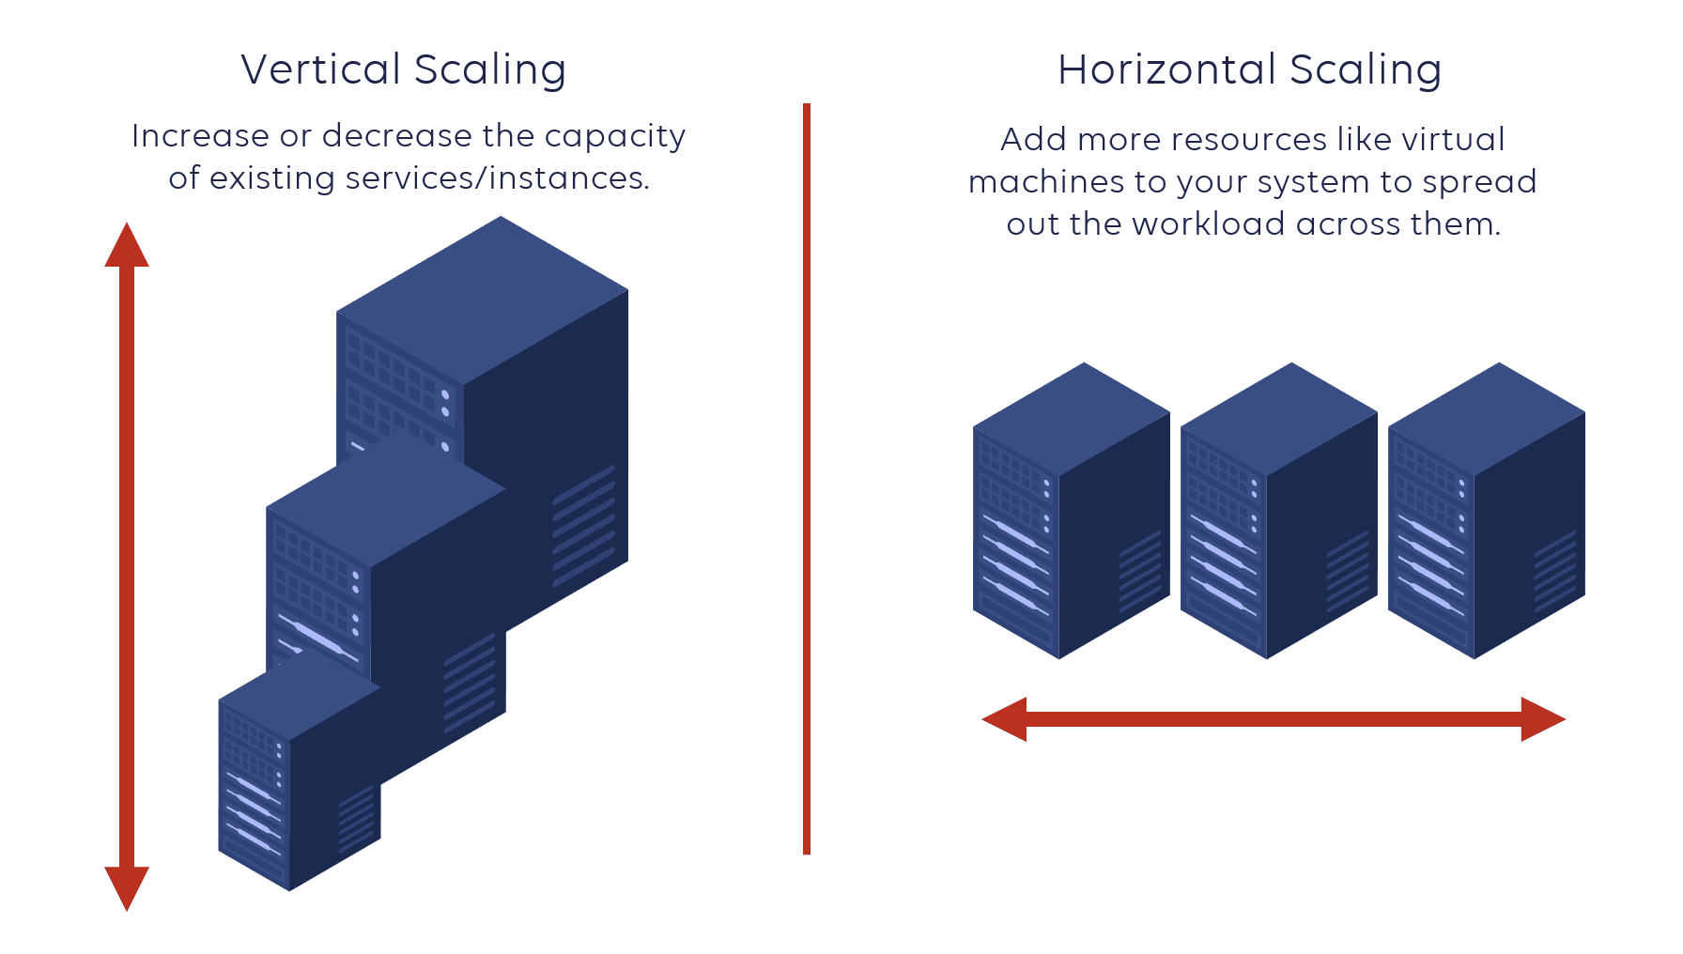

1. Cloud is current/updated

* When we use clouds, we can focus on the things that matter like developing and deploying implementation and concentrate on business.
* Cloud eradicates the trouble of you having to shield and perpetuate the software’s, hardware’s, and other IT management tasks.
* The hardware of cloud is perpetuated and enhanced by the cloud providers.

Example, if component of hardware on rack fails, then it is responsibility of cloud providers to fix it.

* If new hardware/firmware becomes available, you do not have to go through the hassle of upgrading.
* Ensure any updates in either hardware or software is made accessible to you instantly.

1. Reliability

* An entrepreneur always wants his data to be safe and available i.e., the providers of cloud maintain the availability.
* The cloud vendor provides backup of data, disaster recovery and duplication of services to set seal that the data is secure.
* In addition, superfluity is built into the architecture of clouds.
* So, if a component fails, the other component takes its position. It’s called fault tolerance.
* It guarantees that there is no impact on the customers when there is any disaster.
* Disaster recovery, fault tolerance, backups and availability are some of the crucial features offered by the cloud.

1. Cloud is Universal

* Providers of cloud services have data centers which are completely redundant. They are spread across worldwide which are termed as region.
* This gives cloud a footprint which is geographical for the customer so that they feel their applications are running locally and this ensures there will be no delay in the response time even if they are present at any part of the world.
* One can clone the services into various regions for locality and redundancy and have least latency.
* one can mention a particular region to make sure they reach residency of data and compliance loss for the clients.

1. Security

* Considering the security of physical components, the cloud vendors take care of the infra by heavily guarded walls, CCTVs, pylons, and security persons to make sure the physical components are in safe hands.
* They follow strict protocols to guarantee colleagues have access to only specific resources which are authorized to handle.
* One can also be aware that digital security is present.
* One of the unique things about clouds is that you lease, compute and store the resources from a pool which is shared, and data can travel in multiple ways like within and between the data centers and through the internet.
* Cloud providers offer tools to mitigate security threads.

## Comparison

**Cloud Computing**

Pros:

* Installation of the software’s required by cloud computing involves less investment. Business only must pay for the cycle of subscription. The rest is handled by the system. By the usage of cloud computing, one can stamp out the fuss created by maintenance of malfunctioning infrastructure which might lead to loss of data or theft of data.
* With the help of infrastructure of cloud, it provides an opportunity for the admins to either add or remove capacity as per the need. There will be no wastage of ability this way.
* The installation is quite effortless. The deployment is very straightforward in cloud computing. It can be set up within an hour. One can get assistance from a well-trained expert of the cloud service provider for the deployments as it can be achieved in blink of an eye.
* One can invest the time in solving technical issues rather than in maintenance of infrastructure. Since the service providers manage the storage of cloud, it eradicates the need for investing time in the installation of few patches and updating.
* Models of cloud computing detach capacity, computing and arrange assets from the actual hardware resources. By doing so, conventional framework extracts the specialized framework administration and skill required. It moreover gives unique specialized organization for prophylactics. It also conveys specialized protection of cloud devices to handle controls, powerlessness appraisal and firewalls.

Cons

* The service portfolios must be frequently expanded by the cloud providers. It gets complex in selecting, executing, and supervising the cloud services, if your company’s need is more advanced.
* If one is not careful, they might accidentally make use of more services than what was planned which is not very friendly on the pocket.
* Since cloud computing is completely dependent on clouds, one might be troubled on access to the crucial document. The operations of the business might get delayed if one loses access to the important documents at the time of outage of connection which results in a decrease in productivity of the employee.
* After you entrust operations of business to a cloud vendor, you cede control over security. Though cloud suppliers brag about amazing uptime, seldom the services go down. The smallest interruptions might also cause rudimental issues for customers.

**Traditional HPC**

Pros

* The hardware and systems that reinforce the IT infrastructure are owned by your company. It has control of access allocation, execution, and lifespan.
* The operations can be done even without the usage of the internet. Since most companies depend on broadband for the execution of operations, they have a constant trauma of getting deprived of the connection which might affect the productivity and losing access to confidential information. By using In-house HPC, the network internally makes it easier to access without the need for internet.
* When we think of long term, the in-house infrastructure costs reasonably lower than cloud for applications with usage patterns which are predictable. Once the investment is made in hardware, then the only cost involved would be for electricity and assistance.
* There might not be many external dependencies. Hence, the in-house software has low discontinuation.

Cons

* The infrastructure of the organization depends on maintenance and assistance. To ensure the smooth running of hardware and software, one needs to hire a well-trained team.
* If your organization invests in purchasing a lot of servers, the infra demands ebb, which results in not utilizing the capacity of the machine to the max. Purchasing more servers to fulfil an uphill in demand is not termed as cost efficient.
* The maintenance and safety of hardware components in-house is the duty of the IT team. The cost of maintenance is never reduced.
* Having a settled set of preface servers speaks to settled asset capacity. An organization should purchase additional resources when they are required. As it were a number of establishments can construct an inside foundation to coordinate the scope and adaptability of a cloud vendor’s stage and administrations.

Now, let’s compare the top cloud providers in the industry.

|  |  |  |  |
| --- | --- | --- | --- |
|  | AWS | Azure | GCP |
| History | AWS is a subordinate of Amazon. It lends a helping hand to companies, individuals and even government sectors with the on-demand platforms of cloud computing on a subscription basis which is to be paid.  It is one of the oldest players when it comes to cloud market.  Its roots go back to 2006 when it was launched publicly. It provides multiple services like EC2, Amazon S3 and many more.  By the year 2009, EBS was made available to the public. Many services such as CDN and Amazon CloudFront officially joined AWS cloud offerings. | Microsoft Azure was initially termed Azure.  The name was officially changed to Microsoft Azure in the year 2014 though people still fondly call it Azure.  It has spread its roots since 2010.  The main intention of Azure is to offer efficient cloud computing services to various businesses.  Since its establishment, it’s been one of the tough competitors among the cloud platforms | GCP is one of the popular services launched by Google. It is a collection of various services related to cloud computing.  It normally runs on the same internal framework which google uses for products like search engine, Gmail, YouTube and much more which is normally used by its end users.  GCP started its journey in 2011 and there is no look back ever since.  The initial purpose of GCP was to reinforce the services offered by google such as the search engines, YouTube etc. Now, they have made it available for the use of public as well. |
| Availability Zones | AWS has started its journey much before Azure and GCP in cloud domain, indicating plenty of time to set up and stretch their network. Hence, AWS is spread in numerous locations globally. GCP and Azure also spread their wings in plethora of sites, but the variation can be noticed in the count of the AZs. | | |
| There are 66 Availability Zones for AWS. There is going to be an addition of 12 more AZs to the family. | There are a total of 54 regions for Azure worldwide and is available around the globe in 140 countries. | There are 20 regions in which GCP is available around the globe. There will be an addition of three more regions very soon. |
| Market Growth | As per the quarterly earnings of the year 2021, Microsoft Azure stands out with a revenue that is exceeding both its competitors AWS and GCP | | |
| For the quarter, AWS reported an amount in cloud business of US $13.5 billion revenue. | According to the fiscal earnings report, Azure stood out among its peers making a revenue of US $17.7 billion revenue | The last place is taken over by GCP making a revenue of modest $4.05 billion. |

## Cost Analysis

Let us do some R&D on cost analysis to estimate the variation in cost with respect to traditional HPC and Cloud computing. Here we are comparing the costs of on-premises HPC with one of the popular cloud vendor Azure.

In this booming era of cloud technology, many companies are moving from traditional HPC to cloud computing platforms. Normally, this is considered by analyzing the pros and cons of using cloud technology, inspection of total cost of ownership (TCO), develop proof of concepts, put up the production environment which is hybrid and transfer additional workloads of stimulation to the cloud environment. The TCO inspection is generally made by comparing the cost involved in establishment’s in-house HPC over the cost of using cloud computing.

Based on our analysis, we can predict that the cost savings would be approximately as much as **£631,786.17** for the span of three years by the usage of Azure cloud.

|  |  |
| --- | --- |
| Total Investment for In-house HPC for a period of 3 years | Total Investment for Azure for a period of 3 years |
|  |  |
| The In-House TCO is influenced by the data centers and compute prices | By the usage of azure, we can eliminate few of the costs completely |

|  |  |
| --- | --- |
| Total breakdown of investment in In-House HPC | Total breakdown of investment in Azure |
|  |  |
| The estimated investment for a period of 3 years is £1,238,487 | The estimated investment for a period of 3 years is £606,701 |
| From the above, we can notice that by the usage of Azure one can minimize and isolate few of the cost categories by the benefits of the cloud. | |

Summary of the In-house HPC investment breakdown for a span of three years

|  |  |
| --- | --- |
| Type | Price |
| Networking | £130,424.00 |
| Pay for IT labor | £115,059.39 |
| Storage | £21,822.68 |
| Data Center | £68,945.30 |
| Hardware | £632,473.74 |
| Power | £40,940.71 |
| Virtualization | £105,673.50 |
| Software | £123,147.90 |
| Total | £12,38,487.22 |

Summary of the Azure investment breakdown for a span of three years

|  |  |
| --- | --- |
| Type | Price |
| Networking | £6.20 |
| Pay for IT labor | £115,059.3787 |
| Storage | £160,669.23 |
| Compute | £330,966.24 |
| Data Center | £0.00 |
| Total | £606,701.0487 |

So, from the above analysis, we can conclude that we can save around **£631,786.17** for a span of three years

## Recommendation

I recommend cloud computing, preferably Azure cloud over traditional HPC.

**Why should one choose Azure?**

Azure presents a breadth of aspects and features. The portfolio of Microsoft on cloud stands unique and unbeatable than the rest. It can run the workloads of SAP and high end HPC with great efficiency. It also presents multiple features for workloads related to ML or AI. The mobility of license for the products of Microsoft is comparatively easy. Therefore, if one already has license for SQL, windows operating system then Azure cloud is the best platform.

From the cost analysis, we can observe that we will be able to save a tremendous amount in just a span of three years by using Azure services rather than the on premise HPC. Saving an amount of almost **£631,786.17** is no child’s play**.** It’s a huge amount which can make an impact

In future, one can also consider the implementation of the multi cloud strategy.

**What do we mean by multi cloud?**

Multi cloud is nothing but usage of multiple cloud platforms in your existing approach of cloud.

**Why should one choose this approach?**

In our day to day like, many companies use various databases and various applications. Most of the vendors of cloud are specialized in an area. Usage of multiple clouds assures the company the swiftness they are looking for. For instance, you can preserve the existing applications which are highly available in one cloud solution and the confidential data which one need not access often in another solution of cloud.

**Are there any benefits?**

* **Vendor flexibility**: By the usage of multiple cloud, one can have control over the power of negotiating, emaciation, and agility. By the implementation of this strategy of risk management one can have power of their information with the required flexibility.
* **Better recovery from Disaster:** By using multi cloud, even if one of the cloud has downtime, one can access and have their data safe from the other providers.
* **Cherry pick the required Services:** There is not a single vendor who can offer best services for all the requirements. So, it is wise to tailor the services as per your requirement. One can also have a workflow which requires a dedicated service of cloud.
* **Decrement in Investment of capital:** Datacenters require a lot of infrastructure namely, hardware’s, software’s, and electricity. This in turn requires a lot of investment to be made to acquire these resources. The higher the number of resources you have, the lesser will be the free flowing capital to run the operations of business. The cloud is very optimal solution as it decreases the CAPEx

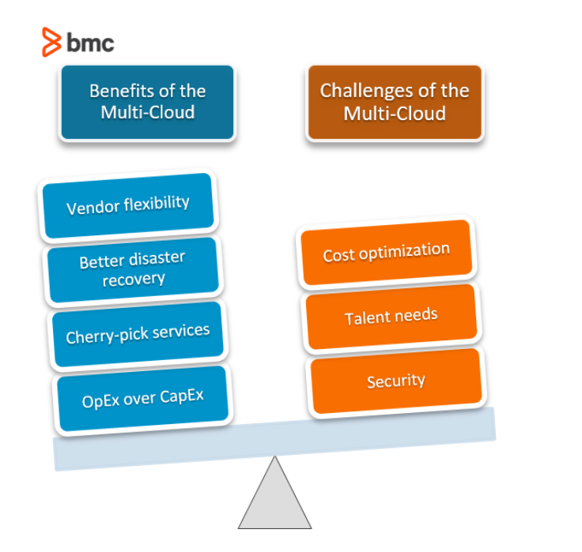

Reference:

Azure, “Total cost of ownership (TCO) Calculator” available at “<https://azure.microsoft.com/en-us/pricing/tco/calculator/>”

Codecademy, 2022, “7 benefits of cloud computing” available at “[7 Benefits of Cloud Computing (codecademy.com)](https://www.codecademy.com/resources/blog/7-benefits-of-cloud-computing/#:~:text=7%20benefits%20of%20cloud%20computing%201%201.%20Scalability,6.%20Security%20...%207%207.%20Disaster%20recovery%20)”

Dr. Gentzsch, W., 2021, “Squashing Total Cost Rumors of In-House Vs. Cloud Computing” available at “https://blog.theubercloud.com/squashing-total-cost-rumors-of-in-house-vs.-cloud-computing”

Jethva, H., 2021, “Cloud Computing vs On Premise – What’s the Difference? (Pros and Cons)” available at “<https://cloudinfrastructureservices.co.uk/cloud-computing-vs-on-premise-whats-the-difference/>”

IntelliPaat, 2020, “AWS vs Azure vs Google Cloud: Choosing the Right Cloud Platform” available at “<https://intellipaat.com/blog/aws-vs-azure-vs-google-cloud/>”

Miller, A., 2021, “The Multi-Cloud & How To Create A Multi-Cloud Strategy” available at “https://www.bmc.com/blogs/multi-cloud-strategy/”

Xue, Z., 2016, “Google Cloud Platform vs HPC“ available at “[Google Cloud Platform vs HPC (zyxue.github.io)](http://zyxue.github.io/2016/03/14/google-cloud-platform-vs-HPC.html)”