Quenched solid density functional theory and
pore size analysis of micro-mesoporous carbons.
Alexander V. Neimark^{a,*}, Yanzheng Linª, Peter I. Ravikovitch^{b}, and Matthias Thommes^{c}
ªRutgers University, Piscataway NJ 08854; ^{b}ExxonMobil Research and Engineering, Annandale, NJ 08801; ^{c} Quantachrome Instruments, Boynton Beach, FL 33426,

Supplementary Information

I. Additional figures.

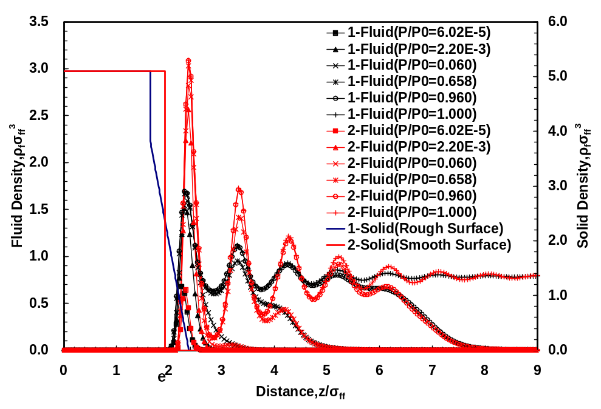
Fig. SI.1. Formation of adsorbed layers on molecularly rough surface of Cabot BP-280 carbon black for nitrogen at 77K Solid density distribution is modeled as a linear ramp, Eq. 12, with the roughness parameter 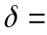0.13 nm. Fluid profiles at different relative vapor pressures (insert) show successive stages of adsorption process: filling the surface corrugations, formation of monolayer, and multilayer liquid-like film.

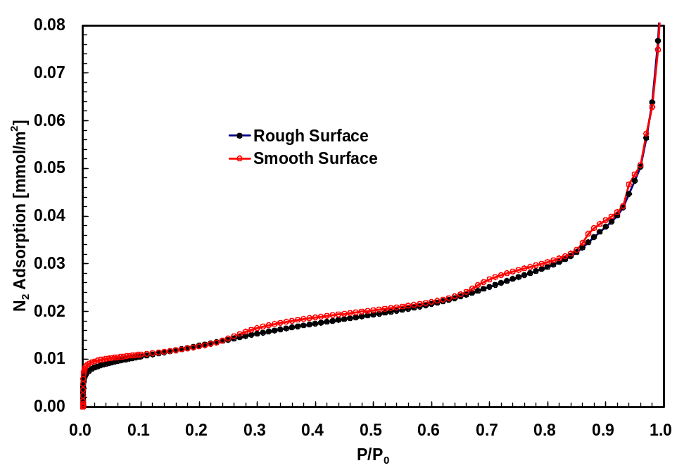

Fig. SI.2. Comparison the calculated adsorption isotherms of N₂ at 77.4K on smooth and molecularly rough (the roughness parameter 0.13 nm) surfaces, which correspond to the examples given in Fig.S1. In contrast with the isotherm on the smooth surface, which shows prominent steps associated with the layering transitions, the isotherm on the molecularly rough surface is perfectly smooth. The extend of surface roughness of less then 30% of the fluid molecular diameter is enough to level down the artificial inflections caused by the packing induced layering.

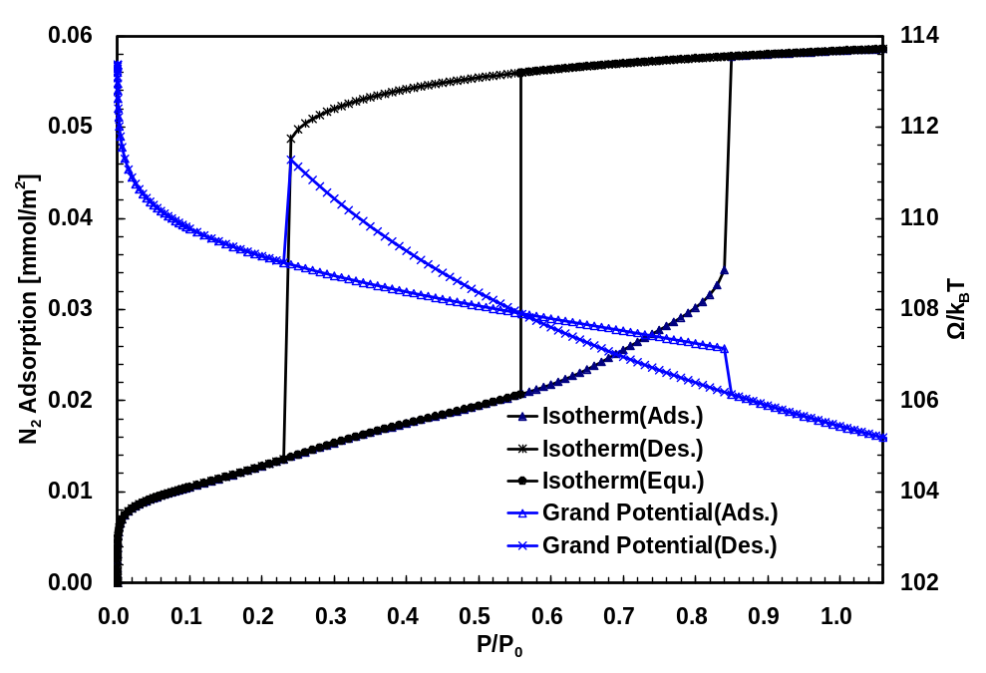
Fig. SI.3. Calculated N₂ adsorption and desorption isotherms at 77.4K in 3.9 nm mesopore. Example of calculated adsorption and desorption isotherms in a mesopore. The isotherms exhibits a hysteresis with steps-wise spontaneous capillary condensation and desorption transitions. The position of equilibrium capillary condensation is determined form the condition of equality of the grand thermodynamic potentials along adsorption and desorption branches.

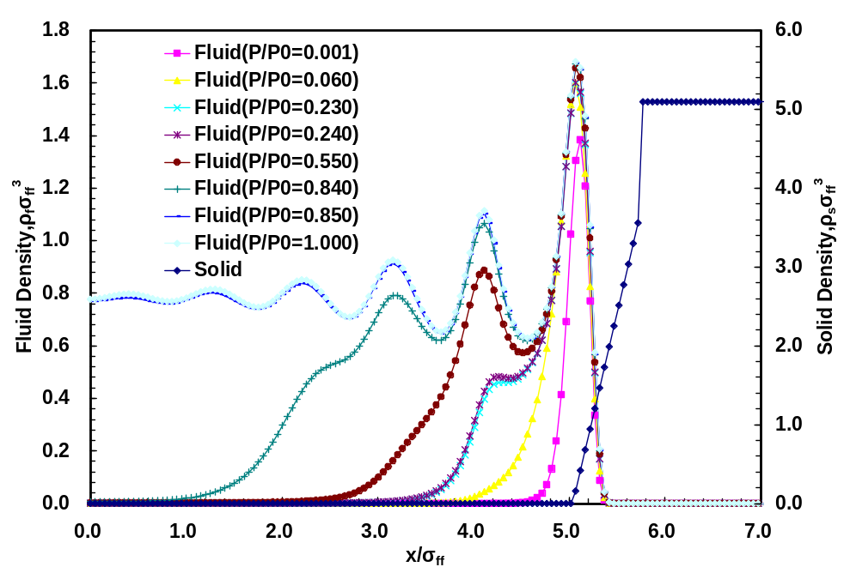
A

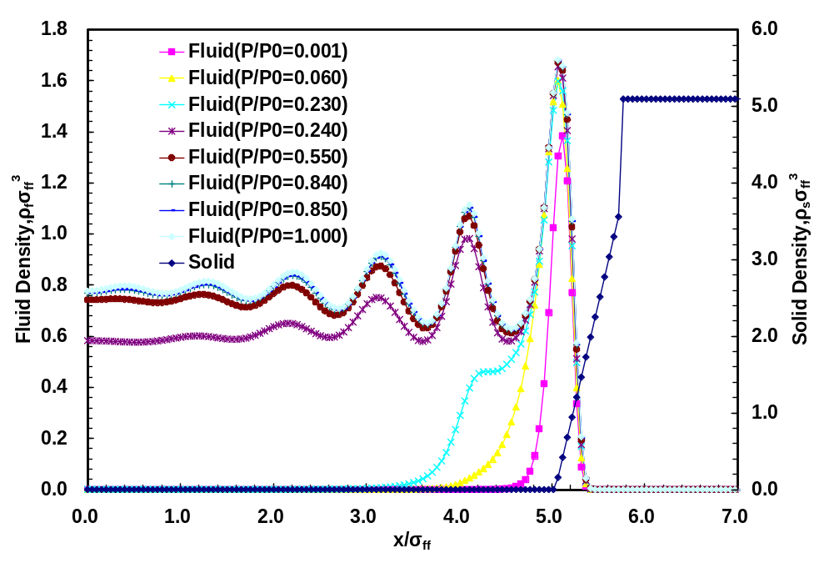
B
Figure. SI.5. Calculated density profiles for selected states along adsorption (A) and desorption (B) isotherms given in Fig.S4 (x is the distance from the pore center). The densities profiles show the formation of mono- and multilayer adsorption film prior to capillary condensation and gradual reduction of adsorbed fluid density during desorption prior to spontaneous evaporation. Note that the density profile oscillations are leveled compared to the smooth wall model.

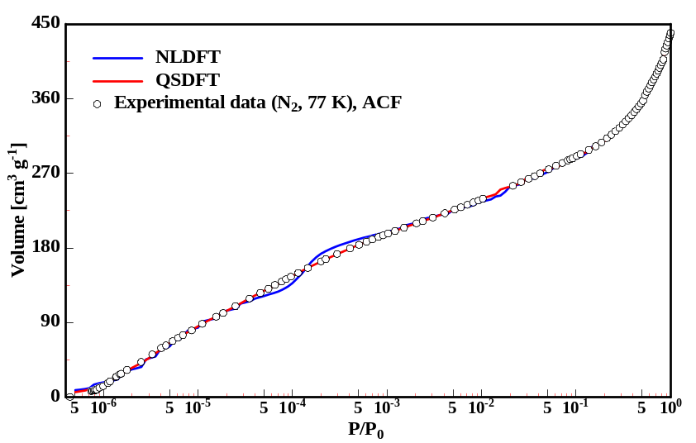

Fig. SI.5a. Experimental N2 (77 K) isotherm (in semi-logarithmic scale) on pitch-based activated carbon fiber P10 (experimental data from ref. [16]) together with NLDFT and QSDFT theoretical isotherms.
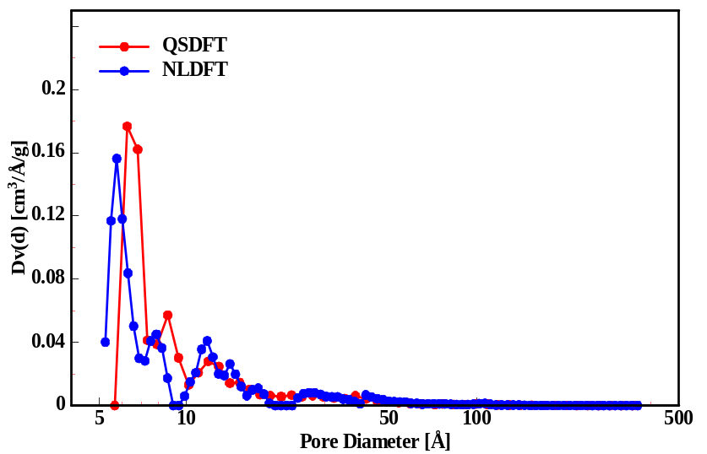
Fig. SI.5b. Differential pore size distribution curves obtained by applying NLDFT and QSDFT on the adsorption isotherm shown in Fig. SI.5 a.

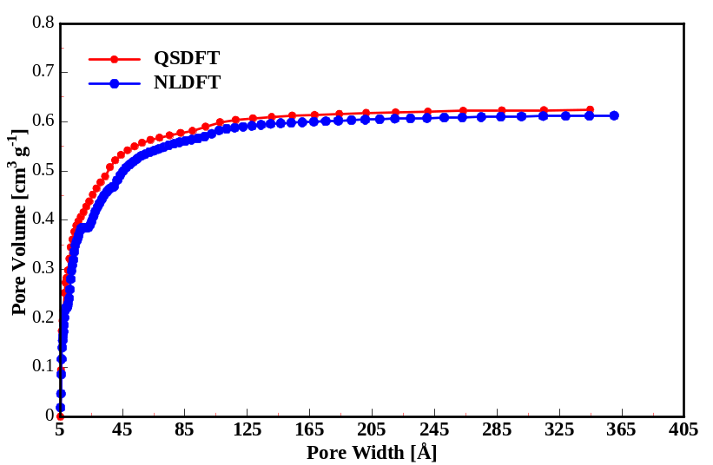
Fig. SI.5.c. Cumulative Pore Volume obtained by applying NLDFT and QSDFT on the adsorption isotherm shown in Fig. SI.5a
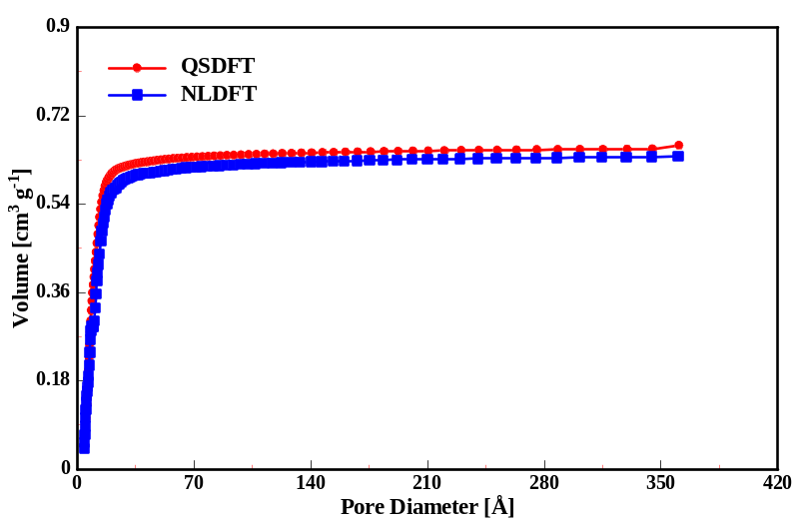
Fig. SI.6 Cumulative Pore Volume obtained by applying NLDFT and QSDFT on the adsorption isotherms shown in Fig. 13A for argon adsorption at 87.3K on CME2 carbon.

II. Filling pressures in carbon pores calculated in the QSDFT model.

Table 1 Equilibrium filling pressure for nitrogen adsorption at 77.4K
Pore size(Å) | Filling pressre(P/P₀) | Pore size(Å) | Filling pressre(P/P₀) | Pore size(Å) | Filling pressre(P/P₀)
4.00 | 1.970E-09 | 16.82 | 9.877E-02 | 78.68 | 8.013E-01
4.15 | 3.769E-09 | 17.56 | 1.160E-01 | 82.27 | 8.112E-01
4.32 | 7.936E-09 | 18.34 | 1.351E-01 | 86.02 | 8.205E-01
4.48 | 1.573E-08 | 19.15 | 1.553E-01 | 89.95 | 8.294E-01
4.66 | 3.311E-08 | 20.00 | 1.766E-01 | 94.05 | 8.377E-01
4.84 | 6.774E-08 | 20.89 | 1.993E-01 | 98.35 | 8.456E-01
5.04 | 1.446E-07 | 21.83 | 2.236E-01 | 102.84 | 8.531E-01
5.24 | 2.901E-07 | 22.8 | 2.483E-01 | 107.55 | 8.602E-01
5.45 | 5.661E-07 | 23.82 | 2.737E-01 | 112.46 | 8.668E-01
5.67 | 1.062E-06 | 24.88 | 2.998E-01 | 117.61 | 8.732E-01
5.90 | 1.939E-06 | 26.00 | 3.263E-01 | 122.99 | 8.792E-01
6.14 | 3.354E-06 | 27.16 | 3.526E-01 | 128.61 | 8.848E-01
6.4 | 5.888E-06 | 28.38 | 3.791E-01 | 134.5 | 8.902E-01
6.66 | 9.836E-06 | 29.66 | 4.053E-01 | 140.66 | 8.953E-01
6.94 | 1.686E-05 | 30.99 | 4.309E-01 | 147.10 | 9.001E-01
7.23 | 2.990E-05 | 32.39 | 4.562E-01 | 153.83 | 9.046E-01
7.53 | 5.365E-05 | 33.85 | 4.807E-01 | 160.88 | 9.090E-01
7.85 | 1.021E-04 | 35.38 | 5.046E-01 | 168.25 | 9.130E-01
8.18 | 2.000E-04 | 36.98 | 5.277E-01 | 175.96 | 9.169E-01
8.52 | 3.866E-04 | 38.65 | 5.500E-01 | 184.02 | 9.205E-01
8.89 | 7.353E-04 | 40.39 | 5.714E-01 | 192.46 | 9.240E-01
9.26 | 1.265E-03 | 42.22 | 5.921E-01 | 201.28 | 9.273E-01
9.66 | 2.093E-03 | 44.13 | 6.119E-01 | 210.51 | 9.304E-01
10.07 | 3.302E-03 | 46.13 | 6.310E-01 | 220.16 | 9.334E-01
10.51 | 5.013E-03 | 48.23 | 6.493E-01 | 230.26 | 9.362E-01
10.96 | 7.665E-03 | 50.42 | 6.668E-01 | 240.82 | 9.388E-01
11.44 | 1.107E-02 | 52.70 | 6.834E-01 | 251.87 | 9.414E-01
11.93 | 1.610E-02 | 55.10 | 6.994E-01 | 263.43 | 9.438E-01
12.45 | 2.106E-02 | 57.60 | 7.146E-01 | 275.51 | 9.460E-01
12.99 | 2.734E-02 | 60.22 | 7.290E-01 | 288.16 | 9.482E-01
13.56 | 3.526E-02 | 62.96 | 7.428E-01 | 301.38 | 9.502E-01
14.16 | 4.483E-02 | 65.83 | 7.558E-01 | 315.22 | 9.522E-01
14.78 | 5.608E-02 | 68.83 | 7.681E-01 | 329.69 | 9.540E-01
15.43 | 6.899E-02 | 71.96 | 7.798E-01 | 344.82 | 9.558E-01
16.11 | 8.321E-02 | 75.24 | 7.908E-01 | 360.65 | 9.575E-01

Table 2 Equilibrium filling pressure for argon adsorption at 87.3K
Pore size(Å) | Filling pressre(P/P₀) | Pore size(Å) | Filling pressre(P/P₀) | Pore size(Å) | Filling pressre(P/P₀)
4.00 | 1.366E-07 | 16.82 | 1.429E-01 | 78.68 | 8.087E-01
4.15 | 2.368E-07 | 17.56 | 1.628E-01 | 82.27 | 8.178E-01
4.32 | 4.292E-07 | 18.34 | 1.837E-01 | 86.02 | 8.265E-01
4.48 | 7.616E-07 | 19.15 | 2.052E-01 | 89.95 | 8.348E-01
4.66 | 1.375E-06 | 20.00 | 2.279E-01 | 94.05 | 8.426E-01
4.84 | 2.477E-06 | 20.89 | 2.514E-01 | 98.35 | 8.499E-01
5.04 | 4.430E-06 | 21.83 | 2.754E-01 | 102.84 | 8.569E-01
5.24 | 7.770E-06 | 22.80 | 2.997E-01 | 107.55 | 8.636E-01
5.45 | 1.295E-05 | 23.82 | 3.245E-01 | 112.46 | 8.699E-01
5.67 | 2.124E-05 | 24.88 | 3.493E-01 | 117.61 | 8.758E-01
5.90 | 3.393E-05 | 26.00 | 3.744E-01 | 122.99 | 8.815E-01
6.14 | 5.310E-05 | 27.16 | 3.991E-01 | 128.61 | 8.869E-01
6.40 | 8.328E-05 | 28.38 | 4.237E-01 | 134.50 | 8.920E-01
6.66 | 1.278E-04 | 29.66 | 4.480E-01 | 140.66 | 8.968E-01
6.94 | 2.010E-04 | 30.99 | 4.716E-01 | 147.10 | 9.014E-01
7.23 | 3.180E-04 | 32.39 | 4.948E-01 | 153.83 | 9.058E-01
7.53 | 5.079E-04 | 33.85 | 5.172E-01 | 160.88 | 9.099E-01
7.85 | 8.274E-04 | 35.38 | 5.390E-01 | 168.25 | 9.138E-01
8.18 | 1.339E-03 | 36.98 | 5.601E-01 | 175.96 | 9.176E-01
8.52 | 2.123E-03 | 38.65 | 5.804E-01 | 184.02 | 9.211E-01
8.89 | 3.339E-03 | 40.39 | 5.998E-01 | 192.46 | 9.245E-01
9.26 | 4.737E-03 | 42.22 | 6.185E-01 | 201.28 | 9.277E-01
9.66 | 7.454E-03 | 44.13 | 6.365E-01 | 210.51 | 9.307E-01
10.07 | 1.011E-02 | 46.13 | 6.537E-01 | 220.16 | 9.336E-01
10.51 | 1.417E-02 | 48.23 | 6.702E-01 | 230.26 | 9.363E-01
10.96 | 1.891E-02 | 50.42 | 6.860E-01 | 240.82 | 9.389E-01
11.44 | 2.534E-02 | 52.70 | 7.010E-01 | 251.87 | 9.413E-01
11.93 | 3.334E-02 | 55.10 | 7.154E-01 | 263.43 | 9.437E-01
12.45 | 4.072E-02 | 57.60 | 7.292E-01 | 275.51 | 9.459E-01
12.99 | 5.077E-02 | 60.22 | 7.423E-01 | 288.16 | 9.480E-01
13.56 | 6.306E-02 | 62.96 | 7.548E-01 | 301.38 | 9.500E-01
14.16 | 7.641E-02 | 65.83 | 7.667E-01 | 315.22 | 9.520E-01
14.78 | 9.111E-02 | 68.83 | 7.780E-01 | 329.69 | 9.538E-01
15.43 | 1.070E-01 | 71.96 | 7.888E-01 | 344.82 | 9.555E-01
16.11 | 1.242E-01 | 75.24 | 7.990E-01 | 360.65 | 9.572E-01

III. Validation of the pore size distribution calculation scheme.

We verified the calculation scheme on a model sample with a given pore size distribution (PSD). The theoretical isotherm was calculated by for this PSD, and then the PSD was determined by applying the QSDFT method to this theoretical isotherm. Agreement between the given and calculated PSDs confirms that the adopted algorithm for PSD calculations works properly.
The given pore size distribution was chosen as
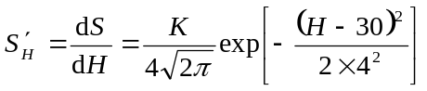
where 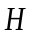 is the carbon slit pore size (Å), is the total surface of pores with widths smaller than . The cumulative pore surface is calculated by,
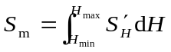
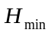=5 Å, 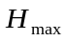=150 Å, 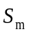= 450 m²/g
Based on the equilibrium QSDFT isotherms in slit pores of different widths and the given pore size distribution, the theoretical adsorption isotherm was generated as,

From the generated isotherm we calculated the pore size distribution using QSDFT model with QNNLS deconvolution method.
The agreement between the given and reconstructed PSDs and isotherms is excellent (Figs. S_III_1 and S_III_2).

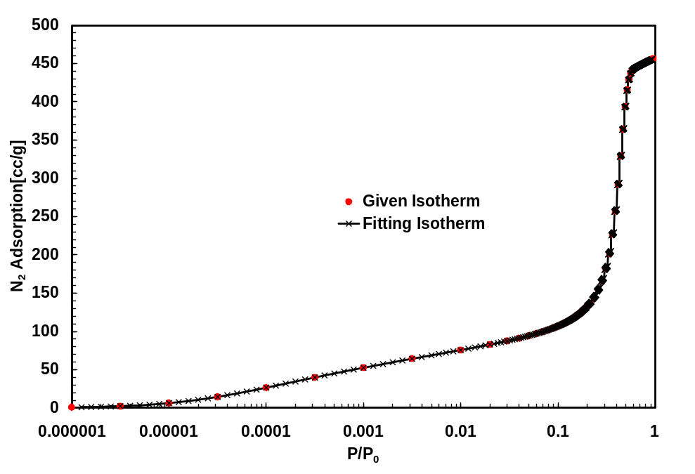
Fig. S_III_1. Isotherm comparison
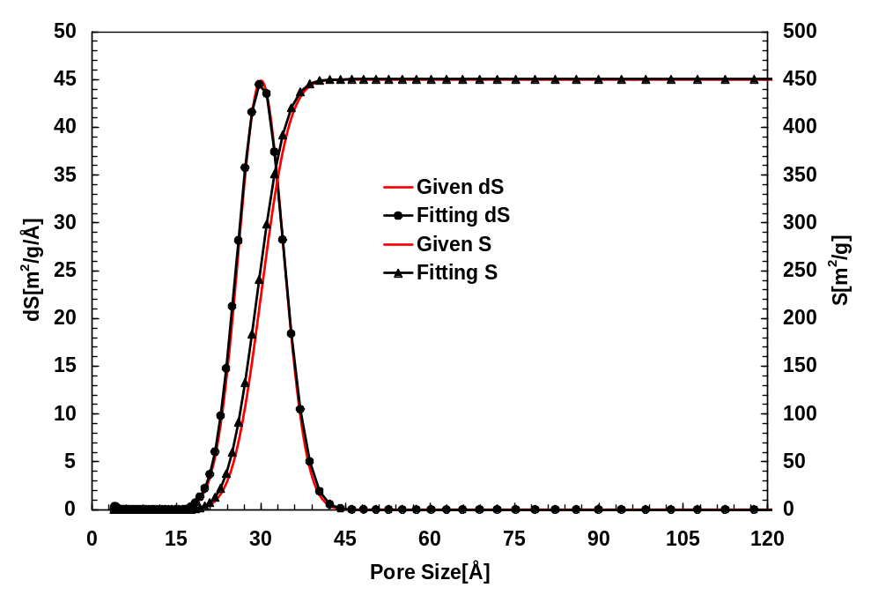
Fig. S_III_2. Pore size distribution comparison.

