# Problem 3 - Grocery Shopping

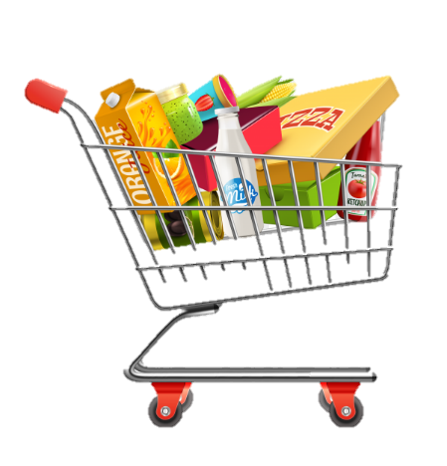

*Jane made a list of products, which she must buy from the nearest supermarket. While completing her list, Jane checks the products in her home.*

On the **first** line, you will receive a **sequence with products,** split by **"|"**.On the **following lines**, until command **"Shop!"**, you will be receiving **commands**. The possible commands are:

* **"Important%{product}"**:
* If the product **exists**, **move** it to the **beginning** of the list (index 0).
* Otherwise, **add** it to the list at the 0 index.
* **"Add%{product}"**:
* If the product **did not** **exist** – **add** it at the **end** of the list.
* Otherwise, print: **"The product is already in the list."**
* **"Swap%{product}%{product}"**:
* If both products exist – swap their places.
* If one of the two products is missing, print: **"Product {product} missing!"**
* **There is no case in which both products are missing at the same time.**
* **"Remove%{product}"**:
* If the product is in the list, **remove** it.
* Otherwise, print: **"Product {product} isn't in the list."**
* **"Reversed"**:
  + Reverse the list of products.

When you receive the command **"Shop!"** you should print each product from the list **on a new line** with **its number** in the list (**starting from 1**) and end the program:

**"1. {product1}**

**2. {product2}**

**…**

**N. {productN}"**

## Input

* On the **first** line, you will receive a sequence with products, split by **"|"**.
* **On the following lines**, until the command **"Shop!"**, you will be receiving commands.

## Output

* Print the output needed as described above.

### Examples

|  |  |
| --- | --- |
| **Input** | **Output** |
| eggs|milk|bread|fish  Important%bread  Swap%eggs%tomato  Shop! | Product tomato missing!  1. bread  2. eggs  3. milk  4. fish |
| apple|cheese|salt|bananas  Remove%cheese  Swap%salt%bananas  Shop! | 1. apple  2. bananas  3. salt |
| kiwi|paper|coffee  Add%coffee  Important%bread  Shop! | The product is already in the list.  1. bread  2. kiwi  3. paper  4. coffee |