Skill-Week4
Session-7:
- Process Synchronization and Child Process Monitoring Using waitpid()
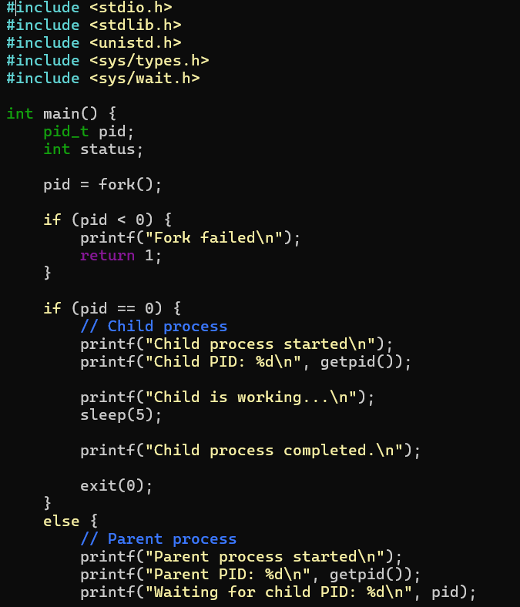

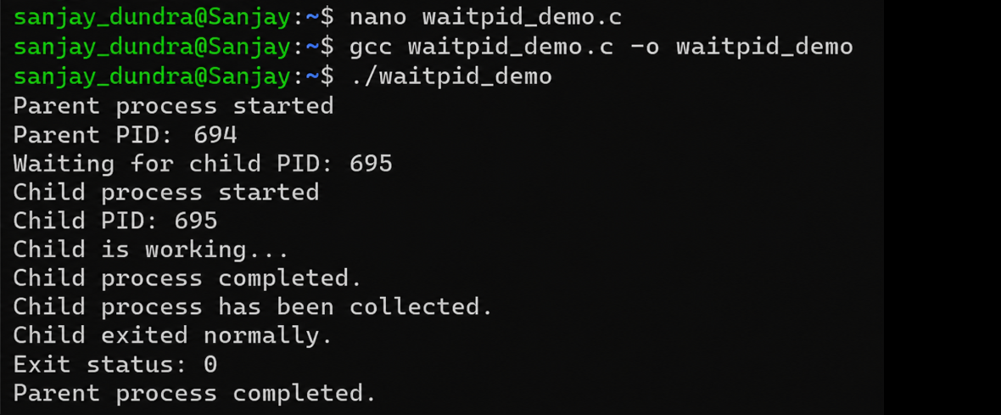
Report: The waitpid() function is used for process synchronization and monitoring a specific child process. The parent process waits until the specified child completes and then collects its exit status. This ensures proper synchronization and prevents zombie processes.

- To Retrieve PATH Variable, Parse Search Directories, Locate Executables, Verify Permissions, Handle Missing Commands, Test Command Resolution
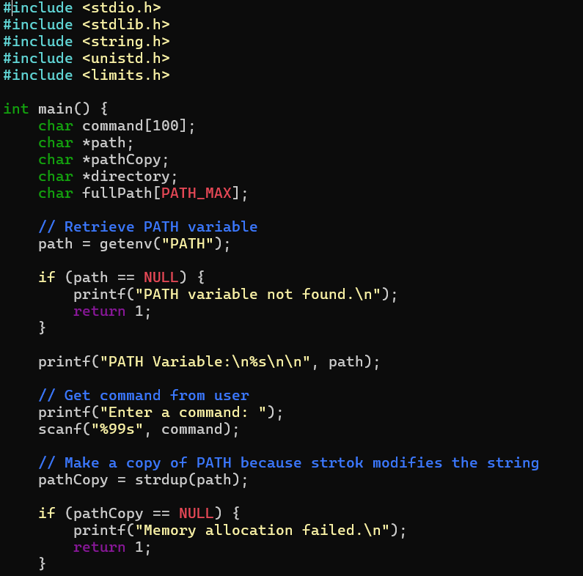

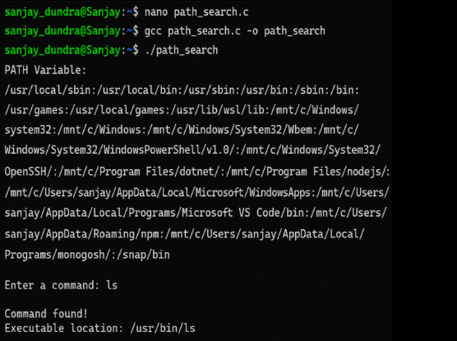
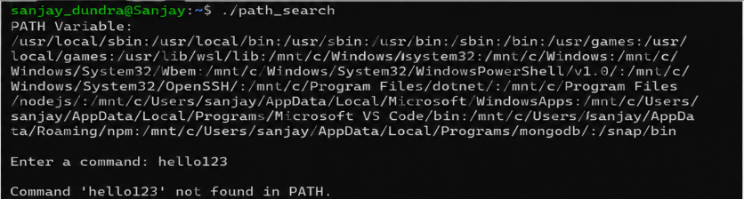

Report: The program successfully retrieved the PATH environment variable and parsed its directories to search for a specified command. It located executable files and verified their execution permissions using the access() function. It also handled missing commands correctly by displaying an appropriate error message. Thus, the program demonstrated how the operating system resolves commands using the PATH variable.

Session-8:
- To Detect Variable References, Expand Values, Handle Undefined Variables, Update Tokens, Support Nested Variables, Test Expansion Logic
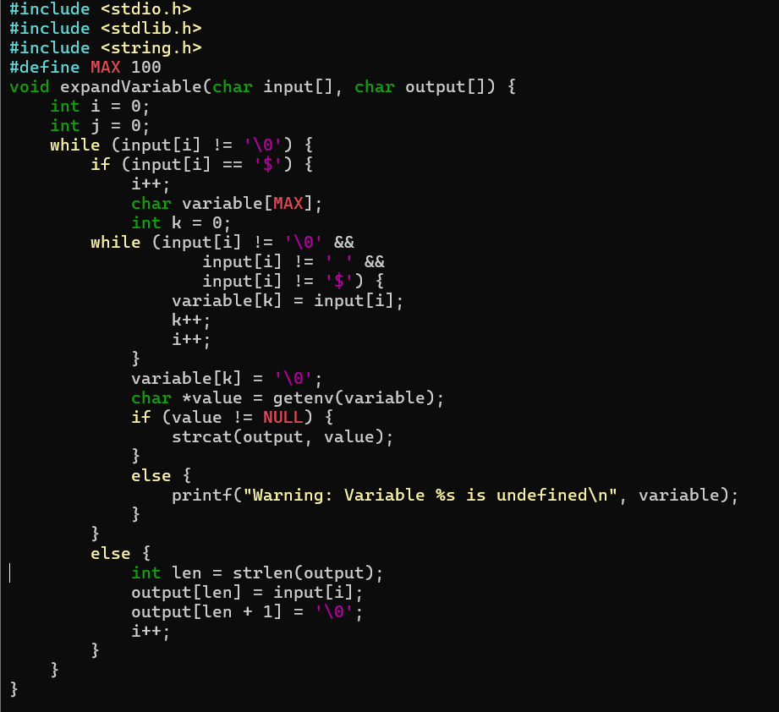

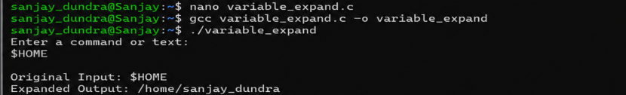

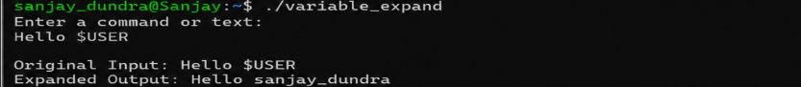

Report: The program successfully detects variable references using the $ symbol and expands them by retrieving their values from environment variables. It also handles undefined variables by displaying an appropriate message. Thus, the program demonstrates the basic process of variable expansion and token updating used in command interpreters and shell programs.

- To Identify Built-ins, Create Dispatch Table, Execute In Process Commands, Handle Invalid Commands, Maintain State, Test Dispatch Logic
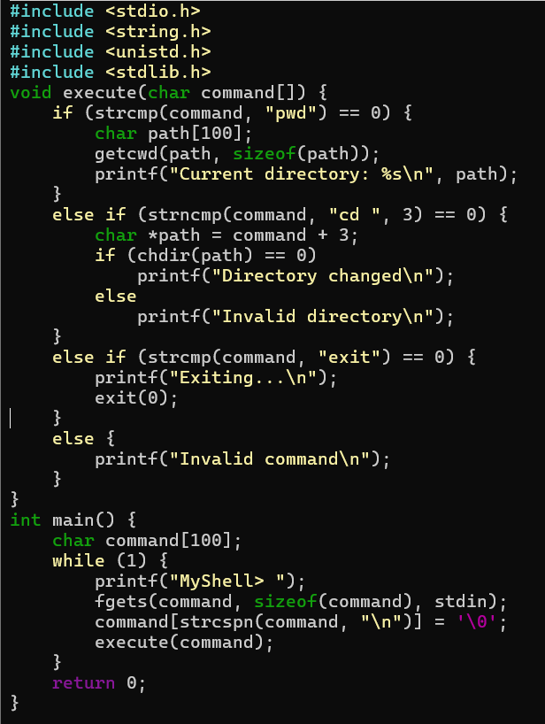

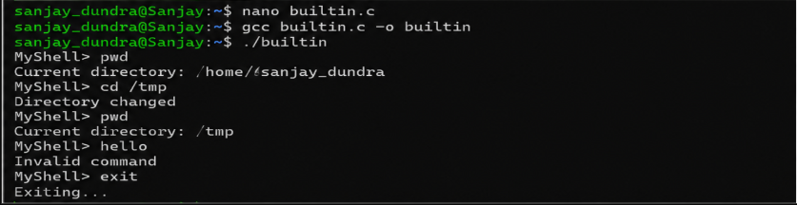

Report: The program identifies built-in commands and executes them within the same process. It handles commands using conditional dispatch, maintains the current directory state using cd, and displays an error message for invalid commands.

