**PUBLIC TRANSPORTATION ANALYSIS:**

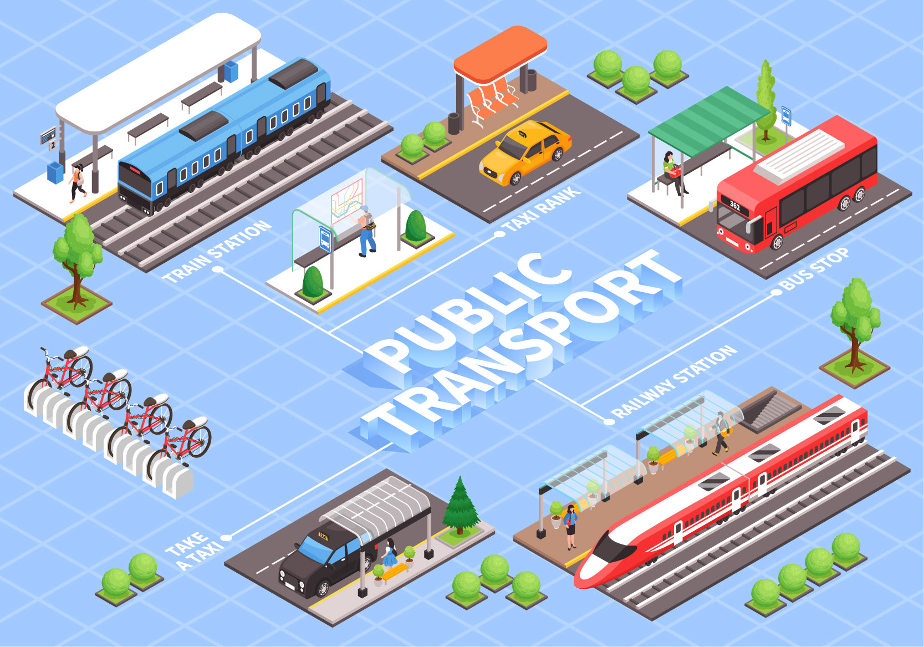

**PROJECT DESCRIPTION**

**INTRODUCTION :**

**Public transport analysis assesses the efficiency, accessibility, and sustainability of transportation systems like buses and trains. By studying factors such as ridership patterns and travel times, it helps optimize services, reduce congestion, and promote eco-friendly commuting, influencing urban planning and policy decisions.**

**PROJECT OBJECTIVES :**

**DATA COLLECTION AND MONITORING :**

**1.Real-Time Passenger Data : Collects live information on passenger numbers, boarding locations, and travel habits using smart ticketing systems and sensors, aiding in route optimization and demand analysis.**

**2. Traffic Flow Monitoring : Tracks vehicle speeds, congestion, and delays along public transport routes, enabling authorities to identify and address bottlenecks, enhancing the reliability of public transportation services.**

**DATA ANALYSIS AND VISUALIZATION :**

**1. Data Analysis: Analyzes collected data to identify trends and commuter behavior in public transport systems.**

**2. Visualization : Presents insights through graphs and charts, aiding decision-makers in understanding complex transportation data visually.**

**PREDICTIVE MODELING :**

**1. Predictive Modeling : Uses algorithms to forecast future trends in public transport demand based on historical data and variables like population growth and events.**

**2. Optimization Strategies : Helps authorities plan routes, schedules, and resources efficiently, minimizing costs and maximizing service quality through predictive modeling insights.**

**IDENTIFYING POLLUTION SOURCES :**

**1. Emission Monitoring : Identifies pollution sources by measuring emissions from public transport vehicles, pinpointing high-pollution areas and contributing factors.**

**2. Air Quality Analysis : Analyzes pollutant levels in specific locations, linking them to public transport routes, vehicle types, and congestion, aiding in pollution source identification.**

**PUBLIC AWARENESS AND EDUCATION :**

**1. Awareness Campaigns : Conducts outreach initiatives to inform the public about the benefits of public transport, encouraging usage and reducing traffic congestion.**

**2. Education Programs : Provides educational resources and workshops to schools and communities, promoting understanding of public transport systems, their environmental impact, and encouraging sustainable commuting habits.**

**POLICY RECOMMENDATIONS :**

**1. Policy Optimization : Offers tailored recommendations to improve public transport policies, focusing on efficiency, accessibility, and environmental sustainability.**

**2. Traffic Management Strategies : Suggests measures like congestion pricing or dedicated lanes, aiding policymakers in reducing traffic congestion and enhancing public transportation viability.**

**PROJECT BENEFITS :**

**1. Reduced Congestion : Optimizes routes, easing traffic congestion and improving overall road efficiency.**

**2. Lower Emissions : Encourages eco-friendly commuting, reducing air pollution and promoting cleaner urban environments.**

**3. Enhanced Accessibility : Ensures public transport services are accessible to more people, fostering social inclusion.**

**4. Time Savings : Reduces travel times through efficient routes, saving commuters time on their journeys.**

**5. Cost Efficiency : Helps minimize operational costs for transport providers, leading to potential fare savings for passengers.**

**CHALLENGES :**

**1. Data Accuracy : Ensuring precise and reliable data collection to base analysis on accurate information.**

**2. Funding Constraints: Limited budgets may hinder the implementation of necessary improvements and expansions in public transport systems.**

**3. Infrastructure Upgrades : Adapting existing infrastructure to accommodate evolving public transport needs and technologies.**

**4.Changing Commuter Behaviour : Addressing resistance to adopting public transport and promoting a shift from private vehicle use.**

**PROGRAM:**

**# Required Libraries**

**import pandas as pd**

**import numpy as np**

**import matplotlib.pyplot as plt**

**# Sample Data**

**# You would typically have data from public transportation sources.**

**# For this example, let's create some sample data.**

**data =**

**{**

**'Date': pd.date_range(start='2023-01-01', periods=12, freq='M'),**

**'Ridership': [2000, 2200, 2400, 2600, 2800, 3000, 3200, 3400, 3600, 3800, 4000, 4200]**

**}**

**df = pd.DataFrame(data)**

**# Data Analysis**

**# You can perform various analyses on the data, such as calculating trends, seasonality, or anomalies.**

**# Trend Analysis**

**plt.figure(figsize=(10, 6))**

**plt.plot(df['Date'], df['Ridership'])**

**plt.title('Public Transportation Ridership Over Time')**

**plt.xlabel('Date')**

**plt.ylabel('Ridership')**

**plt.grid(True)**

**plt.show()**

**# Seasonal Decomposition**

**from statsmodels.tsa.seasonal import seasonal_decompose**

**result = seasonal_decompose(df['Ridership'], model='additive', freq=3)**

**result.plot()**

**plt.show()**

**# Anomaly Detection**

**from sklearn.ensemble import IsolationForest**

**X = df['Ridership'].values.reshape(-1, 1)**

**iso_forest = IsolationForest(contamination=0.05)**

**outliers = iso_forest.fit_predict(X)**

**anomalies = df.loc[outliers == -1]**

**# Visualize Anomalies**

**plt.figure(figsize=(10, 6))**

**plt.plot(df['Date'], df['Ridership'], label='Ridership')**

**plt.scatter(anomalies['Date'],**

**anomalies['Ridership'], colour='red', label='Anomalies')**

**plt.title('Public Transportation Ridership Anomalies')**

**plt.xlabel('Date')**

**plt.ylabel('Ridership')**

**plt.legend()**

**plt.grid(True)**

**plt.show()**

* **OUTPUT:**

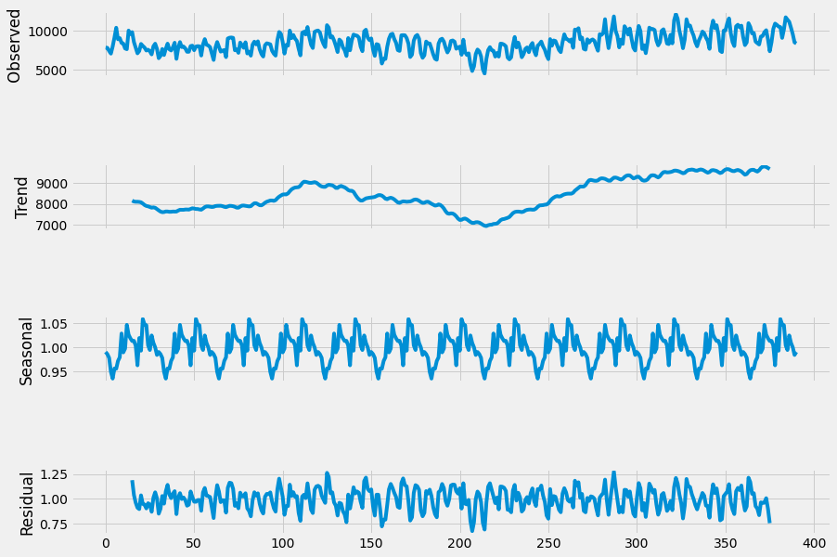

**CONCLUSION :**

**Public transport analysis revolutionizes urban living by optimizing travel experiences. By dissecting data, it refines routes and schedules, making commuting smoother and more time-efficient. This approach not only reduces traffic congestion but also minimizes environmental impact, championing cleaner air and greener cities.**

**DATASET :**

**Ridership Demand:**

**Ridership (R): The number of passengers using the transit service is often estimated based on various factors, which can include population (P), employment (E), and a mode choice factor (MCF). An example formula might be:**

**R = P x E x MCF**

**Service Quality:**

**On-Time Performance (OTP): The percentage of trips that are on time.**

**Customer Satisfaction (CS): A rating or index of passenger satisfaction based on surveys.**

**Operating Cost (OC):**

**The total cost to operate the transit system, including labour (L), fuel (F), maintenance (M), and administration (A).**

**OC = L + F + M + A**

**Revenue:**

**Revenue from Fares (RF):**

**The income generated from passenger fares.**

**Subsidies (S): The financial support provided to the transit system.**

**Total Revenue = RF + S**

**Performance Metrics:**

**Cost per Passenger Mile (CPPM):**

**The average cost of transporting a passenger one mile. This is calculated by dividing the operating cost by the total passenger miles.**

**CPPM = OC / Total Passenger Miles**