- Shift Reduce Parser:

#include <stdio.h>
#include <stdlib.h>
#include <string.h>

int k = 0, z = 0, i = 0, j = 0, c = 0;

char a[16], ac[20], stk[15], act[10];

void check()
{
strcpy(ac, "REDUCE TO E");

// c=length of input string
for (z = 0; z < c; z++)
if (stk[z] == 'i' && stk[z + 1] == 'd')
{
stk[z] = 'E';
stk[z + 1] = '\0';
printf("\n$%s\t%s$\t%s", stk, a, ac);
j++;
}
for (z = 0; z < c; z++)
if (stk[z] == 'E' && stk[z + 1] == '+' && stk[z + 2] == 'E')
{
stk[z] = 'E';
stk[z + 1] = '\0';
stk[z + 2] = '\0';
printf("\n$%s\t%s$\t%s", stk, a, ac);
i = i - 2;
}
for (z = 0; z < c; z++)
if (stk[z] == 'E' && stk[z + 1] == '*' && stk[z + 2] == 'E')
{
stk[z] = 'E';
stk[z + 1] = '\0';
stk[z + 1] = '\0';
printf("\n$%s\t%s$\t%s", stk, a, ac);
i = i - 2;
}
for (z = 0; z < c; z++)
if (stk[z] == '(' && stk[z + 1] == 'E' && stk[z + 2] == ')')
{
stk[z] = 'E';
stk[z + 1] = '\0';
stk[z + 1] = '\0';
printf("\n$%s\t%s$\t%s", stk, a, ac);
i = i - 2;
}
}

int main()
{
puts("GRAMMAR is E->E+E \n E->E*E \n E->(E) \n E->id");

// a is input string
puts("Enter input string: ");
gets(a);

c = strlen(a);

//"SHIFT" is copied to act to be printed
strcpy(act, "SHIFT->");

printf("\nStack \t Input \t Action");

for (k = 0, i = 0; j < c; k++, i++, j++)
{
if (a[j] == 'i' && a[j + 1] == 'd')
{
stk[i] = a[j];
stk[i + 1] = a[j + 1];
stk[i + 2] = '\0';
a[j] = ' ';
a[j + 1] = ' ';
printf("\n$%s\t%s$\t%sid", stk, a, act);
check();
}
else
{
stk[i] = a[j];
stk[i + 1] = '\0';
a[j] = ' ';
printf("\n$%s\t%s$\t%ssymbols", stk, a, act);
check();
}
}

if (stk[0] == 'E' && stk[1] == '\0')
printf("\n\t\t\tAccept\n");
else
printf("\n\t\t\tReject\n");
}

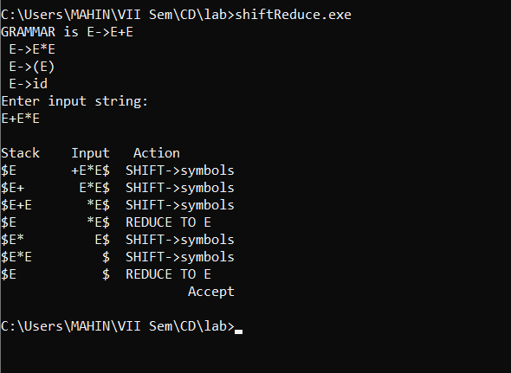

- Operator Precedence Parser:
/*
The grammar in this program is:
E -> i / E*E / E+E / (E) / E^E
i for identifier.
E is the start symbol.

*/

#include<stdio.h>
#include<string.h>
#include<stdlib.h>

char *input;
int i=0;
char lasthandle[6],stack[50],handles[][5]={")E(","E*E","E+E","i","E^E"};
//(E) becomes )E( when pushed to stack

int top=0,l;
char prec[9][9]={
/*stack + - * / ^ i ( ) $ */
/* + */ '>', '>','<','<','<','<','<','>','>',

/* - */ '>', '>','<','<','<','<','<','>','>',

/* * */ '>', '>','>','>','<','<','<','>','>',
/* / */ '>', '>','>','>','<','<','<','>','>',
/* ^ */ '>', '>','>','>','<','<','<','>','>',
/* i */ '>', '>','>','>','>','e','e','>','>',
/* ( */ '<', '<','<','<','<','<','<','>','e',
/* ) */ '>', '>','>','>','>','e','e','>','>',
/* $ */ '<', '<','<','<','<','<','<','<','>',

};

int getindex(char c)
{
switch(c)
{
case '+':return 0;
case '-':return 1;
case '*':return 2;
case '/':return 3;
case '^':return 4;
case 'i':return 5;
case '(':return 6;
case ')':return 7;
case '$':return 8;
}
}
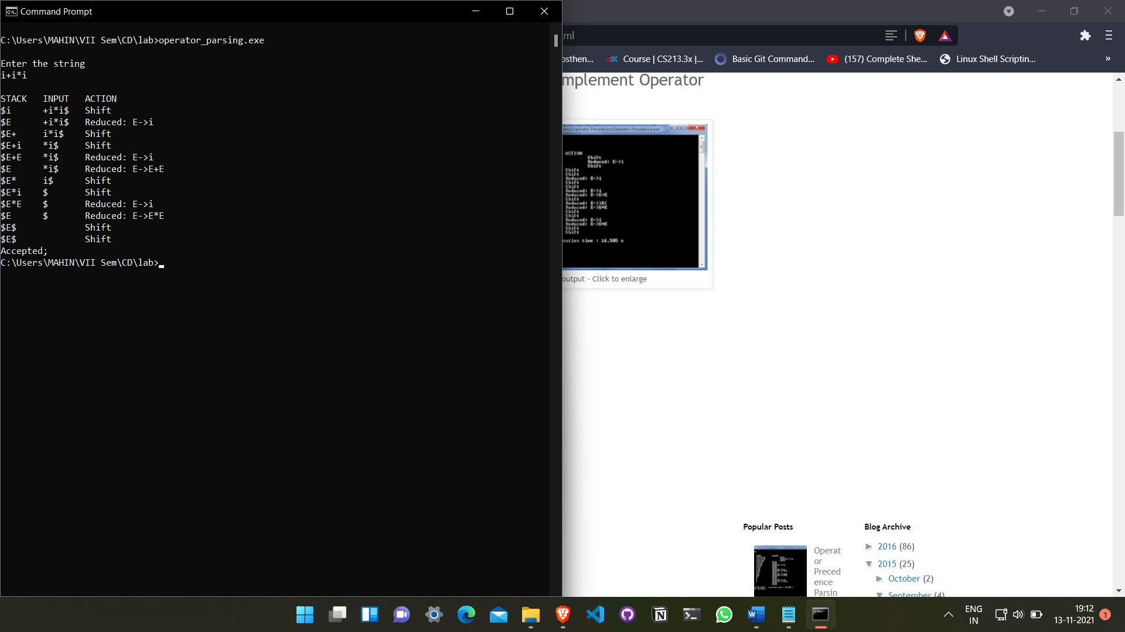

- Predictive Parser:
#include<iostream>
#include<string>
#include<deque>
using namespace std;
int n,n1,n2;
int getPosition(string arr[], string q, int size)
{
for(int i=0;i<size;i++)
{
if(q == arr[i])
return i;
}
return -1;
}
int main()
{
string prods[10],first[10],follow[10],nonterms[10],terms[10];
string pp_table[20][20] = {};
cout<<"Enter the number of productions : ";
cin>>n;
cin.ignore();
cout<<"Enter the productions"<<endl;
for(int i=0;i<n;i++)
{
getline(cin,prods[i]);
cout<<"Enter first for "<<prods[i].substr(3)<<" : ";
getline(cin,first[i]);
}
cout<<"Enter the number of Terminals : ";
cin>>n2;
cin.ignore();
cout<<"Enter the Terminals"<<endl;
for(int i=0;i<n2;i++)
{
cin>>terms[i];
}
terms[n2] = "$";
n2++;
cout<<"Enter the number of Non-Terminals : ";
cin>>n1;
cin.ignore();
for(int i=0;i<n1;i++)
{
cout<<"Enter Non-Terminal : ";
getline(cin,nonterms[i]);
cout<<"Enter follow of "<<nonterms[i]<<" : ";
getline(cin,follow[i]);
}

cout<<endl;
cout<<"Grammar"<<endl;
for(int i=0;i<n;i++)
{
cout<<prods[i]<<endl;
}

for(int j=0;j<n;j++)
{
int row = getPosition(nonterms,prods[j].substr(0,1),n1);
if(prods[j].at(3)!='#')
{
for(int i=0;i<first[j].length();i++)
{
int col = getPosition(terms,first[j].substr(i,1),n2);
pp_table[row][col] = prods[j];
}
}
else
{
for(int i=0;i<follow[row].length();i++)
{
int col = getPosition(terms,follow[row].substr(i,1),n2);
pp_table[row][col] = prods[j];
}
}
}
//Display Table
for(int j=0;j<n2;j++)
cout<<"\t"<<terms[j];
cout<<endl;
for(int i=0;i<n1;i++)
{
cout<<nonterms[i]<<"\t";
//Display Table
for(int j=0;j<n2;j++)
{
cout<<pp_table[i][j]<<"\t";
}
cout<<endl;
}
//Parsing String
char c;
do{
string ip;
deque<string> pp_stack;
pp_stack.push_front("$");
pp_stack.push_front(prods[0].substr(0,1));
cout<<"Enter the string to be parsed : ";
getline(cin,ip);
ip.push_back('$');
cout<<"Stack\tInput\tAction"<<endl;
while(true)
{
for(int i=0;i<pp_stack.size();i++)
cout<<pp_stack[i];
cout<<"\t"<<ip<<"\t";
int row1 = getPosition(nonterms,pp_stack.front(),n1);
int row2 = getPosition(terms,pp_stack.front(),n2);
int column = getPosition(terms,ip.substr(0,1),n2);
if(row1 != -1 && column != -1)
{
string p = pp_table[row1][column];
if(p.empty())
{
cout<<endl<<"String cannot be Parsed."<<endl;
break;
}
pp_stack.pop_front();
if(p[3] != '#')
{
for(int x=p.size()-1;x>2;x--)
{
pp_stack.push_front(p.substr(x,1));
}
}
cout<<p;
}
else
{
if(ip.substr(0,1) == pp_stack.front())
{
if(pp_stack.front() == "$")
{
cout<<endl<<"String Parsed."<<endl;
break;
}
cout<<"Match "<<ip[0];
pp_stack.pop_front();
ip = ip.substr(1);
}
else
{
cout<<endl<<"String cannot be Parsed."<<endl;
break;
}
}
cout<<endl;
}
cout<<"Continue?(Y/N) ";
cin>>c;
cin.ignore();
}while(c=='y' || c=='Y');
return 0;
}
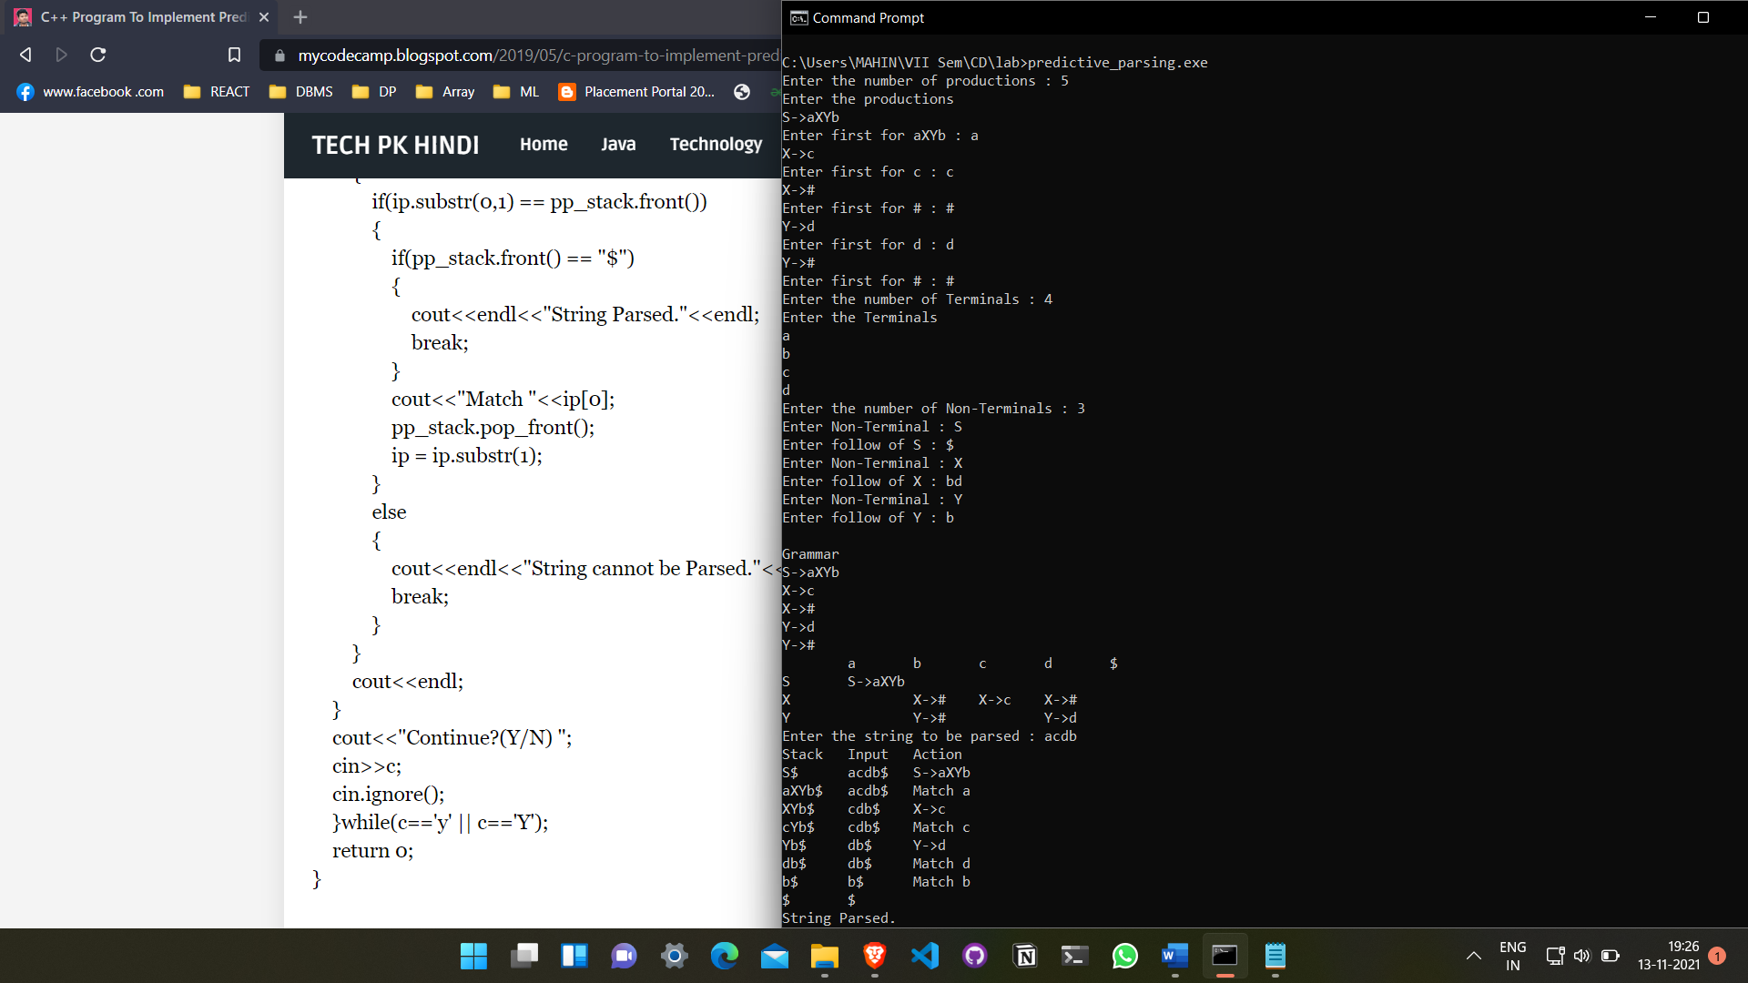
- First And Follow:
#include <bits/stdc++.h>
#define max 20
using namespace std;
char prod[max][10], ter[10], nt[10], first[10][10], follow[10][10];
int eps[10],c=0;
int findpos(char ch)
{
int n;
for (n = 0; nt[n] != '\0'; n++)
if (nt[n] == ch)
break;
if (nt[n] == '\0')
return 1;
return n;
}
int IsCap(char c)
{
return (c >= 'A' && c <= 'Z') ? 1 : 0;
}
void add(char *arr, char c)
{
int i, flag = 0;
for (i = 0; arr[i] != '\0'; i++)
if (arr[i] == c)
{
flag = 1;
break;
}
if (flag != 1)
arr[strlen(arr)] = c;
}
void addarr(char *s1, char *s2)
{
int i, j, flag = 99;
for (i = 0; s2[i] != '\0'; i++)
{
flag = 0;
for (j = 0;; j++)
{
if (s2[i] == s1[j])
{
flag = 1;
break;
}
if (j == strlen(s1) && flag != 1)
{
s1[strlen(s1)] = s2[i];
break;
}
}
}
}
void addprod(char *s)
{
int i;
prod[c][0] = s[0];
for (i = 3; s[i] != '\0'; i++)
{
if (!IsCap(s[i]))
add(ter, s[i]);
prod[c][i - 2] = s[i];
}
prod[c][i - 2] = '\0';
add(nt, s[0]);
c++;
}
void findfirst()
{
int i, j, n, k, e, n1;
for (i = 0; i < c; i++)
{
for (j = 0; j < c; j++)
{
n = findpos(prod[j][0]);
if (prod[j][1] == (char)238)
eps[n] = 1;
else
{
for (k = 1, e = 1; prod[j][k] != '\0' && e == 1; k++)
{
if (!IsCap(prod[j][k]))
{
e = 0;
add(first[n], prod[j][k]);
}
else
{
n1 = findpos(prod[j][k]);
addarr(first[n], first[n1]);
if (eps[n1] == 0)
e = 0;
}
}
if (e == 1)
eps[n] = 1;
}
}
}
}
void findfollow()
{
int i, j, k, n, e, n1;
n = findpos(prod[0][0]);
add(follow[n], '$');
for (i = 0; i < c; i++)
{
for (j = 0; j < c; j++)
{
for (k = strlen(prod[j]) - 1; k > 0; k--)
{
if (IsCap(prod[j][k]))
{
n = findpos(prod[j][k]);
if (prod[j][k + 1] == '\0') // A -> aB
{
n1 = findpos(prod[j][0]);
addarr(follow[n], follow[n1]);
}
if (IsCap(prod[j][k + 1])) // A -> aBb
{
n1 = findpos(prod[j][k + 1]);
addarr(follow[n], first[n1]);
if (eps[n1] == 1)
{
n1 = findpos(prod[j][0]);
addarr(follow[n], follow[n1]);
}
}
else if (prod[j][k + 1] != '\0')
add(follow[n], prod[j][k + 1]);
}
}
}
}
}
int main()
{
char s[max], i;
cout << "\nEnter the productions (type 'end' at the last of the production)\n";
cin >> s;
while (strcmp("end", s))
{
addprod(s);
cin >> s;
}
findfirst();
findfollow();
for (i = 0; i < strlen(nt); i++)
{
cout << "\nFIRST[" << nt[i] << "]: " << first[i];
if (eps[i] == 1)
cout << (char)238 << "\t";
else
cout << "\t";
cout << "FOLLOW[" << nt[i] << "]: " << follow[i];
}
return 0;
}
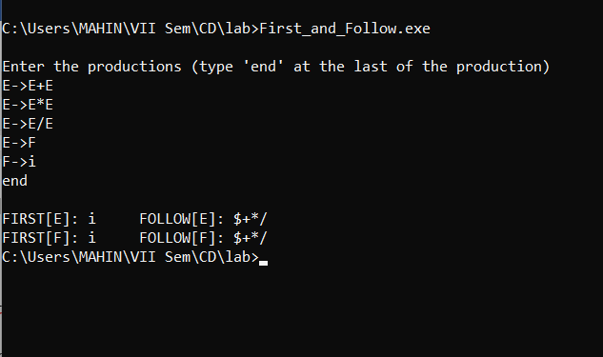

- Leading and Trailing:
#include<bits/stdc++.h>
using namespace std;
#include <cstring>
int nt, t, top = 0;
char s[50], NT[10], T[10], st[50], l[10][10], tr[50][50];
int searchnt(char a)
{
int count = -1, i;
for (i = 0; i < nt; i++)
{
if (NT[i] == a)
return i;
}
return count;
}
int searchter(char a)
{
int count = -1, i;
for (i = 0; i < t; i++)
{
if (T[i] == a)
return i;
}
return count;
}
void push(char a)
{
s[top] = a;
top++;
}
char pop()
{
top--;
return s[top];
}
void installl(int a, int b)
{
if (l[a][b] == 'f')
{
l[a][b] = 't';
push(T[b]);
push(NT[a]);
}
}
void installt(int a, int b)
{
if (tr[a][b] == 'f')
{
tr[a][b] = 't';
push(T[b]);
push(NT[a]);
}
}
int main()
{
int i, s, k, j, n;
char pr[30][30], b, c;
cout<< "Enter the no of productions:";
cin>> n;
cout << "Enter the productions one by one\n";
for (i = 0; i < n; i++)
cin >> pr[i];
nt = 0;
t = 0;
for (i = 0; i < n; i++)
{
if ((searchnt(pr[i][0])) == -1)
NT[nt++] = pr[i][0];
}
for (i = 0; i < n; i++)
{
for (j = 3; j < strlen(pr[i]); j++)
{
if (searchnt(pr[i][j]) == -1)
{
if (searchter(pr[i][j]) == -1)
T[t++] = pr[i][j];
}
}
}
for (i = 0; i < nt; i++)
{
for (j = 0; j < t; j++)
l[i][j] = 'f';
}
for (i = 0; i < nt; i++)
{
for (j = 0; j < t; j++)

tr[i][j] = 'f';
}
for (i = 0; i < nt; i++)
{
for (j = 0; j < n; j++)
{
if (NT[(searchnt(pr[j][0]))] == NT[i])
{
if (searchter(pr[j][3]) != -1)
installl(searchnt(pr[j][0]), searchter(pr[j][3]));
else
{
for (k = 3; k < strlen(pr[j]); k++)
{
if (searchnt(pr[j][k]) == -1)
{
installl(searchnt(pr[j][0]), searchter(pr[j][k]));
break;
}
}
}
}
}
}
while (top != 0)
{
b = pop();
c = pop();
for (s = 0; s < n; s++)
{
if (pr[s][3] == b)
installl(searchnt(pr[s][0]), searchter(c));
}
}
for (i = 0; i < nt; i++)
{
cout << "Leading[" << NT[i] << "]"
<< "\t{";
for (j = 0; j < t; j++)
{
if (l[i][j] == 't')
cout << T[j] << ",";
}
cout << "}\n";
}
top = 0;
for (i = 0; i < nt; i++)
{
for (j = 0; j < n; j++)
{
if (NT[searchnt(pr[j][0])] == NT[i])
{
if (searchter(pr[j][strlen(pr[j]) - 1]) != -1)
installt(searchnt(pr[j][0]), searchter(pr[j][strlen(pr[j]) - 1]));
else
{
for (k = (strlen(pr[j]) - 1); k >= 3; k--)
{
if (searchnt(pr[j][k]) == -1)
{
installt(searchnt(pr[j][0]), searchter(pr[j][k]));
break;
}
}
}
}
}
}
while (top != 0)
{
b = pop();
c = pop();
for (s = 0; s < n; s++)
{
if (pr[s][3] == b)
installt(searchnt(pr[s][0]), searchter(c));
}
}
for (i = 0; i < nt; i++)
{
cout << "Trailing[" << NT[i] << "]"
<< "\t{";
for (j = 0; j < t; j++)
{
if (tr[i][j] == 't')
cout << T[j] << ",";
}
cout << "}\n";
}
return 0;
}
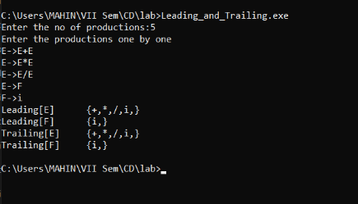
- LR(0):
#include <cstdlib>
#include <iostream>
#include <string>
#include <string.h>
#include <vector>
#include <algorithm>
#include <map>

using namespace std;

typedef map<char, vector<string> > AugmentedGrammar;
typedef map<string, int> GotoMap; // <aps productions to LR(0) item ids

// structy for representing an augmented grammar production
struct AugmentedProduction
{
char lhs; // left hand side of production
string rhs; // right hand side of production

AugmentedProduction() {}
AugmentedProduction(char _lhs, string _rhs) : lhs(_lhs), rhs(_rhs) {}
};

// Class for representing LR(0) items.
class LR0Item
{
private:
// list of productions
vector<AugmentedProduction*> productions;

public:
// list of out-edges
map<char, int> gotos;

// constructor
LR0Item() {}
// destructor
~LR0Item() {}

// add production
void Push(AugmentedProduction *p) { productions.push_back(p); }
// return the number of productions
int Size() { return int(productions.size()); }

// return whether or not this item contains the production prodStr
bool Contains (string production) {
for (auto it = productions.begin(); it != productions.end(); it++) {
string existing = string(&(*it)->lhs, 1) + "->" + (*it)->rhs;
if (strcmp(production.c_str(), existing.c_str()) == 0) {
return true;
}
}
return false;
}

// overloaded index operator; access pointer to production.
AugmentedProduction* operator[](const int index) {
return productions[index];
}
};

/* void add_closure
* If 'next' is the current input symbol and next is nonterminal, then the set
* of LR(0) items reachable from here on next includes all LR(0) items reachable
* from here on FIRST(next). Add all grammar productions with a lhs of next */
void
add_closure(char lookahead, LR0Item& item, AugmentedGrammar& grammar)
{
// only continue if lookahead is a non-terminal
if (!isupper(lookahead)) return;

string lhs = string(&lookahead, 1);
// iterate over each grammar production beginning with p->rhs[next]
// to see if that production has already been included in this item.
for (int i = 0; i<grammar[lookahead].size(); i++) {
string rhs = "." + grammar[lookahead][i];
// if the grammar production for the next input symbol does not yet
// exist for this item, add it to the item's set of productions
if (!item.Contains( lhs + "->" + rhs )) {
item.Push(new AugmentedProduction(lookahead, rhs));
}
}
}

// produce the graph of LR(0) items from the given augmented grammar
void
get_LR0_items(vector<LR0Item>& lr0items, AugmentedGrammar& grammar, int& itemid, GotoMap& globalGoto)
{
printf("I%d:\n", itemid);

// ensure that the current item contains te full closure of it's productions
for (int i = 0; i<lr0items[itemid].Size(); i++) {
string rhs = lr0items[itemid][i]->rhs;
char lookahead = rhs[rhs.find('.')+1];
add_closure(lookahead, lr0items[itemid], grammar);
}

int nextpos;
char lookahead, lhs;
string rhs;
AugmentedProduction *prod;

// iterate over each production in this LR(0) item
for (int i = 0; i<lr0items[itemid].Size(); i++) {
// get the current production
lhs = lr0items[itemid][i]->lhs;
rhs = lr0items[itemid][i]->rhs;
string production = string(&lhs,1) + "->" + rhs;

// get lookahead if one exists
lookahead = rhs[rhs.find('.')+1];
if (lookahead == '\0') {
printf("\t%-20s\n", &production[0]);
continue;
}

// if there is no goto defined for the current input symbol from this
// item, assign one.
if (lr0items[itemid].gotos.find(lookahead) == lr0items[itemid].gotos.end()) {
// that one instead of creating a new one
// if there is a global goto defined for the entire production, use
if (globalGoto.find(production) == globalGoto.end()) {
lr0items.push_back(LR0Item()); // create new state (item)
// new right-hand-side is identical with '.' moved one space to the right
string newRhs = rhs;
int atpos = newRhs.find('.');
swap(newRhs[atpos], newRhs[atpos+1]);
// add item and update gotos
lr0items.back().Push(new AugmentedProduction(lhs, newRhs));
lr0items[itemid].gotos[lookahead] = lr0items.size()-1;
globalGoto[production] = lr0items.size()-1;
} else {
// use existing global item
lr0items[itemid].gotos[lookahead] = globalGoto[production];
}
printf("\t%-20s goto(%c)=I%d\n", &production[0], lookahead, globalGoto[production]);
} else {
// there is a goto defined, add the current production to it
// move . one space to right for new rhs
int at = rhs.find('.');
swap(rhs[at], rhs[at+1]);
// add production to next item if it doesn't already contain it
int nextItem = lr0items[itemid].gotos[lookahead];
if (!lr0items[nextItem].Contains(string(&lhs, 1) + "->" + rhs)) {
lr0items[nextItem].Push(new AugmentedProduction(lhs, rhs));
}
swap(rhs[at], rhs[at+1]);
printf("\t%-20s\n", &production[0]);
}
}
}

/**
* void load_grammar
* scan and load the grammar from stdin while setting first LR(0) item */
void load_grammar(AugmentedGrammar& grammar, vector<LR0Item>& lr0items)
{
string production;
string lhs, rhs;
string delim = "->";

getline(cin, lhs); // scan start production
grammar['\''].push_back(lhs);
lr0items[0].Push(new AugmentedProduction('\'', "." + lhs));
printf("'->%s\n", lhs.c_str());

while(1) {
getline(cin, production);
if (production.length() < 1) return;

auto pos = production.find(delim);
if(pos!=string::npos){
lhs = production.substr(0,pos);
rhs = production.substr(pos+delim.length(),std::string::npos);
}

grammar[lhs[0]].push_back(rhs);
printf("%s->%s\n", lhs.c_str(), rhs.c_str());
lr0items[0].Push(new AugmentedProduction(lhs[0], "." + rhs));
}
}

// main
int main() {
int itemid = -1; // counter for the number of LR(0) items
AugmentedGrammar grammar;
vector<LR0Item> lr0items = { LR0Item() }; // push start state
GotoMap globalGoto;

printf("Augmented Grammar\n");
printf("-----------------\n");
load_grammar(grammar, lr0items);
printf("\n");

printf("Sets of LR(0) Items\n");
printf("-------------------\n");
while (++itemid < int(lr0items.size())) {
get_LR0_items(lr0items, grammar, itemid, globalGoto);
}
printf("\n");
return 0;
}

