Automating Data Import and Relationship Mapping Using Import Sets & Dot Walking

Introduction
Create an employee data file in Google Sheets with fields: name, email, department, manager, and phone number, then download it as a CSV or XLSX file.
Load the file into ServiceNow using System Import Sets → Load Data and create a new Import Set table named import_employee. Create a Transform Map linking the import_employee table (source) to the User [sys_user] table (target). Map all fields properly, including reference fields like department and manager, using Auto Map and Mapping Assist . Run the Transform and verify that employee records are successfully inserted into the sys_user table. Configure the Incident form to use dot walking (Assigned to.department, Assigned to.email, Assigned to.manager) so related details auto-populate when an employee is selected.

Process
Steps for Creating Employee Record
1. Open google sheet
2. Name the fields as name,email,department, manager and phone number
3. Enter some records
4. Save the sheet as: employee data
5. Download the file as .xlsx , .csv (or) .xml file

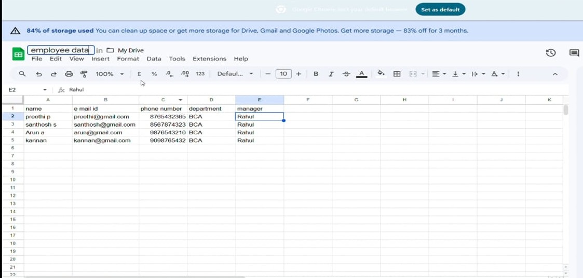

Steps for Importing Data
- Open Service Now.
- Click on All →System Import Sets →Load Data.
- Select create table.
- Give the import set table name as: import employee.
- Choose the file which we created in the XL sheet.
- The data is imported, click on personalized list and add Fields.
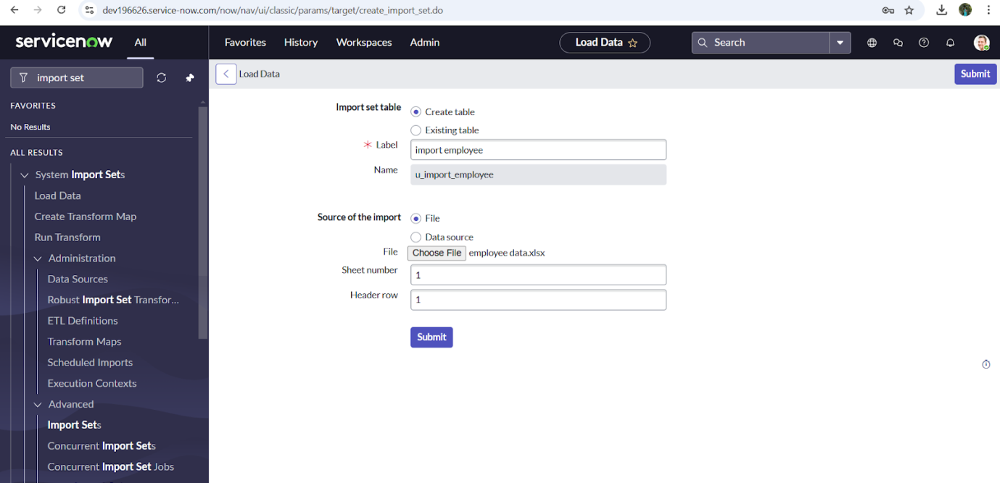

Steps for Creating Transform Map
- Open service now.
- Click on All >> search for import set
- Select create transform map under import sets
- Click on new
- Fill the following details to create a new transform map
- Give name as: Test
- Select source table: @123
8.Select target table: user[sys_user]
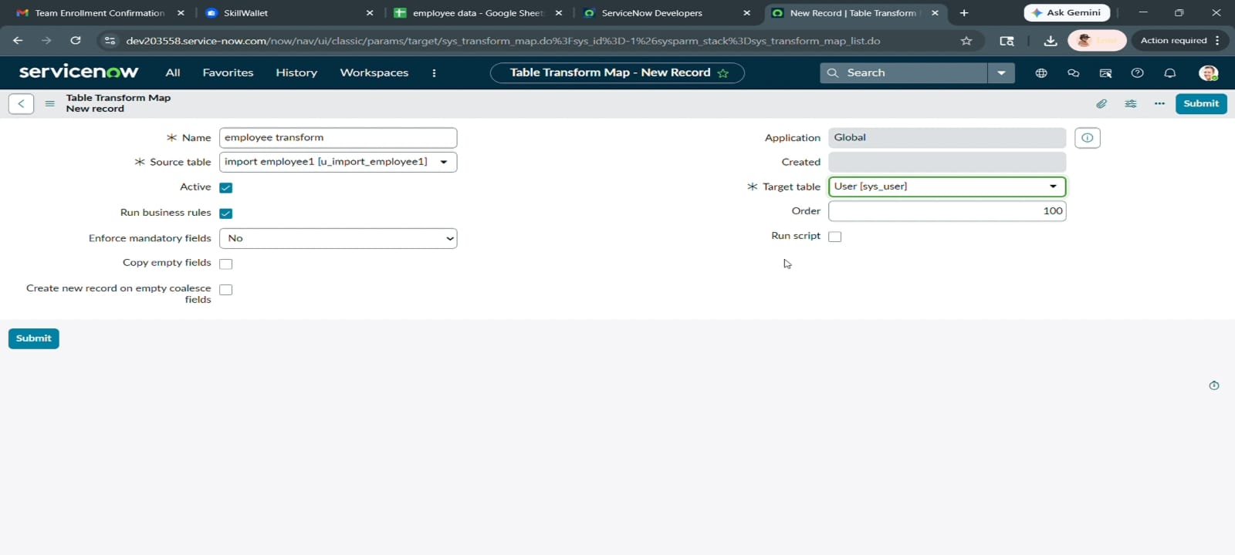

Steps for Matching the Fields
- Scrolled down the created transform map form
- Click on auto matching fields
- Then in the mapping fields some fields are matched
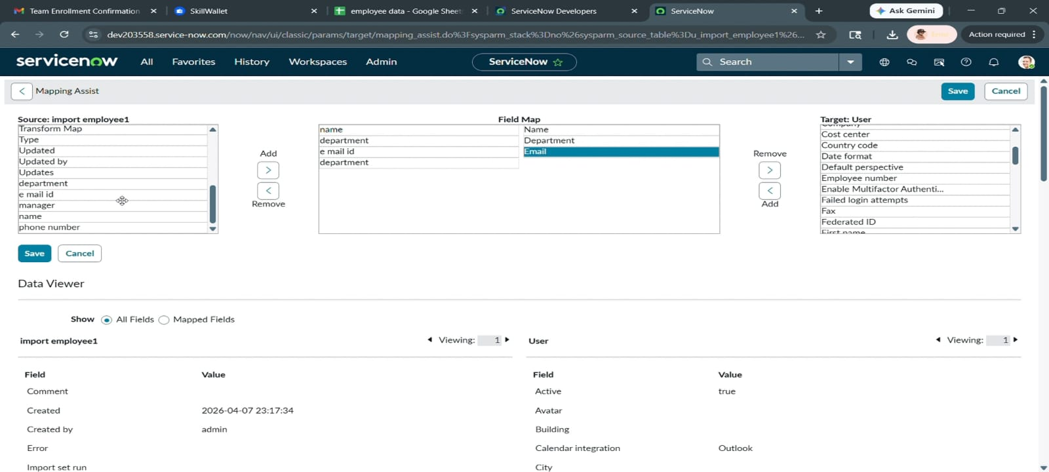
4.Using mapping assist map the manager field.
5.Select the fields which you are mapping in the staging table and target table
6.Select manager in source table and add
7.Select manager field in target table
8.click on the save button.

Steps for Transforming Data
- Click on transform in the related links.
- Click on transform.
- Data's transform state is completed
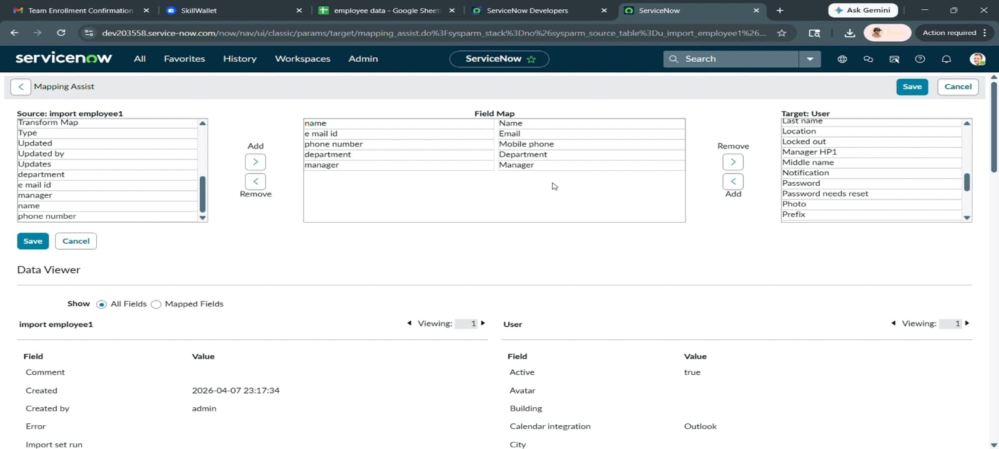

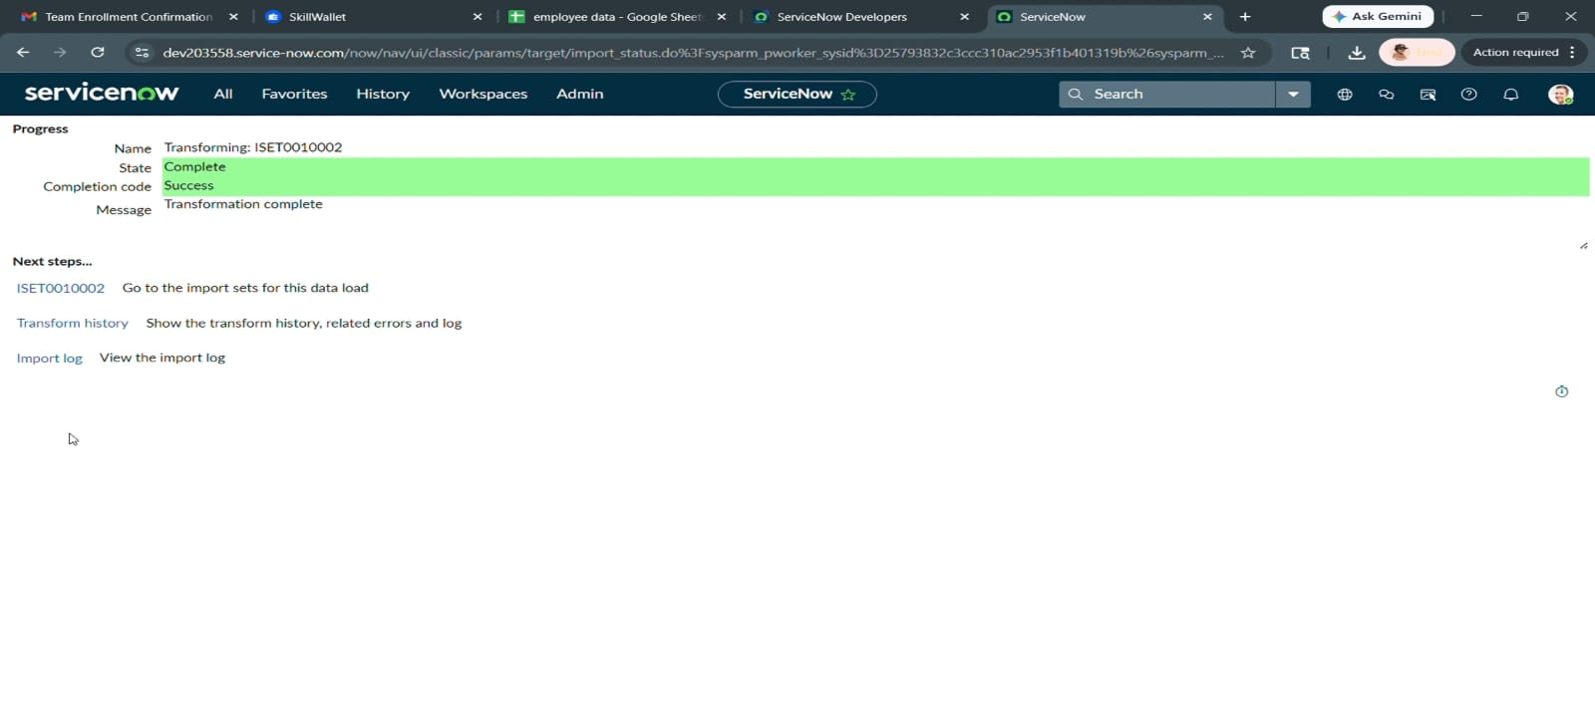

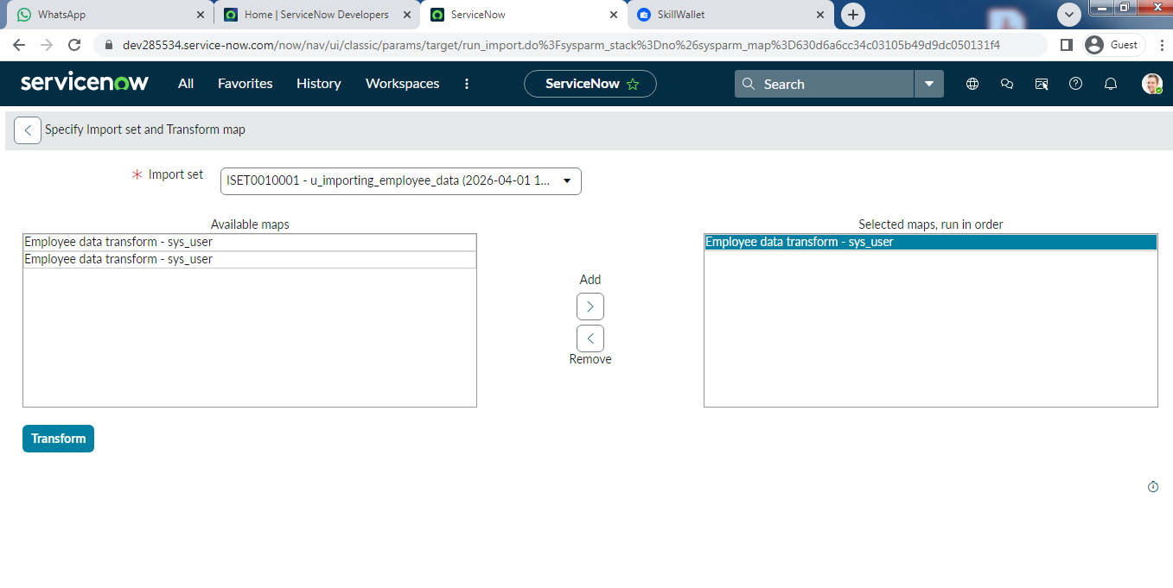
.
- Click on the Transform button and the data transform state is completed.
- Click on ISET0010001 under next steps.
- Four rows are inserted.

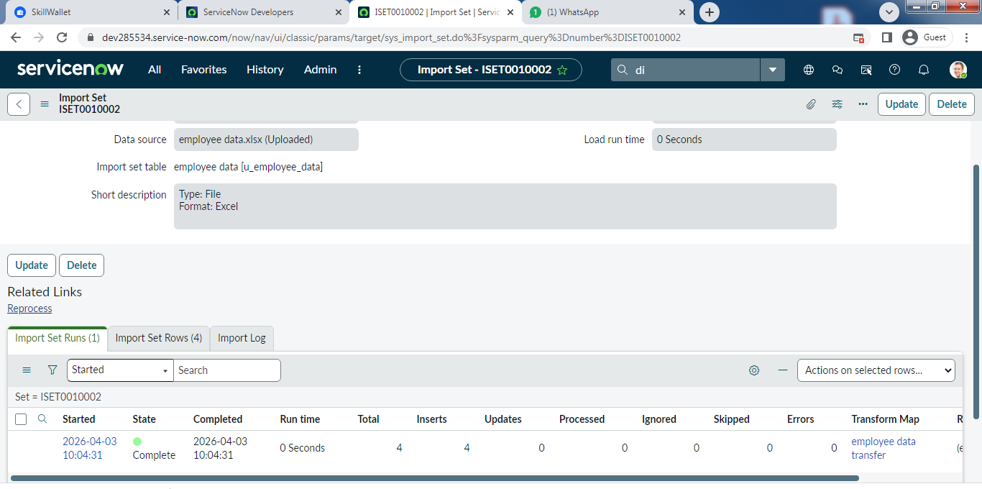

Steps for Dot Walking
- Open service now.
- Click on All >> incident
- Select create new under incidents
- There is no field like department in the form
- Email and manager fields are not visible
- By using dot walking retrieve the data without opening the record
- Click on context menu go to configure and select form layout
- Select assigned to.department as mentioned below
- Click on save
- Add another field assignment.email.
- Also add assignment.manager field
12.Click on save.
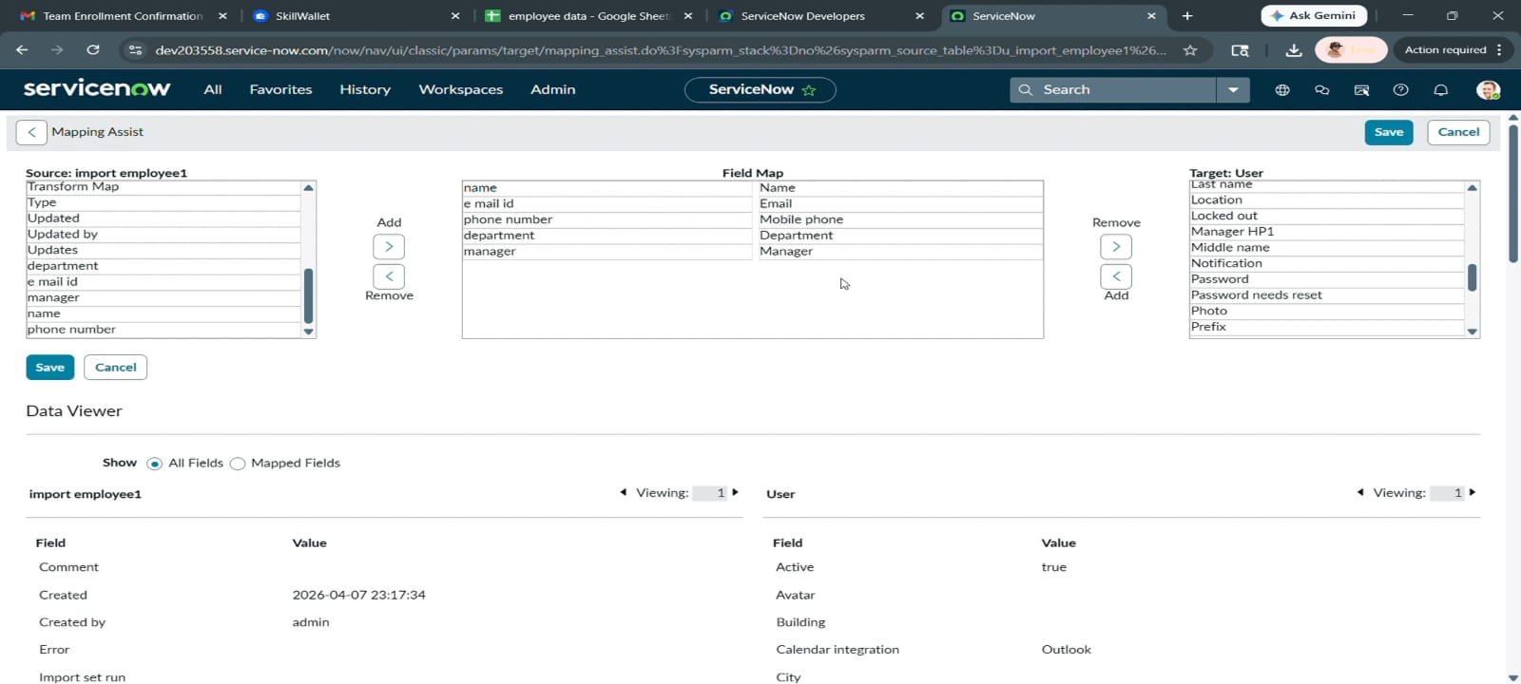
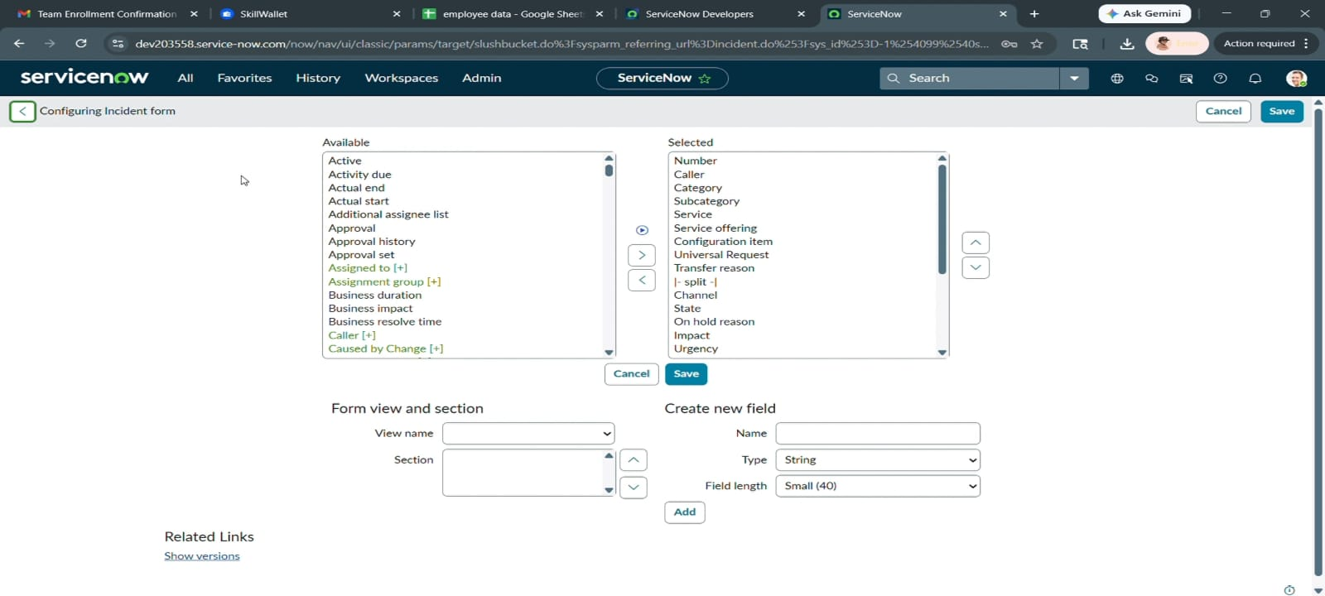
13. Open an incident form
14. Fill the mandatory fields and assigned to just imported user
15. Then department and email field is automatically filled
Testing
- Open the New incident form.
- Insert the assigned to field, then automatically it will update the email, department and manager.
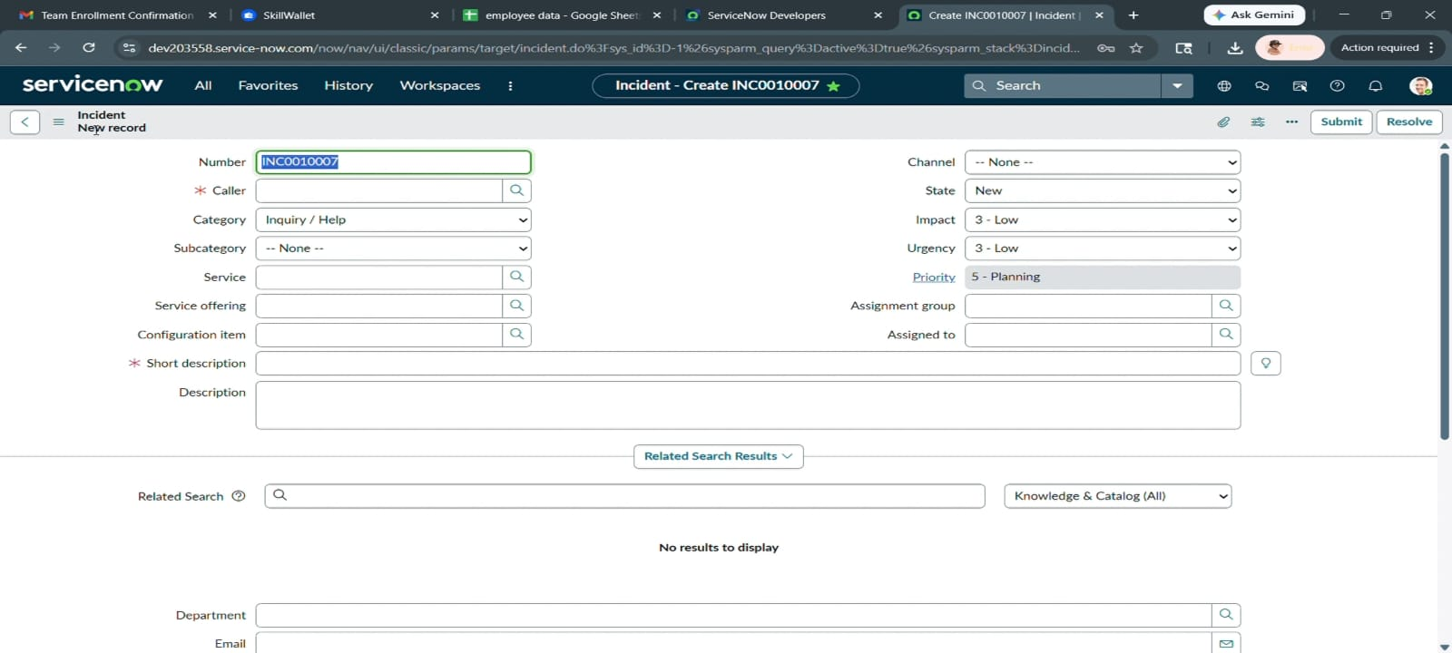
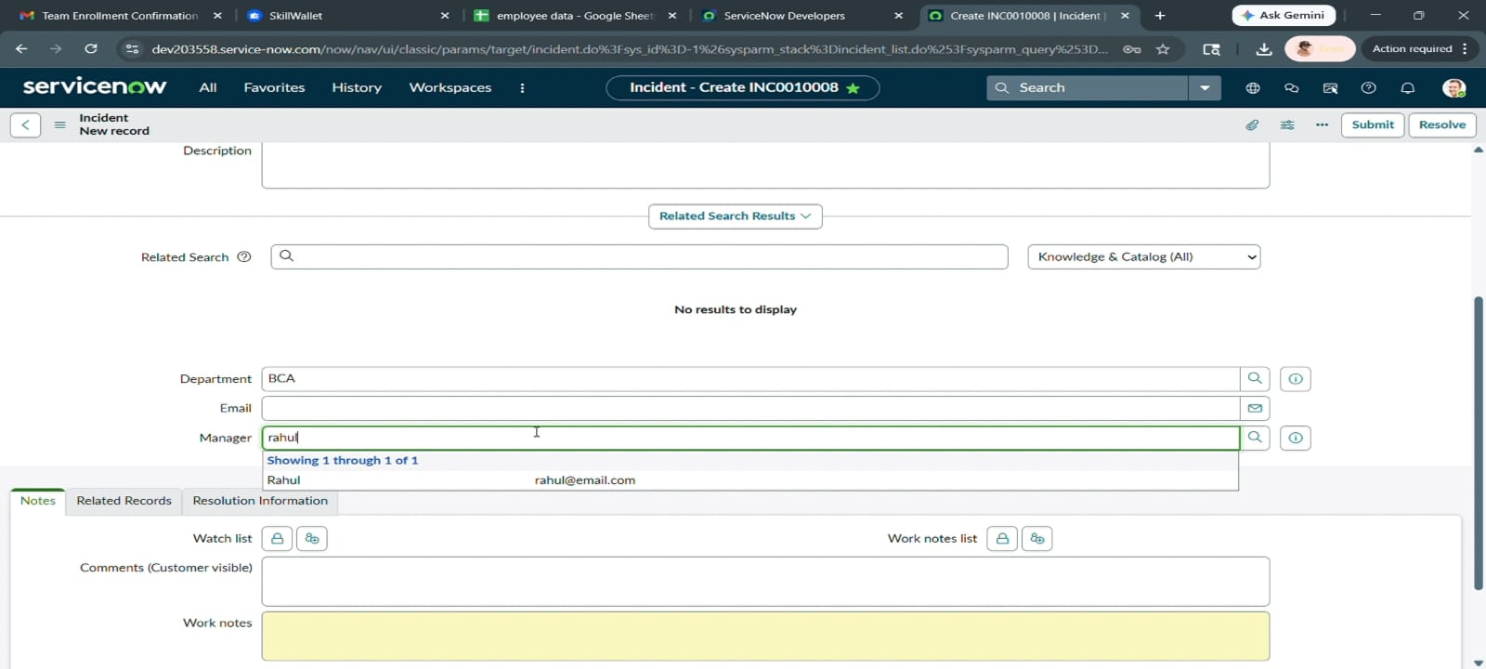
Conclusion
The Automating Employee Data project delivers a reliable and efficient data management solution. It significantly reduces manual workload through intelligent automation. The system ensures high accuracy and consistency of employee records. The solution is scalable and adaptable to future needs. In conclusion, it transforms employee data management into a streamlined and effective process.

