1ST Prompt:
Starting your Bookstore E-commerce App from the backend step by step is a good approach. Here's a detailed guide to get you started on the backend with MERN technologies (Node.js, Express, MongoDB):
Step 1: Setup Project and Install Dependencies
- Initialize a new Node.js project:
bash
mkdir bookstore-backend
cd bookstore-backend
npm init -y
- Install necessary packages:
bash
npm install express mongoose dotenv cors bcryptjs jsonwebtoken
  - express: Web framework for backend.
  - mongoose: MongoDB ODM for schema management.
  - dotenv: For environment variables.
  - cors: Handle cross-origin requests.
  - bcryptjs: Password hashing.
  - jsonwebtoken: JWT-based authentication.
Step 2: Setup Server and Database Connection
- Create a file app.js:
js
const express = require('express');
const mongoose = require('mongoose');
const cors = require('cors');
require('dotenv').config();

const app = express();
app.use(cors());
app.use(express.json());

// Connect to MongoDB
mongoose.connect(process.env.MONGO_URI, { useNewUrlParser: true, useUnifiedTopology: true })
.then(() => console.log('MongoDB connected'))
.catch((err) => console.error('MongoDB connection error:', err));

// Basic route
app.get('/', (req, res) => {
res.send('Bookstore API is running...');
});

const PORT = process.env.PORT || 5000;
app.listen(PORT, () => {
console.log(`Server running on port ${PORT}`);
});
- Add a .env file at root with:
text
MONGO_URI=your_mongo_db_connection_string
Step 3: Define Mongoose Models
- For example, create a models folder and add Product.js for books:
js
const mongoose = require('mongoose');

const productSchema = new mongoose.Schema({
title: { type: String, required: true },
author: { type: String, required: true },
description: String,
price: { type: Number, required: true },
image: String,
createdAt: { type: Date, default: Date.now }
});

module.exports = mongoose.model('Product', productSchema);
Step 4: Setup Basic Routes
- Create routes/productRoutes.js:
js
const express = require('express');
const router = express.Router();
const Product = require('../models/Product');

// GET all products
router.get('/', async (req, res) => {
try {
const products = await Product.find({});
res.json(products);
} catch (error) {
res.status(500).json({ message: 'Server error' });
}
});

// POST create a product
router.post('/', async (req, res) => {
try {
const newProduct = new Product(req.body);
const savedProduct = await newProduct.save();
res.status(201).json(savedProduct);
} catch (error) {
res.status(400).json({ message: 'Invalid data' });
}
});

module.exports = router;
- Import and use routes in app.js:
js
const productRoutes = require('./routes/productRoutes');
app.use('/api/products', productRoutes);

Once these steps are done, you can test your backend with Postman or a similar tool: hitting GET and POST endpoints for products.
Would you like to continue with user authentication next or add more product-related APIs? Let me know!

*How Frontend connects to Backend:
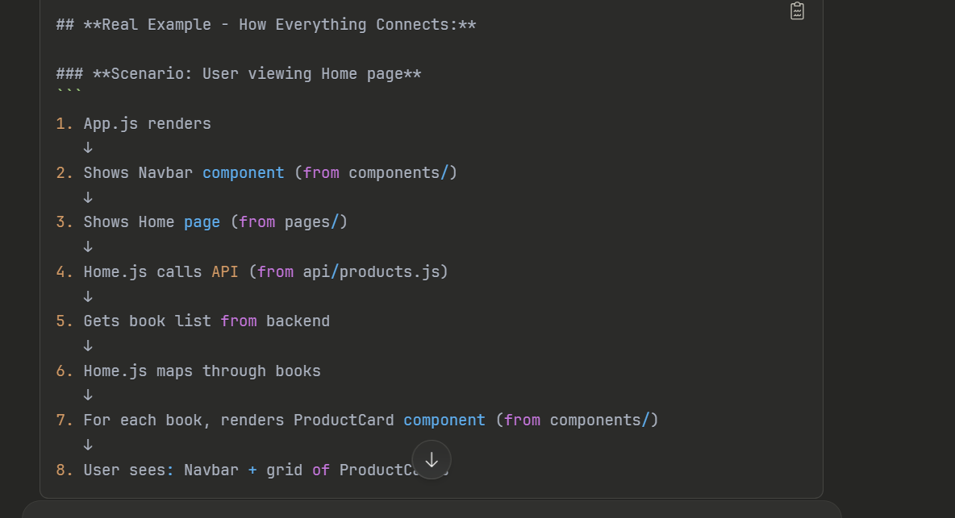
Refer the visual studio project structure

*External endpoints :
1. Stripe API (Payment Processing)
- Purpose: Accept credit/debit card payments (and digital wallets), handle real checkout flows and orders.
- Use cases: Secure “Buy Now” and cart checkout features.
- Docs: Stripe API Documentation

4. Book Reviews/Rating APIs
- Goodreads API (limited/public): Display ratings, reviews from real readers. Goodreads restricted new API keys, so check for alternatives.
- Alternatives: Book Review Aggregator APIs.

5. Social Login (OAuth: Google, Facebook)
- Purpose: Let users login/register to your site using Google/Facebook accounts.
- Use cases: Quicker registration, more secure authentication.
- Docs: See Google OAuth

