Business Insights Assessment
Solution Design
1. Business Requirements
- Pull restaurant order data from SQL Server and process it in AWS.
- Use PySpark for ingestion, cleaning, transformations and business metrics.
- Calculate Customer Lifetime Value (CLV) daily and keep customer-level history.
- Support RFM segmentation, churn indicators, sales trends, loyalty analysis, location performance and discount analysis.
- Use scheduling, encryption, failure/reload handling and an interactive Streamlit dashboard.
- Use GitHub Actions for CI/CD deployment.
2. Proposed Architecture
SQL Server is the source. AWS Glue PySpark jobs ingest and process the data through S3 Bronze, Silver and Gold layers. Amazon Athena queries the Gold data and Streamlit presents the final insights. Glue Workflow controls the job sequence and EventBridge runs the pipeline on a daily schedule. Secrets Manager stores database credentials, KMS provides encryption, and GitHub Actions deploys Glue code changes.
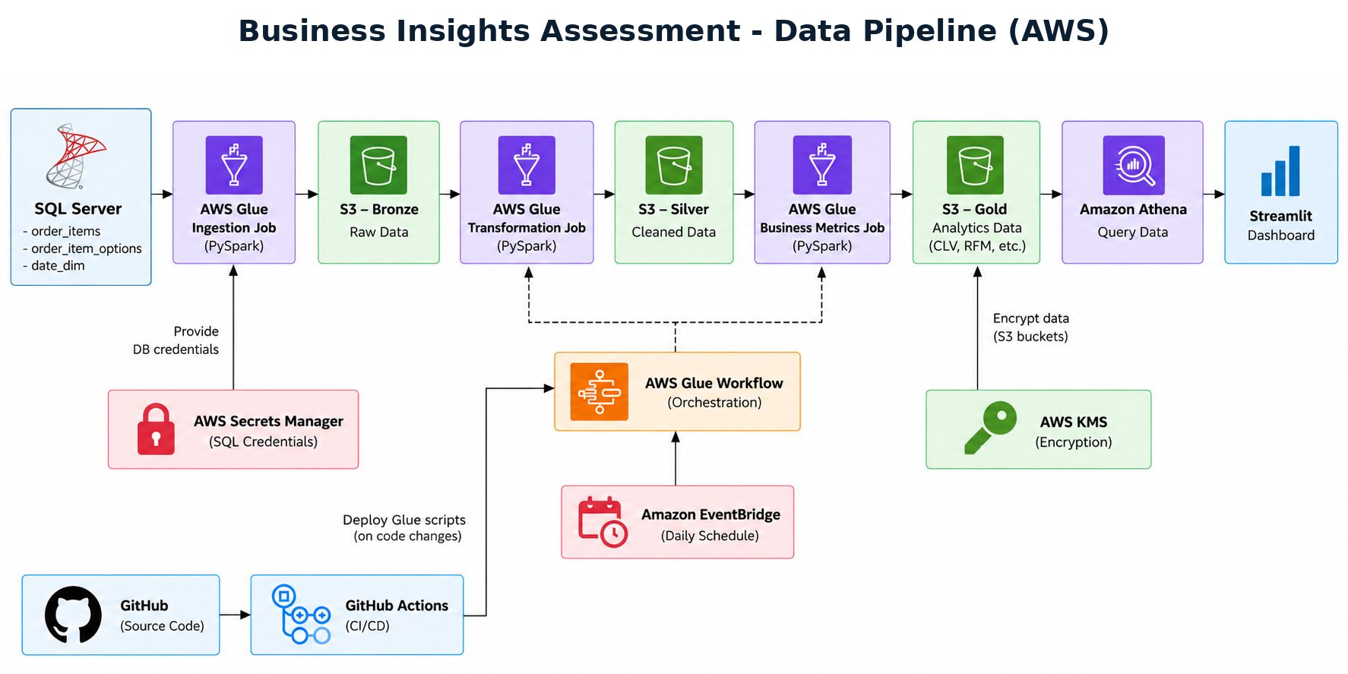
Figure 1. Business Insights - AWS Data Pipeline
3. Pipeline Flow
- SQL Server -> Glue Ingestion: Glue connects through JDBC and loads source tables.
- Bronze: Stores raw source data so it can be reprocessed if needed.
- Bronze -> Silver: Glue cleans, validates, standardizes and writes Parquet data.
- Silver -> Gold: Glue creates CLV and the required business-ready datasets.
- Gold -> Athena -> Streamlit: Athena queries the analytics data and Streamlit displays the dashboard.
- EventBridge -> Glue Workflow: Runs the pipeline daily and keeps dependent jobs in the correct order.
- GitHub -> GitHub Actions -> Glue: Code changes are validated and deployed through CI/CD.
4. Why These Tools
Tool | Why it is used
SQL Server | Required source database for the restaurant tables.
AWS Glue | Runs the PySpark ingestion, transformation and metric jobs without managing servers.
Amazon S3 | Simple, scalable storage for Bronze, Silver and Gold data.
Glue Workflow | Orchestrates jobs and prevents downstream processing when an earlier job fails.
EventBridge | Starts the pipeline on the daily schedule.
Secrets Manager | Keeps SQL Server credentials out of the source code.
AWS KMS | Provides encryption for data stored in AWS.
Amazon Athena | Queries Gold data directly in S3 using SQL.
Streamlit | Provides the interactive business dashboard.
GitHub Actions | Automates CI/CD for validating and deploying Glue scripts.
5. S3 Medallion Design
Bronze: Raw data copied from SQL Server with minimal changes.
Silver: Cleaned, validated and standardized data stored in Parquet.
Gold: Analytics-ready datasets for CLV, RFM, churn, sales, loyalty, locations and discounts.
6. Data Model
The main analytical model is customer-centered. Order data is joined using order_id and lineitem_id, and date_dim supports daily, weekly, monthly and seasonal analysis. The Gold layer keeps a daily customer CLV snapshot so CLV can be tracked over time rather than storing only the latest value.
- Primary output: customer_daily_clv - customer_id, snapshot_date, daily_spend, cumulative_clv, CLV group.
- Additional Gold datasets: RFM/customer segments, churn indicators, sales trends, loyalty comparison, location performance and discount effectiveness.
7. Incremental Load and Failure Handling
The SQL Server ingestion should use a watermark such as creation_time_utc to pull only new or changed records after the previous successful run. The watermark is updated only after a successful load.
- If ingestion fails, the watermark is not advanced, so the same data can be retried.
- Bronze data is preserved so failed transformation jobs can be rerun.
- Glue Workflow starts downstream jobs only after the required previous job succeeds.
- CloudWatch logs can be used to troubleshoot failed Glue runs.
8. Analytics and Dashboard
The Streamlit dashboard will show customer CLV and value groups, RFM segments, churn-risk indicators, sales and seasonal trends, loyalty vs. non-loyalty performance, restaurant location performance, and discount/promotion effectiveness.
9. CI/CD
Glue PySpark scripts are stored in GitHub. On approved code changes, GitHub Actions can run basic checks, upload the scripts to the project S3 script location and update the Glue jobs. This keeps deployment repeatable and avoids manually copying code into Glue.
10. Project Deliverables
- Pipeline architecture diagram and this solution design document.
- PySpark ETL scripts and PySpark/SQL metric queries.
- Setup/configuration files required by the project.
- Streamlit dashboard.
- GitHub Actions CI/CD workflow.
- Short project video explaining the pipeline, dashboard and why each technology was chosen.

