Assignment report

**GROUP**

**NAME ROLL NO**

SANJAY RAGHUWANSHI 140107053

AKSHAY GUPTA 140107007

# TASK 1: BAYESIAN CLASSIFIER PART (a)

1. **When the samples of a given characters are modelled by separate covariance matrix.**

**Accuracy of character E is : 94**

**Accuracy of character C is : 90**

**Accuracy of character L is : 97**

**Overall Accuracy of the this model is : 93.667**

1. **When the samples of all given characters are pooled to generate a common diagonal covariance matrix.**

**Accuracy of character E is : 84**

**Accuracy of character C is : 76**

**Accuracy of character L is : 98**

**Overall Accuracy of the this model is : 86**

1. **When the covariance matrix of each class is forced to be identity matrix.**

**Accuracy of character E is : 87**

**Accuracy of character C is : 85**

**Accuracy of character L is : 100**

**Overall Accuracy of the this model is : 90.6667**

**Here we use the regularization term to be 0.7.**

# PART (b)

**For part (i) following images are misclassified:**

**For character E : 201 222 230 234 245 247**

**For character C : 205 221 222 223 238 274 288 293 295 299**

**For character L : 226 239 244**

## For part (ii) following images are misclassified

**For character E : 215 216 218 219 220 222 223 228 229 230 234 241 245 255 264 275**

**For character C : 210 212 214 221 223 233 234 238 242 245 248 249 250 256 259 267 270 273 274 279 282 283 284 285**

**For character L :** **246 247**

## For part (iii) following images are misclassified

**For character E : 215 216 218 219 222 223 229 230 236 241 245 254 255**

**For character C : 210 212 214 221 223 234 238 242 245 250 256 273 274 283 285**

**For character L : NONE**

# TASK 2: GMM BASED CLUSTERING PART (a) Segmented Output

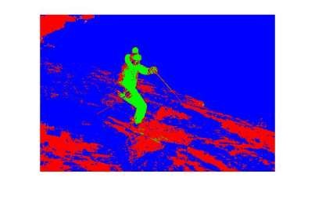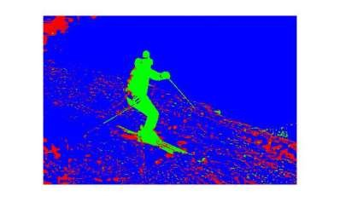

*Figure 1 Output for 1 iteration* *Figure 2 Output for 2 iteration*

*Figure 3 Output for 3 iteration**Figure 4 Output for 4 iteration*

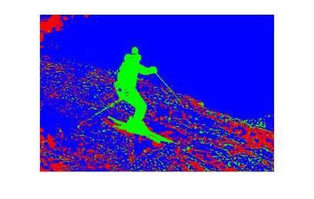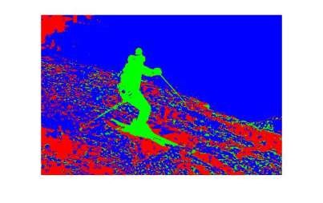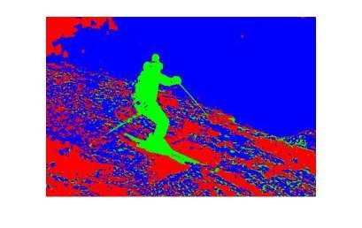

*Figure 5 Output for 5 ite*

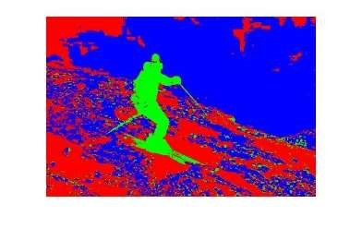

*Figure 6*

*Output for 1*

*0*

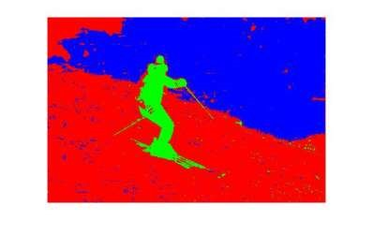

*Figure 9 Output for 5*

*0*

*iteration*

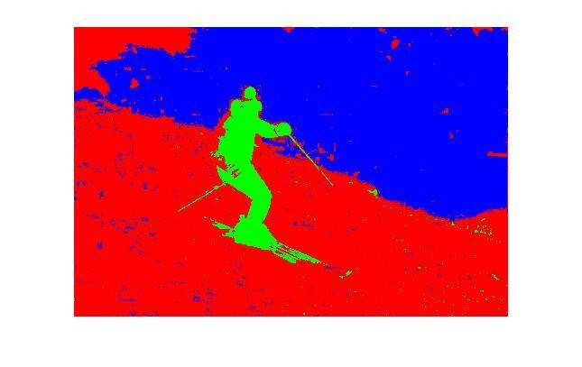

*Figure*

*1*

*Output for 100*

*iteration*

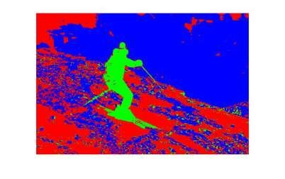

*Figure 7 Output for 15*

*iteration*

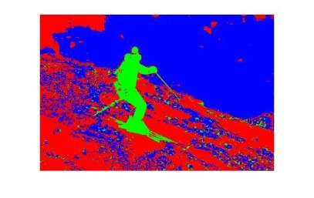

*Figure 8 Output for 25*

*iteration*

# 

# PART (b)

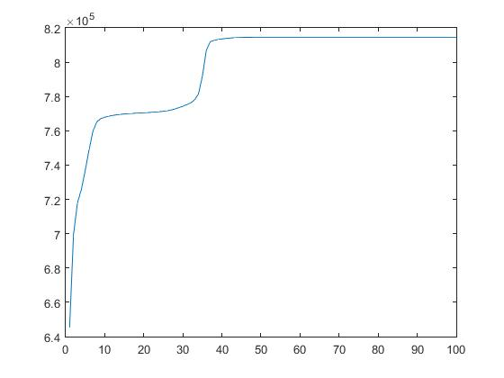

*Figure : Log likelihood function for 100 iterations*

# TASK 3

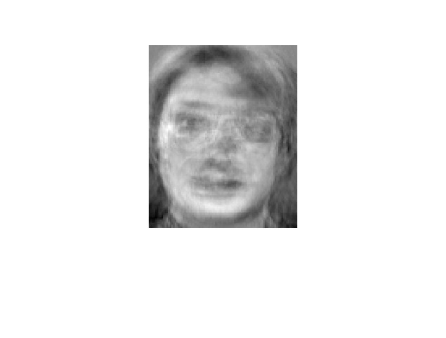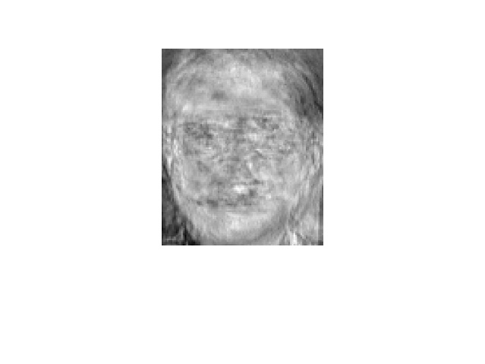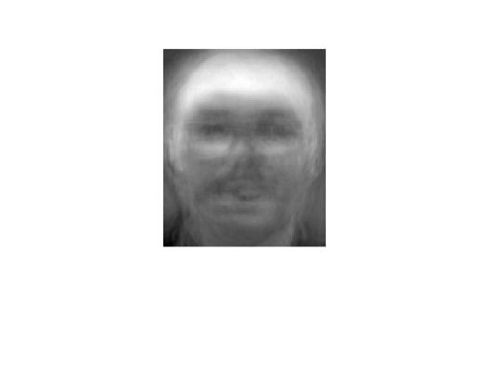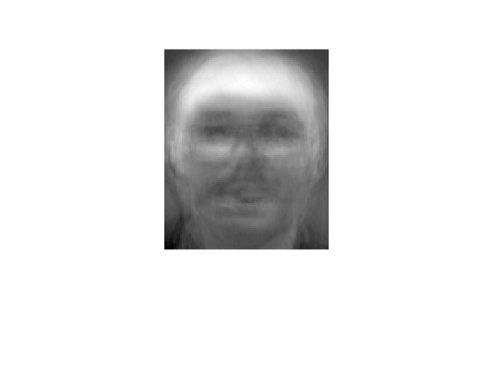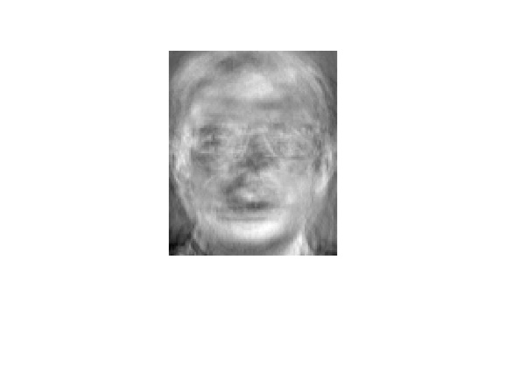*Figure 1 Output for To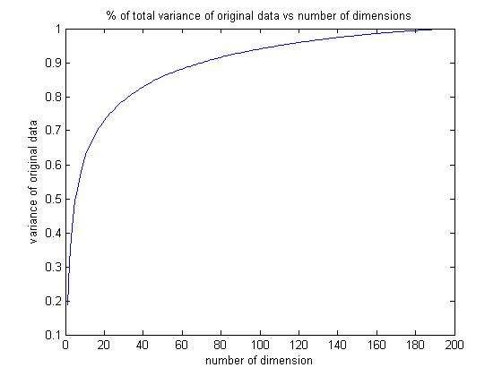p five eigen faces*

*Figure 4 Total variance vs no of dimensions*

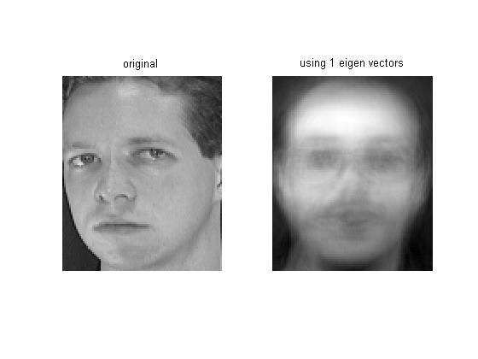

*Figure*

*6*

*face input 1 reconstruction using largest eigenvector*

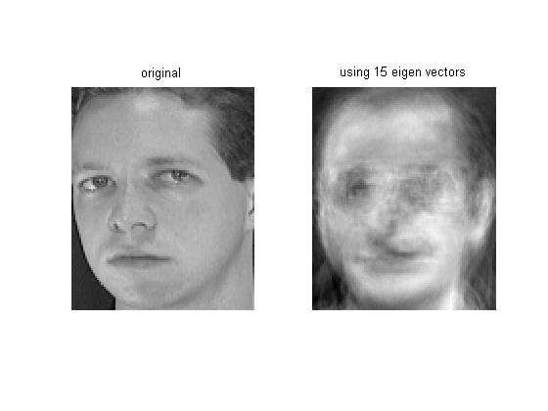

*Figure*

*5*

*face input 1 reconstruction us*

*i*

*ng*

*top 15*

*eigenvector*

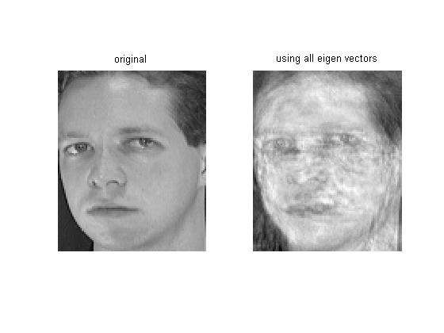

*Figure*

*8*

*fac*

*e input 1 reconstruction using all*

*eigenvector*

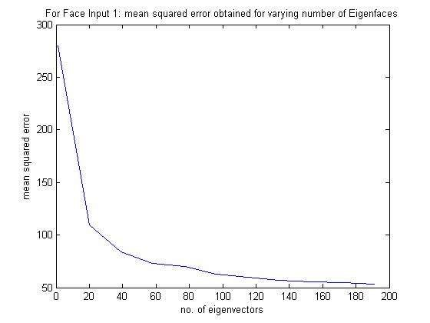

*Figure 7 Mean squared error for face input 1 for different eigenvectors*

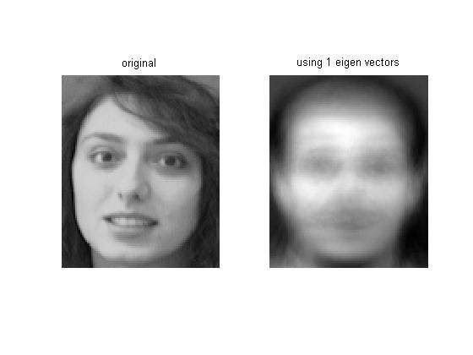

*Figure*

*10*

*face i*

*nput 2 reconstruction using largest*

*eigenvector*

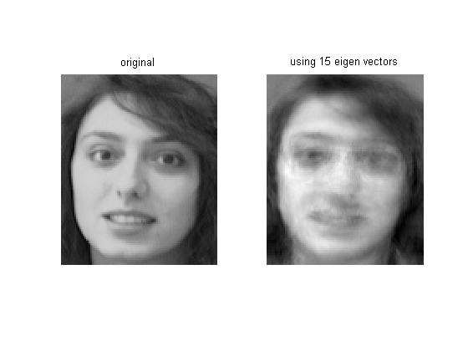

*Figure*

*9*

*face*

*input 2 reconstruction using top 15*

*eigenvector*

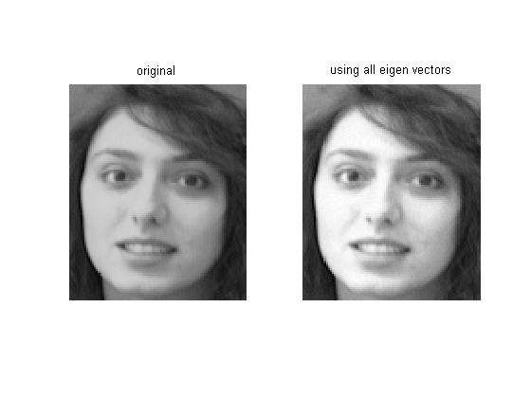

*Figure*

*12*

*fac*

*e input 2 reconstruction using all*

*eigenvector*

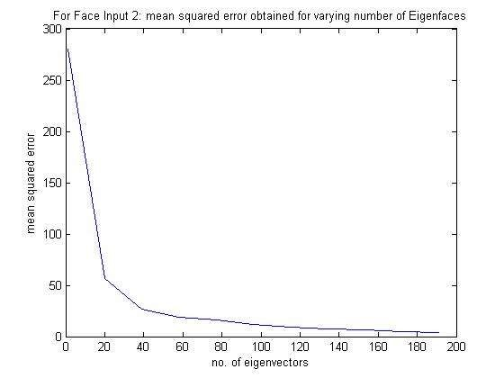

*Figure 11 mean squared error for face input 2*

Task 4

SVM

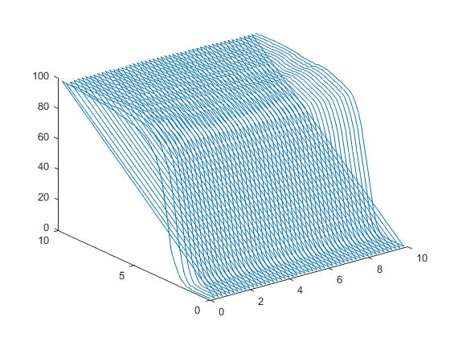

Figure c vs g vs accuracy