**TICKET AUTOMATION SYSTEM USING RPA**

1. SANJAY.R. B, KGiSL Instiute of Technology, Coimbatore.

2.SAM DANY.R, KGiSL Institute of Technology, Coimbatore.

3. RAMSHANKARAN.Y, KGiSL Institute of Technology, Coimbatore.

4. PRATHVIK.S, KGiSL Institute of Technology, Coimbatore.

**ABSRTACT**

Under the acceleration of the wheel of technology around the world, various ways of automating information have occurred to replace old-fashioned ways that don't serve the pace of everyday lifestyle. There are many things that we should change in our work systems such as paper, stand-alone systems, phone calls or even email. Every kind of companies has different sections that help the process of paperwork concerning personnel and maintenance. However, some of this paperwork might be overlooked or delayed, which could lead to slow down the outcome of the organization. So, they need to improve their system work to save time, effort and make an efficient mechanism to follow requests and tickets of any organization or customer. So, we should replace any old system with RPA to facilitate the work of supporting and following tickets. As a solution to that, we have come with the idea of the " Ticket Automation System Using RPA." The application aim is to eliminate manual intervention in ticket creation and it raise a ticket based on the complaint mail. If the details are incomplete (e.g. customer id is missing), send a mail to customer asking for missing details and Link the subsequent responses from the customer to the original ticket. Recognize the bounced mails and initiate appropriate action via sending auto response to template-based mails (complaints/queries) i.e. no free text. It is a modern way to solve problems.

**KEYWORDS**

NLP, Gensim, Heapq, Uipath.

**1.INTRODUCTION**

The ticket automation is playing a huge role in maintaining a successful support operation and is helping to revolutionize the industry. The days of the “gatekeeper” that directed customer support issues to the right people are over. Now, with customer support software and ticket automation, triggers can be created so if a ticket is submitted via email or a customer portal it goes to a specific agent or group. For example, a trigger where the subject line contains the word “how” (i.e. how do I add a user) could automatically route all emails to the training group. And it also Remind customers to follow up, Close tickets automatically, Get alerts for urgent tickets, Weekends and holidays

**2. LITERATURE REVIEW**

Management and maintenance of IT infrastructure resources such as hardware, software and network is an integral part of software development and maintenance projects. Service management ensures that the tickets submitted by users, i.e. software developers, are serviced within the agreed resolution times. Failure to meet those times induces penalty on the service provider. To prevent a spurious penalty on the service provider, nonworking hours such as waiting for user inputs are not included in the measured resolution time, that is, a service level clock pauses its timing. Nevertheless, the user interactions slow down the resolution process, that is, add to user experienced resolution time and degrade user experience. Therefore, this work is motivated by the need to analyse and reduce user input requests in tickets’ life cycle. To address this problem, we analyse user input requests and investigate their impact on user experienced resolution time. We distinguish between input requests of two types: real, seeking information from the user to process the ticket and tactical, when no information is asked but the user input request is raised merely to pause the service level clock. Next, we propose a system that pre-empts a user at the time of ticket submission to provide additional information that the analyst, a person responsible for servicing the ticket, is likely to ask, thus reducing real user input requests. Further, we propose a detection system to identify tactical user input requests. To evaluate the approach, we conducted a case study in a large global IT company. We observed that around 57% of the tickets have user input requests in the life cycle, causing user experienced resolution time to be almost twice as long as the measured service resolution time. The proposed pre-emptive system pre-empts the information needs with an average accuracy of 94–99% across five cross validations while traditional approaches such as logistic regression and naive Bayes have accuracy in the range of 50–60%. The detection system identifies around 15% of the total user input requests as tactical. Therefore, the proposed solution can efficiently bring down the number of user input requests and, hence, improve the user-experienced resolution time.

**3. EXISTING SYSTEM**

In existing system Man power is required to assign a unique ticket. It also saves the solved solutions in a database in order to solve when the same queries arise. So typically, there will be two teams

1. Support team
2. Technical support team

Tickets will be analysed and redirected to the technical support team by the support team.

Customers can call only to the support team and further procedures will be done by the support team

**3.1. DISADVANTAGES**

Since the system needs manpower it requires funding for those people.

And if they seem to do OT then an extra funding should be arranged to fulfil their needs. It also includes the Computer usage and energy consumption according to the manpower. In general humans cannot work continuously so they need to provide the working timings to the customers and this may lead a customer to avoid our products. In Business, customer satisfaction plays a important role in order to promote the product so their interest is more important than our hardships.

In some organizations they have also installed a third-party Ticket automation software. So that system analyses the queries raised by the customers and it assigns the ticket and redirects to the technical support team. But this software is best suited for large scale industries and it also grabs a fund from the organisation.

**3.2 PROPOSED SYSTEM**

The proposed system is RPA bot which uses NLP algorithm to solve the user’s queries. This system should be able to analyse and understand user’s queries and react accordingly. For any product related queries, we have put a mail to customer support team and it will be forwarded to the particular domain members in order to provide the solution. Frequently solved queries will be stored in the database to provide solutions when the similar queries raised by the user. Without this system an organisation needs a team for assigning the tokens to the domain related persons.

Our system is built using NLP algorithms that analyses user’s queries and understand user’s message. The system is designed for support team in all product organisations where users can ask any product related questions. The system recognizes user’s query and understands what he wants to convey and simultaneously answers them appropriately. The NLP algorithm analyses users queries then convert into tokens. Then the tokens are assigns to the persons in the particular domain. The main workflow of our system

* + - Get the complaint mails from the users.
    - Segregate the mail, understands the user queries and assign the ticket to the particular complain mail.
    - If the queries already solved, then replay with the existing solution and close the ticket.
    - If the problem is not solved then perform the analysis on the mail and raise the ticket to appropriate person.

**3.3. ADVANTAGES**

Since our system is built using Uipath it can be bought by any organization that can be a small scale or large scale and they can be utilized as long as they need. For updates, it requires only one technical person and this system is capable to run in as many systems in parallel. Comparing to other software, it is one of the cheapest software in the market and it won’t require any services at a higher level. It uses excel as the backend, it’s also a user-friendly application.

**4.RESULTS**

This system is been implemented as follows:

Initailly the bot starts its work by getting credentials from the user and if he/she is a valid user the he/she will be redirected to the mail trigger module

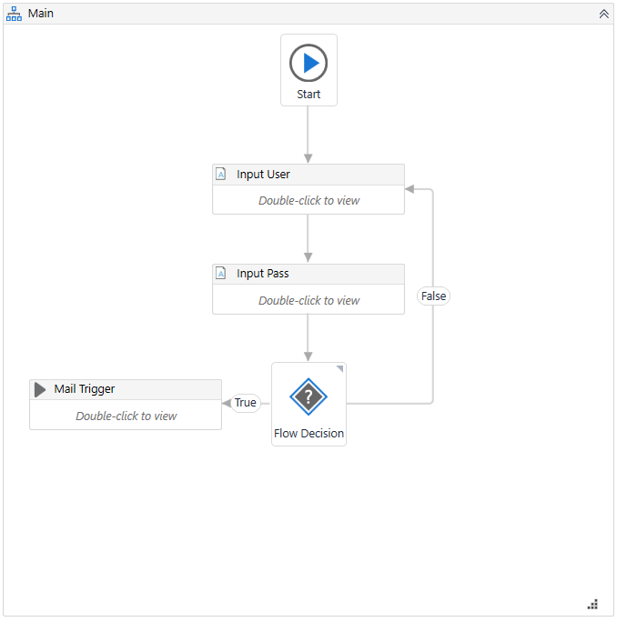

**4.1.Mail trigger**

In the Mail trigger module the real work starts this mail trigger will be running at the background synchronously to get the mail from the organisation mail inbox if there is no email it will wait for 1 minute else if a new mail comes it will redirect it to the check mail module.

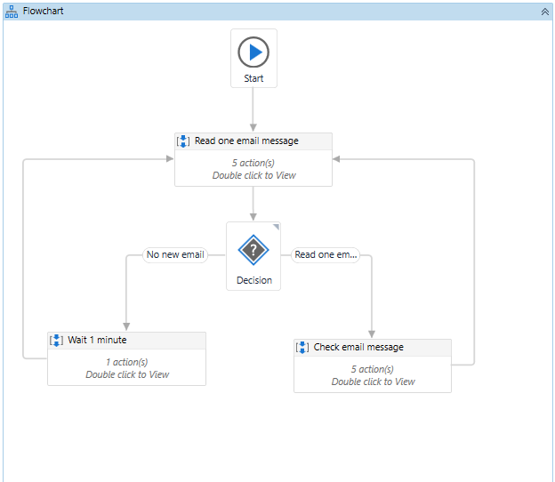

**4.2.Check Email Message**

In this module the mail will be analysed and extracts the text and sends a response email to the respective customer after sending the response mail it will be redirected to the process mail module.

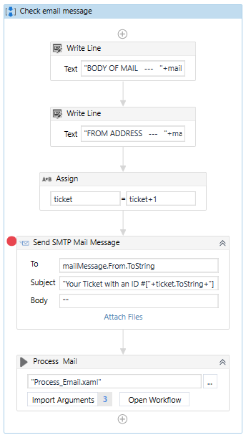

**4.3.Process mail**

This module initially loads the obtained text information’s from the previous module the python script which uses NLP and Gensim in order to make the unstructured data to structured by removing space, special characters. Then call getsummary() method gets the summary and getkeywords() method gets the keywords and after generating the summary it will be redirected to the check mail module.

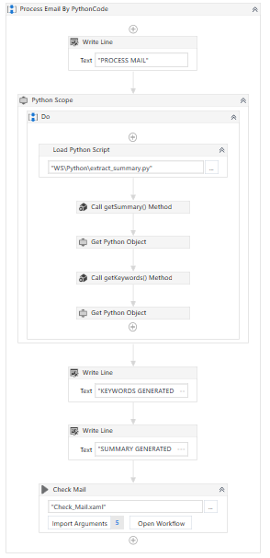

**4.4.Check Mail**

This module checks with Datastore module whether this problem is solved already or not if it exists it replies with that solution else it raises a ticket to the technical support team.

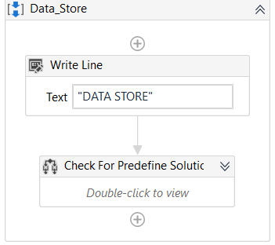

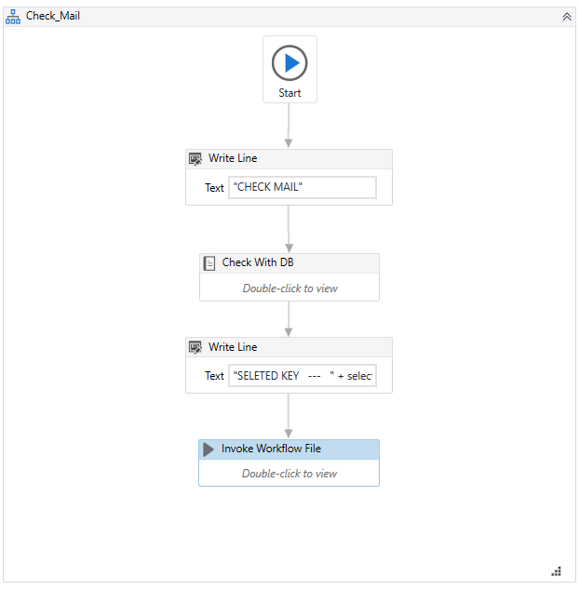

**4.5.Database Design:**

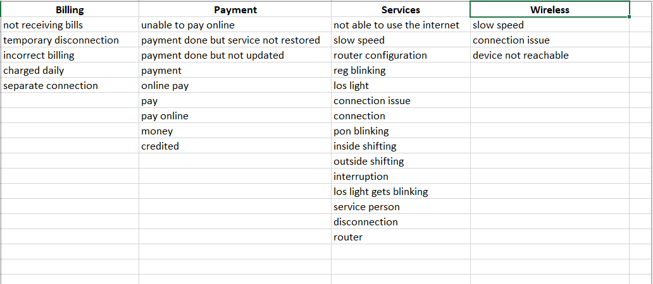



**5.CONCLUSION**

In the proposed Ticket automation System, the manual intervention of the ticket creation is eliminated it raise a ticket based on the complaint mail. If the details are incomplete (e.g. customer id is missing), send a mail to customer asking for missing details and Link the subsequent responses from the customer to the original ticket. Recognize the bounced mails and initiate appropriate action via sending auto response to template-based mails (complaints/queries)

i.e. no free text. This system makes short time response to the customer.

## 6. FUTURE ENHANCEMENT

A login account can be created which deals with customer support services instead of giving queries in the mail. So, this serves as a private login which helps the user to define their queries using the predefined keywords and the customer id can be easily notified to the company with the help of their login id. This eliminate the process of sending the mails regarding the incomplete data (e.g. customer id is missing) to the customer. The system which has this RPA workflow can be considered as a hub system and this hub plays as a role of routing the tickets to the particular persons system(node) according to their domain. This overcomes the process of installation of this workflow in all the system.

**7.REFERENCES**

1. S. Agarwal, R. Sindhgatta, B. Sengupta **SmartDispatch: enabling efficient ticket dispatch in an IT service environment** Proceedings of the 18th ACM SIGKDD international conference on Knowledge discovery and data mining (2012), pp. 1393-1401
2. C. Aggarwal, C. Zhai**A survey of text classification algorithms**

Mining Text Data, Springer, Boston, MA (2012), pp. 163-222

1. A. Cater-Steel, R. Valverde, A. Shrestha, M. Toleman**Decision support systems for IT service management**

Int. J. Inf. Decision Sci. (2016)

1. S. Foo, S.C. Hui, P.C. Leong, S. Liu**An integrated help desk support for customer services over the World Wide Web – a case study**

Comput. Ind., 41 (2000), pp. 129-145

J. Greer, G. McCalla, J. Cooke, J. Collins, V. Kumar, A. Bishop, J. Vassileva**Th e intelligent helpdesk: supporting peer-help in a university course** International Conference on Intelligent Tutoring Systems (1998), pp. 494-503

1. M. Jäntti **Examining challenges in IT service desk system and processes: a case study**

In the Seventh International Conference on Systems (ICONS) (2012), pp. 105108

1. A. Joulin, E. Grave, P. Bojanowski, T. Mikolov**Bag of tricks for efficient text classification**

Short Papers

Proceedings of the 15th Conference of the European Chapter of the Association for Computational Linguistics (2017), pp. 427-431

1. X. Tang, Y. Todo**A study of service desk setup in implementing IT service management in enterprises**

Technol. Investment, 4 (3) (2013), pp. 190-196

1. A. Tanovic, N.E. Mastorakis**Advantage of using service desk management systems in real organizations**

Int. J. Econ. Manage. Syst., 1 (2016), pp. 81-86

[10] X. Zhu, W. Zhou, T. Li**A visual tool for ticket monitoring and management**

2017 IEEE 12th International Conference on Intelligent Systems and Knowledge Engineering (ISKE) (2017), p. 107