1. Write a program to print ‘Welcome to Java’.

**Code**

class Hello

{

public static void main(String args[])

{

System.out.println("Welcome To Java");

}

}

**Output**

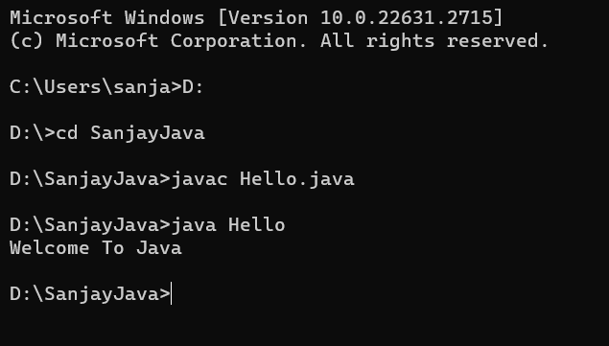

1. WAP to display two numbers received as command line argument, and print its product.

**Code**

class Java12

{

public static void main(String args[])

{

int a=Integer.parseInt(args[0]);

int b=Integer.parseInt(args[1]);

System.out.println("Product of "+a+" and "+b+" is "+a*b);

}

}

**Output**

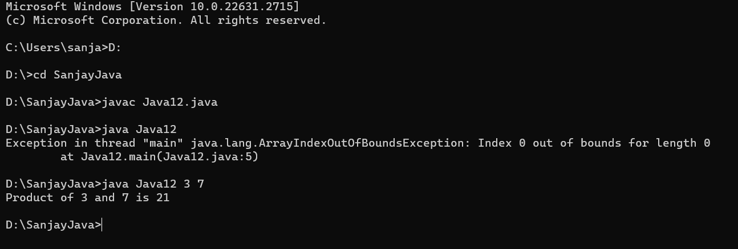

1. WAP to read two numbers and display the output in the form of ‘Sum of 2 and 3

**Code**

import java.io.*;

class Java13

{

public static void main(String args[])

{

DataInputStream in=new DataInputStream(System.in);

try{

System.out.println("Enter no1");

int n1=Integer.parseInt(in.readLine());

System.out.println("Enter no2");

int n2=Integer.parseInt(in.readLine());

System.out.println("Sum of "+n1+" and "+n2+" is "+(n1+n2));

}catch(Exception e)

{

System.out.println(e);

}

}

}

**Output**

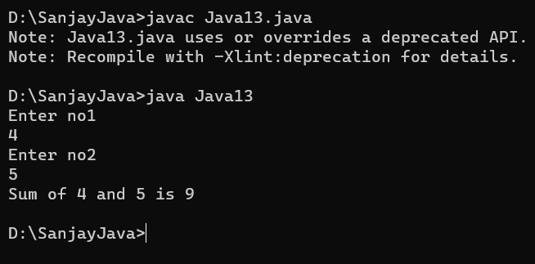

1. WAP to accept two numbers from the keyboard and swap them.

**Code**

import java.io.*;

class Java14

{

public static void main(String args[])

{

int n1,n2,n3,temp=0;

DataInputStream in=new DataInputStream(System.in);

try{

System.out.println("Enter no1");

n1=Integer.parseInt(in.readLine());

System.out.println("Enter no2");

n2=Integer.parseInt(in.readLine());

System.out.println("Before swapping n1 = "+n1+" n2 = "+n2);

temp=n1;

n1=n2;

n2=temp;

System.out.println("After swapping n1 = "+n1+" n2 = "+n2);

}catch(Exception e)

{

System.out.println(e);

}

}

}

**Output**

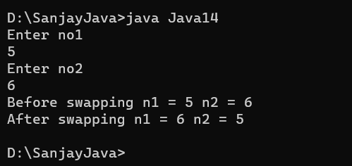

1. WAP to read three numbers and the maximum.

**Code**

import java.io.*;

class Java22

{

public static void main(String args[])

{

int n1,n2,n3,min=0;

DataInputStream in=new DataInputStream(System.in);

try{

System.out.println("Enter no1");

n1=Integer.parseInt(in.readLine());

System.out.println("Enter no2");

n2=Integer.parseInt(in.readLine());

System.out.println("Enter no3");

n3=Integer.parseInt(in.readLine());

min=Math.min(Math.min(n1,n2),n3);

System.out.println("Smallest is :"+min);

}catch(Exception e)

{

System.out.println(e);

}

}

}

**Output**

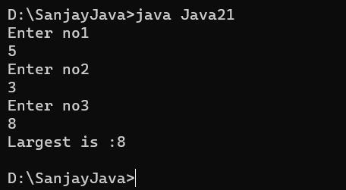

1. Find the minimum of three numbers using a single statement.

**Code**

import java.io.*;

class Java22

{

public static void main(String args[])

{

int n1,n2,n3,min=0;

DataInputStream in=new DataInputStream(System.in);

try{

System.out.println("Enter no1");

n1=Integer.parseInt(in.readLine());

System.out.println("Enter no2");

n2=Integer.parseInt(in.readLine());

System.out.println("Enter no3");

n3=Integer.parseInt(in.readLine());

min=Math.min(Math.min(n1,n2),n3);

System.out.println("Smallest is :"+min);

}catch(Exception e)

{

System.out.println(e);

}

}

}

**Output**

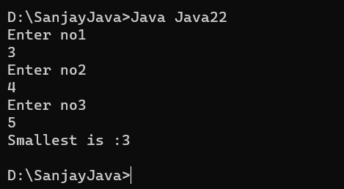

1. WAP to search for a given element in an array.

**Code**

import java.io.*;

class Java23

{

public static void main(String args[])

{

int a[]={};

int n,s,i,flag=0;

DataInputStream in=new DataInputStream(System.in);

try{

System.out.println("Enter the size of array");

n=Integer.parseInt(in.readLine());

a=new int[n];

System.out.println("Enter the array");

for(i=0;i<n;i++)

{

a[i]=Integer.parseInt(in.readLine());

}

System.out.println("Enter the value to search");

s=Integer.parseInt(in.readLine());

for(i=0;i<n;i++)

{

if(a[i]==s)

{

System.out.println("Element found at "+i+" position");

flag=1;

break;

}

}

if(flag==0)

System.out.println("Element not found");

}catch(Exception e)

{

System.out.println(e);

}

}

}

**Output**

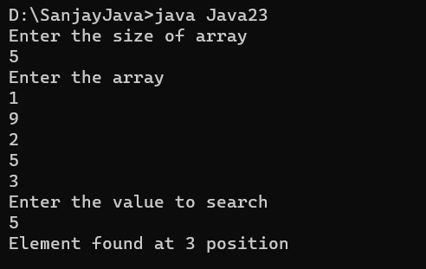

1. WAP to sort elements in an array in ascending order.

**Code**

import java.io.*;

class Java24

{

public static void main(String args[])

{

int a[]={};

int n,temp,i,j;

DataInputStream in=new DataInputStream(System.in);

try{

System.out.println("Enter the size of array");

n=Integer.parseInt(in.readLine());

a=new int[n];

System.out.println("Enter the array");

for(i=0;i<n;i++)

{

a[i]=Integer.parseInt(in.readLine());

}

for(i=0;i<n-1;i++)

for(j=i+1;j<n;j++)

if(a[i]>a[j])

{

temp=a[i];

a[i]=a[j];

a[j]=temp;

}

System.out.println("Sorted array");

for(i=0;i<n;i++)

{

System.out.print(" "+a[i]);

}

}catch(Exception e)

{

System.out.println(e);

}

}

}

**Output**

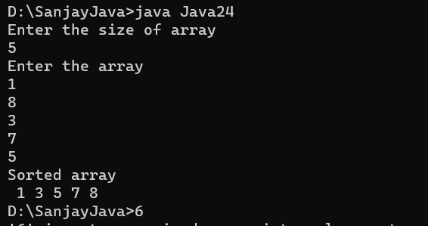

1. Write a program to print the row wise and column wise sum of a 2D array.

**Code**

import java.io.*;

class Java25

{

public static void main(String args[])

{

int a[][]={};

int n,temp,i,j,sumr,b[]={};

DataInputStream in=new DataInputStream(System.in);

try{

System.out.println("Enter the size of array");

n=Integer.parseInt(in.readLine());

a=new int[n][n];

b=new int[n];

System.out.println("Enter the array");

for(i=0;i<n;i++)

b[i]=0;

for(i=0;i<n;i++)

for(j=0;j<n;j++)

{

a[i][j]=Integer.parseInt(in.readLine());

b[j]=b[j]+a[i][j];

}

System.out.println("2D Matrix");

for(i=0;i<n;i++)

{

sumr=0;

for(j=0;j<n;j++)

{

System.out.print(a[i][j]+" ");

sumr=sumr+a[i][j];

}

System.out.print(" |"+sumr);

System.out.println();

}

for(j=0;j<n;j++)

System.out.print(" "+b[j]);

}catch(Exception e)

{

System.out.println(e);

}

}

}

**Output**

