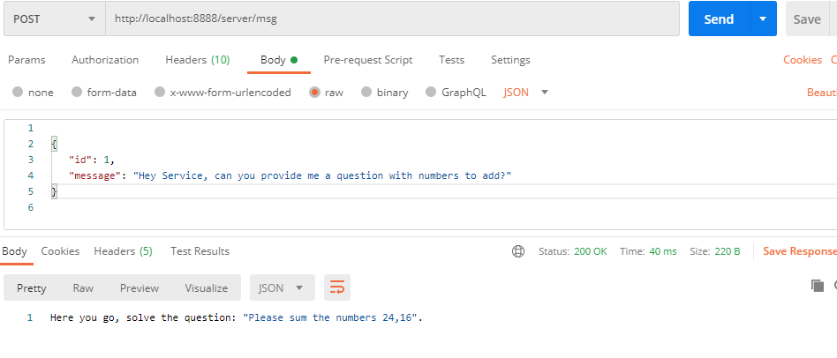

In Console –

Message: Hey Service, can you provide me a question with numbers to add?

Here you go, solve the question: "Please sum the numbers 24,16".

