- Region problem
Resolved cross-region incompatibility between AWS Lambda and S3 by redesigning architecture to ensure triggers functioned correctly.
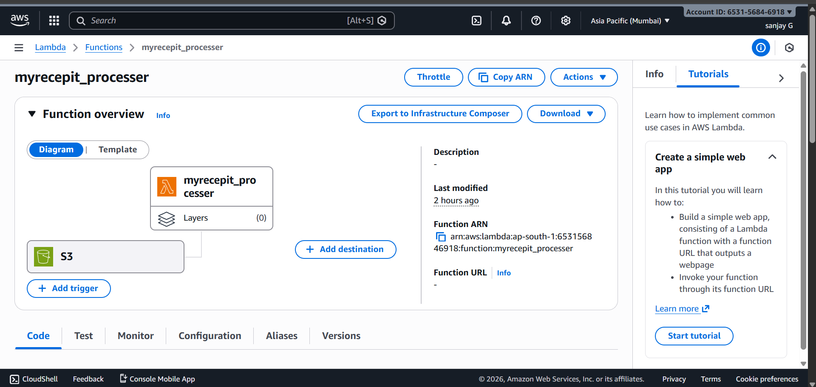
- Subcription error
This error is coming from AWS Textract’s AnalyzeExpense API.
Cause: The AnalyzeExpense operation is part of Textract’s advanced features (like invoice/receipt parsing). These require explicit subscription/enablement in my AWS account.
