# Create a new App Service plan

An App Service plan defines a set of compute resources for a web app to run. These compute resources are analogous to the server farm in conventional web hosting. One or more apps can be configured to run on the same computing resources (or in the same App Service plan).

In this article, we will see how to create an **App Service plan**.

**Step 1**- Go to Azure portal and click on “**Create a resource**” button on left hand navigation at the top.

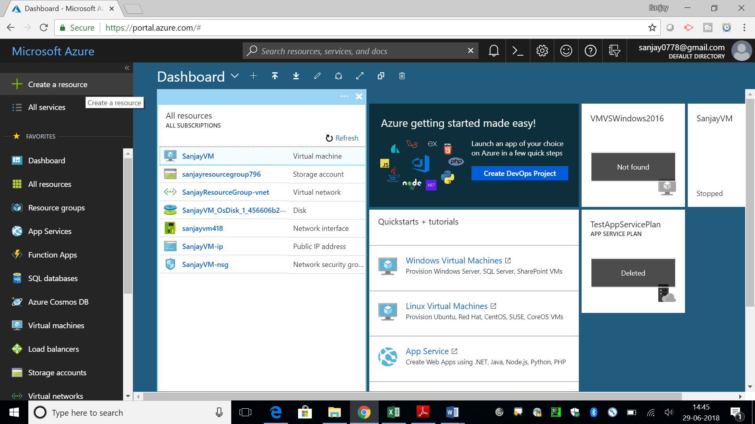

**Step 2**- Type **App service** in search box and select **App service plan** from drop down.

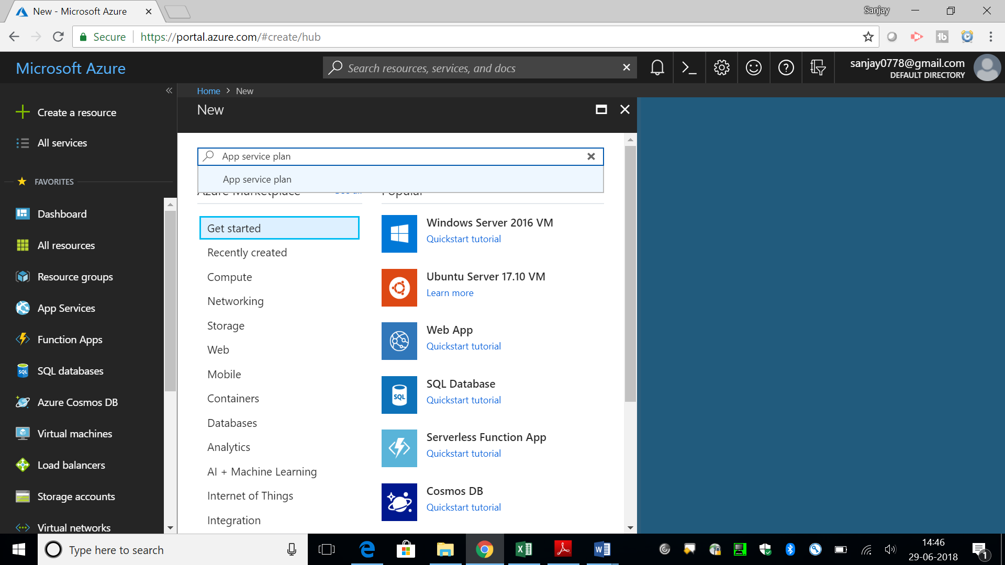

**Step 3**- Click on **Create** button to create new **App Service Plan**.

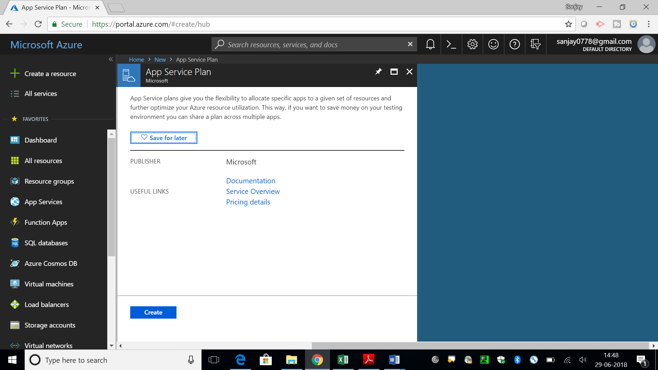

**Step 4** – Give name of your **App Service Plan (SanjayAppServicePlan)**, select **Subscription (Free Trial)**, **Resource Group (SanjayResourceGroup)**, Operating System (e.g **Windows**), **Location** (**West India**) and **Pricing Tier** (e.g **S1 Standard** license). Check **Pin to dashboard** checkbox at bottom to add it to your **Dashboard**.

There are different **pricing tiers / licensing** available for **Dev/Test** and **Production** as you can see in middle of the screen.

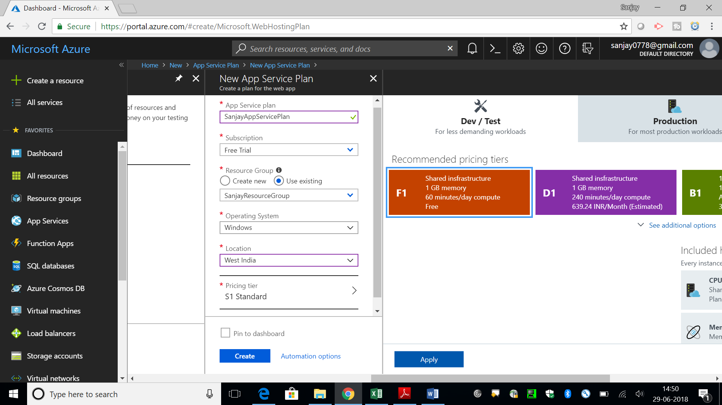

**Step 5**- Your App Service Plan **(SanjayAppServicePlan)** will be created in few minutes. You can see the Overview of the plan to check all the details like, **Resource group, Status, Location, Subscription and Pricing tier/ license**

