# Creating And Deploying Microsoft Azure WebJobs

**WebJobs** is a feature of **Azure App Service** that enables you to **run a program or script** in the **same context as a web app, API app**, or mobile app. There is **no additional cost** to use **WebJobs**.

**Azure WebJobs** can run **continuously** or **on** **demand** or on a **schedule**.

**Azure WebJobs** can be created using the following **scripts**:

* .cmd, .bat, .exe (using **Windows** **cmd**)
* .ps1 (using **PowerShell**)
* .sh (using bash)
* .php (using php)
* .py (using python)
* .js (using **node**)

This article demonstrates the use of **C# Command line App**.

**Step 1-** Open **Visual Studio**. Click File > **New Project**, and then in the New Project dialog box click **Cloud > Azure WebJob (.NET Framework)**. Give name of the **Web Job (SanjayWebJob)**.

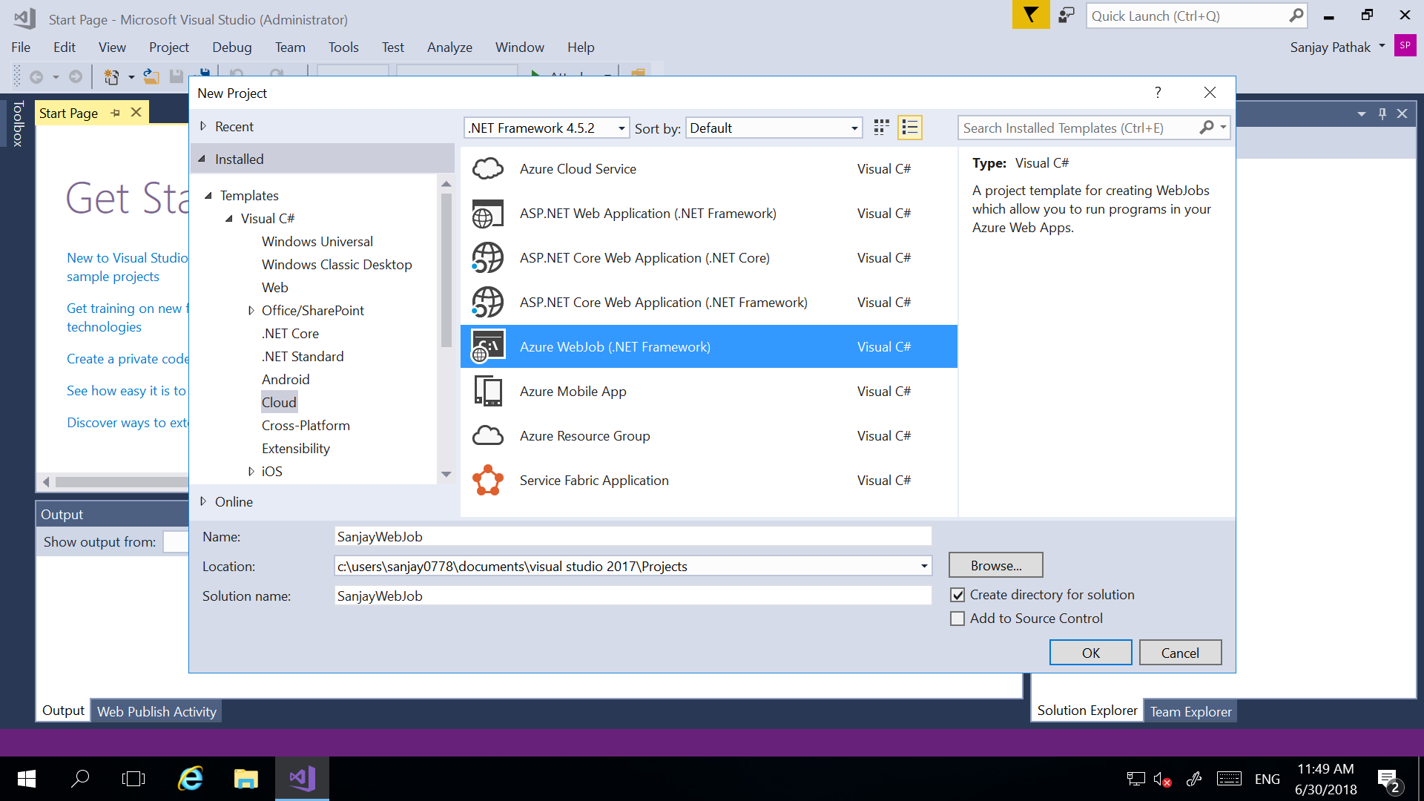

**Step 2**- A **Console Application** is created. Right-click the Console Application project in Solution Explorer, and then click **Publish as Azure WebJob**.

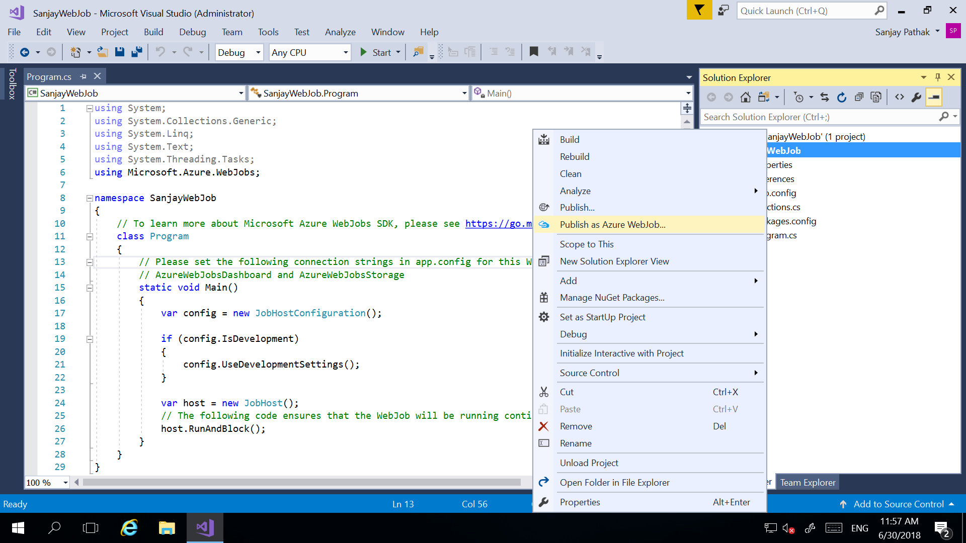

**Step 3**- The **Add Azure WebJob** dialog box appears, with the project selected in the **Project name** box. The **Add Azure WebJob** dialog lets you enter the **WebJob name (SanjayWebJob)** and **WebJob run mode** setting for your WebJob. Here I have selected **‘Run Continuosly’**. Complete the Add Azure WebJob dialog box, and then click OK.

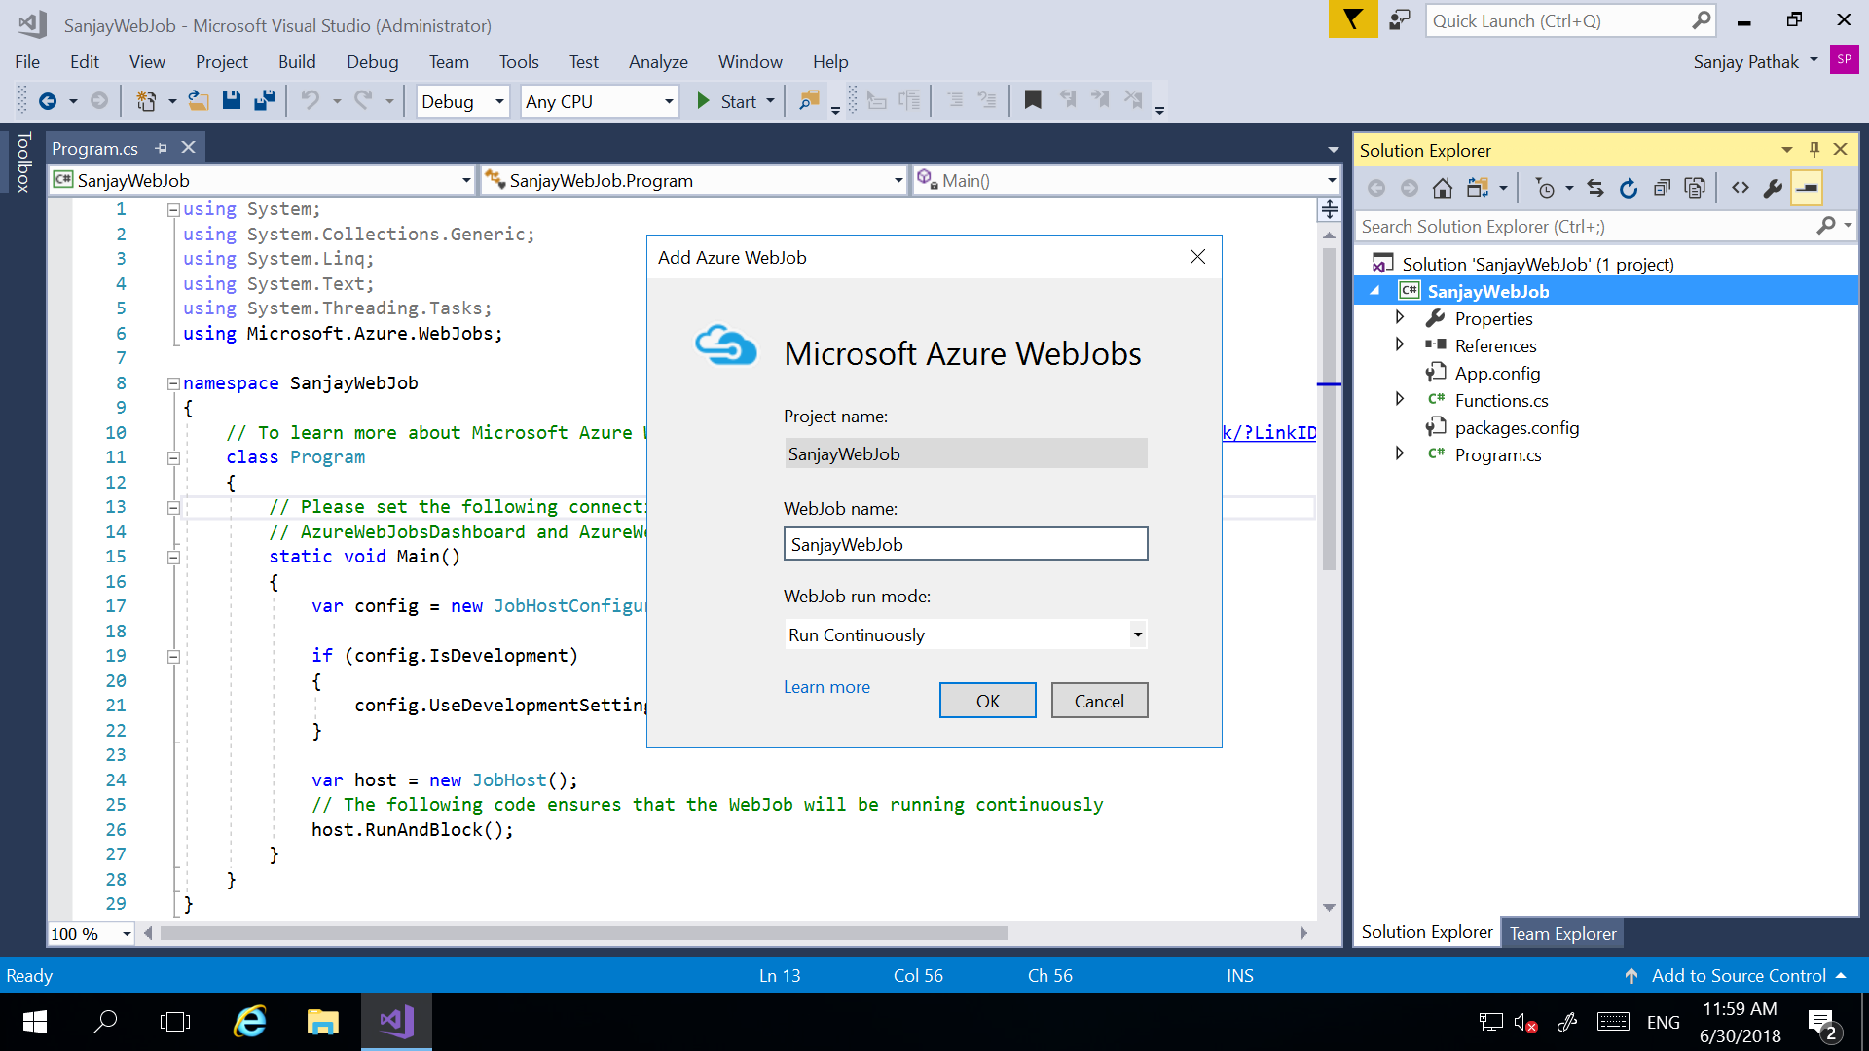

**Step 4-** In next screen, **Select a publish target**, in this example the target will be a **Microsoft Azure App Service** (Azure Web App).

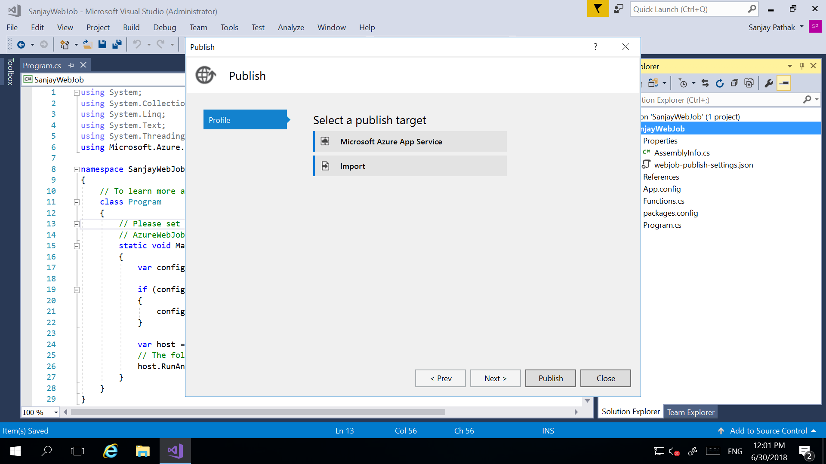

**Step 5-** In next screen, we need to select **App Service** in whose context this **Web Job** will run. Here we are selecting existing ASP.Net **Azure Web App**. Our **Web Job** will run in the context of selected **App Service/ Web App**. You can also create a new **App Service/ Web App** by using ‘**New’** button.

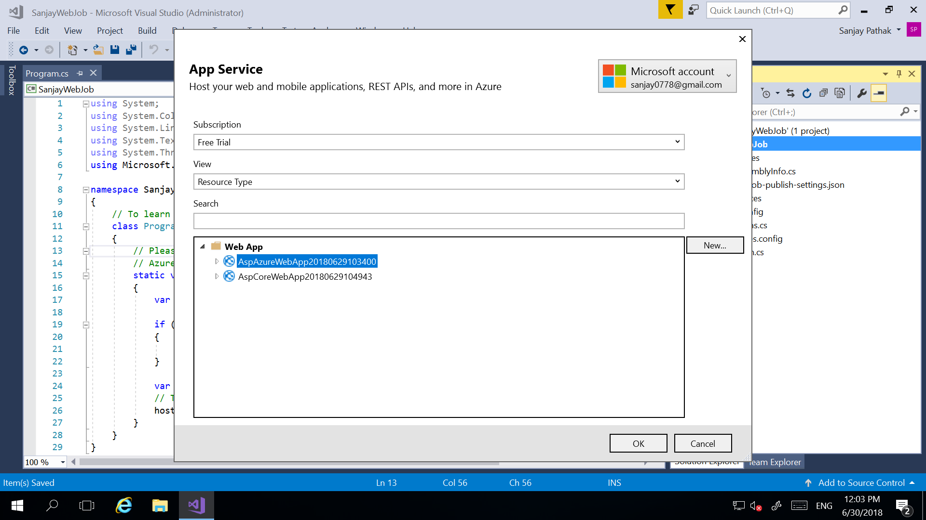

**Step 6**- Once you click OK. It will populate all the **Connection** details of selected **App Service/ Web App**. If you want you can validate connection by clicking on ‘**Validate Connection’** button

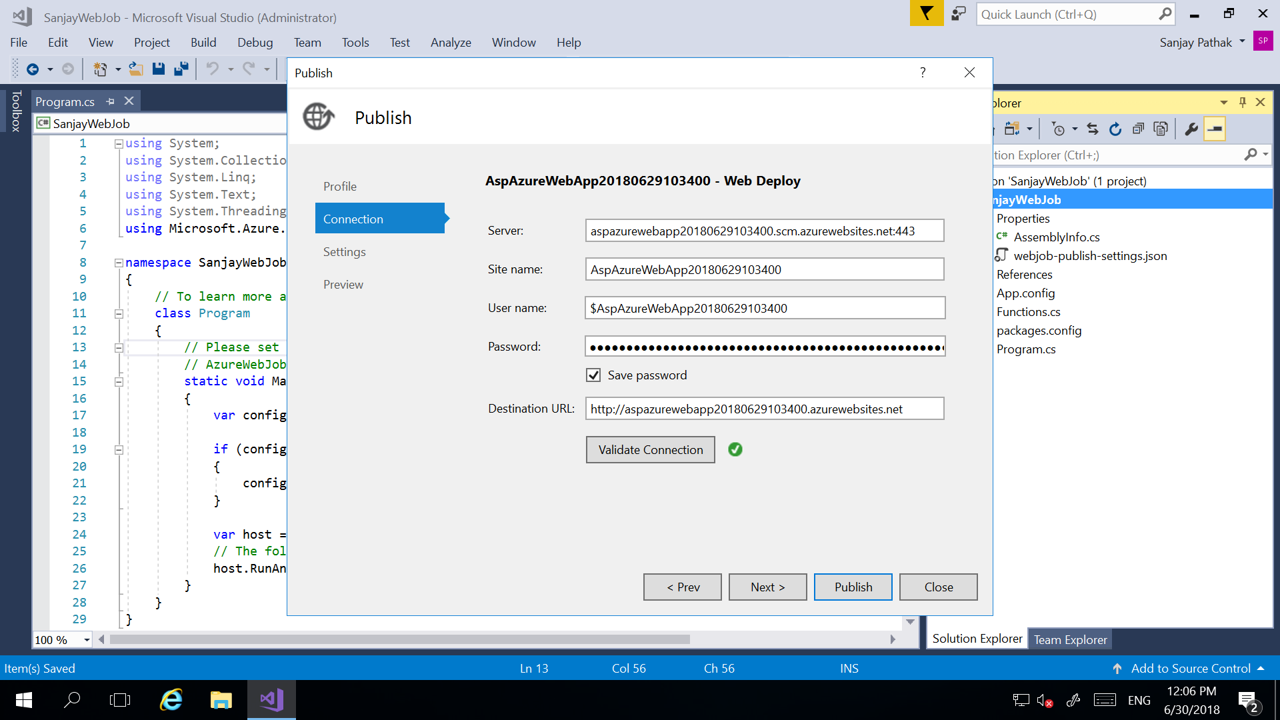

**Step 7-** Click on ‘**Next’** button to see configuration **Setting**. It can be **Debug** or **Release**. Click on **Publish** button to publish this **Web Job**.

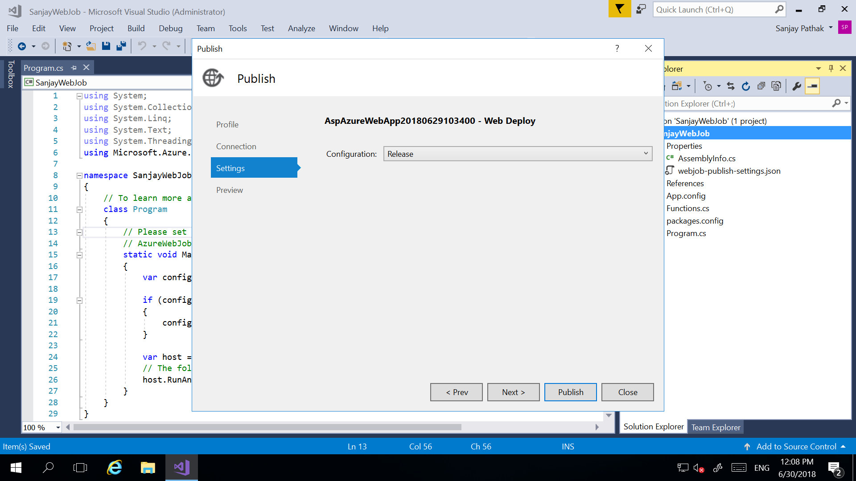

**Step 8**- To see **Web Job** associated with your **Web App/ App Service**, open your **App Service** and type web in search box inside **App Service** and select ‘**WebJobs’** as shown below.

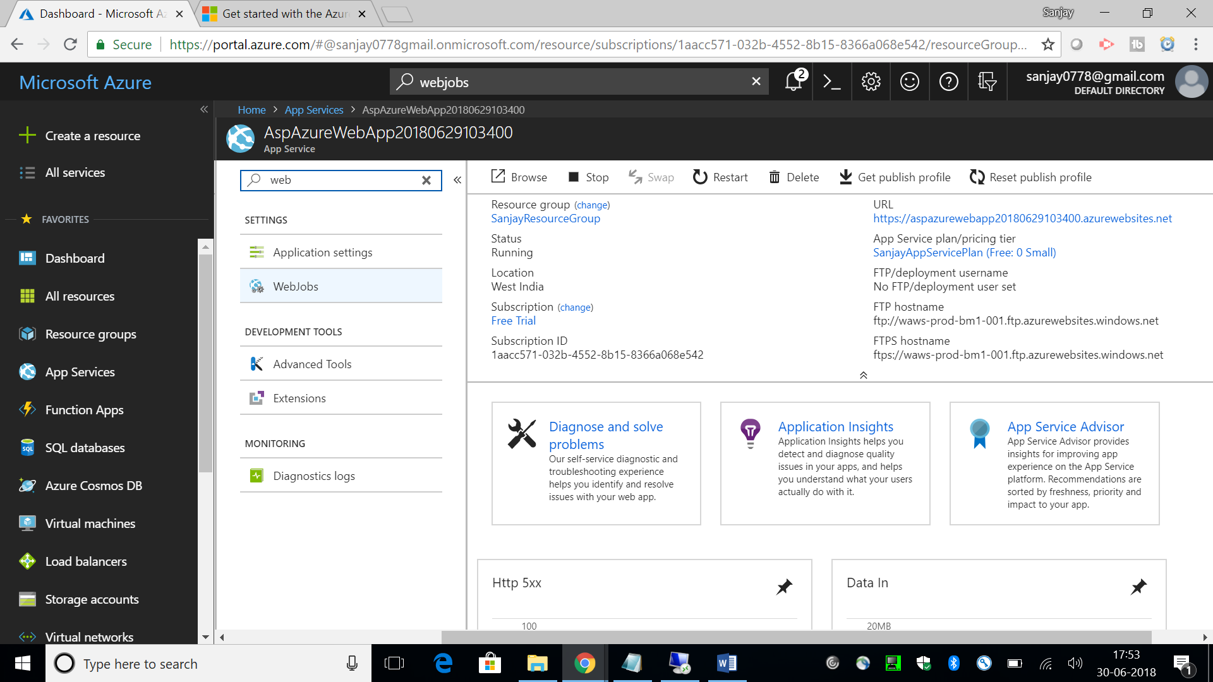

**Step 9**- Once you click on ‘**WebJobs’** inside your **App Service**, you can see your deployed **WebJob/ WebJobs** with all the details.

