# Step by step guide to create ASP.NET Web App in Azure

**Azure App Service Web Apps** (or just **Web Apps**) is a **service** for hosting **web applications, REST APIs**, and mobile back ends. You can develop in your favourite **language**, be it .NET, .NET Core, Java, Ruby, Node.js, PHP, or Python.

**Web Apps** not only adds the power of Microsoft Azure to your application, such as **security, load balancing, autoscaling, and automated management**. You can also take advantage of its **DevOps capabilities, such as continuous deployment from VSTS, GitHub, Docker Hub**, and other sources, package management, staging environments, **custom domain, and SSL certificates**.

In this article we will see how to create and deploy ASP.NET Web Application to Azure Web Apps.

**Step 1**- Create a new project of type ‘**ASP.NET Web Application’** in **Visual Studio**. Named **AspAzureWebApp.**

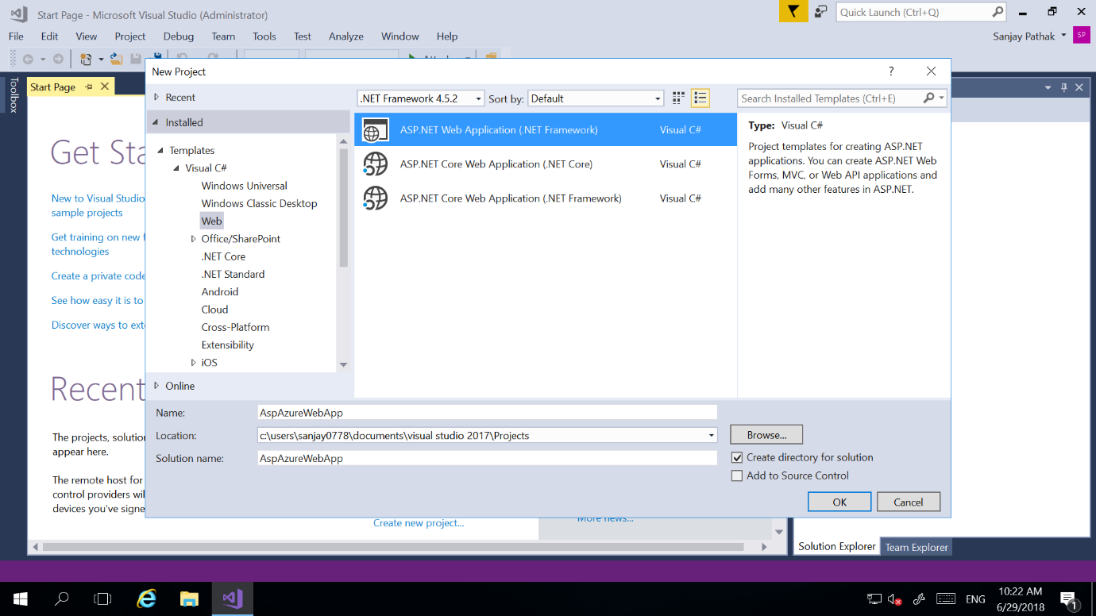

**Step 2**- Select any template which you want to use for your project. Here I am selecting MVC.

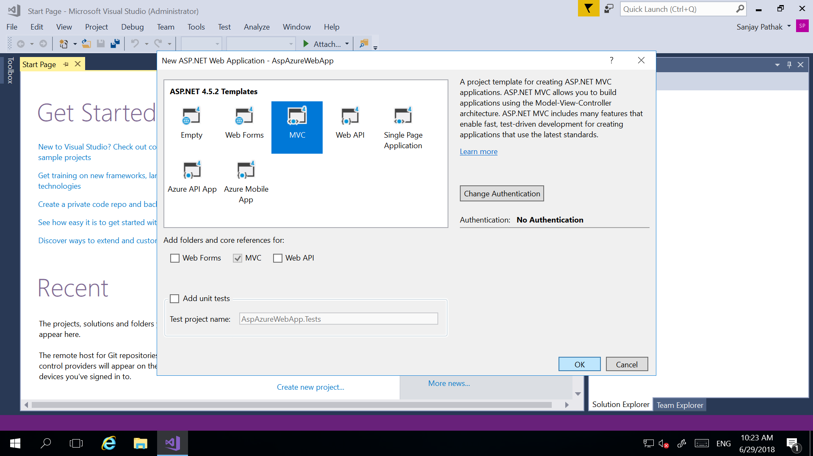

**Step 3-** Change **Views\Home\Index.cshtml** file to add your own text for testing purpose.

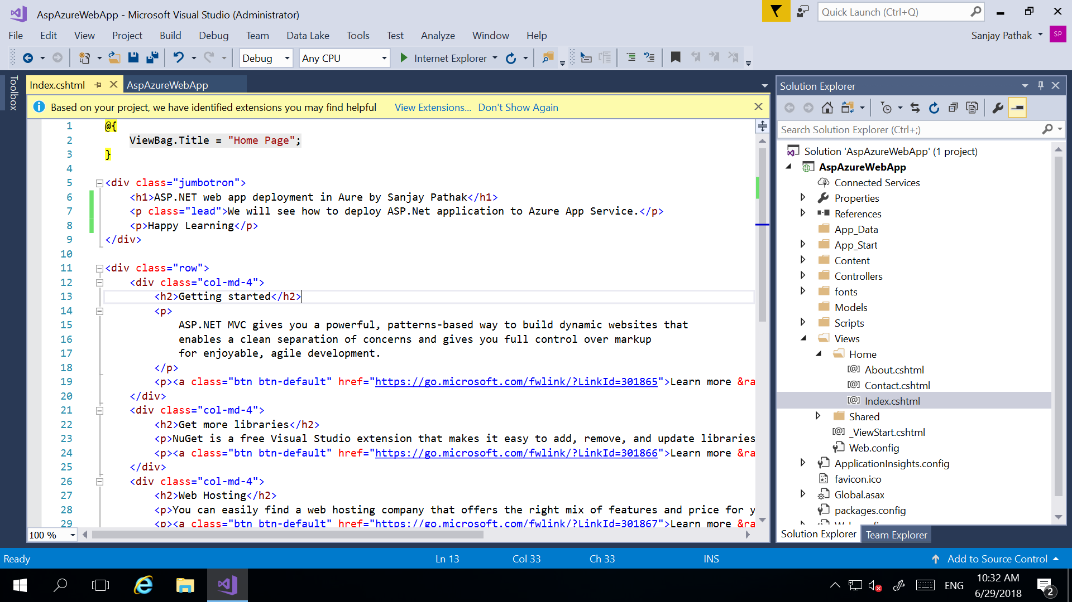

**Step 4-** Now **publish** your web application to **Azure Web Apps**. Right click on your web application project in **Visual Studio** and select **Publish** option.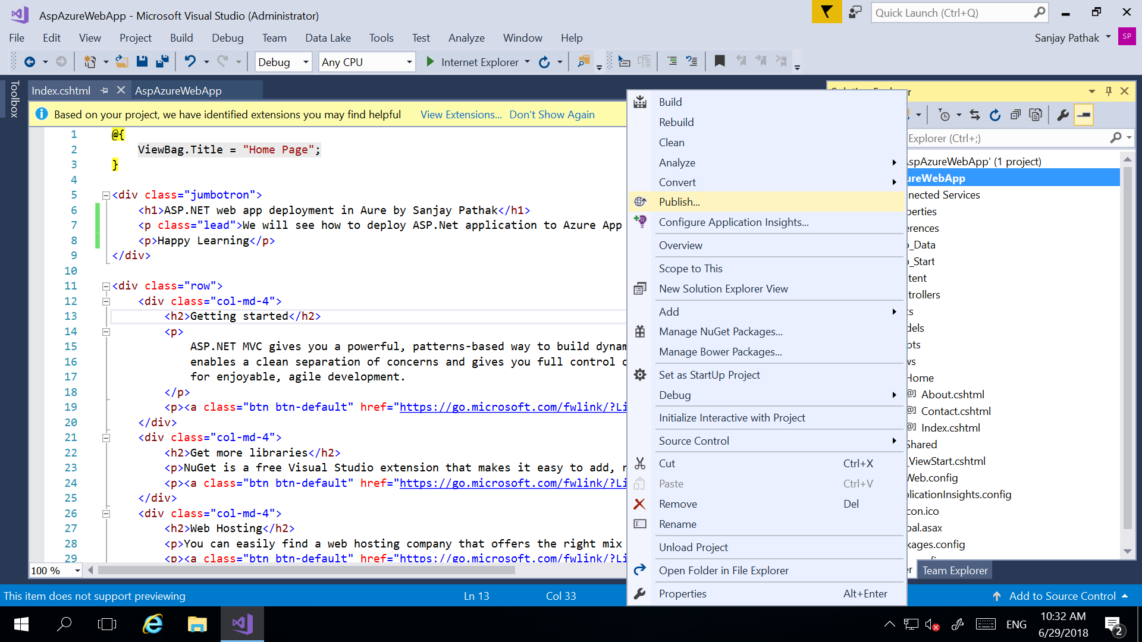

**Step 5**- In Visual Studio **Publish** screen you need to select option ‘**Microsoft Azure App Service’** and then either select ‘**Create New’** to create new **Web App/ App Service** or select ‘**Select Existing**’ to use existing **Web App/ App Servicee**. Here we will create a **new Web App/ App Service** by selecting **‘Create New’** and click on **Publish** button.

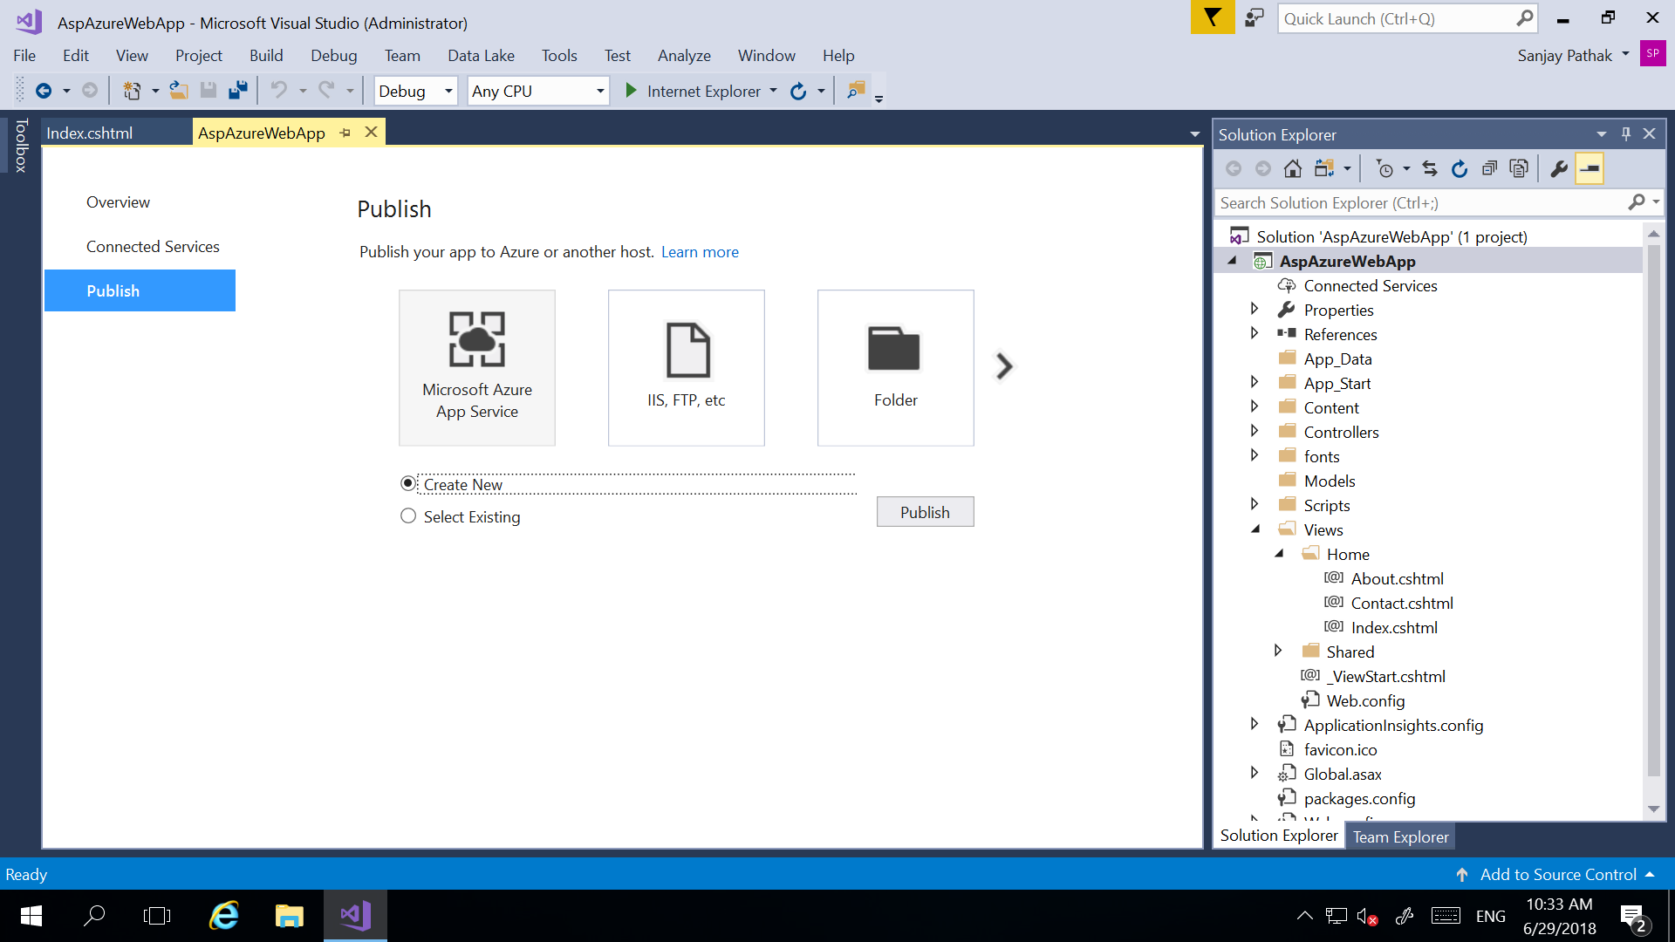

**Step 6-** Give name of your new **Web App/ App Service.** Select **Subscription**, **Resource** **Group** and **App Service Plan** where you want to add/ create your **Azure Web App**. Click on **Create** button to create and deploy **Azure** **Web App/ App Service**.

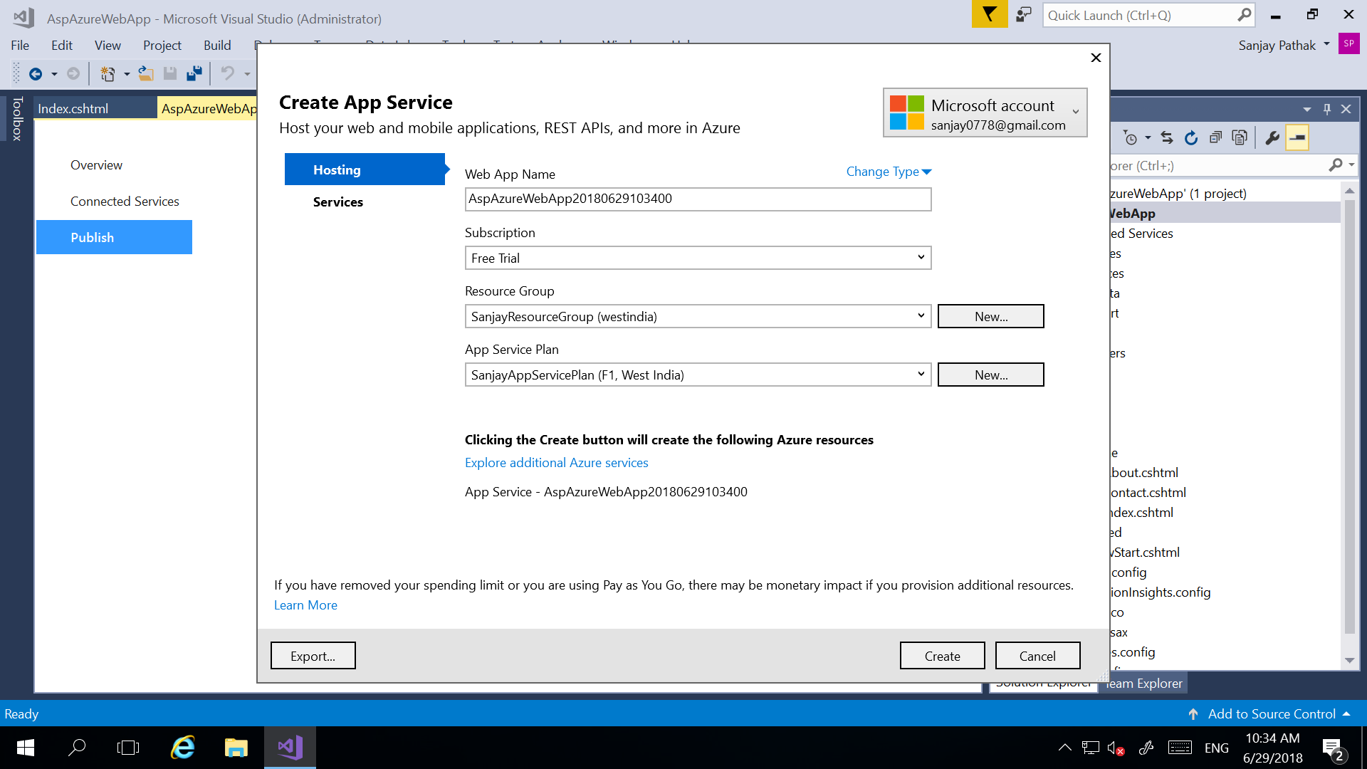

**Step 7**- Now your **Asp.Net Web Application** is deployed to **Azure App Service**. You can see the url of app service in browser.

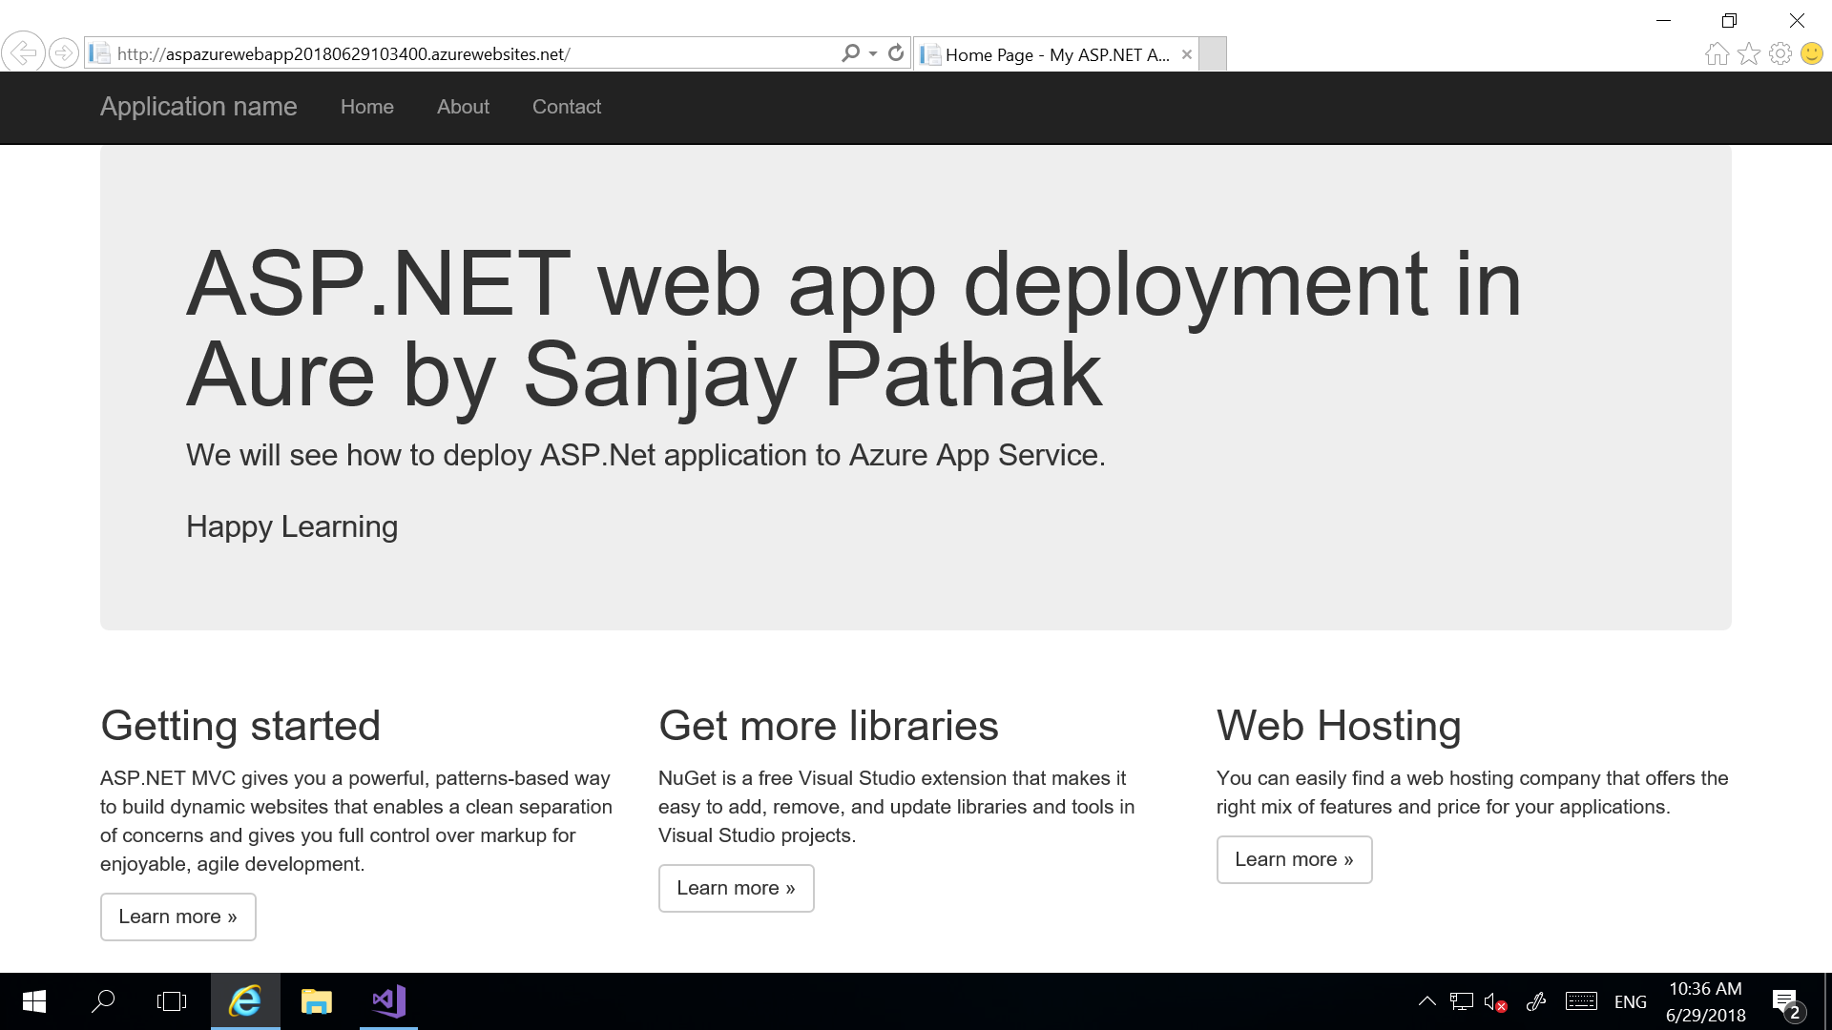

**Step 8**- You can manage your **Web App** in **Azure**. Go to **App Service** in **Azure** portal. Search your **Web App** by name. Click on your **Azure Web App**.

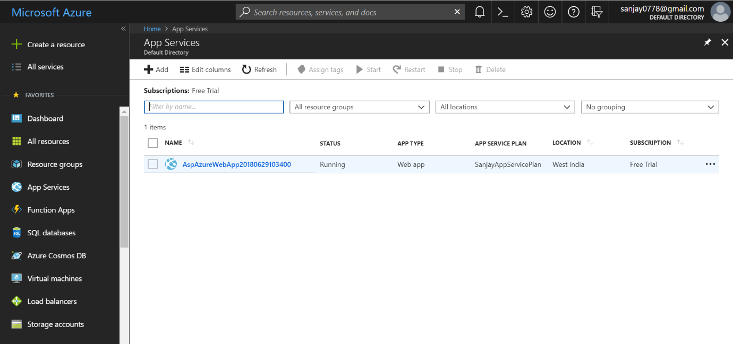

**Step 9**- You can see your **Web App's Overview** page. Here, you can perform **basic management tasks** like **browse, stop, start, restart, and delete**. Url of the Web App is visible in top right of the **Overview** page.

