# Deploying Console Application as Azure WebJob

You can deploy your **C#** **Console Application** as **Azure WebJob.**

**Step 1**- In Visual Studio, create a **Console Application (**ConsoleAppWebJob**)**. Select ‘**Console App (.NET Framework)** project template.

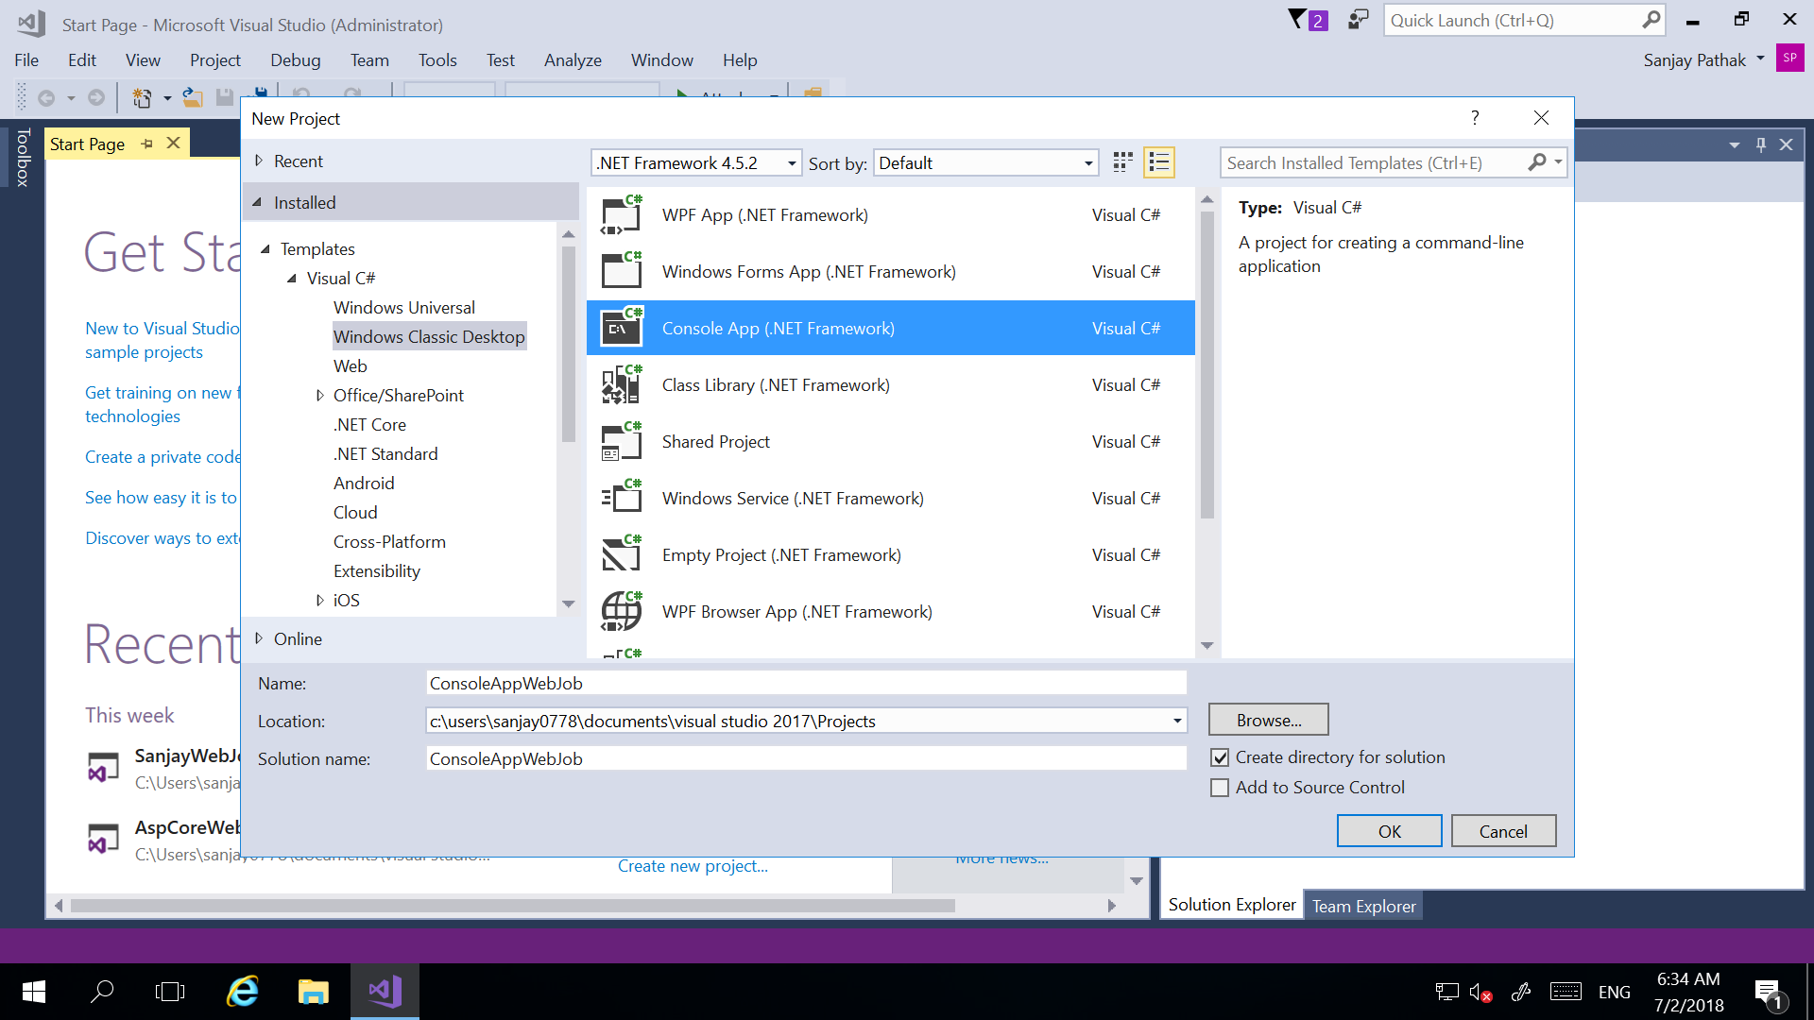

**Step 2**- Update Main() method with your code.

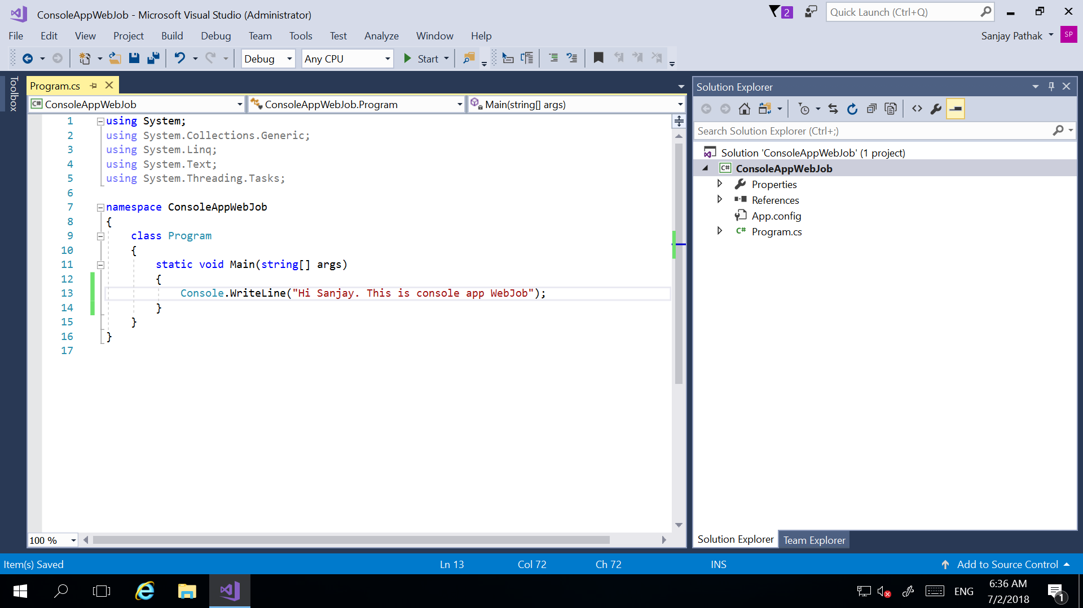

**Step 3-** **Build** the application. Go to the **Bin/Debug** path of the Application and add all the contents in a .zip file. **ConsoleAppWebJob.zip**

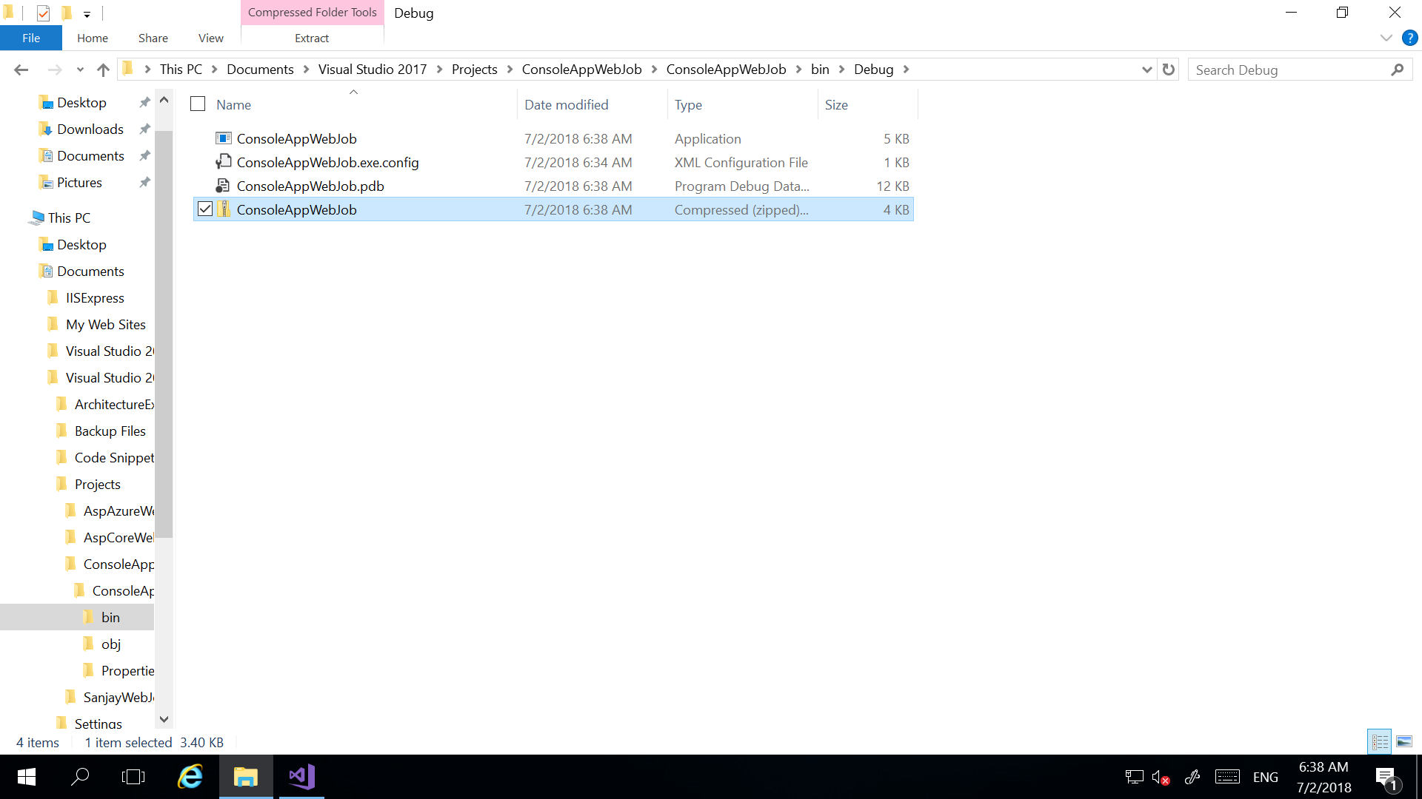

**Step 4**- Go to the Azure **Portal**, select your **App Service/ Web App**, then go to **WebJobs** and click **+Add** button to add job.

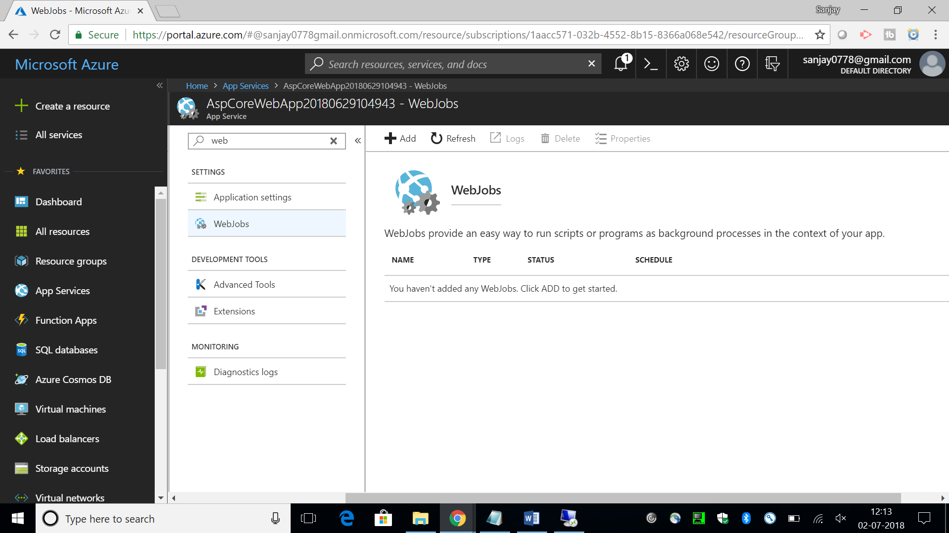

**Step 5**- In **Add WebJob** window, enter a Job **Name**, In **File Upload**, select the .zip file **ConsoleAppWebJob.zip**, select **Type** (when the job shall run). **Continous** – The **Azure WebJob** is continuously running in the background or run of events. **Triggered** – Runs only when triggered **manually** or on a **schedule**. Select **Triggers** as **Manual**. Click OK.

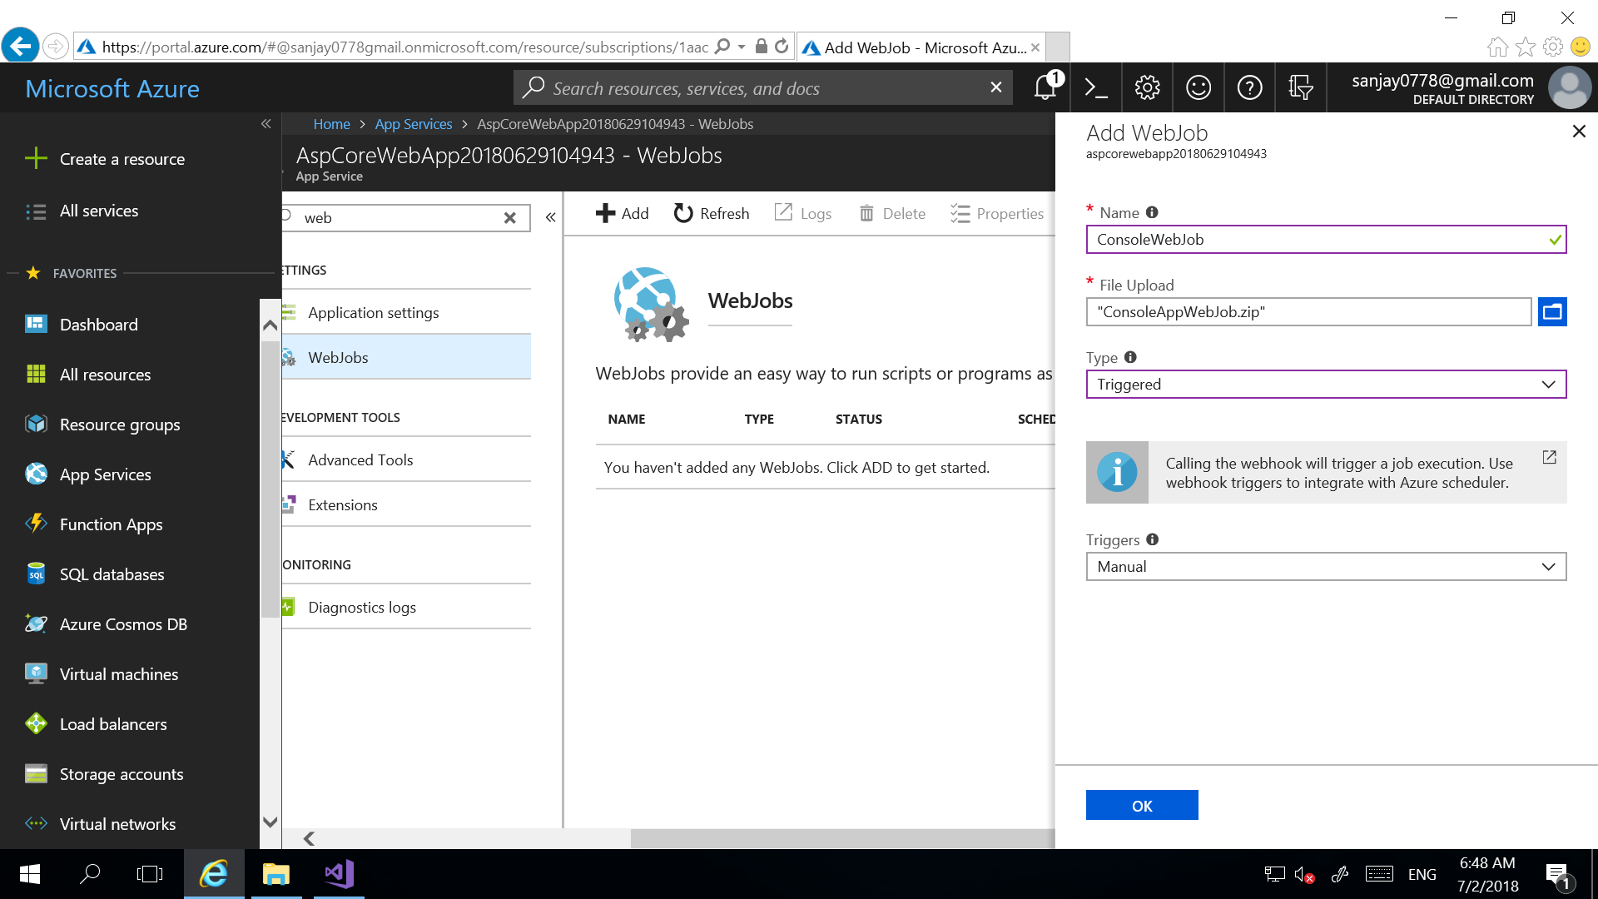

**Step 6**- Wait for the Job to be uploaded and created. Once **WebJob (ConsoleWebJob)** is created you can see it in **WebJobs** page of the **App Service.**

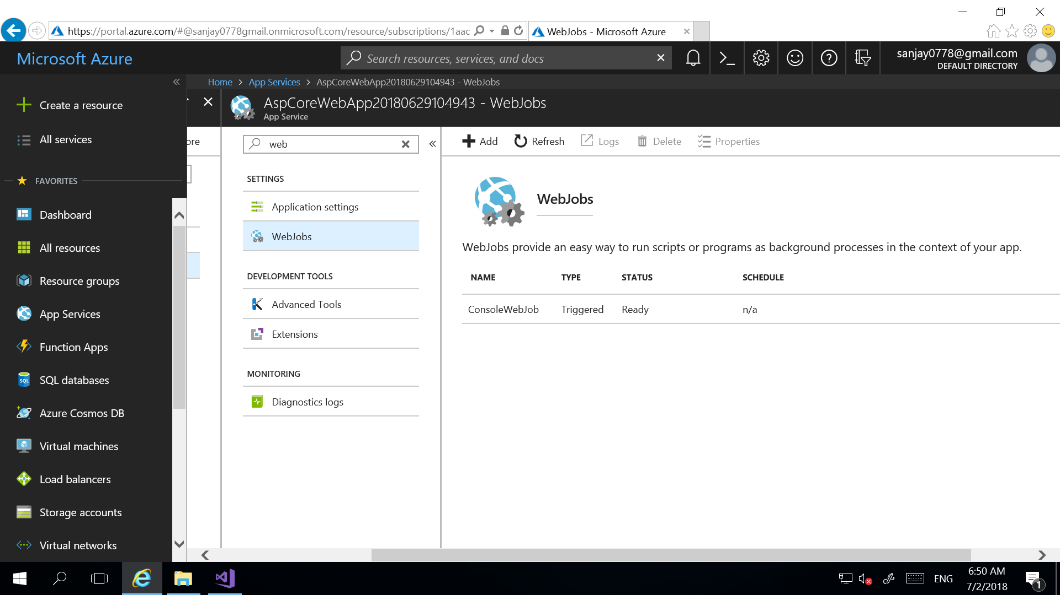

**Step 7-** To run a **Triggered Manual WebJob**, select the job and click on **Run** at the top of the page.

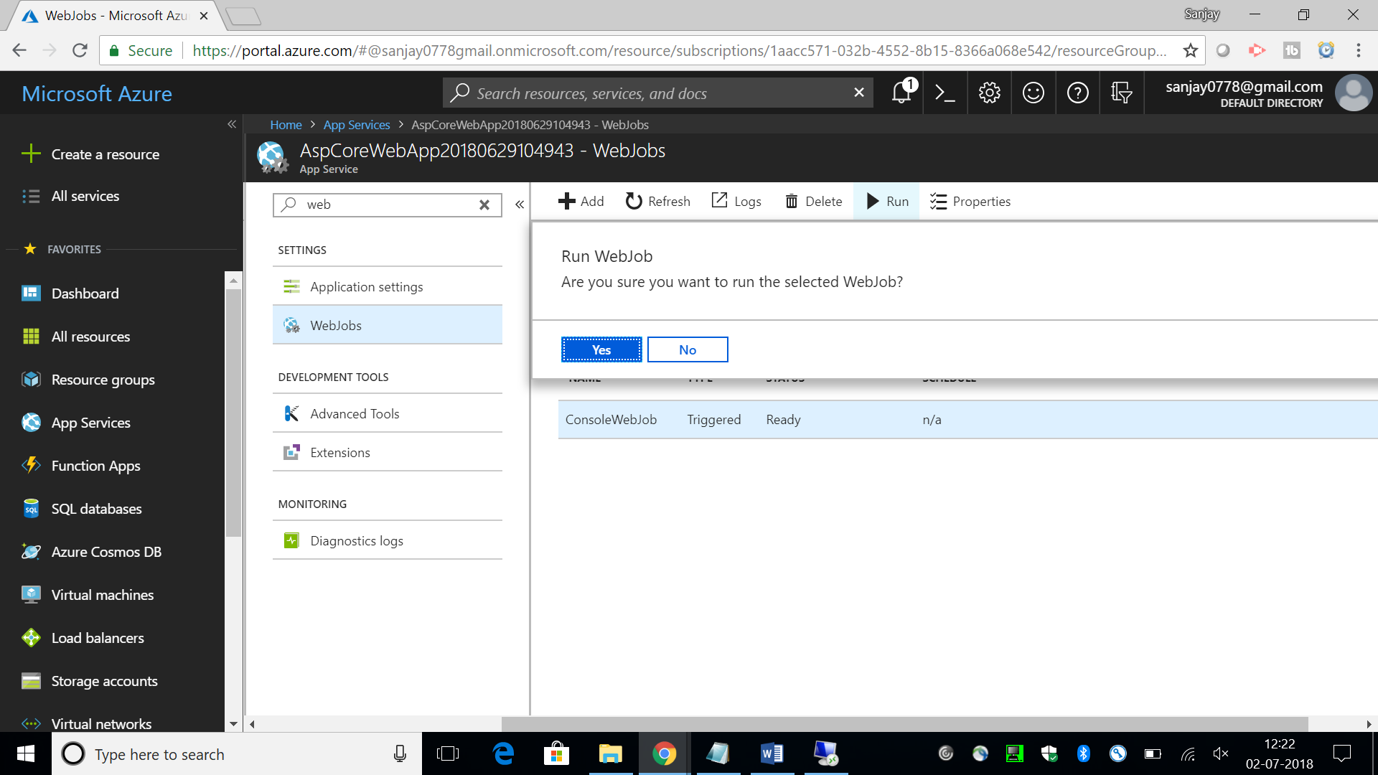

**Step 8**- When the run completes, it will show **Status** as **Completed**.

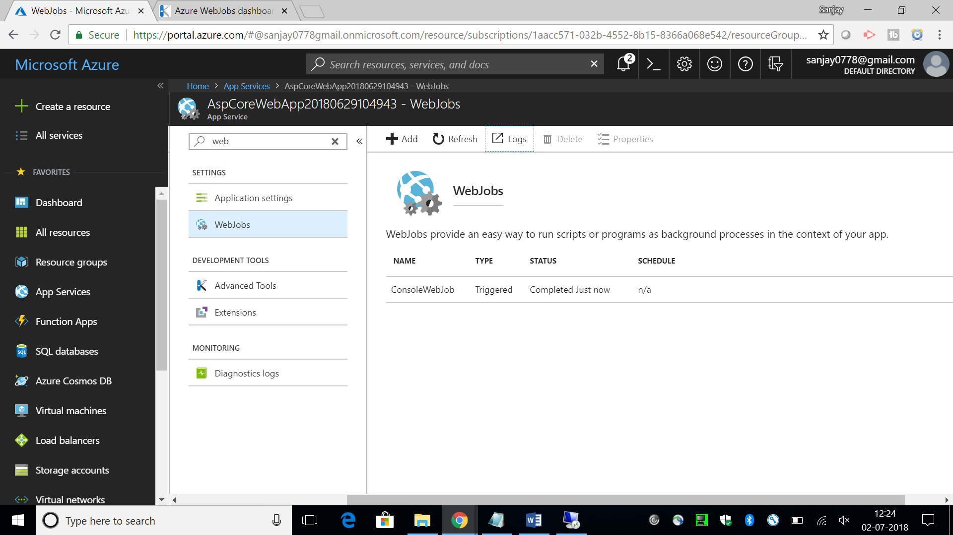

**Step 9-** To access the **WebJobs** **Logs** page, click on the **Logs** button at the top of **WebJobs** screen. It will open a new window with all the **WebJobs** associated with the **App Service.** This page will show the log/ run history of the **WebJobs.**

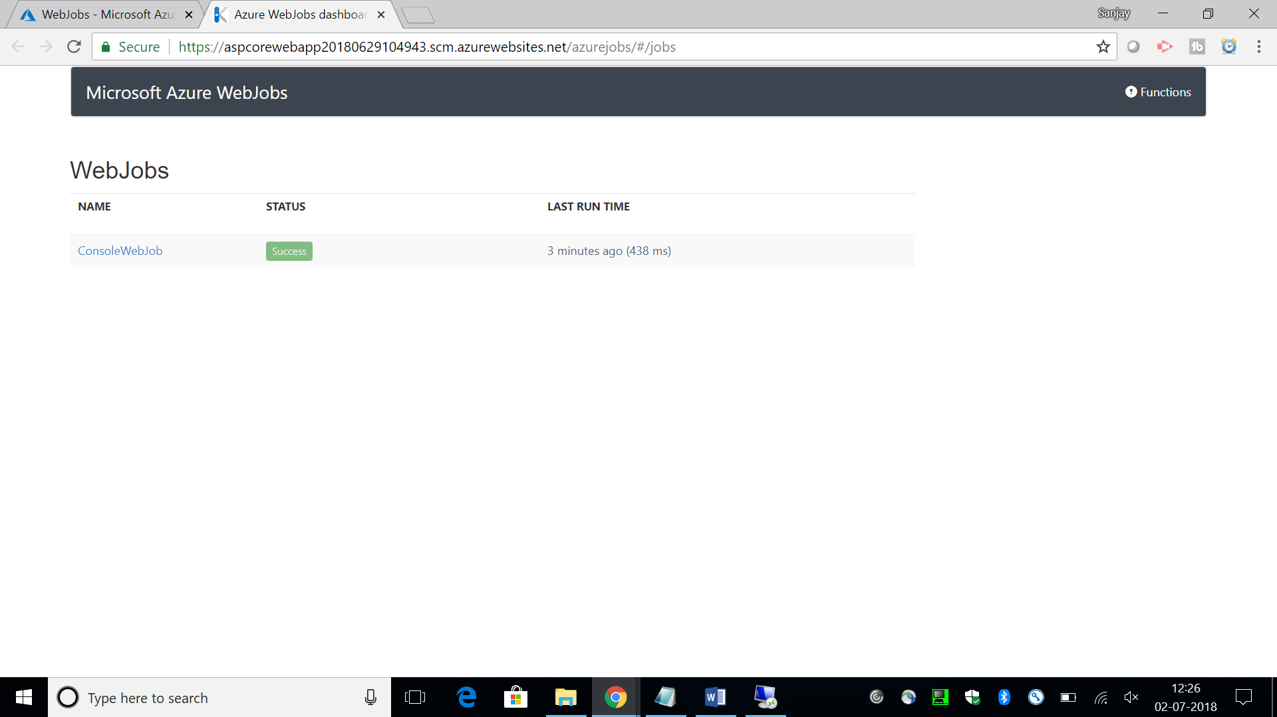

**Step 10-** By **selecting a specific run**, **statistics** about the job together with the Job Log can be obtained. You can see the message of Main method ‘**Hi Sanjay. This is console app WebJobs’** in the **WebJob Run Details** page.

