# Windows VM with Visual Studio installed

Here we will see how to create **Azure** **Virtual Machine** having **Visual Studio** on **Windows**.

**Step 1**- Login to you azure portal and click on **Virtual machines** link in left navigation. Click **Add** button.

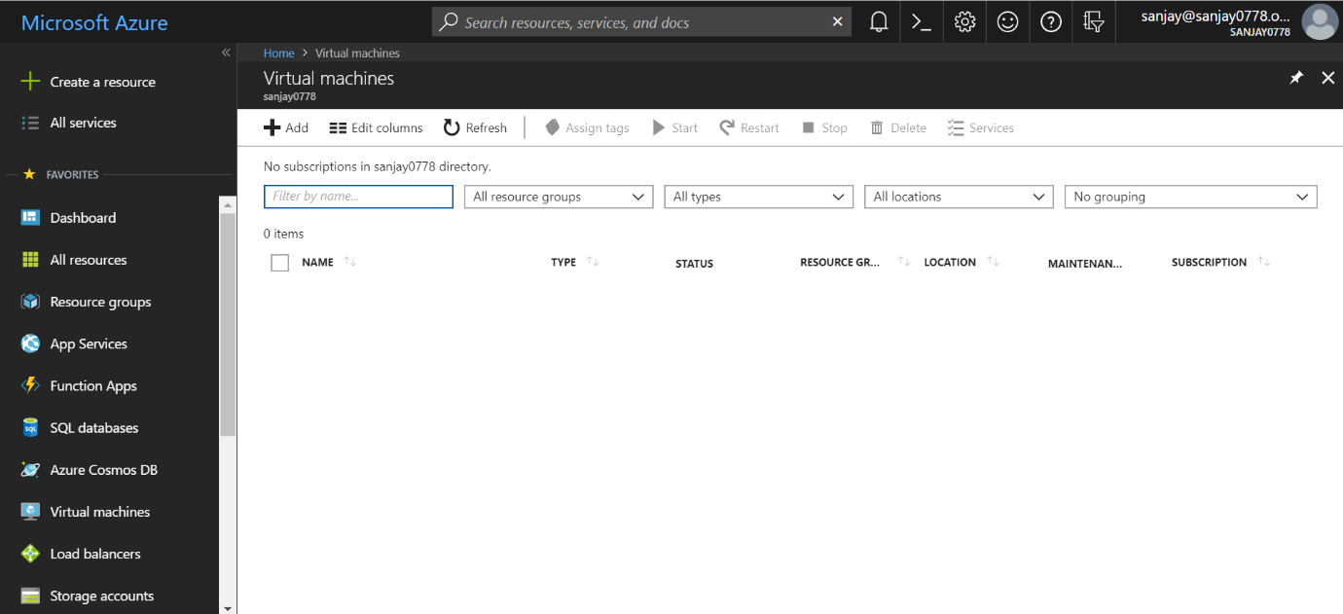

**Step 2**- Inside Virtual machines Compute, click Add and search ‘visual studio’. Select the version you want from the list as shown below.

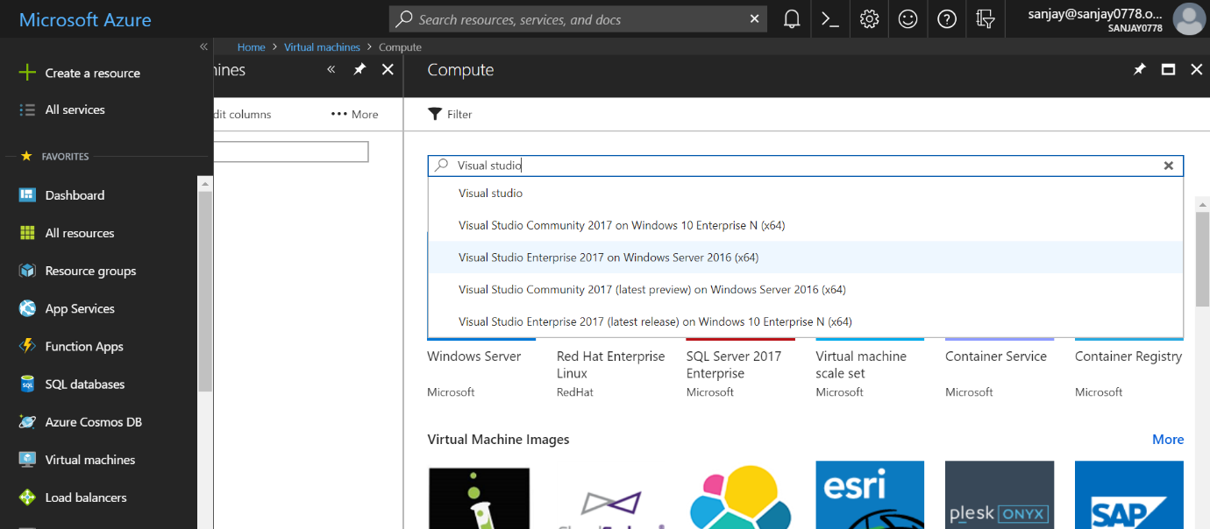

**Step 3**- I have selected **Visual Studio Community 2017 on Windows Server 2016** Virtual Machine Image

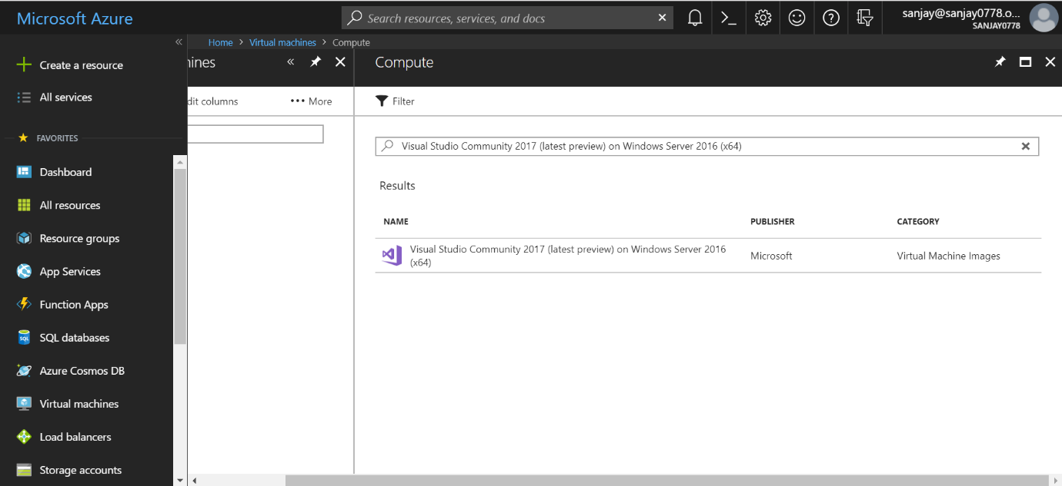

**Step 4**- Select your **Virtual Machine Image** and click on **Create** button as shown below. In deployment model, select default **Resource Manager.**

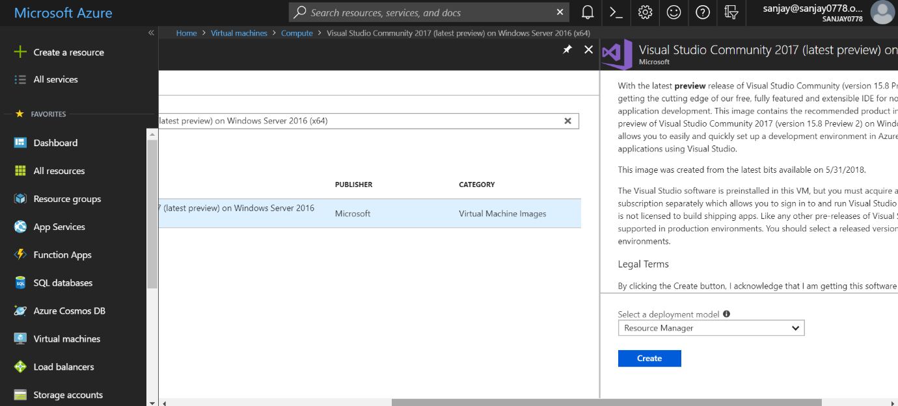

**Step 5**- Provide the required information. Like VM **Name**, **VM disk type** (e.g SSD), **Username** and **Password** used to **login to VM**. **Subscription**, **Resource** **group**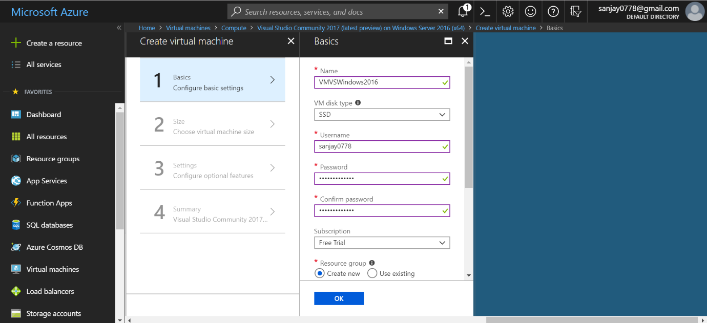

**Step 6** – Chose **size** for you VM. You can change size later also. This is the **disk space** for your VM.

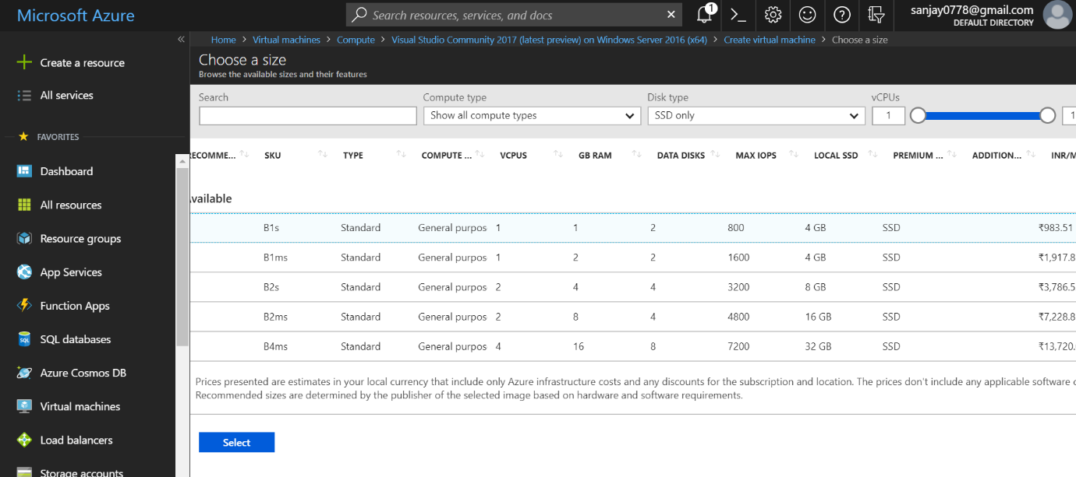

**Step 7**- Complete all configuration. On **Summary** page, you can see summary of your VM. Now click on ‘**Create’** button to create your VM. It will start creation of your new VM. You have to wait for sometime till your VM gets created. 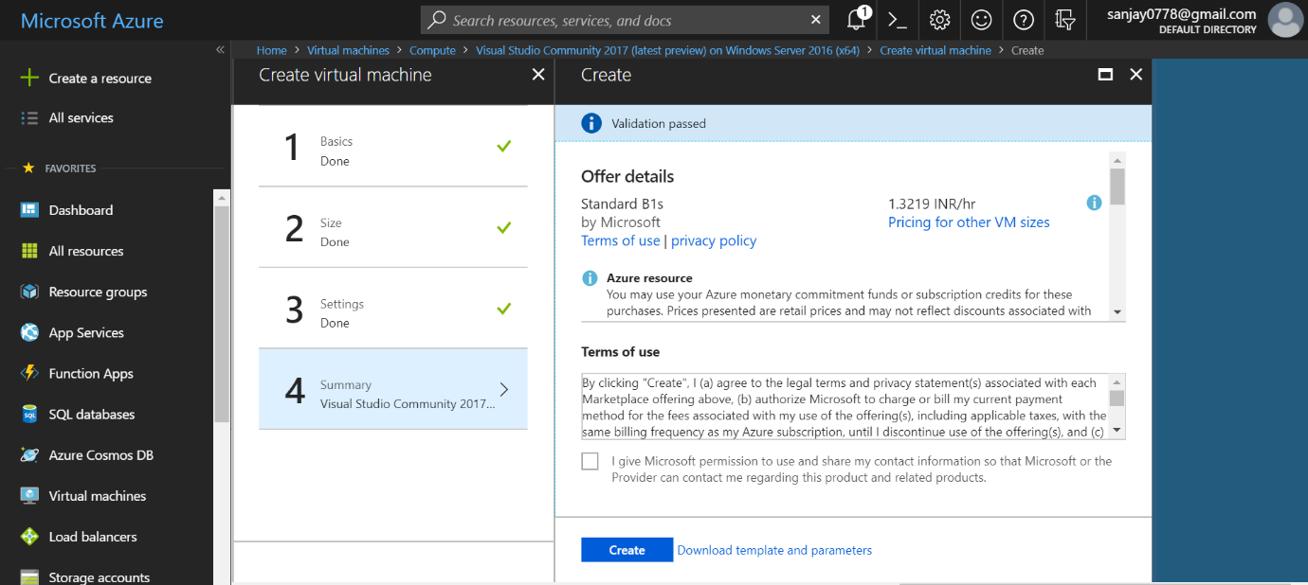

**Step 8-** Once your VM is created, you can see your VM from **Virtual Machines** link in left navigation. Now, configure **RDP** connection to connect your VM. Click on your **Virtual Machine** and go to ‘**Networking’** settings. **Add inbound security rule**. Select **RDP** as **Service**, give **Priority**, **Name** and **Description**.

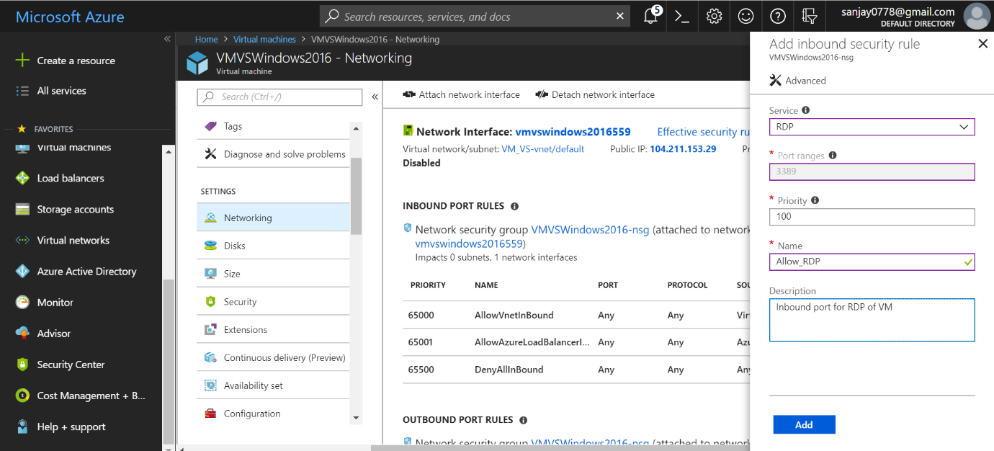

**Step 9**- Configure **DNS Name**. This is **optional**. You can access you VM using IP address also. Go your **Virtual Machine Overview** page. In **DNS name** click on **Configure** link.

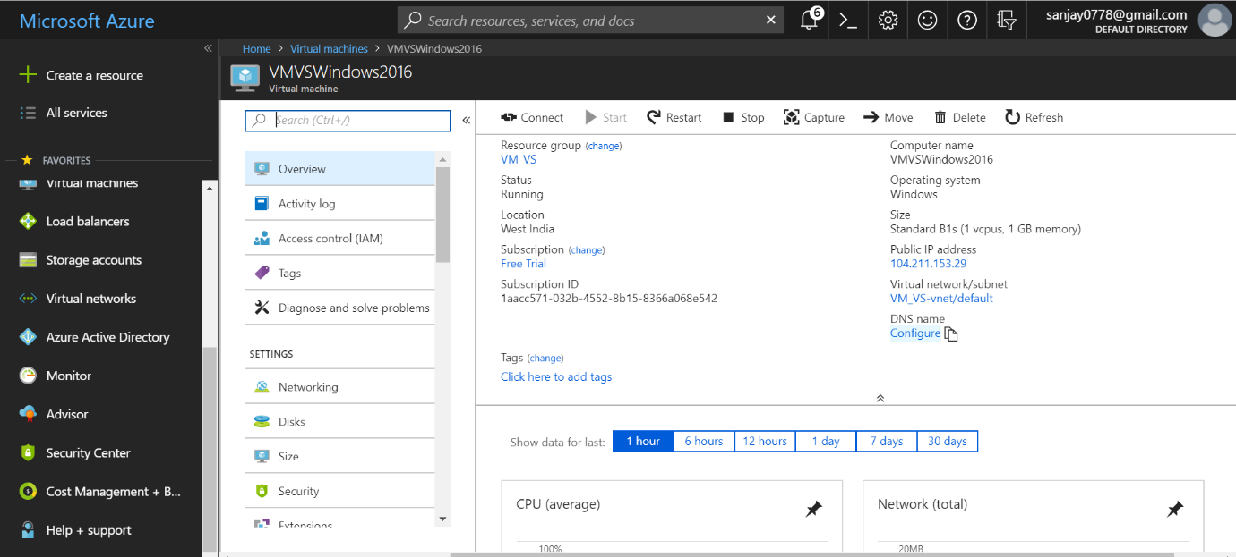

**Step 10-** Provide the details in **Configuration** screen. **Assignment** **Dynamic**. **DNS name label** (e.g **vmvs**)

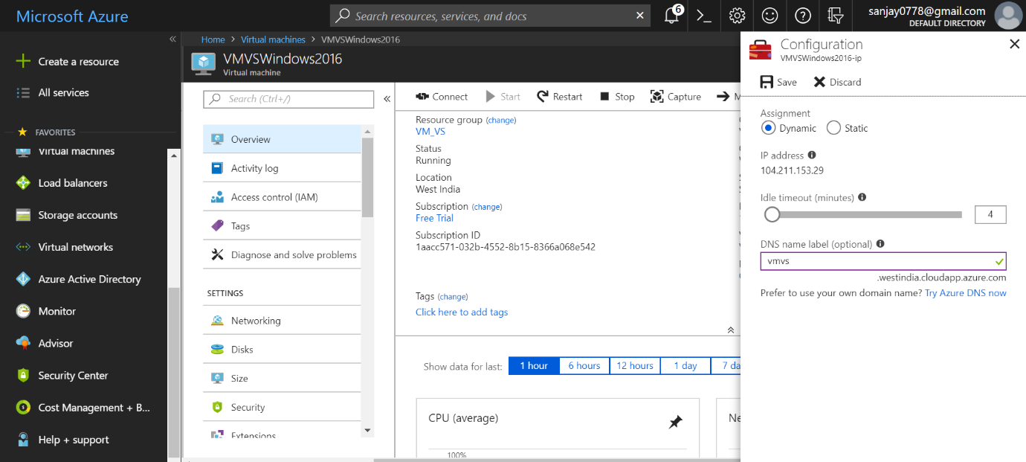

**Step 11-** Now you can see **DNS name** in your VM **Overview** page.

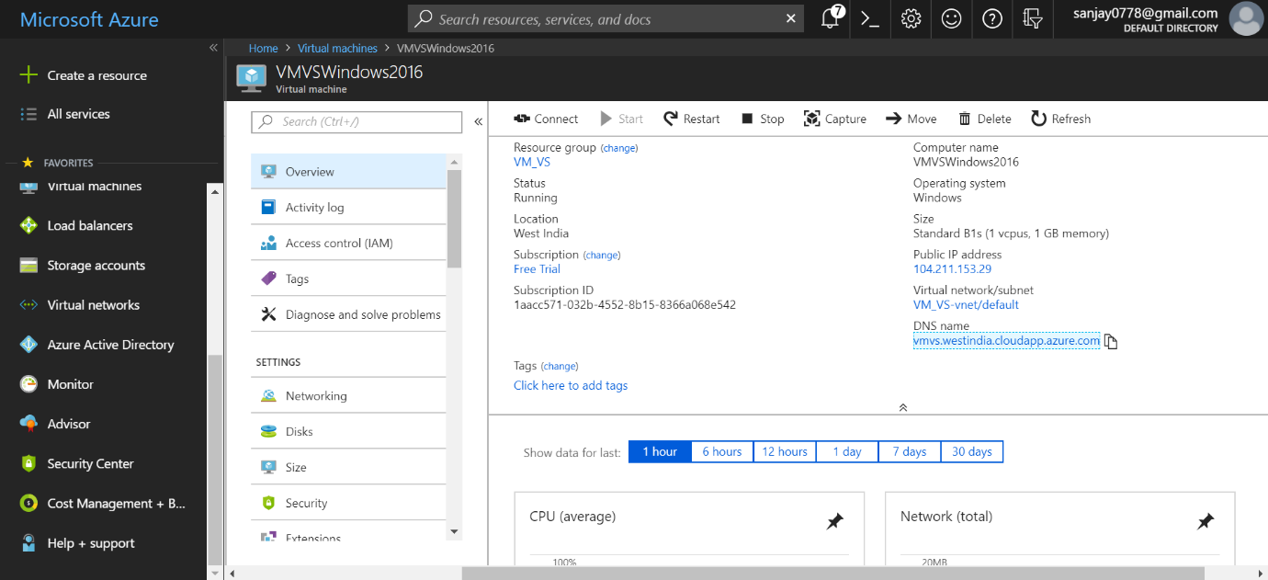

**Step 12**- Now connect to your newly created **Virtual Machine**. Give the full name of your VM along with domain details like (**vmvs.westindia.cloudapp.azure.com**) and enter user credentials which you provided during VM creation.

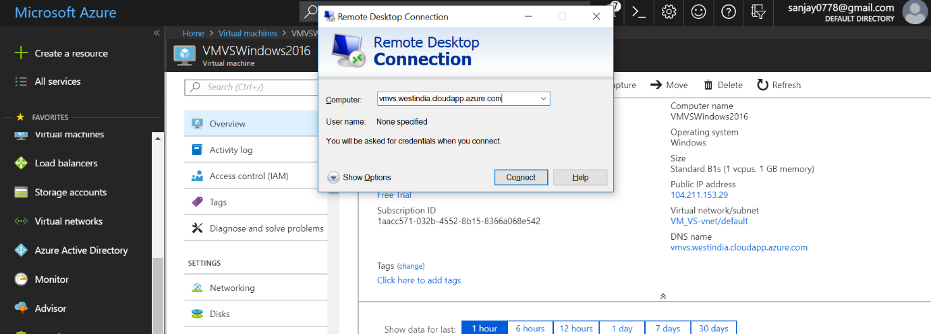

**Step 13-** Now your VM is connected. You can see the **Visual Studio** is installed as part of your VM Image.