# Azure App Service — Troubleshooting

## Method 1

You can troubleshoot your app service by looking at ‘**Application Event Logs’**

Open **Diagnose and solve problems > Diagnostic Tools > Application Event Logs**:

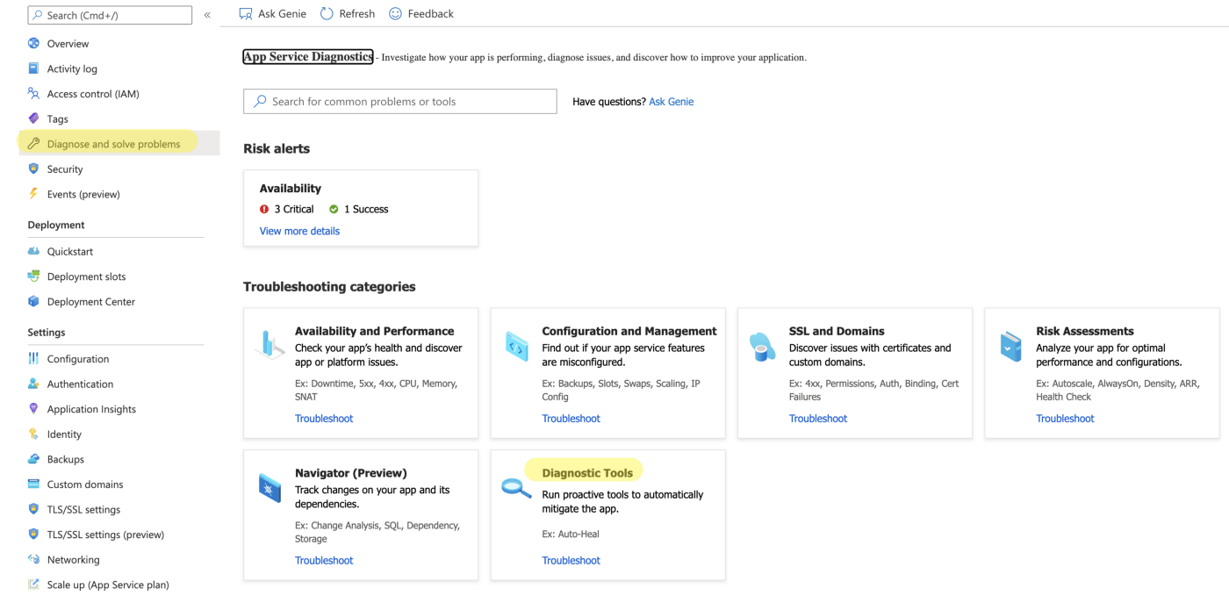

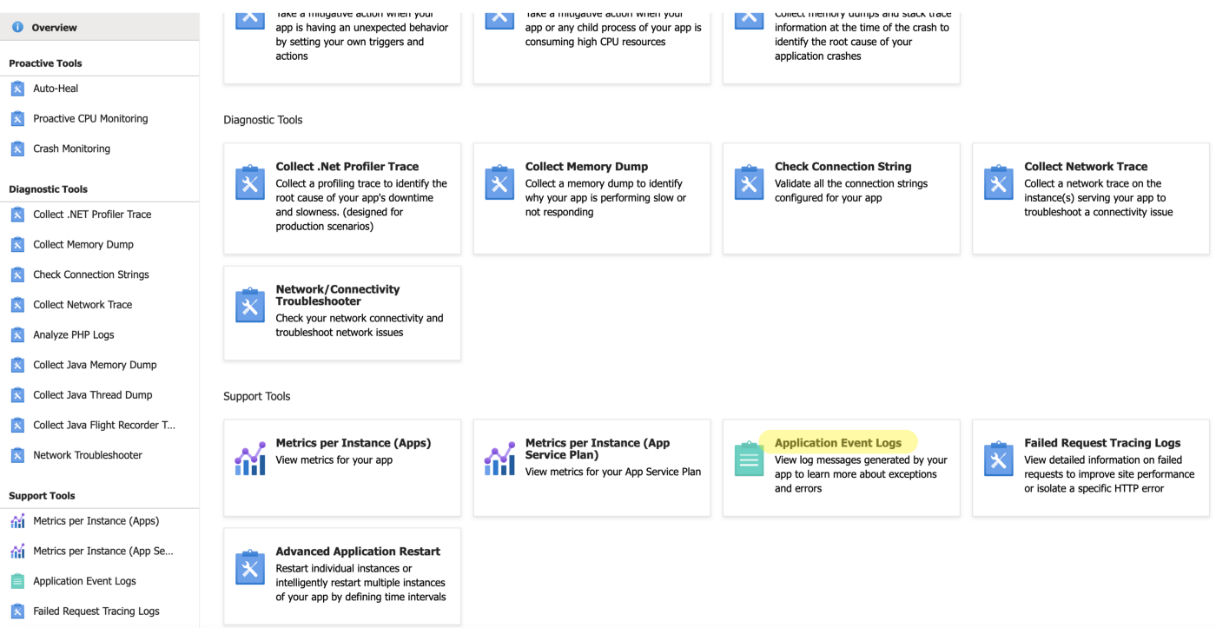

Where you can see the exceptions:

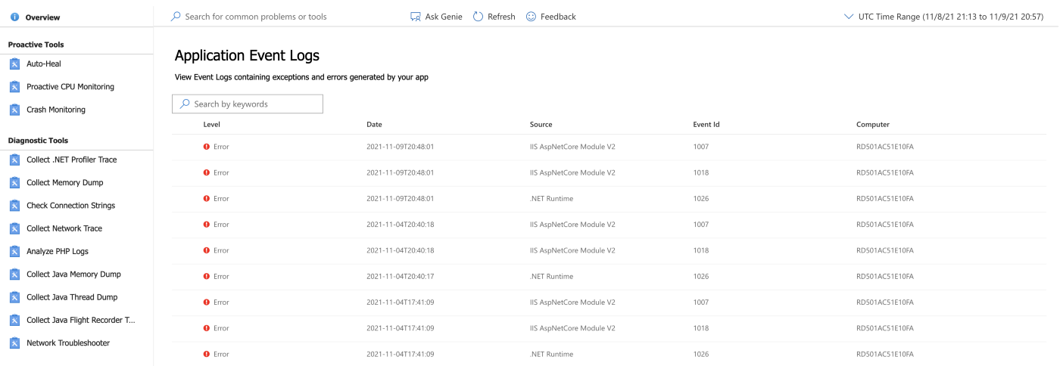

You can click on any exception to see the detail of the exception:

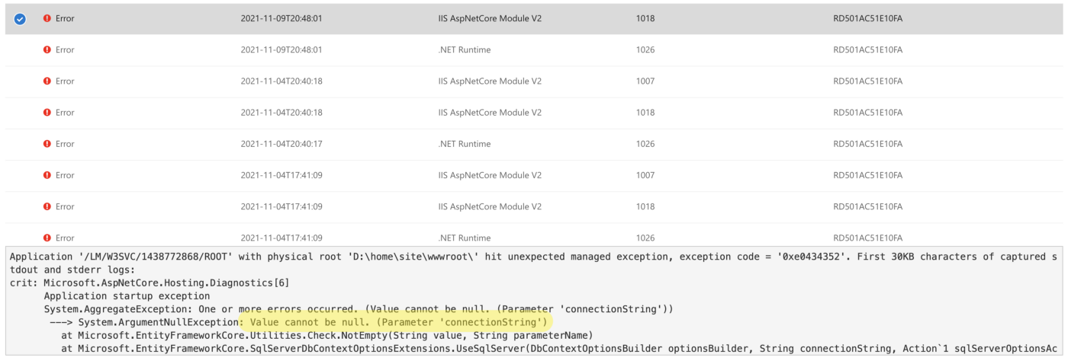

## Method 2

There is another option to see this exception **Availability and Performance > Web App Down**:

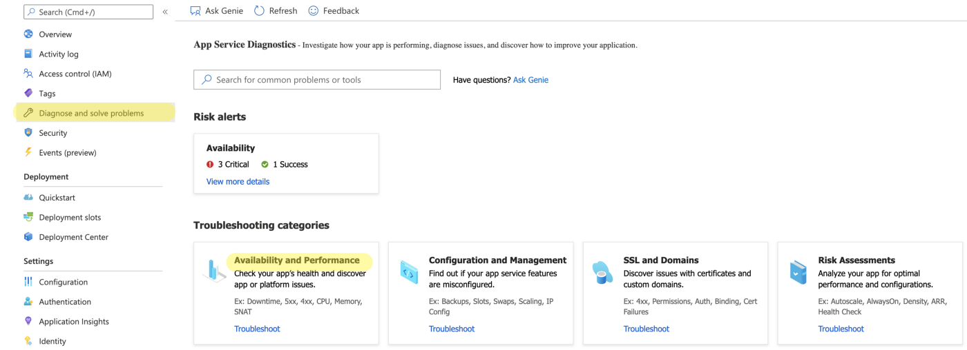

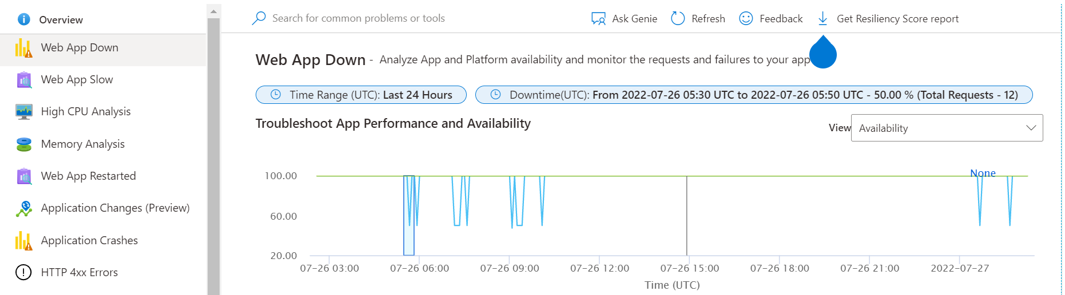

If you scroll down on this page and click on **Observations and Solutions**:

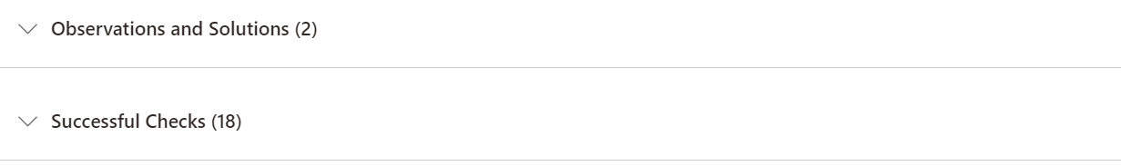

You can see the details of error:

