# Azure Free Services

Microsoft offer many products and services that are either free for an additional 12 months, or remain free for the lifetime of the account. These accounts are perfect for IT professionals or developers to get hands on with Azure.

1- Once you have created free trial account of azure using link <https://azure.microsoft.com/en-us/free/>, go to your Azure portal.

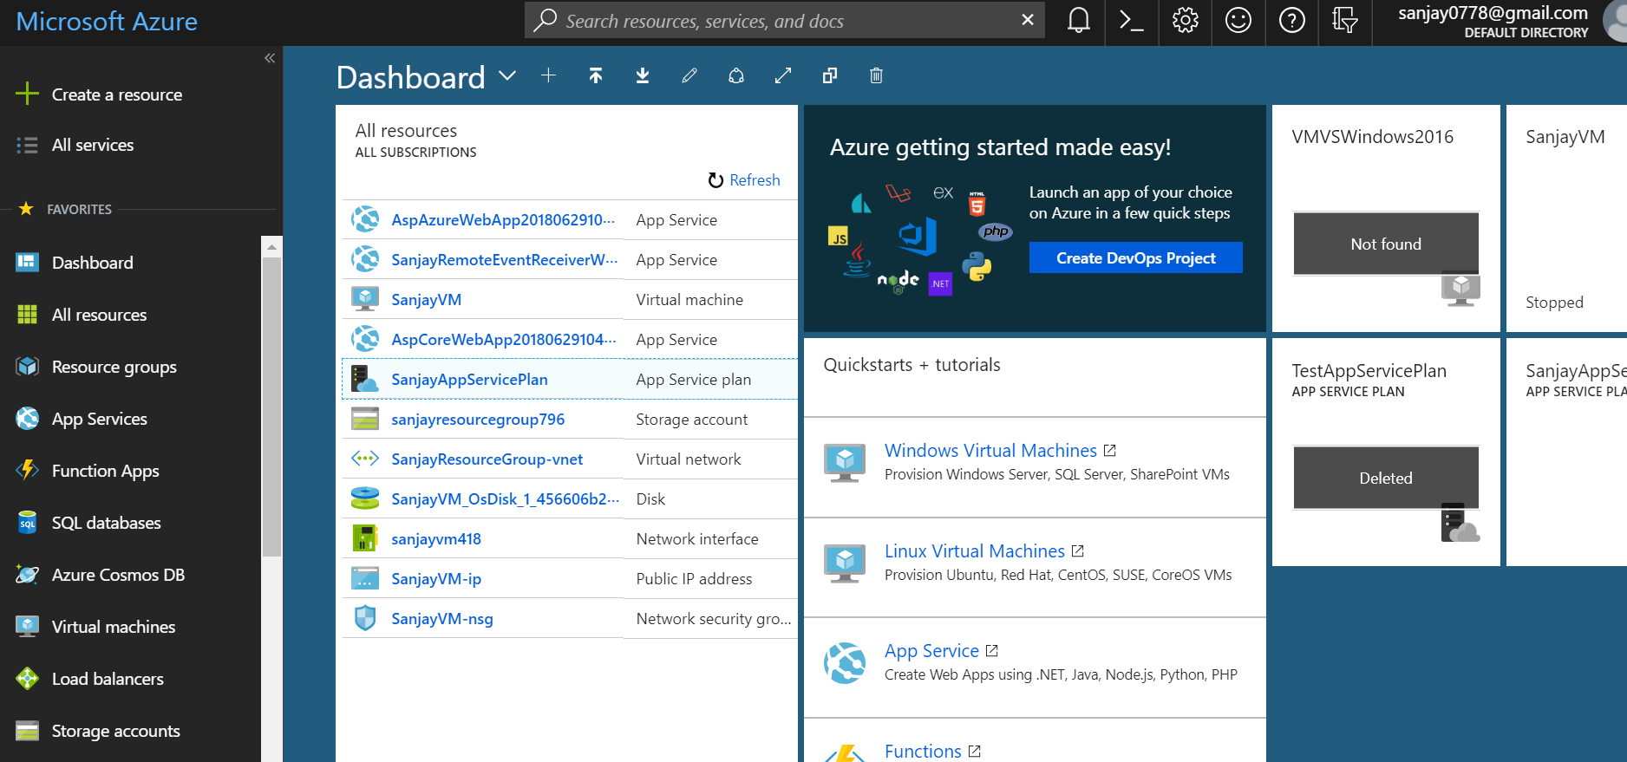

2- Type free services in top search box.

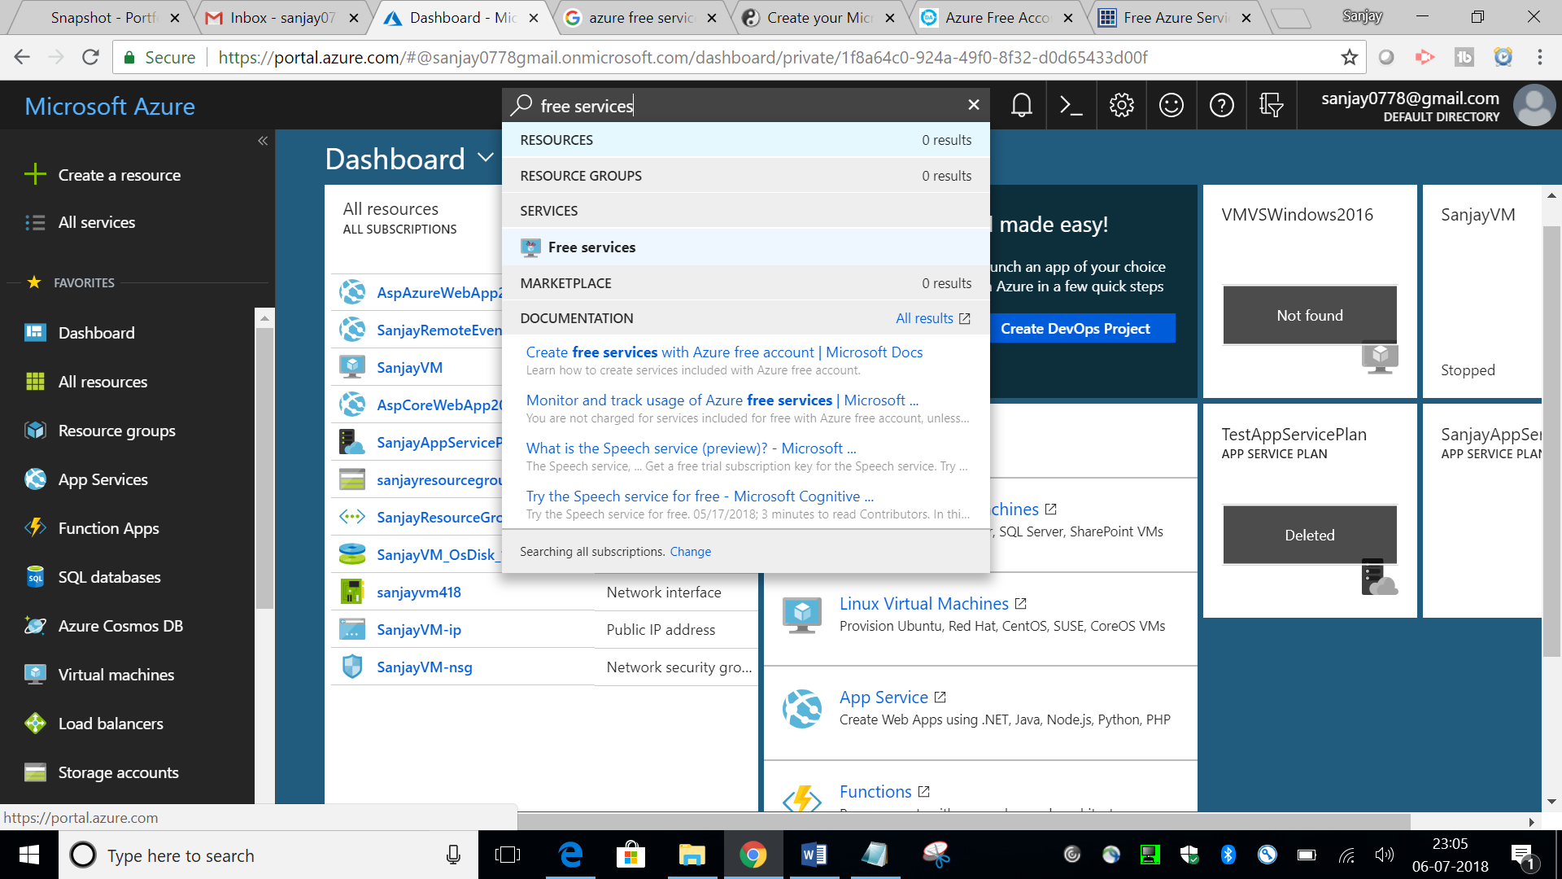

3- You will be redirected to page ‘https://portal.azure.com/#blade/Microsoft_Azure_Billing/FreeServicesBlade’. Here you can see all free services.

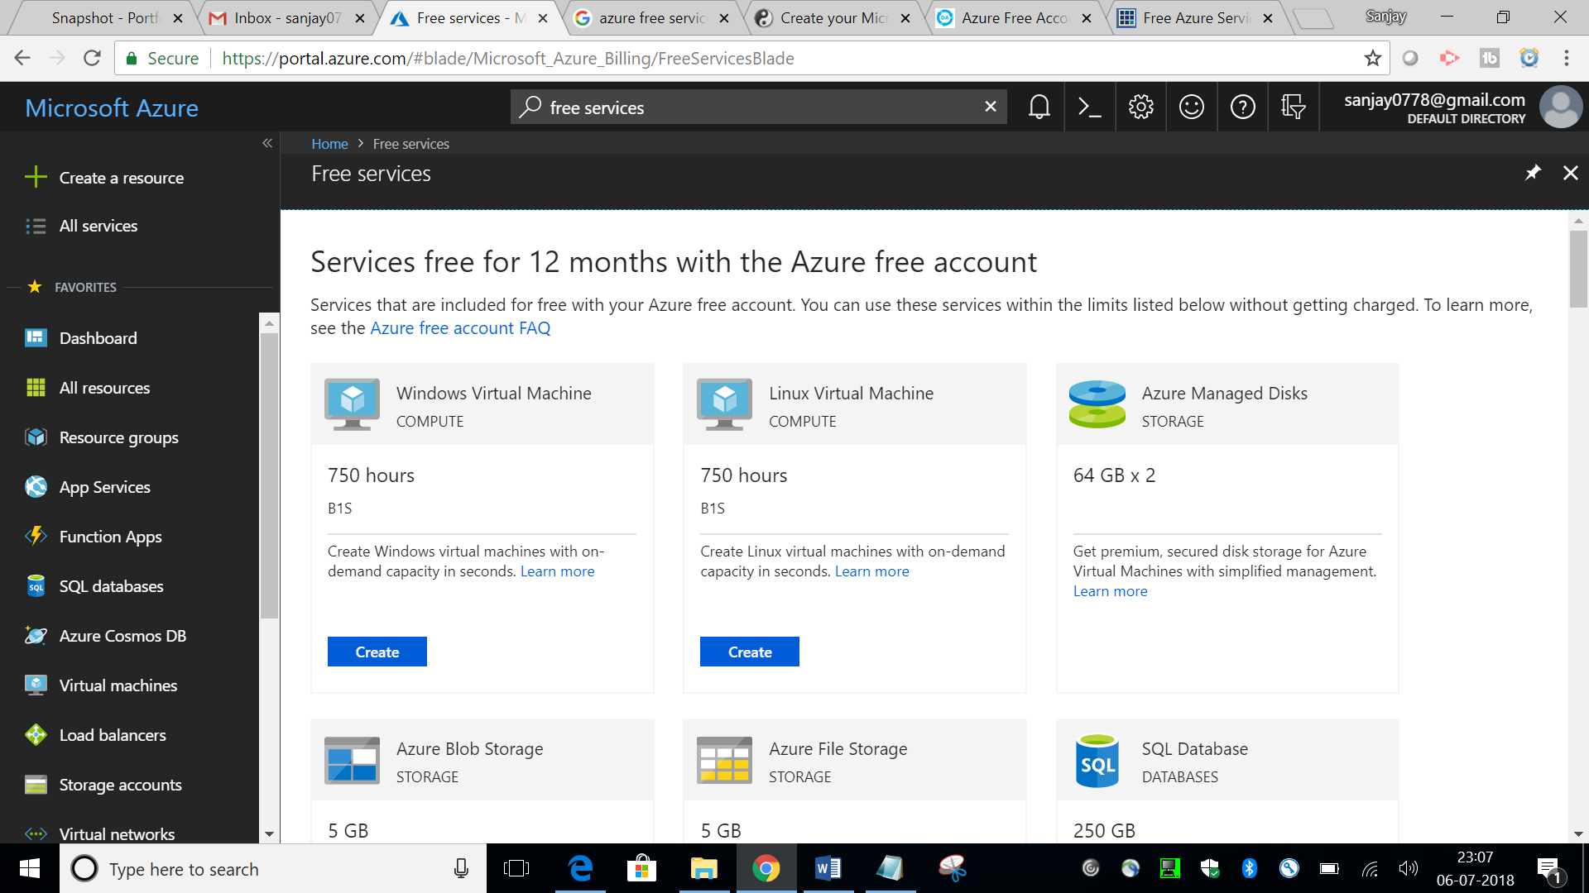

4- Services free for 12 months with the Azure free account.

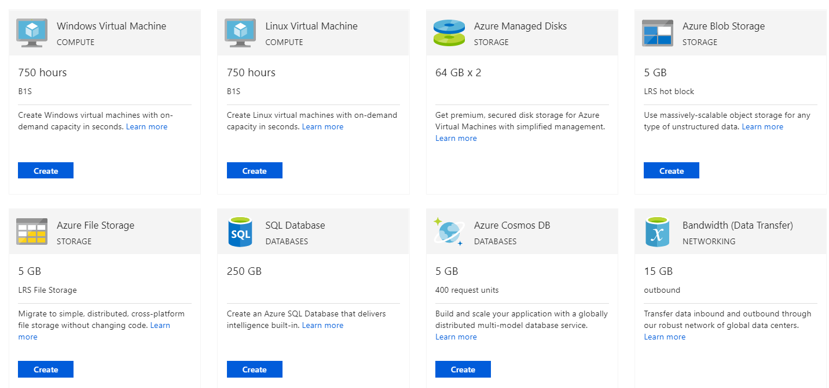

5- Always free services

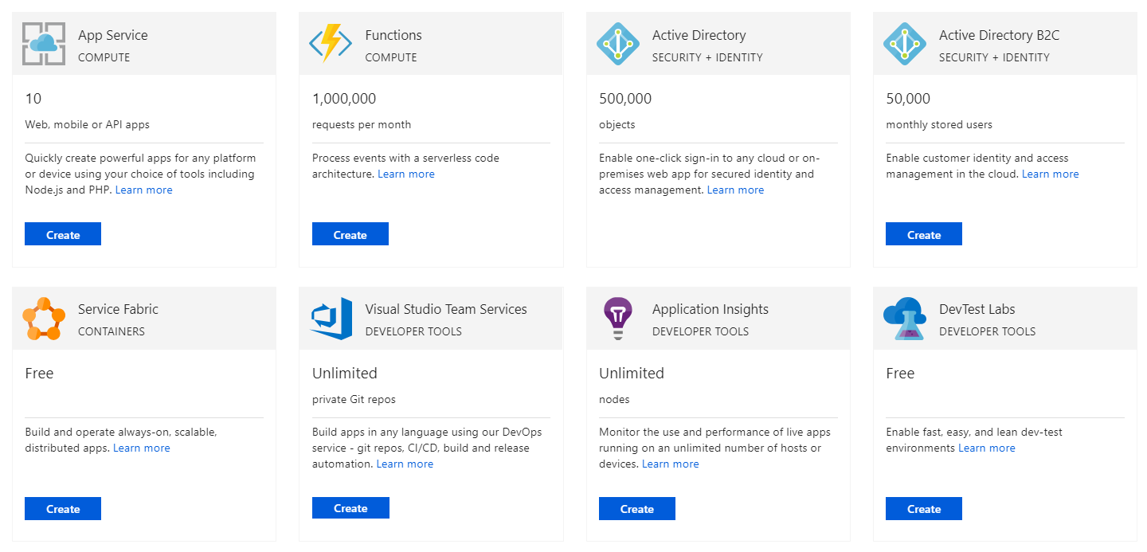

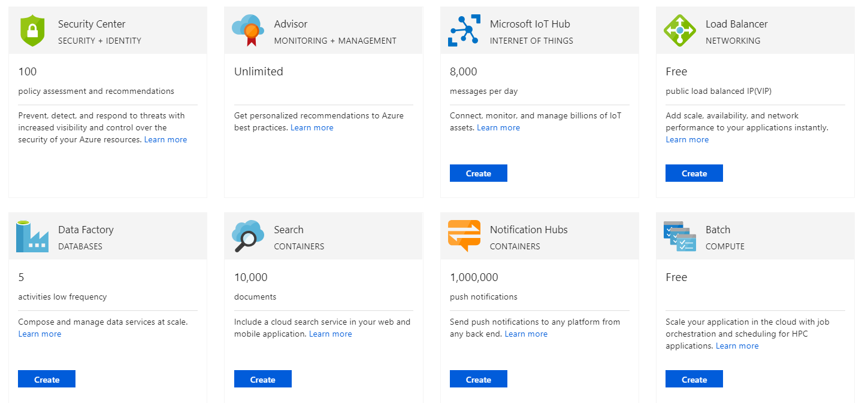

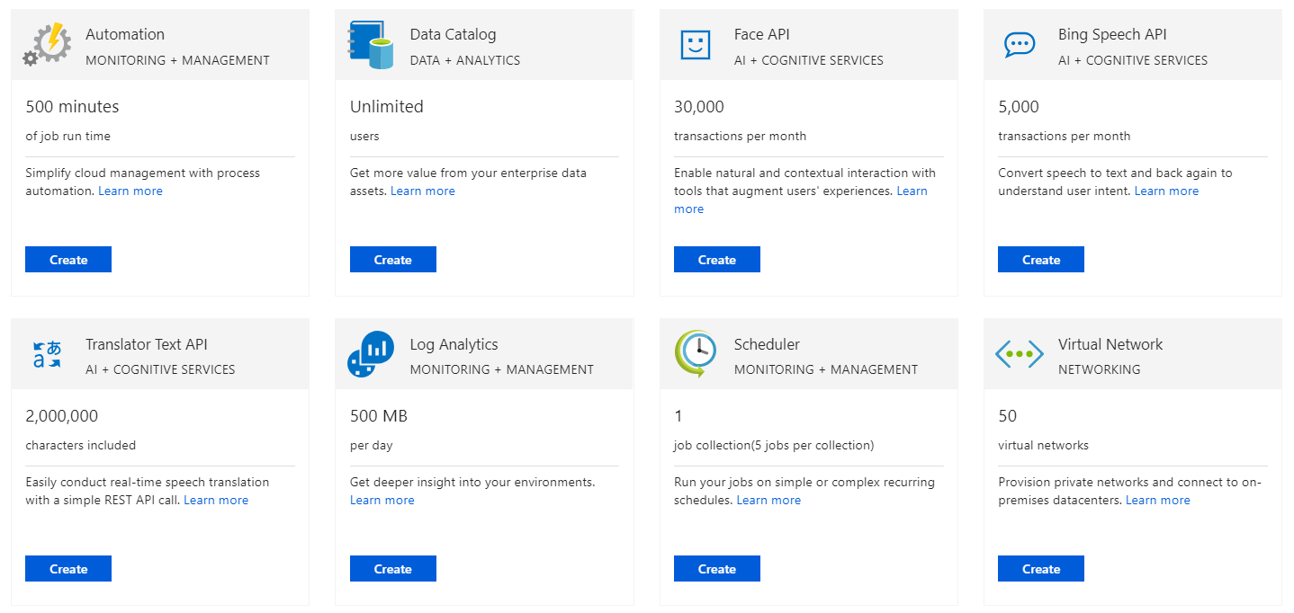

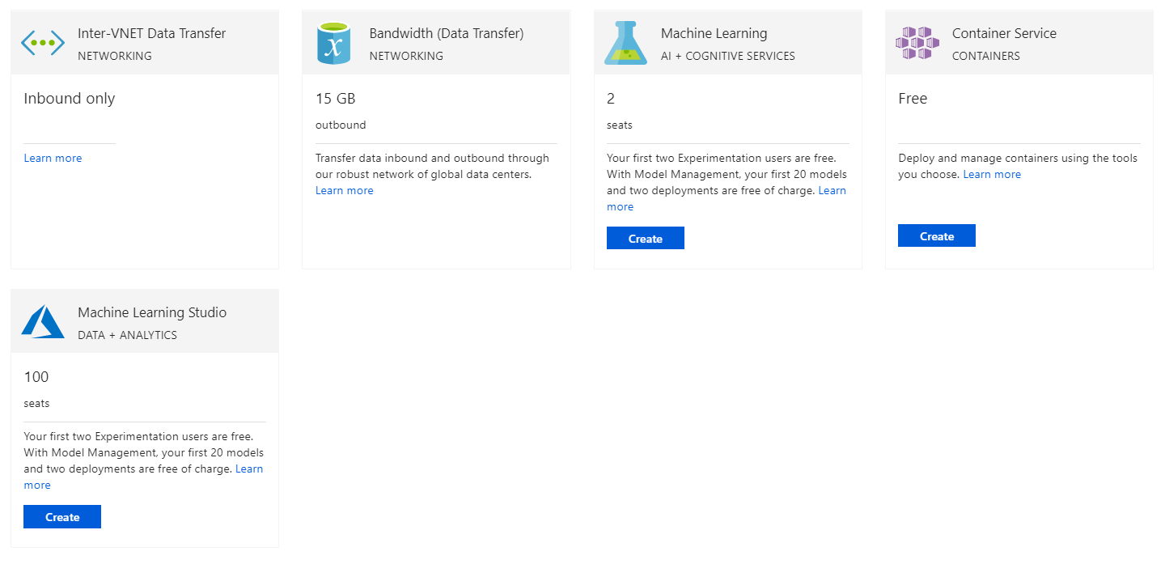

Here is the list of free products in Azure:

|  |  |
| --- | --- |
| **PRODUCTS** | **PERIOD OF FREE AVAILABILITY** |
| 750 hours of Azure B1S General Purpose Virtual Machines for Microsoft Windows Server | 12 months |
| 750 hours of Azure B1S General Purpose Virtual Machines for Linux | 12 months |
| 128 GB of Managed Disks as a combination of two 64 GB (P6) SSD storage, plus 1 GB snapshot and 2 million I/O operations | 12 months |
| 5 GB of LRS-Hot Blob Storage with 2 million read, 2 million write and 2 million write/list operations | 12 months |
| 5 GB of LRS File Storage with 2 million read, 2 million list and 2 million other file operations | 12 months |
| 250 GB of SQL Database Standard S0 instance with 10 database transaction units | 12 months |
| 5 GB of Azure Cosmos DB with 400 reserved in units | 12 months |
| 15 GB of bandwidth for outbound data transfer with free unlimited inbound transfer | 12 months |
| 5 GB of bandwidth for outbound data transfer with free unlimited inbound transfer | Always free after first 12 months |
| 10 web, mobile or API apps with Azure App Service with 1 GB storage | Always free |
| 1 million requests and 4,00,000 GBs of resource consumption with Azure Functions | Always free |
| Free Azure Container service to cluster virtual machines | Always free |
| 50,000 stored objects with Azure Active Directory with Single Sign-On (SSO) for 10 apps per user | Always free |
| 50,000 monthly stored users and 50,000 authentications per month with Azure Active Directory B2C | Always free |
| Free Azure Service Fabric to build microservice apps | Always free |
| First 5 users free with Visual Studio Team Services | Always free |
| Unlimited nodes (server or platform-as-a-service instance) with Application Insights and 1 GB of telemetry data included per month | Always free |
| Unlimited use of Azure DevTest Labs | Always free |
| Machine learning with 100 modules and 1 hour per experiment with 10 GB included storage | Always free |
| Free policy assessment and recommendations with Azure Security Center | Always free |
| Unlimited recommendations and best practices with Azure Advisor | Always free |
| Free Azure Lot Hub edition includes 8,000 messages per day with 0.5 KB message meter size | Always free |
| Free public load-balanced IP with Azure Load Balancer | Always free |
| 5 free low frequency activities with Azure Data Factory | Always free |
| 50 MB storage for 10,000 hosted documents with Azure Search including 3 indexes per service | Always free |
| Free namespace and 1 million push notifications with Azure Notification Hubs | Always free |
| Unlimited Azure Batch usage for job scheduling and cluster management | Always free |
| Free 500 minute of job run time with Azure Automation | Always free |
| Unlimited users and 5,000 catalog objects with Azure Data Catalog | Always free |
| 30,000 transactions per month processing at 20 transactions per minute with Face API | Always free |
| 5,000 transactions per month with Bing Speech API | Always free |
| Free 2 million characters included for Translator Text API | Always free |
| Free 5 GB per month analysis plus 31-day retention period with Log Analytics | Always free |
| Free Scheduler with 1 job collection, 5 jobs per collection and 3,600 job executions | Always free |
| 50 virtual networks free with Azure Virtual Network | Always free |
| Unlimited inbound Inter-VNet data transfer | Always free |

For more details you can check following link: <https://azure.microsoft.com/en-in/free/free-account-faq/>