Display, edit, and create a record in a data source.

If you add a **Display form** control, the user can display all fields of a record or only the fields that you specify. If you add an **Edit form** control, the user can edit those fields, create a record, and save those changes to a data source.

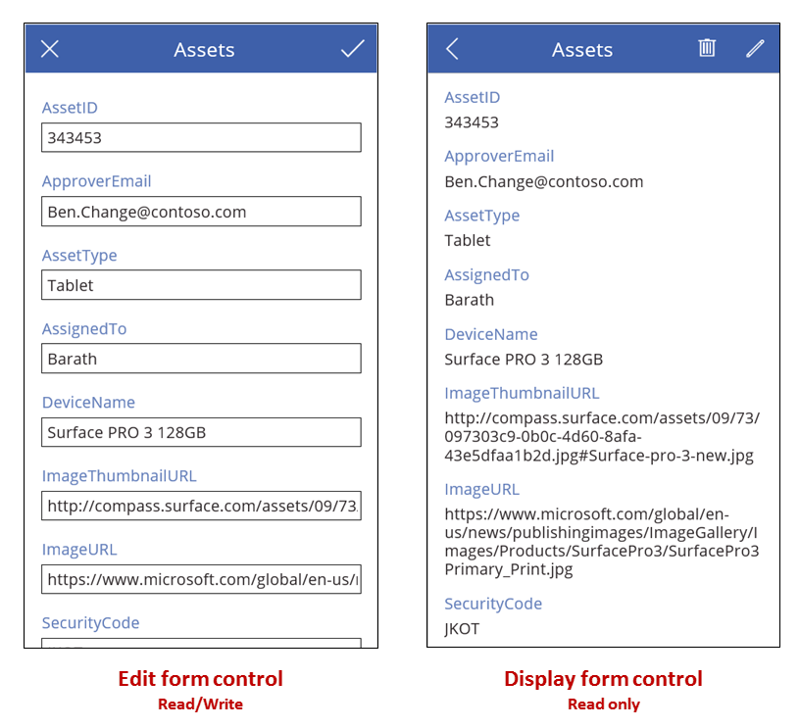

If you add a [**Gallery**](https://docs.microsoft.com/en-us/power-apps/maker/canvas-apps/controls/control-gallery) control, you can configure it to show a table in a data source and then configure a form to show whichever record the user selects in the gallery. You can also add one or more [**Button**](https://docs.microsoft.com/en-us/power-apps/maker/canvas-apps/controls/control-button) controls that the user can select to save edits, cancel edits, and create a record. By using controls together, you can [create a complete solution](https://docs.microsoft.com/en-us/power-apps/maker/canvas-apps/working-with-forms).