An *environment* is a space to store, manage, and share your organization's business data, apps, chatbots, and flows. It also serves as a container to separate apps that might have different roles, security requirements, or target audiences.

In Power Apps, there are five types of environments that you can create, so in this section, we’re gonna list these PowerApps environments types to know the characteristics of each environment.

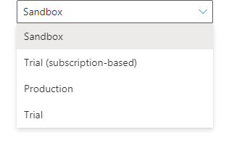PowerApps environment types

1. Default environment,
2. Developer environment,
3. Production environment,
4. The sandbox environment, and
5. Trial environment.

**1) Default environment in PowerApps**

* PowerApps automatically creates a single default environment for each tenant, and You cannot block the automatic provisioning of the Default environment.
* The default environment is shared by all users in the tenant. So it Communicates with everyone. That environment is not for developing critical apps. And it shouldn’t be used to host production apps.
* The default environment can’t be disabled or deleted.

**2) Developer environment in PowerApps**

* the developer environment provided by the community plan
* It can’t be shared with other users, only for individual use by its owner.
* Although the developer environment locked for any user except the user who subscribed to the community plan, the Applications can be moved out of the environment if needed.

**3) Production environment in PowerApps**

* The production environment is used for permanent work in an organization.
* You can only create two production environments and two trial environments with your Power Apps P2 license.
* The Production environment can be created and owned by an administrator or anyone with a Power Apps license.
* The Production environment will provide you with 1 G database capacity.

**4) Sandbox environment in PowerApps**

* Sandbox environments are non-production environments, which offer features like copy and reset.
* Sandbox environments are used for development and testing, separate from production.
* Sandbox environment Requires 1GB of Dataverse database capacity to provision.
* Provisioning Sandbox environments can be restricted to admins.

**5) Trial environment in PowerApps**

* This type of environment expires after 30 days.
* Trial environments are intended to support short-term testing needs.
* Trial environments are automatically cleaned after the expiration period that is 30.
* If you want to use the environment for more than 30 days, you must convert the trial to a Production environment.
* It is limited to one user only.