You can create a database and build apps by using Dataverse as a data store. You can either create your own custom tables or use the predefined tables. To create a database, you first need to either create an environment, or be assigned to an existing environment as an **Environment Admin**. In addition, you must be assigned the appropriate license.

You can only add a single database to an environment. This topic applies to those who haven't yet added a Dataverse database to an environment.

There are various ways to add or create a database:

* In the Microsoft Power Platform admin center
* In the **Tables** pane of Power Apps (make.powerapps.com)

**Add a database in the admin center**

1. In the [admin center](https://admin.powerplatform.microsoft.com/), in the left navigation pane, select **Environments**.
2. Select the environment to which you want to add the database.
3. Select **+ Add database**.

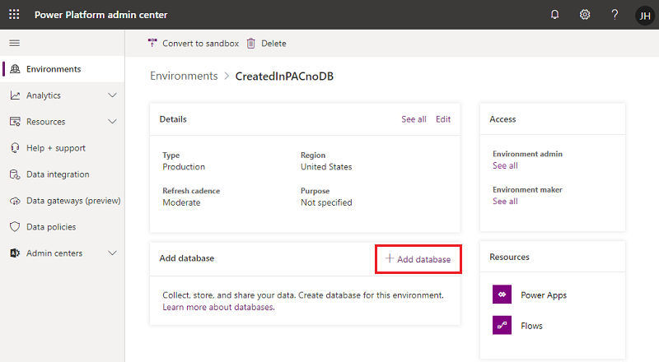

Enter the following, and then select **Add**.

| **Setting** | **Description** |
| --- | --- |
| Language | The default language for this environment. More information: [Dataverse language collations](https://docs.microsoft.com/en-us/power-platform/admin/language-collations) |
| Currency | The base currency used for reporting. |
| Enable Dynamics 365 apps | Select **Yes** and make a selection to automatically deploy apps such as Dynamics 365 Sales and Dynamics 365 Customer Service. |
| Deploy sample apps and data | Select **Yes** to include sample apps and data. Sample data gives you something to experiment with as you learn. You must select **No** for **Enable Dynamics 365 apps** for this setting to appear. |
| Security group | Select a security group to restrict access to this environment. |

**Create a database in the Tables pane of Power Apps**

1. Sign in to [Power Apps](https://make.powerapps.com/).
2. In the left pane, expand the **Data** section, select **Tables** in the left navigation pane.
3. Select **Create a database** to create the database.

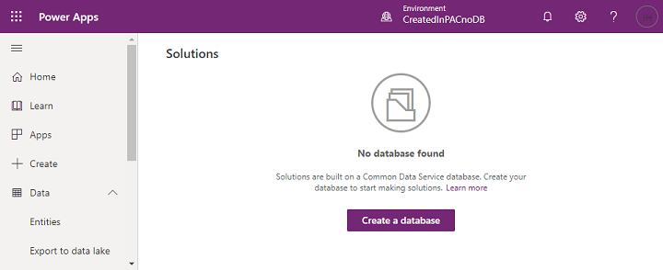

**Security model for the databases**

When a database is created, the users who have environment roles assigned to them, will continue to maintain those privileges.  
Users with **Environment Admin** role are now assigned to **System Administrator** role. Users with **Environment Maker** continue to possess the same role.