Power Apps- InfoPath like Repeating Table in PowerApps

We want to create a repeating table in Power Apps form same as repeating table in InfoPath. For this we have to create a multiline text field in SharePoint list or any other data source where you want to store the data. We have to use Gallery control of Power Apps to create a repeating table. All the data in gallery control will be saved in single multiline text field in semi colon (;) separated for data of same row and pipe (|) separated for each row. So columns of same row are separated by semi colon (;) and each row is separated by pipe (|)

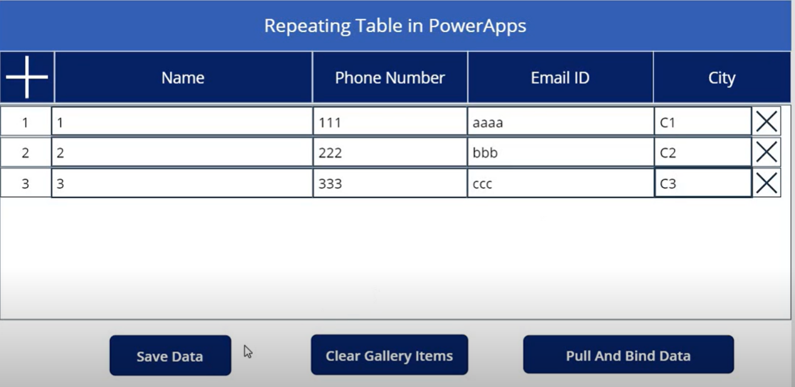

### Combine table data into one string variable

Set(AllItemsString,Concat(GalleryRepeatingTable.AllItems,Concatenate(ItemSerialNumber.Text,";",VisitorName.Text,";",VisitorPhoneNumber.Text,";",VisitorEmail.Text,";",VisitorCity.Text,"|")))

### Save Data button select

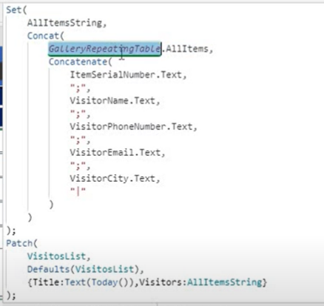

### Add new blank row in Gallery – new button/ icon select

Collect(CollItems,{CItemSerialNumber: Text(Last(CollItems).CItemSerialNumber + 1) ,CVisitorName:"",CVisitorPhone:"",CVisitorEmail:"",CVisitorCity:""})

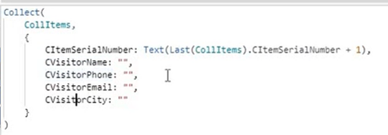

### Remove Row from Gallery – delete button/ icon select

RemoveIf(CollItems,CItemSerialNumber = ThisItem.CItemSerialNumber)

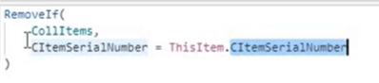

### Pull data and generate collection object – Pull and Bind Data button select

Clear(CollItems);

Set(AllItemsString,Left(AllItemsString, Len(AllItemsString)-1));

ForAll(Split(AllItemsString,"|"),

Collect(CollItems,

{CItemSerialNumber: Text(Last(FirstN(Split(Result,";").Result,1).Result).Result),

CVisitorName:Text(Last(FirstN(Split(Result,";").Result,2).Result).Result),

CVisitorPhone:Text(Last(FirstN(Split(Result,";").Result,3).Result).Result),

CVisitorEmail:Text(Last(FirstN(Split(Result,";").Result,4).Result).Result),

CVisitorCity:Text(Last(FirstN(Split(Result,";").Result,5).Result).Result)}))

