Mobile users often need to be productive even when they have limited or no connectivity. When you build a canvas app, you can perform these tasks:

* Open Power Apps Mobile and run apps when offline.
* Determine when an app is offline, online, or in a metered connection by using the [Connection](https://docs.microsoft.com/en-us/power-apps/maker/canvas-apps/functions/signals#connection) signal object.
* Use [collections](https://docs.microsoft.com/en-us/power-apps/maker/canvas-apps/create-update-collection) and leverage the **[LoadData](https://docs.microsoft.com/en-us/power-apps/maker/canvas-apps/functions/function-savedata-loaddata)**[and](https://docs.microsoft.com/en-us/power-apps/maker/canvas-apps/functions/function-savedata-loaddata)**[SaveData](https://docs.microsoft.com/en-us/power-apps/maker/canvas-apps/functions/function-savedata-loaddata)** functions for basic data storage when offline.

The **LoadData** and **SaveData** functions might show an error in Power Apps Studio because browsers don't support them. However, they'll perform normally after you deploy this app to a device.

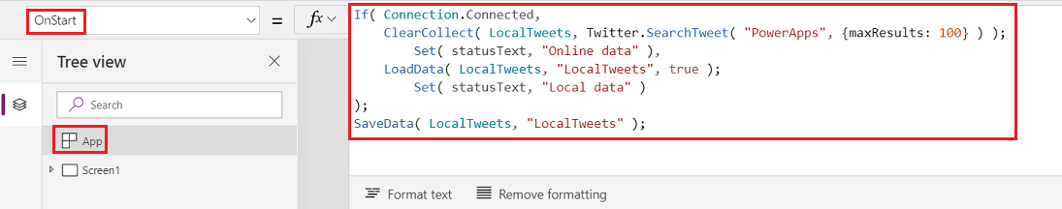

*If( Connection.Connected,*

*ClearCollect( LocalTweets, Twitter.SearchTweet( "PowerApps", {maxResults: 10} ) );*

*Set( statusText, "Online data" ),*

*LoadData( LocalTweets, "LocalTweets", true );*

*Set( statusText, "Local data" )*

*);*

*SaveData( LocalTweets, "LocalTweets" );*

This formula checks whether the device is online:

* If the device is online, the formula loads up to 10 tweets with the search term "PowerApps" into a **LocalTweets** collection.
* If the device is offline, the formula loads the local cache from a file called "LocalTweets" if it's available.

**Show connection status**

1. Under the gallery, insert a label, and then set its **Color** property to **Red**.
2. Set the newest label's **Text** property to this formula:

*If( Connection.Connected, "Connected", "Offline" )*

**Add a button to post the tweet**

*If( Connection.Connected,*

*Twitter.Tweet( "", {tweetText: NewTweetTextInput.Text} ),*

*Collect( LocalTweetsToPost, {tweetText: NewTweetTextInput.Text} );*

*SaveData( LocalTweetsToPost, "LocalTweetsToPost" )*

*);*

*Reset( NewTweetTextInput );*