## What is PnP PowerShell?

PnP PowerShell is a **cross-platform** PowerShell Module providing over 600 cmdlets that work with Microsoft 365 environments and more specifically SharePoint Online, Microsoft Teams, Microsoft Planner and Microsoft Flow. This module is a successor of the [SharePointPnPPowerShellOnline](https://github.com/pnp/pnp-powershell" \t "_blank) module, which is now regarded legacy and not maintained anymore.

## How to Install the PnP PowerShell Module for SharePoint Online?

* Uninstall the Legacy SharePointPnPPowerShellOnline Module if installed already.
* Install the New PnP PowerShell Module.
* Register Azure AD Application and Grant Access to the tenant.

It is recommended to use PowerShell 7.x, which can be installed by following [these instructions](https://docs.microsoft.com/powershell/scripting/install/installing-powershell-on-windows). Most of the cmdlets should work under PowerShell 5.x as well, though.

**Step 1:** Uninstall the Legacy SharePointPnPPowerShellOnline Module

Uninstall Any previous PnP PowerShell Modules for SharePoint Online installed.

***Uninstall-Module SharePointPnPPowerShellOnline -Force –AllVersions***

**Step 2:** Install the New PnP PowerShell Module

Install the new PnP PowerShell module using:

***Install-Module PnP.PowerShell***

**Step 3:** Register a new Azure AD Application and Grant Access to the tenant

***Register-PnPManagementShellAccess***

The final step is to grant access to the tenant for the PnP Management Shell Multi-Tenant Azure AD Application. On executing the above cmdlet, you’ll be prompted to log in and provide consent for your tenant. You must log in as a Global Admin (or Tenant Administrator) and complete this step.

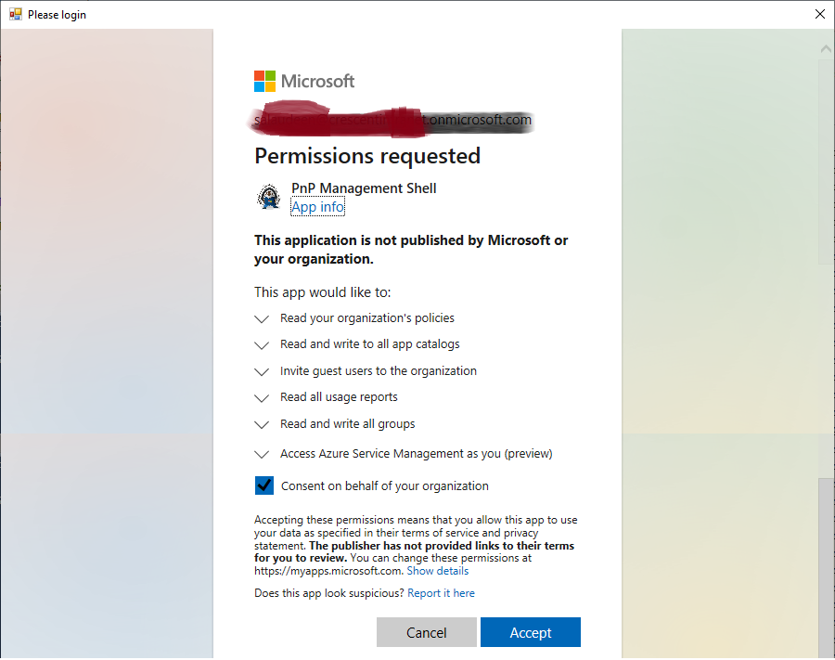

In case you are not a global admin, use: ***Register-PnPManagementShellAccess -ShowConsentUrl*** and share the URL you get from this cmdlet with the Tenant Admin, and they can complete this consent step from the URL you share.

Finally, you can verify the installation with:

***Get-Command -Module PnP.Powershell***

**Connect SharePoint Online site using PnP PowerShell**

Once you are done with the above steps, You can connect to SharePoint Online through PnP PowerShell as:

#Connect to PnP Online

***Connect-PnPOnline -Url "https://test.sharepoint.com/sites/sales" -Credential (Get-Credential)***

#Get All Lists

***Get-PnPList***

**Connect-PnPOnline using MFA:**

To connect to SharePoint Online using PnP PowerShell MFA: Use the ***“-Interactive”*** switch instead of “Credentials” if your account is MFA enabled.

#Connect to PnP Online

***Connect-PnPOnline -Url "https://test.sharepoint.com/sites/sales/" -Interactive***

#Get All Lists

***Get-PnPList***

**Update PnP PowerShell for SharePoint Online**

To update the PnP PowerShell, run:

***Update-Module -Name "PnP.PowerShell"***

**Uninstall PnP PowerShell Module**

If you would like to remove the PnP PowerShell, you can run:

**Uninstall-Module -Name "PnP.PowerShell"**

If you would like to use the PnP PowerShell module for SharePoint Server (On-Premises), You can install it along with Pnp.PowerShell module as:

**Install-Module -Name SharePointPnPPowerShell2019 –AllowClobber**

This script installs the SharePointPnPPowerShell2019 module and makes cmdlets available from this module. You can use “Import-Module SharePointPnPPowerShell2019” at the first line to instruct your script to load and use Cmdlets from this specific module.