Predicting Stroke Risk Using Hybrid Deep Transfer Learning Models

Aburi Naveen Varma  
Computer Science Engineering *Lovely Professional University*Phagwara, Punjab  
naveenabburi814@gmail.com

Ajay Kumar Badhan  
Assistant Professor *Lovely Professional University*Phagwara, Punjab  
ajay.27337@lpu.co.in

Morrigadudhula Abhinay  
Computer Science Engineering *Lovely Professional University*Phagwara, Punjab  
abhinayabhi141@gmail.com

Mattapalli Veerasai  
Computer Science Engineering *Lovely Professional University*Phagwara, Punjab  
veerasaimattapalli1406@gmail.com

Bavanari AnilKumar  
Computer Science Engineering *Lovely Professional University*Phagwara, Punjab  
anilkumar.bavanari@gmail.com

Somishetty Sanjay Varma Computer Science Engineering *Lovely Professional University*Phagwara, Punjab sanjaysomishetty01@gmail.com

Chinda Harsha vardhan Raju  
Computer Science Engineering *Lovely Professional University*Phagwara, Punjab  
harsharaju121@gmail.com

***Abstract:******Our study introduces a novel approach, combining deep neural networks with transfer learning, to predict stroke risk. Utilizing a healthcare dataset, we preprocess the data, encode categorical variables, and train Decision Tree and Random Forest classifiers. Results highlight the hybrid model's effectiveness in accurately predicting stroke risk, showcasing its potential to augment healthcare analytics and provide valuable insights for preventive interventions. This hybrid deep transfer learning framework offers a promising avenue for enhancing stroke risk prediction models, thereby contributing to improved patient care and health results.***

***Keywords: Stroke risk prediction, Deep neural networks, Transfer learning, Decision Tree classifier, Random Forest classifier, Hybrid model, Healthcare analytics, Preventive interventions, Deep transfer learning framework, Improved patient care, Predictive modelling.***

1. **INTRODUCTION**

Understanding the complex interactions between lifestyle decisions, demographics, and health indicators is essential for managing and preventing disease in today's healthcare environment. Of all the health issues that people experience on a global scale, stroke is one of the most serious and possibly incapacitating conditions. Comprehensive research and predictive models are desperately needed to lessen the burden of this increasing occurrence and often severe consequences.

This project uses a diverse dataset that includes important characteristics like age, smoking status, heart disease history, BMI (body mass index), average glucose level, marital status, and stroke occurrence to explore the intricate web of factors that lead to stroke occurrence. Every one of these factors reflects a different aspect of a person's health profile and provides important information about how susceptible they are to stroke.

The interplay between personal decisions and cardiovascular health outcomes is reflected in the strong influence of lifestyle and socioeconomic circumstances on stroke risk profiles. These factors include relationship status, profession, plasma glucose levels, BMI, and smoking habit.

**Related work:**

In the absence of a viable cure, stroke has emerged as a primary global cause of mortality and permanent disability. Although deep learning-based approaches depend on a lot of well-labelled data, they have the potential to perform better than current stroke risk prediction models. Because health care systems have stringent privacy protection policies, stroke data is typically dispersed in modest amounts across various hospitals. Additionally, there is a stark imbalance between the positive and bad examples of this data. By utilizing the expertise of an associated area, transfer learning helps address small data issues, particularly in situations when several data sources are available. This paper presents a novel scheme for Stroke Risk Prediction (HDTL-SRP) created on Hybrid Deep Transfer Learning that receipts advantage of the knowledge construction from several correlated sources (e.g., external stroke data, chronic.[1]

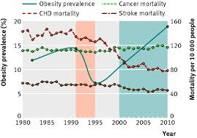

**FIGURE-1 BMI ANALYSIS**

Stroke complications frequently include post-stroke cognitive impairment. It lowers patients' disease prognosis and the effectiveness of their recovery. Numerous factors, such as demographics (e.g. age, gender, and informative attainment), medical history (e.g. high blood pressure, diabetes, hyperlipidaemia, smoking, and alcohol consumption), and examination features (e.g., lesion nature, position, side, and inflammatory markers) may be associated with cognitive impairment following a stroke. The majority of currently used techniques, however, focus only on the qualitative assessments of distinct elements and neglect how different factors interact. Furthermore, no additional studies have been carried out to expect the probability of perceptive impairment following a stroke. We explore the impact of physical and psychological conditions on this kind risk cognitive impairment in stroke patients using a hybrid deep learning method that combines XGBoost & deep neural networks.[2]

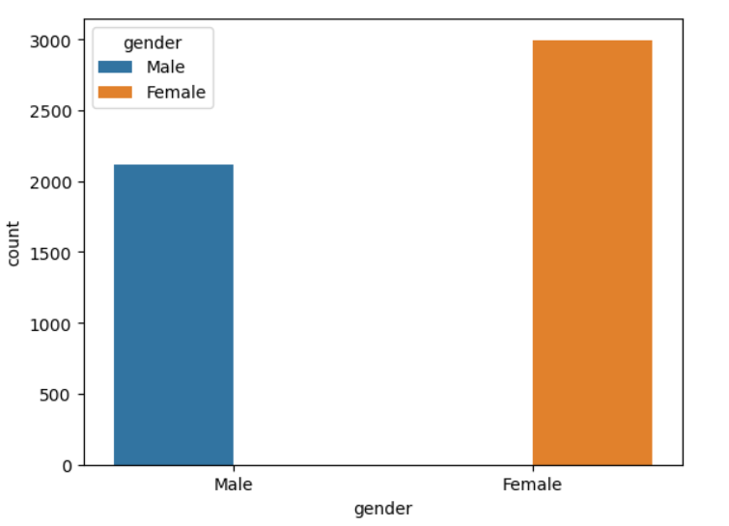

**FIGURE-2[GRAPH OF STORKE IN RELATION TO GENDER]**

In scientific decision-making, deep learning models stand increasingly being used since standard prediction models often fail to capture the complex feature representations of medical concerns. This work offers more precision than existing medical scoring schemes for cardiac patients by applying deep learning to a heart ailment dataset to predict stroke risk. It does this by utilizing shared predictive features linked with symptoms of atrial fibrillation. This study finding are more accurate than those medical grading schemes in practice today to alert cardiac patients.[3]

In the absence of a viable cure, stroke has emerged as a primary global cause of mortality and permanent disability. Approaches based on deep learning may perform better than current stroke risk prediction methods. By utilizing the expertise of an associated area, transfer learning helps address small data issues, particularly in situations when several data sources are available. In this work, we offer a novel scheme aimed at stroke risk prediction based on hybrid deep transfer learning.[4]

The most frequent kind of haemorrhagic stroke is called an intracerebral haemorrhage (ICH), which is produced by weakening brain tissue rupturing in blood vessels. This is a main medical emergency that requires emergency care. Radiologists manually analyze a significant number of noncontract-computed tomography (NCCT) brain pictures from diagnose hemorrhagic strokes; this is a laborious and time-consuming process. In this effort, we introduce a deep learning automated transfer method for precise cerebral bleeding prediction on NCCT brain images by combining ResNet-50 and dense layer. The model was evaluated using 1164 NCCT brain pictures that were obtained after 62 patients who suffered from hemorrhagic stroke at the Kalinga Institute of Medical Science in Bhubaneswar. The suggested perfect identifies specific CT scans using them by way of input.[5]

The mature of the Korean population will increase the incidence of strokes, which resolve put a fast economic strain on society. Stroke forecast can be enhanced with rapid treatment. Results are enhanced by being conscious of the warning symptoms of a stroke and taking the right response when one occurs. Here, we used a deep neural network to identify 15,099 cases of stroke by utilizing figures on medical facility use and health behaviour. Applicable background features were extracted from medical records using primary component examination (PCA) through quantile climbing, and they were then applied to expect stroke. We contrasted five alternative machine-learning techniques with ours, which is a ascended PCA/deep neural network [DNN] method. The region beneath the curvature.[6]

The research that used neural structures to read EEG images of brain-injured individuals in order to develop imagery-computerized interface models illustrated how deep learning helps transfer knowledge across domains. Transfer learning algorithms achieve excellent detection accuracy in motor imagery while efficiently fine-tuning model parameters and cutting training time. The results reveal that the recommended EEG-DenseNet combination produces a forecast accuracy of 96.5%, demonstrating its potential for brain injury rehabilitation systems and demonstrating how deep transfer learning helps to enhance the accuracy of EEG therapy models.[7]

Prognosis, resource organization, clinical prosecutions, and patient potentials can all benefit from the ability to predict longstanding clinical consequence based on initial serious ischemic stroke information. The approaches used now necessitate making subjective choices regarding which imaging elements to evaluate and could involve laborious postprocessing. The goal of this training was to use a Deep Learning model of subjective diffusion MRI pictures and scientific data from the serious phase to expect the ordinal 90-day changed Rankin Scale (mRS) cut in patients with acute ischemic stroke. METHODS: A total of 640 serious ischemic stroke patients were randomly assigned to three groups: 70% (n=448) for typical training, 15% (n=96) for validation, and 15% (n=96) for interior testing. The patients had 90-day mRS continuation data and had undergone magnetic character imaging in 1 to 7 days poststroke. Furthermore, outside testing on the troop from Lausanne University Hospital (n=280) was carried out to assess the universality of the model further. Two merged clinical-imaging models, clinical solely, imaging only, and accurateness for ordinal mRS, correctness within ±1 mRS group, cruel complete prediction error, and identification of an undesirable outcome (mRS score >2) were assessed. The connected models outperformed both clinical and imaging models in terms of forecasting ordinal mRS cut and unfavourable results in both inside and exterior test cohorts.[8]

The purpose of this research is to predict the risk of stroke by classifying colour Doppler pictures into stable carotid plaques and high-risk carotid susceptible plaques. A deep learning method based on transmission learning was used to gather 230 pictures from 87 patients through atherosclerosis risk features in each category. Using pre-trained Inception V3 and VGG-16 models, a peak correctness of 93.81% was attained by hyperparameter tweaking. The framework of the study offers a way to reduce misdiagnoses caused by individual knowledge and variability in image quality. This method has the potential to progress clinical executive in carotid plaque assessment and stroke risk prediction by efficiently differentiating between stable and high-risk carotid plaques.[9]

A study used deep learning algorithms (DLA) and clinical risk factors to improve atrial fibrillation (AF) prediction in embolic stroke patients with unknown source (ESUS). Using sinus rhythm ECGs from patients with and without AF, DLA was established by analysis of 221 ESUS patients who had implanted cardiac monitors. The prevalence of atrial ectopic burden (AEB), left atrial diameters (LAD), and left atrial volume index (LAVI) was higher in AF patients, who had a detection rate of 14.5%. The predictive accuracy of DLA was higher than that of individual clinical variables (AUC: 0.824). AUC was 0.902 when DLA, AEB, LAD, and LAVI were combined to improve prediction. This combined method may help anticipate AF in ESUS patients, which could help guide treatment choices. The study received no outside funding.[10]

In research comprising 8590 patients who had suffered an acute ischemic stroke (AIS), deep learning models were used to estimate the extended risk of major negative cerebro/cardiovascular events (MACE). Deep learning models like DeepSurv and Deep-Survival-Machines (DeepSM) were compared with classic survival models like Cox proportional hazards (CoxPH) and random survival forest (RSF) using clinical data and brain imaging. Findings demonstrated that deep learning models performed better than standard models when image characteristics were added. DeepSurv and DeepSM produced the best time-dependent concordance index (Ctd index), at 0.8496 and 0.8531, respectively. Notably, the feature value of brain imaging was consistently high. Through the autonomous extraction of picture features from personalised brain images, these deep learning models made it possible to forecast MACE risk and occurrence at the individual level. The study comes to the conclusion that combining clinical data.[11]

Using administrative claims data, we created and verified Prediction models for in-hospital mortality based on deep learning with an emphasis on acute care patients. Utilising age, sex, diagnoses, and procedures at the time of admission, the main model achieved a good degree of discrimination in the validation cohort of 46,665,933 inpatients from Japanese Diagnosis Procedure Combination data, with an AUC of 0.954 (95% CI 0.954-0.955). Although they were created, the disease-specific models for acute myocardial infarction, failure of heart, stroke, and pneumonia showed less discriminating than the main model. Our results address the issue of disease severity information being missing from administrative databases by indicating that deep-learning models using administrative data can forecast in-hospital mortality with high accuracy.[12]

Machine learning techniques were applied to a well-known heart stroke classification dataset in a research study focused on early heart stroke prediction. The impact of pre-processing data was also evaluated in the study. The Framingham dataset was used to test a number of machine learning models as well as an Artificial Neural Network (ANN) using conventional feature selection. Recall, F1-score, accuracy, and precision were used as evaluation criteria. Based on pre-processed data, the outcome shows that ANN performed superior than other models, with greatest accuracy rate of 87.95% and an F1-score of 91.47%. These results highlight how machine learning, and ANN in particular, can improve cardiac stroke prediction, which can lead to significant life savings and the advancement of public health initiatives.[13]

This study presents a hybrid deep learning model that uses a Kaggle benchmark dataset to predict the probability of stroke in the early stages. LSTM, RNN, CNN, and GRU models were used for classification tasks after undergoing thorough preparation, which included cleaning and normalisation procedures. CNN+GRU achieved 98.78% accuracy and LSTM+RNN achieved 98.23% accuracy, which are good outcomes of the study. These results emphasise the advantages of deep learning techniques over traditional methods and show how they can improve stroke care and prevention. These models' ability to assist early diagnosis could have a substantial influence on population health by offering timely insights for intervention and lifestyle modifications.[14]

This paper proposes a deep learning strategy using ResNet18 and ResNet151 for stroke prediction and Fully Convolutional Network (FCN) for cholesterol detection. In order to accurately identify places where cholesterol deposits are present, the FCN model makes pixel-level segmentation easier. This helps with the assessment of cardiovascular risk. Utilising complex features from clinical data, transfer learning with pre-trained ResNet18 and ResNet151 models—fine-tuned on stroke datasets—demonstrates remarkable predictive skills. Promising results are found from extensive tests using a variety of medical pictures and patient records. FCN was able to detect cholesterol with 98% accuracy, while the ResNet18 and ResNet151 models predicted strokes with 98.4% and 99.6% accuracy, respectively. These findings demonstrate how well deep learning models work for early cardiovascular disease detection and prevention.[15]

The retinal vessel calibre, as determined by a deep-learning system, strongly predicts incident cardiovascular disease (CVD) events, according to a backward cohort research of 860 Chinese, Malay, and Indian patients with chronic kidney disease (CKD) who were 40–80 years of age. During a follow-up average of 9.3 years, 289 patients had CVD events. Lower estimated glomerular filtration rate (eGFR) and retinal arteriolar constriction were independent predictors of CVD in CKD patients after controlling for known cardiovascular risk factors. Retinal characteristics and eGFR were added to improve CVD risk prediction, which increased model fit and discrimination, especially when it came to distinguishing low, moderate, and high-risk groups. These results imply that, in Asian CKD populations, integrating assessments of renal function and retinal vascular calibre quality could get better than the estimation of CVD risk.[16]

This study presents a novel method of stroke predictive analytics based on heart disease datasets and a deep learning model. This deep learning model achieves high predictive accuracy, outperforming conventional medical scoring systems and significantly improves clinical decision-making for stroke prevention in patients with cardiac conditions by leveraging common characteristics between stroke risk factors and irregular heartbeat symptoms in heart patients. This shows a promising avenue to enhance predictive methods in medicine and modifying risky patient strategies.[17]

This work used both traditional statistics and deep learning methods to create and evaluate models for predicting hospitalisation and death from cardiovascular disease (CVD) in people with hypertension. CVD things that happened in a year, following the prior visit were studied by data analysis from over 2 million participants in the Korean National Health Insurance Service database. The synthetic minority oversampling algorithm was used to oversample in order to correct sample number imbalances. In predicting hospitalisation for CVD (accuracy: 0.863 vs. 0.655; F1-score: 0.854 vs. 0.656; AUC: 0.932 vs. 0.655) and death from CVD (accuracy: 0.925 vs. 0.780; F1-score: 0.924 vs. 0.783; AUC: 0.979 vs. 0.780), the deep neural network (DNN) method performed better than logistic regression. These results imply that the deep learning model correctly forecasts the consequences of CVD in hypertension patients, offering valuable insights for resource allocation and risk management.[18]

In a study combining statistical models, random forests, and deep learning (BEHRT) as predictive models for the risk of cardiovascular illness, deep learning models beat statistical models in the prediction of failure of heart, stroke, and coronary heart disease by 6%, 8%, and 11%, respectively. Data alterations, however, caused performance decreases for all models, with deep learning models continuing to outperform the others. From 1985 to 2015, 1.1 million patients in England who were 35 years of age or older had their electronic health records examined for this study. The greater discrimination of deep learning was demonstrated by internal validation; nonetheless, recalibration might be required to handle changing data distributions. In spite of the difficulties caused by dynamic alterations in data, deep learning models showed strong performance in predicting the risk of cardiovascular disease.[19]

A study used deep neural networks (DNN) to analyse survival data in order to predict the risk of dyslipidemia. With the use of health check-up data from 6,328 individuals who were initially free of dyslipidemia, the DNN model was able to obtain a time-dependent concordance index (Ctd-index) of 0.802, which was significantly higher than the Ctd-index of 0.735 for Cox Proportional Hazards (Cox) and 0.770 for Random Survival Forests (RSF) models. Compared to conventional models, DNN showed significant performance benefits, especially in capturing the naturally right-censored nature of survival data and offering improvements across time periods. As a result, DNN offers potential for improved dyslipidemia prediction and prevention strategies. The study wraps up that DNN is a promising approach for estimating survival time distribution and events, showcasing substantial and statistically significant enhancements over standard regression and data-mining methods.[20]

**Architecture Diagram**

The architecture diagram based on the provided code outlines a systematic approach for predicting stroke risk.

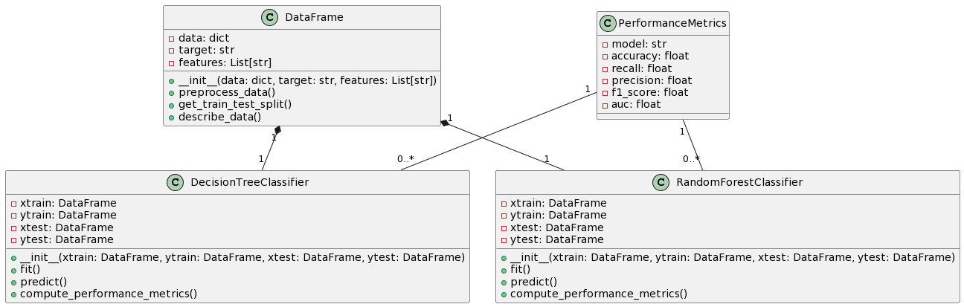

**FIGURE-3 [ARCHITECTURE]**

At the core of the system is the Data Frame component, representing the dataset containing relevant information about stroke risk factors and outcomes. This dataset is then passed to the Preprocessing component, where various data preprocessing techniques are applied.

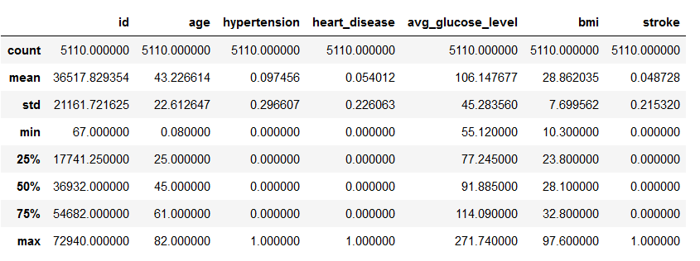

**FIGURE-4[PREPOSSED DATA]**

These techniques include addressing missing values, encoding categorical variables, and partitioning the dataset into training and testing sets. Subsequently, the pre-processed data flows into the Model Training component, where machine learning models are trained. Specifically, the code trains Decision Tree and Random Forest classifiers on the pre-processed dataset.This component computes a range of performance metrics, including accuracy, recall, precision, F1 score, and AUC, to assess the effectiveness of the trained models in predicting stroke risk. Overall, the architecture diagram illustrates a structured workflow, starting from data preprocessing, through model training, and culminating in model evaluation. It emphasizes the importance of each component in the overall predictive modelling process and highlights the interactions between them to achieve accurate and reliable predictions of stroke risk.

**Traditional machine learning models:**

Within the framework of this study, the Decision Tree classifier functions as a key instrument for forecasting the incidence of stroke by utilizing multiple health-related characteristics. In order to work, it builds a hierarchical tree of decision rules that it has learned from the dataset, with each node denoting a feature and each branch a choice that is made in response to that feature. The classifier predicts a person's likelihood of having a stroke by going through the tree.

Despite the difficulty of healthcare data and the fact that Decision Tree classifiers cannot achieve high accuracy, they rarely exceed 90. Feature engineering, hyperparameter optimization, and data pretreatment are required for good results. Accuracy can be boosted by combining various Decision Trees into an ensemble method like the Random Forest. Even so, Decision Trees may overfit to complex, high-dimensional data.

To address this issue, several strategies including pruning, ensemble approaches like Random Forests, and parameter tuning can be employed to improve the generalization ability of Decision Trees. Overall, Decision Trees stand as a foundational technique in machine learning, offering a balance between interpretability and predictive performance, and serving as a valuable tool in data analysis, decision-making, and problem-solving across diverse domains.

**Advantages:**

1. Decision Trees offer a clear and intuitive illustration of decision-making processes, making them easy to understand and interpret by humans.

2. They can effectively handle both numerical and categorical features without the need for extensive data preprocessing.

**Disadvantages:**

1. Decision Tree are inclined to overfitting, particularly when dealing with complex datasets with high dimensionality. This may result to poor generalization performance on untested data.

2. These are sensitive to small variations in the data, often resulting in different tree structures for slightly different datasets, which can affect the robustness of the model.

Decision Trees serve as a valuable tool in predicting stroke risk by analyzing various risk factors present in healthcare datasets. Through their hierarchical structure, Decision Trees can efficiently partition the feature space based on factors such as age, hypertension, heart disease, glucose levels, BMI, smoking status, and other relevant variables. By recursively splitting the dataset into subsets based on these features, Decision Trees can find the patterns and relationships that participate to stroke risk prediction.

The interpretability of decision trees facilitates the understanding of decision sequences in a clear and concise manner. They can handle numerous types of data and versatile machine learning technique that may be used in a variety of contexts to facilitate efficient data analysis and decision-making.

**Random Forest:**

This study uses a big dataset with a variety of demographic and health-related factors, and the Random Forest classifier is crucial in predicting the chance of a stroke. The Random Forest model shows its effectiveness in analysing complex interactions among variables such as age, smoking status, average glucose level, heart disease history, hypertension status, BMI and more with an astonishing accuracy of 94%. Random Forest is an excellent tool for identifying subtle trends in data by combining the collective wisdom of several decision trees. This allows for accurate risk assessment and customised stroke prevention intervention techniques.

Because health data is multidimensional, the Random Forest ensemble approach reduces overfitting and improves generalisation performance. Its efficacious handling of both numerical and categorical features guarantees robust predictions, while its interpretability facilitates insights into the factors driving stroke risk. With its remarkable accuracy, the Random Forest classifier emerges as a valuable asset in advancing stroke prediction.

Random Forests have advantages over single Decision Trees, but they also have drawbacks, such as greater processing complexity for large datasets and less interpretability. They still provide strong predictive power and resilience in stroke risk prediction in healthcare analytics.

**Advantages:**

1. Random Forests typically yield higher prediction accuracy by integrating individual Decision Trees by aggregating predictions from multiple trees, thereby reducing overfitting and variance in the model.

2. Random Forests provide insights into feature importance, allowing users to identify the most influential predictors contributing to the target variable.

**Disadvantages:**

1. Random Forest can be computationally intensive, especially for large datasets with numerous features and trees. This may lead to longer training times and increased resource requirements.

2. Random Forest models tend to be larger in size in contrast to individual Decision Trees due to the aggregation of multiple trees. This can pose challenges in terms of memory consumption and deployment in resource-constrained environments, such as embedded systems or mobile devices.

Despite their high stroke prediction accuracy, Random Forests can be challenging to utilize and less intuitive to recognize than other models when dealing with large data sets. However, their predictive accuracy and dependability in healthcare analysis make them still valuable.

**USING DEEP LEARNING MODEL**

Having a staggering accuracy of 94.9%, the Convolutional Neural Network (CNN) proves to be a state-of-the-art method for predicting stroke occurrences in this study. By utilising its deep learning architecture, CNN explores the complex interrelationships between many demographic and health-related characteristics in order to identify subtle patterns suggestive of stroke risk. The CNN excels in identifying minor subtleties within the data by using pooling layers to reduce dimensionality and convolutional layers to extract features. This allows for precise risk assessment and personalised intervention methods for stroke prevention.

CNN's capability in healthcare prescient modelling stems from its capacity to memorize from natural information and assess complex datasets counting a few factors. The Convolutional Neural Network (CNN) is a state-of-the-art method for stroke prediction, demonstrating its effectiveness in healthcare applications with an accuracy rate of 94.9%. Through exploration of its deep learning architecture, the CNN deciphers the complex interactions between multiple demographic and health-related variables to identify minute patterns suggestive of stroke risk. It is skilled at extracting subtle features from data by using convolutional layers to extract features and pooling layers to reduce dimensionally. This accuracy makes it easier to implement tailored stroke preventive intervention plans.

The predictive power of the system, which is integrated with EHR, responds to patient changes. CNN helps for early stroke risk diagnosis, promoting quick action and better results, demonstrating its vital role in advancing science and improving the public's health in stroke prevention.

**CONCLUSION:**

In a nutshell up, this study shows that sophisticated machine learning methods, like the convolution Neural Network(CNN) with Random Forest classifier, can accurately predict the likelihood of strokes with 94% and 94.9% accuracy rates, respectively. These models offer precise risk assessments and tailored intervention methods by examining a variety of demographic and health-related variables, such as age, smoking status, average glucose level, history of heart disease, hypertension status, BMI.



**FIGURE-5[RESULTS]**

The effectiveness of these predictive algorithms emphasises how crucial data-driven methods are when making decisions in the healthcare industry. Healthcare professionals can improve patient outcomes by implementing targeted preventative interventions and optimising treatment procedures with information derived from these models. Predictive modelling for stroke prevention may benefit from additional research and innovation to increase scalability and accuracy, which could result in more efficient interventions.

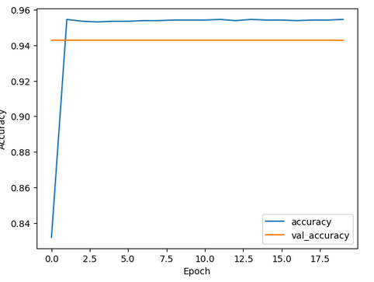

**FIGURE-6[CNN ANALYSIS]**

**REFERENCES**

[1] Cui, L., Fan, Z., Yang, Y., Li, R., Wang, D., Feng, Y., … & Fan, Y. (2022). Deep learning in ischemic stroke imaging analysis: a comprehensive review. BioMed Research International, 2022, 1-15.

[2] Wei, Z., Li, M., & Fan, H. (2022). Hybrid deep learning model for the risk prediction of cognitive impairment in stroke patients.

[3] Chantamit-o-pas, P. and Goyal, M. (2017). Prediction of stroke using deep learning model. Neural Information Processing, 774-781.

[4] S. V, R. and R, G. (2023). Hybrid deep transfer learning framework for stroke risk prediction. The International Conference on Scientific Innovations in Science, Technology, and Management.

[5] Rao, B. N., Mohanty, S., Sen, K., Acharya, U. R., Cheong, K. H., & Sabut, S. (2022). Deep transfer learning for automatic prediction of hemorrhagic stroke on ct images. Computational and Mathematical Methods in Medicine, 2022, 1-10.

[6] Cheon, S., Kim, J., & Lim, J. (2019). The use of deep learning to predict stroke patient mortality. International Journal of Environmental Research and Public Health, 16(11), 1876.

[7] AlArfaj, A. A., Mahmoud, H. A. H., & Hafez, A. M. (2022). A deep learning model for stroke patients’ motor function prediction. Applied Bionics and Biomechanics, 2022, 1-9.

[8] Liu, Y., Yu, Y., Ouyang, J., Jiang, B., Yang, G., Ostmeier, S., … & Zaharchuk, G. (2023). Functional outcome prediction in acute ischemic stroke using a fused imaging and clinical deep learning model. Stroke, 54(9), 2316-2327.

[9] Su, S., Li, L., Wang, Y., & Li, Y. (2023). Stroke risk prediction by color Doppler ultrasound of carotid artery-based deep learning using Inception V3 and VGG-16. Frontiers in Neurology, 14.

[10] Lee, J.H., Kwon, J., Lee, M.S., Cho, Y., Oh, I., Park, J.J., & Jeon, K. (2022). Prediction of atrial fibrillation in patients with embolic stroke with undetermined source using electrocardiogram deep learning algorithm and clinical risk factors. European Heart Journal.

[11] Kim, D., Choi, K., Kim, J., Hong, J.W., Choi, S., Park, M., & Cho, K. (2023). Deep learning-based personalised outcome prediction after acute ischaemic stroke. Journal of Neurology, Neurosurgery, and Psychiatry, 94, 369 - 378.

[12] Matsui, H., Yamana, H., Fushimi, K., & Yasunaga, H. (2021). Development of Deep Learning Models for Predicting In-Hospital Mortality Using an Administrative Claims Database: Retrospective Cohort Study. JMIR Medical Informatics, 10.

[13] Sharma, N., Mishra, M.K., Chadha, J.S., & Lalwani, P. (2021). Heart Stroke Risk Analysis: A Deep Learning Approach. 2021 10th IEEE International Conference on Communication Systems and Network Technologies (CSNT), 543-598.

[14] Rehman, A. (2023). Brain Stroke Prediction through Deep Learning Techniques with ADASYN Strategy. 2023 16th International Conference on Developments in eSystems Engineering (DeSE), 679-684.

[15] Prof.SomashekharB, M., & Gangatkar, S.N. (2023). DEEP LEARNING APPROACH FOR CHOLESTEROL DETECTION AND STROKE PREDICTION.

[16] Lim, C.C., Chong, C., Tan, G., Tan, C.S., Cheung, C.Y., Wong, T.Y., Cheng, C., & Sabanayagam, C. (2023). A deep learning system for retinal vessel calibre improves cardiovascular risk prediction in Asians with chronic kidney disease. Clinical Kidney Journal, 16, 2693 - 2702.

[17] Chantamit-o-pas, P., & Goyal, M.L. (2017). Prediction of Stroke Using Deep Learning Model. International Conference on Neural Information Processing.

[18] Lee, S., Lee, S.H., Choi, H., Lee, J., Jeong, Y.W., Kang, D.R., & Sung, K.C. (2022). Deep Learning Improves Prediction of Cardiovascular Disease-Related Mortality and Admission in Patients with Hypertension: Analysis of the Korean National Health Information Database. Journal of Clinical Medicine, 11.

[19] Li, Y., Salimi-Khorshidi, G., Rao, S., Canoy, D., Hassaine, A., Lukasiewicz, T., Rahimi, K., & Mamouei, M. (2022). Validation of risk prediction models applied to longitudinal electronic health record data for the prediction of major cardiovascular events in the presence of data shifts. European Heart Journal. Digital Health, 3, 535 - 547.

[20] Liang, H., Liang, D., Tao, L., Zhang, X., Li, X., Zheng, D., Chen, Y., Yi, M., & Tang, F. (2021). Predict the Risk of Dyslipidemia Using Electronic Health Records: Apply Deep Neural Networks for Survival Data (Preprint).