**PURBANCHAL UNIVERSITY**

**COLLEGE OF INFORMATION TECHNOLOGY AND ENGINEERING**

**KATHMANDU, NEPAL**

**(2012/BIT)**



**“Hotel Reservation Management System”**

Prepared By:

Amrit Rai (380904)

Sanjay Khadka (380912)

Nov 2017

Kathmandu, Nepal

**PURBANCHAL UNIVERSITY**

**COLLEGE OF INFORMATION TECHNOLOGY AND ENGINEERING**

**KATHMANDU, NEPAL**

**(2012/BIT)**



**“Hotel Reservation Management System”**

Prepared By:

Amrit Rai (380904)

Sanjay Khadka (380912)

**Project Supervisor**

Mr. Chandra Shekhar Bhusal

A Project Report Submitted in Partial Fulfillment of the Requirement for the Degree of Bachelor of Information Technology Eighth Semester  
  
Nov 2017

**RECOMMENDATION**

The undersigned certify that it has been read and recommended to the Department of Science and Technology for acceptance, a project entitled **“Hotel Reservation Management System”,** submitted by **Amrit Rai (380904) and Sanjay Khadka (380912)** in partial fulfillment of the requirement for the award of the degree of **“Bachelor in Information Technology”** Eighth Semester.

…………………………….

**Project Supervisor**

Mr. Chandra Shekhar Bhusal

Department of Science and Technology

College of Information Technology and Engineering

Purbanchal University, Nepal

………………………………….

**External Examiner**

…………………………………..

…………………………………..

…………………………………..

**LETTER OF ACCEPTANCE FROM DEPARTMENT**

The project entitled**,** submitted by **Amrit Rai and Sanjay Khadka pa**rtial fulfillment of the requirement for the award of the degree of **“Bachelor in Information Technology”** Eighth Semester has been accepted as a bonafide record of work independently carried out by the group in the department.

…………………………..

**Er. Bhanu Bhakta Niraula**

Department Head

Department of Science and Technology

College of Information Technology and Engineering

Purbanchal University, Nepal

**ACKNOWLEDGEMENT**

We are glad that with all hard work and in a short notice our report on **“Hotel Reservation Management System”** has been complete. We would like to extend our sincere thanks to Chandra Shekhar Bhusal and Er. Bhanu Bhakta Niraula sir who helped in report writing by providing guidelines.

We would also like to thank our all friends of Bachelor in Information Technology from bottom of our heart for their support and helped us in Technical analysis of coding and in report writing.

Lastly, we would like to express immense gratitude and remember all our supporters and helpers once again.

Thanking you all!!!

Project Members:

Amrit Rai (380904)

Sanjay Khadka (380912)

**ABSTRACT**

The title of our project is “Hotel Reservation management System” which is web-based application and is build using PHP language and MYSQL as database. The system is developed to establish to the customer for booking of hotels room. The client uses MS Excel and maintains their records, however, it is not possible them to share the data from multiple systems in the multi-user environment, there is the lot of duplicate work and the chance of mistake. When the records are changed they need to update each and every excel file. There is no option to find and print previously saved records. There is no security; anybody can access any report and sensitive data, also no reports to the summary report. This online hotel booking system is used to overcome the entire problem which they are facing currently, and making complete atomization of manual system to computerized system.

**TABLE OF CONTENT**

Chapter 1: INTRODUCTION 11

1.1 Background Information: 11

1.2 Problem Statement 11

1.2.1 Problems faced by Users: 11

1.2.2 Problems faced by Customers: 12

1.3 System Planning: 12

Chapter 2: REQUIREMENT SPECIFICATION AND ANALYSIS 14

2.1 Feasibility Analysis: 14

2.1.1 Technical Feasibility: 14

2.1.2 Operational Feasibility: 15

2.2 Software Requirement Specification: 15

2.2.1 Functional Requirement: 15

Chapter 3: SYSTEM DESIGN 17

3.1 Use Case Diagram: 17

3.2 Data Flow Diagram: 18

3.2.1 Context Diagram: 18

3.3 Schema Diagram: 19

Chapter 4: TECHNOLOGY OVERVIEW 20

4.1 PHP Programming Language: 20

4.2 MySql Workbench 6.1: 22

4.3 Xampp: 22

4.4 Google Chrome & Mozilla Firefox: 22

4.5 Notepad++: 22

Chapter 5: TESTING 23

5.1 Unit Testing 23

5.2 Integrating Testing: 23

Chapter 6: TIMELINE AND CONCLUSION 24

6.1 Timeline: 24

6.2 Conclusion: 25

SNAPSHOT OF THE PROJECT 26

Bibliography 28

**LIST OF FIGURE**

Chapter1 fig 1 : SDLC 14

Chapter3 fig 1 : Use case diagram as per admin 18

Chapter3 fig 2 : Use case diagram as per User 19

Chapter3 fig 3: Level 0 DFD 19

Chapter3 fig 4: Schema Diagram 20

Chapter6 fig 1: Gantt chart 25

**LIST OF ACRONYMS**

1. DFD - Data Flow Diagram
2. SDLC - System Development Life Cycle
3. HTML - Hypertext Markup Language
4. CSS - Cascading Style Sheet
5. PHP - Hypertext Preprocessor
6. XML- Extended-Markup language
7. MySQL- My Structured Query language
8. SQL- Structured Query Language

# Chapter 1: INTRODUCTION

## Background Information:

We have made selection of project which is related with Hotel sector. Our project is mainly focused to solve problem related to owners and customers. The application helps owners to keep records of their customer details. Hotel Reservation is a popular method for booking rooms in the hotel. Customers can book rooms on a computer by using internet security to protect their privacy and financial information. Customers can get knowledge about hotels by using several online travel agents to compare prices and facilities at different hotels. Preceding to the internet, customers could write, telephone the hotel directly, or use an agent to make a booking. Online travel agents have a lot of pictures of hotels and rooms, information on prices for room booking and even information on local spots. Hotel room booking is also helpful for making last minute travel arrangements.

Hotel Reservation Management System is to manage all data in our hotel, example booking date, check in, check out bills etc. A developing number of hotels are building their hotels directly to customers. Hotel rooms are very in need of something fast and reliable to use to make their booking flow fast and organize. Since the advance technology takes place, hotel reservation system was invented. It provides the hotels room as easy way of doing booking without wasting time and energy. Hotel Reservation System is here to help you market your inventory online and reach out to the customer directly. It is a cost effective method to help create, sustain and expand your inventory online. Hotel Reservation System allows sales and booking team can access availability of room rates, accommodation and special rates from a central booking office.

* 1. Problem Statement**:**

### 1.2.1 Problems faced by Users:

We conducted our research on Hotel Business who provides accommodation facilities to the customers. The hotels are using the same old technology like MS Excel and Booking Keeping System to record the customer details and reservation of rooms. These consumes more files and data might get lost. The customer details are immobilized and unsophisticated.

### **1.2.2 Problems faced by Customers**:

Customers wants easy and comfortable environment for bookings of the hotels room.

Since the customer doesn’t have sufficient time to call and book the room. So, they just want to reserve the rooms on a click by staying at home.

**1.3** Objective:

Objectives of the project are pointed out as following:

* To help Customer Book there rooms by staying at home with a click.
* To develop a user-friendly interface for customers as well as Owner.
* To record and store data of users.
* To attract more customer and help to flourish their business
* To make a proper registration and authentication.

## 1.3 System Planning:

**System Life Cycle Development Methods:**

The Software Development Lifecycle (SDLC) for small to medium database application development efforts.

This project uses iterative development lifecycle, where components of the application are developed through a series of tight iteration. The first iteration focus on very basic functionality, with subsequent iterations adding new functionality to the previous work and or correcting errors identified for the components in production.

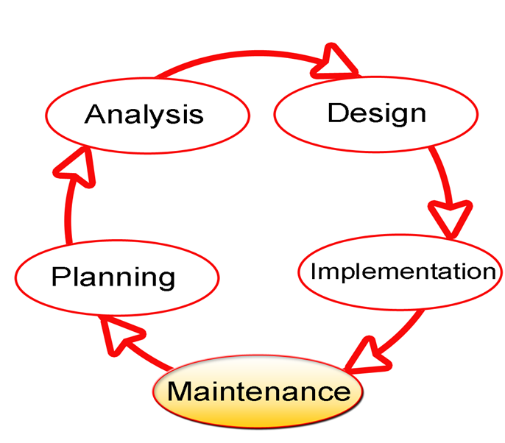

Chapter1 fig1 : SDLC

The six stages of the SDLC are designed to build on one another, taking outputs from the previous stage, adding additional effort, and producing results that leverage the previous effort and are directly traceable to the previous stages. During each stage, additional information is gathered or developed, combined with the inputs, and used to produce the stage deliverables. It is important to note that the additional information is restricted in scope, new ideas that would take the project in directions not anticipated by the initial set of high-level requirements or features that are out-of-scope are preserved for later consideration.

Too many software development efforts go awry when development team and customer personnel get caught up in the possibilities of automation. Instead of focusing on high priority features, the team can become mired in a sea of nice to have features that are not essential to solve the problem, but in themselves are highly attractive. This is the root cause of large percentage of failed and or abandoned development efforts and is the primary reason the development team utilizes the iterative model.

# Chapter 2: REQUIREMENT SPECIFICATION AND ANALYSIS

## Feasibility Analysis:

### 2.1.1 Technical Feasibility:

In the feasibility study first step is that the organization or company has to decide that what technologies are suitable to develop by considering existing system.

Here in this application used the technologies like Notepad++ and MySql.

#### 2.1.1.1 Hardware Requirements (For development):

Processor : Intel P-IV system

Processor Speed : 250MHz to 833MHz

RAM : 512MB RAM

Hard Disk : 40GB

#### 2.1.1.2 Software Requirements (For development):

Operating System : Windows10

Database : MYSQL Server

Server side technology : PHP

#### 2.1.1.3 Hardware requirements (For deployment):

* + - Any device with input Capabilities and has ability to access internet is enough to use our web application. (A general-purpose PC recommended for office use)

#### 2.1.1.4 Software Requirements (For Deployment):

* Any OS that supports Web Browser can be used.

### 2.1.2 Operational Feasibility:

Not only must an application make economic and technical sense, it must also make operational sense.  Issues to be consider when determining the operational feasibility of a project.

|  |  |
| --- | --- |
| Operations Issues | Support Issues |
| * What tools are needed to support operations? * What skills will operators need to be trained in? * What processes need to be created and/or updated? * What documentation does an operation need? | * What documentation will users be given? * What training will users be given? * How will change requests be managed? |

Very often we will need to improve the existing operations, maintenance, and support infrastructure to support the operation of the new application that we intend to develop.  To determine what the impact will be we will need to understand both the current operations and support infrastructure of our organization and the operations and support characteristics of our new application.

To operate this system the user need not require any technical knowledge that we used to develop this project like Php, Html, JavaScript, etc. This application provides rich user interfaces to user and can do the operation in flexible manner.

## Software Requirement Specification:

### 2.2.1 Functional Requirement:

**Fu-R1: User**

Explanation: User needs to go to the Desirable Rooms.

Input: Fill out the forms and submit.

Result: The forms is recorded in admin database.

**Fu-R2: Admin Login**

Explanation: Admin needs to login to the interface for Conformation of reserved rooms.

Input: Admin should provide Username and Password.

Result: Redirect to the admin page.

**Fu-R5: Admin edit and delete Rooms**

Explanation: Admin can edit and delete rooms.

Input: Click on delete and confirm.

Result: Confirmation page

Rational: Update or delete product form database.

Reliance: Depends on admin to edit or delete rooms.

# Chapter 3: SYSTEM DESIGN

## Use Case Diagram:

Use case diagram is a graphical representation of interaction of elements in the system. It is used in analysis of system to identify, clarify and organize system’s requirements. It follows a standard notation for modeling of real- world objects and system known as Unified modeling language. Use case is a popular methodology used to analyze system to identify, clarify and organize system requirements. Use case diagram are employed in Unified Modeling Language (UML) which is a standard notation for the modeling of real world objects and system. Bellow we have illustrated use case diagram of our system showing different actors who use this system.

**Use Case Diagram of admin:**

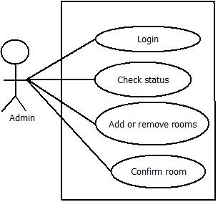

Chapter3 fig 1: Use case diagram as per admin

The above diagram is use case diagram of online Hotel Reservation System through the perspective of admin. Here admin is the actor and different use cases as per the functional and non-functional requirements are connected. A default admin is set in the system and will be able to conduct above features. Only admin can verify the available rooms that a user demanded.

**Use case diagram of User**

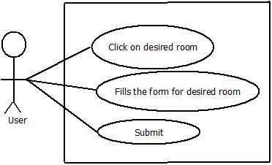

Chapter3 fig 2: Use case diagram as per User

In the above figure we have demonstrated use case diagram of system as per user. Users are actor in the above figure. It shows different use case under system boundaries that are carried out by actor who is User. User first need to choose the desired room. Fill out the forms for the desired rooms and finally submit the forms. The submitted form are stored in admin database.

## Data Flow Diagram:

3.2.1 Context Diagram: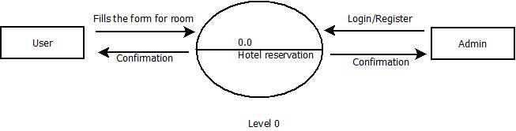

Chapter3 fig 3: Level 0 DFD

## 3.3 Schema Diagram:

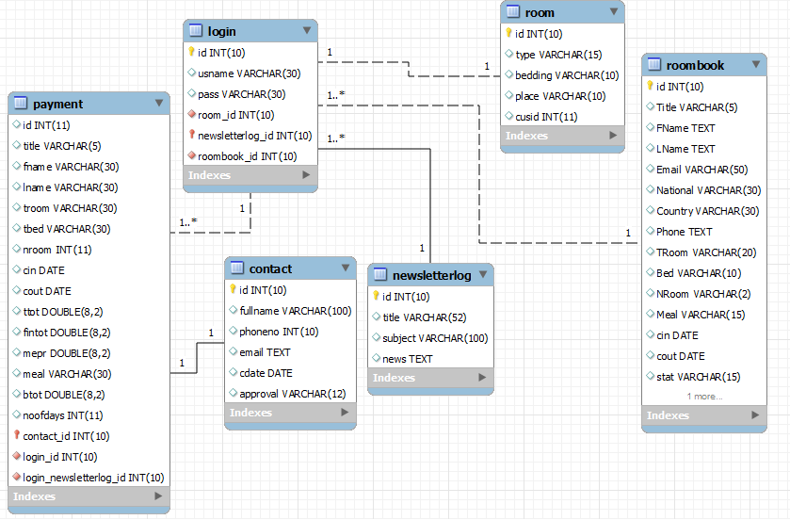

Chapter3 fig 4: Schema Diagram

# Chapter 4: TECHNOLOGY OVERVIEW

## 4.1 PHP Programming Language:

PHP is mainly focused on server-side scripting, so we can do anything any other CGI program can do, such as collect form data, generate dynamic page content, or send and receive cookies. But PHP can do much more.

There are main areas where PHP scripts are used.

1. **Server-Side scripting:** This is the most traditional and main target field for PHP. You need three things to make this work. The PHP parser (CGI or server module), a web server and a web browser. We need to run the web server, with a connected PHP installation. We can access the PHP program output with a web browser, viewing the PHP page through the server. All these can run on our home machine.
2. **Command Line Scripting:** We can make a PHP script to run it without any server or browser. We only need the PHP parser to use it this way. This type of usage is ideal for scripts regularly executed using cron (on *nix or Linux) or Task Scheduler (on Windows). These scripts can also be used for simple text processing tasks.
3. **Writing Desktop Application:** PHP is probably not the very best language to create a desktop application with a graphical user interface, but if we know PHP very well, and would like to use some advanced PHP features in your client-side applications we can also use PHP-GTK to write such programs. We also have the ability to write cross-platform applications this way. PHP-GTK is an extension to PHP, not available in the main distribution.

PHP can be used on all major operating systems, including Linux, many Unix variants (including HP-UX, Solaris and OpenBSD), Microsoft Windows, Mac OS X, RISC OS, and probably others. PHP has also support for most of the web servers today. This includes Apache, Microsoft Internet Information Server, Personal Web Server, Netscape and iPlanet servers, Oreilly Website Pro server, Caudium, Xitami, OmniHTTPd, and many others. For the majority of the servers PHP has a module, for the others supporting the CGI standard, PHP can work as a CGI processor.

So with PHP, we have the freedom of choosing an operating system and a web server. Furthermore, we also have the choice of using procedural programming or object oriented programming, or a mixture of them. Although not every standard OOP feature is implemented in PHP 4, many code libraries and large applications (including the PEAR library) are written only using OOP code. PHP 5 fixes the OOP related weaknesses of PHP 4, and introduces a complete object model.

With PHP we are not limited to output HTML. PHP's abilities include outputting images, PDF files and even Flash movies (using libswf and Ming) generated on the fly. We can also output easily any text, such as XHTML and any other XML file. PHP can auto generate these files, and save them in the file system, instead of printing it out, forming a server-side cache for your dynamic content.

One of the strongest and most significant features in PHP is its support for a wide range of databases. Writing a database-enabled web page is incredibly simple. The following databases are currently supported are dBase, mSQL, MYSQL, PostgreSQL, SQlite, Sybase.

We also have a database abstraction extension (named PDO) allowing you to transparently use any database supported by that extension. Additionally PHP supports ODBC, the Open Database Connection standard, so you can connect to any other database supporting this world standard.

PHP also has support for talking to other services using protocols such as LDAP, IMAP, SNMP, NNTP, POP3, HTTP, COM (on Windows) and countless others. We can also open raw network sockets and interact using any other protocol. PHP has support for the WDDX complex data exchange between virtually all Web programming languages. Talking about interconnection, PHP has support for instantiation of Java objects and using them transparently as PHP objects. We can also use our CORBA extension to access remote objects.

PHP has extremely useful text processing features, from the POSIX Extended or Perl regular expressions to parsing XML documents. For parsing and accessing XML documents, PHP 4 supports the SAX and DOM standards, and you can also use the XSLT extension to transform XML documents. PHP 5 standardizes all the XML extensions on the solid base of libxml2 and extends the feature set adding Simple XML and XML Reader support.

## 4.2 MySql Workbench 6.1:

MySQL Workbench is a unified visual tool for database architects, developers, and DBAs. MySQL Workbench provides data modeling, SQL development, and comprehensive administration tools for server configuration, user administration, backup, and much more. MySQL Workbench enables a DBA, developer, or data architect to visually design, model, generate, and manage databases. It includes everything a data modeler needs for creating complex ER models, forward and reverse engineering, and also delivers key features for performing difficult change management and documentation tasks that normally require much time and effort.

## 4.3 Xampp:

XAMPP is a completely free, easy to install Apache distribution containing MySQL, PHP, and Perl. The XAMPP open source package has been set up to be incredibly easy to install and to use.

## 4.4 Google Chrome & Mozilla Firefox:

Chrome and Firefox are used as baseline web browsers for creating and testing the project as each complemented with the features the other lacked.

## 4.5 Notepad++:

This is very light weight editor which provides full control of the code to the developer.

# Chapter 5: TESTING

## Unit Testing

Unit testing is done to check if every module of software is working as good as user has determined. In this testing each module is checked one by one to be sure that every module is working properly.

Each of these modules has passed unit testing and each module of this software works as we desired.

## Integrating Testing:

The main purpose of doing integrating testing is to check if overall program is running perfectly as user has desired. After passing unit testing programmer should be well aware about creating a link between all their modules. When all the modules work together the software becomes complete. This is where integrating testing should be done to see if as the whole software works as desired or not.

As for our modules mentioned earlier, we were also able to create link between all the modules of E-shop. All the modules work together creating the output of software as expected.

Hence this software has also passed integrating testing.

# Chapter 6: TIMELINE AND CONCLUSION

## Timeline:

|  |  |  |  |  |  |  |
| --- | --- | --- | --- | --- | --- | --- |
| **Contents** |  |  |  |  |  |  |
| Topic Selection |  |  |  |  |  |  |
| Proposal & Research Work |  |  |  |  |  |  |
| Analysis and Design |  |  |  |  |  |  |
| Coding |  |  |  |  |  |  |
| Testing |  |  |  |  |  |  |
| Bug Fixing |  |  |  |  |  |  |
| Documental |  |  |  |  |  |  |
| **No. of days** | **15** | **30** | **45** | **60** | **75** | **90** |

Chapter6 fig 1: Gantt chart

## 6.2 Conclusion:

At the end of this project, we have created HOTEL RESERVATION MANAGEMENT SYSTEM. This system is capable of being used by any user. The project has met its objectives.

# SNAPSHOT OF THE PROJECT

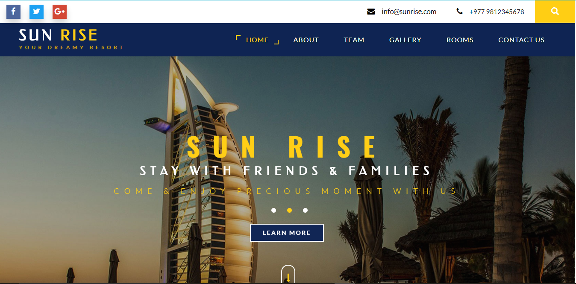

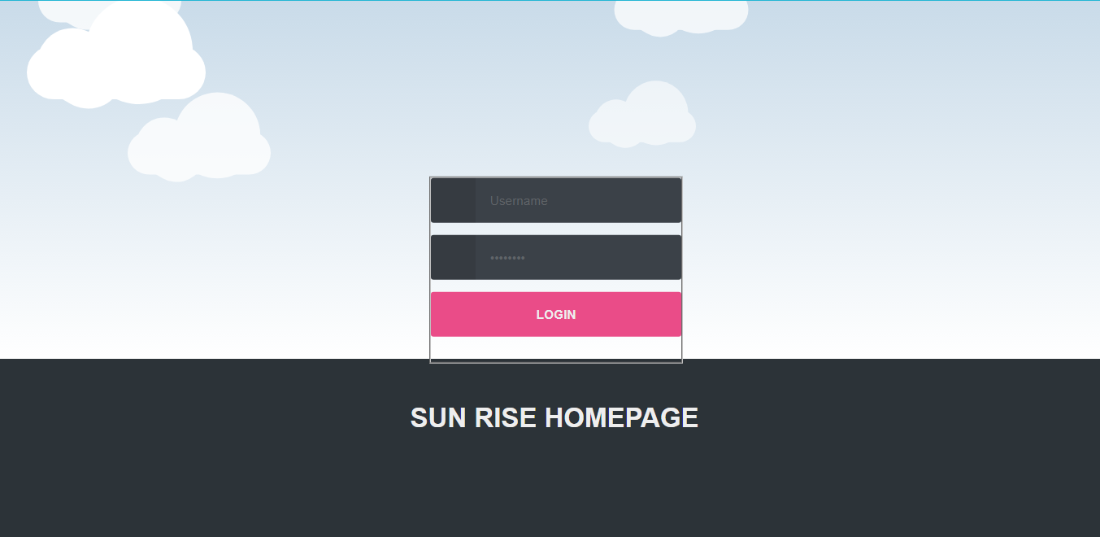

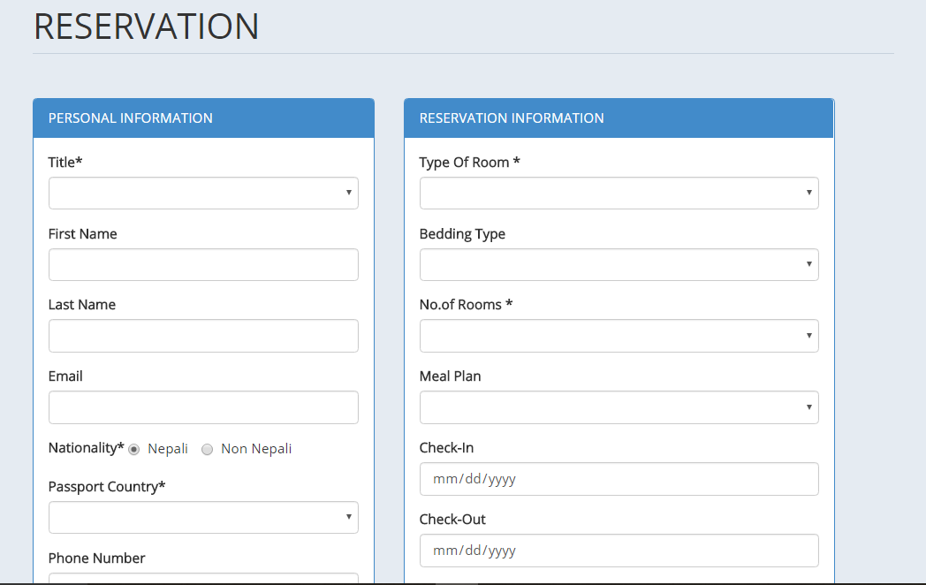

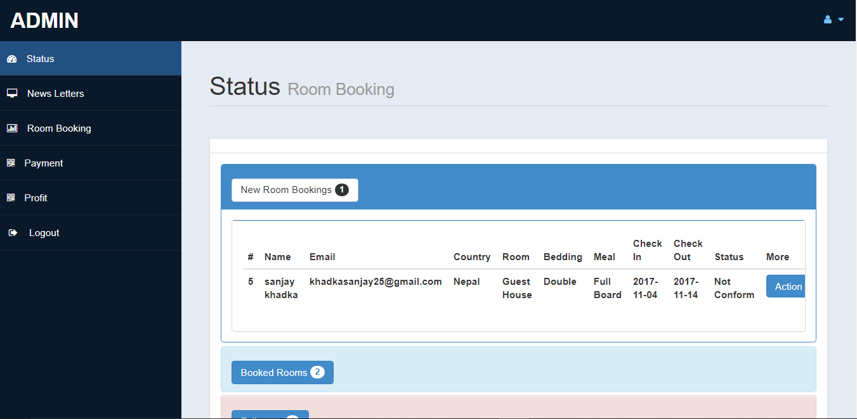

# Bibliography

* <https://www.nurakantech.com/blogs>
* <https://www.sitepoint.com>
* <https://www.w3schools.com>
* <https://www.getbootstrap.com>