|  |  |
| --- | --- |
| **Ex. No : 1**  **Date:** | **HTML & CSS** |

**AIM:**

Creation of Web Pages using Map Hotspots, Frames, Links, and Different Types of CSS (Inline, Internal, External)

**PROGRAM:**

a)HTML:

<!DOCTYPE html>

<html>

 <head>

    <title>Hotspot</title>

    <!-- Link to the external CSS file -->

    <link rel="stylesheet" type="text/css" href="style1.css">

    <style>

        h1 {

            text-align: center;

            color: #333;

            margin-top: 20px;

        }

    </style>

 </head>

 <body>

    <!-- Inline style for the image itself (optional to override or enhance external styles) -->

    <h1>Interactive Map of India</h1>

    <img src="image.png" usemap="#indiamap" width="900" height="720" alt="Map of India">

    <map name="indiamap">

        <area shape="rect" coords="324,578,407,535" alt="Tamil Nadu" href="https://en.wikipedia.org/wiki/Tamil_Nadu">

        <area shape="rect" coords="343,655,398,599" alt="Tamil Nadu" href="https://en.wikipedia.org/wiki/Tamil_Nadu">

        <area shape="rect" coords="407,538,395,602" alt="Tamil Nadu" href="https://en.wikipedia.org/wiki/Tamil_Nadu">

        <area shape="rect" coords="346,653,397,605" alt="Tamil Nadu" href="https://en.wikipedia.org/wiki/Tamil_Nadu">

        <area shape="rect" coords="406,537,324,579" alt="Tamil Nadu" href="https://en.wikipedia.org/wiki/Tamil_Nadu">

    </map>

 </body>

</html>

a)CSS

@charset "ISO-8859-1";

body {

    font-family: Arial, sans-serif;

    margin: 0;

    padding: 0;

    background-color: #f4f4f4;

}

img {

    display: block;

    margin: 0 auto;

    border-radius: 8px;

    box-shadow: 0 4px 6px rgba(0, 0, 0, 0.1);

}

area {

    outline: none;

    border: none;

    transition: transform 0.3s ease-in-out;

}

area:hover {

    transform: scale(1.1);

}

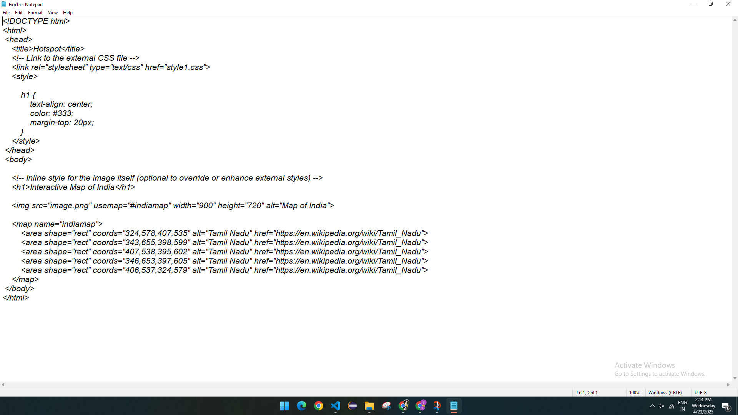

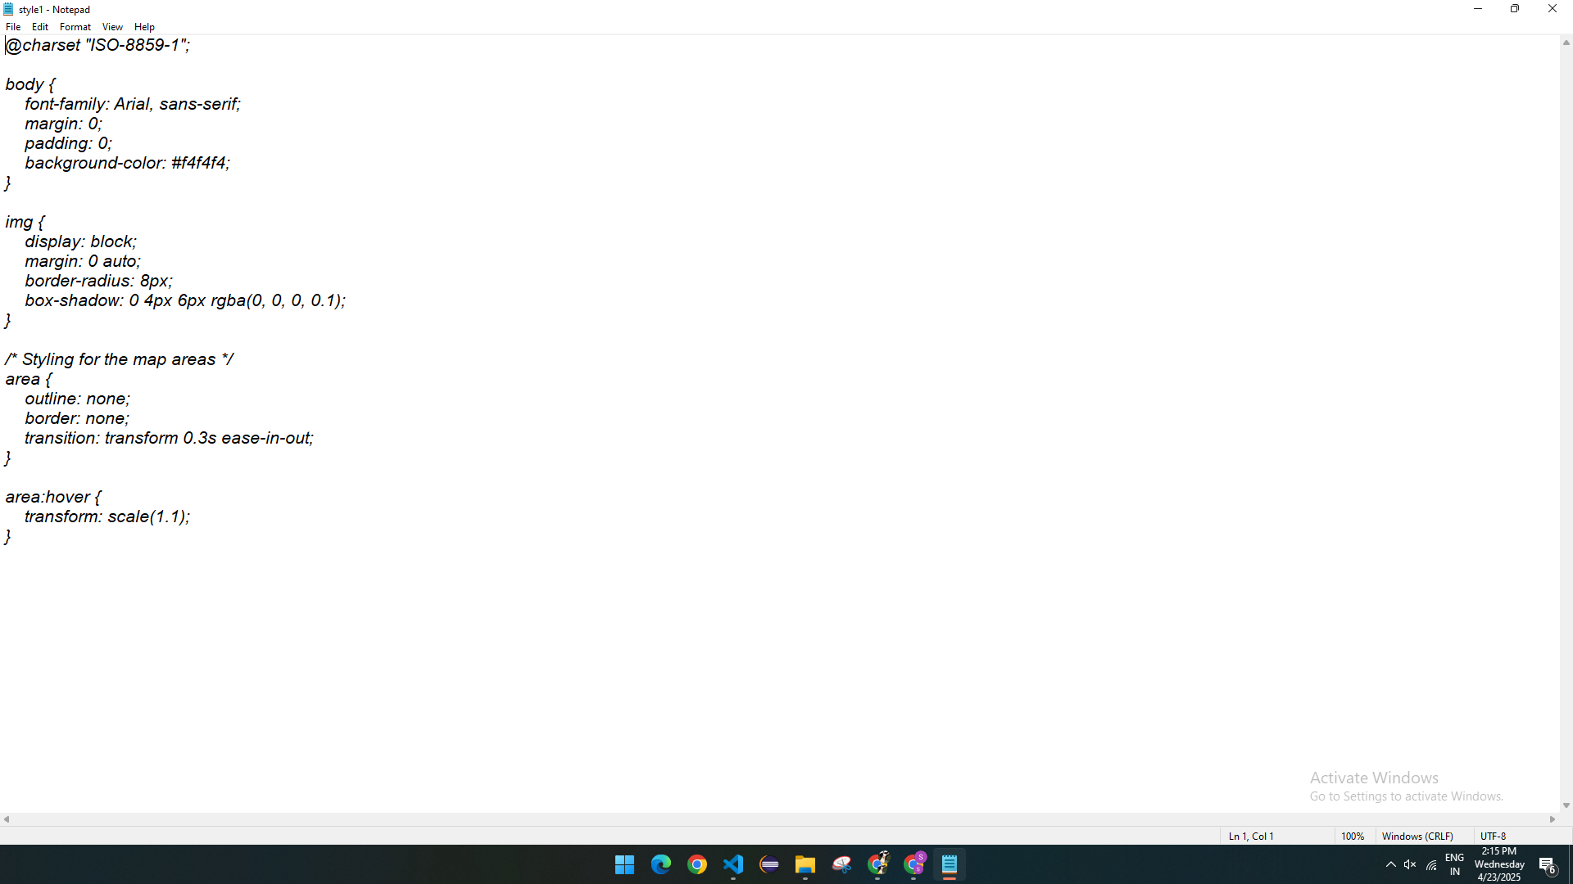

**OUTPUT:**

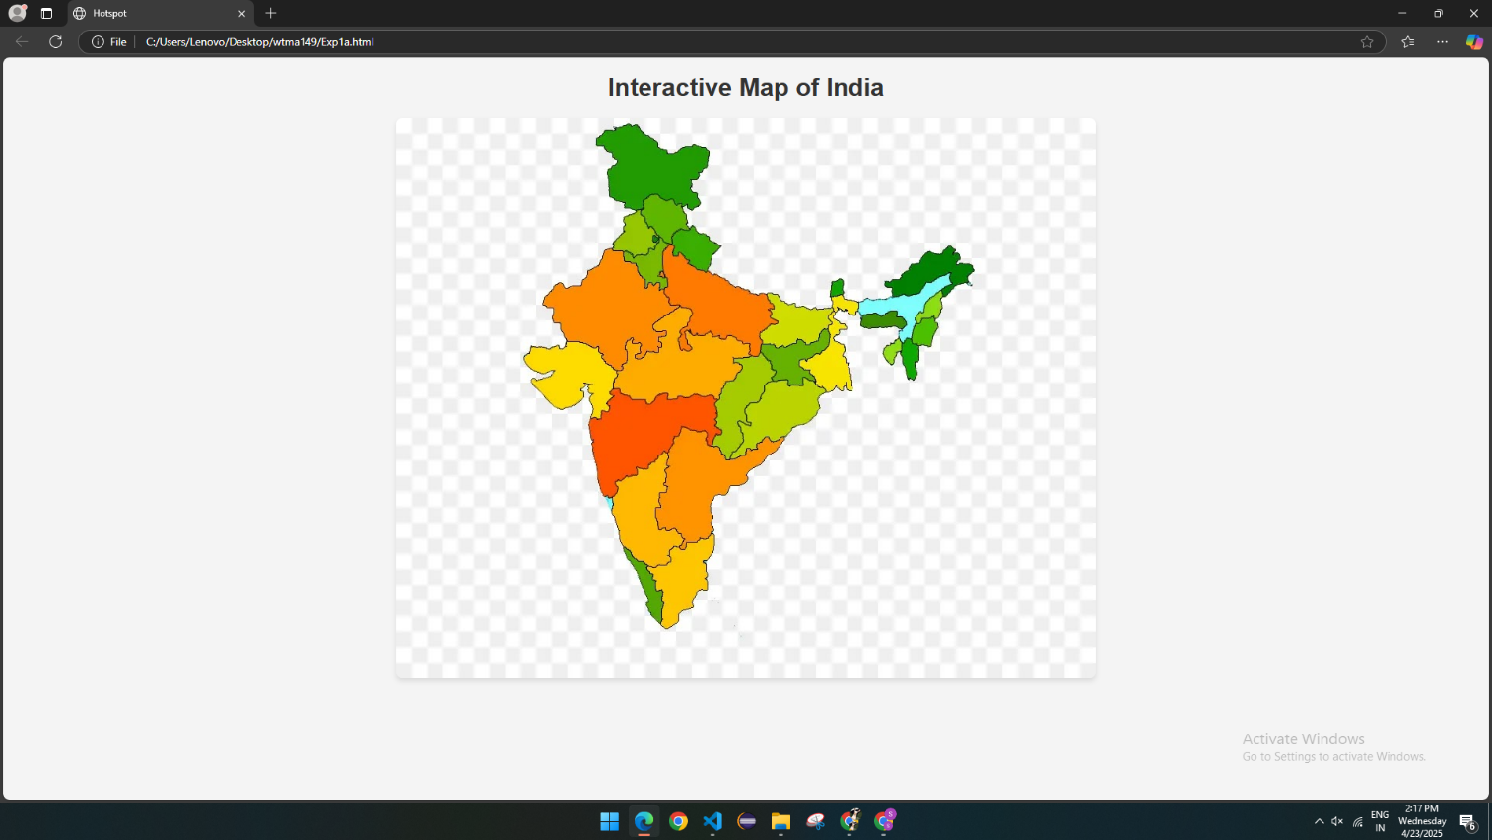

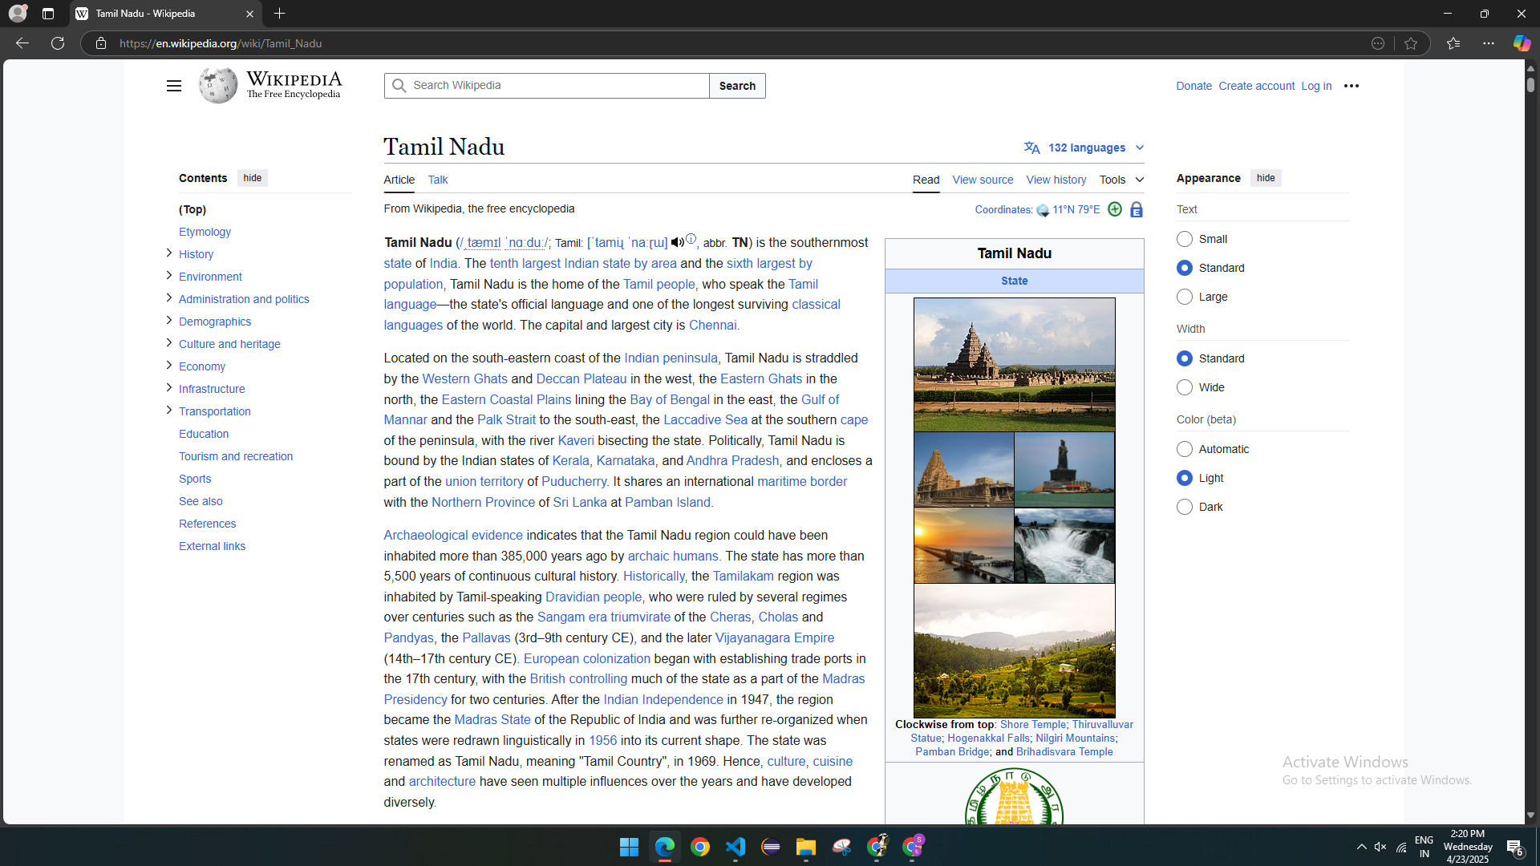

b)HTML:

<html>

<head>

  <title>CSS Types</title>

  <link rel="stylesheet" type="text/css" href="style2.css">

  <style>

    h1 {

      color: blue;

      text-align: center;

    }

  </style>

</head>

<body>

  <p style="color: green;">This is an inline styled paragraph.</p>

  <h1>This heading uses embedded CSS</h1>

  <p>This paragraph uses external CSS styling.</p>

</body>

</html>

b)CSS

p{

    font-family: Arial, sans-serif;

    font-size: 16px;

    background-color: #f2f2f2;

    padding: 10px;

  }

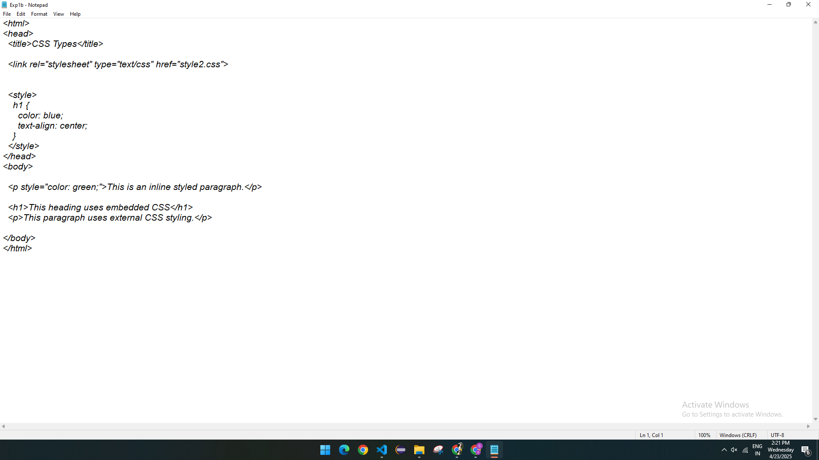

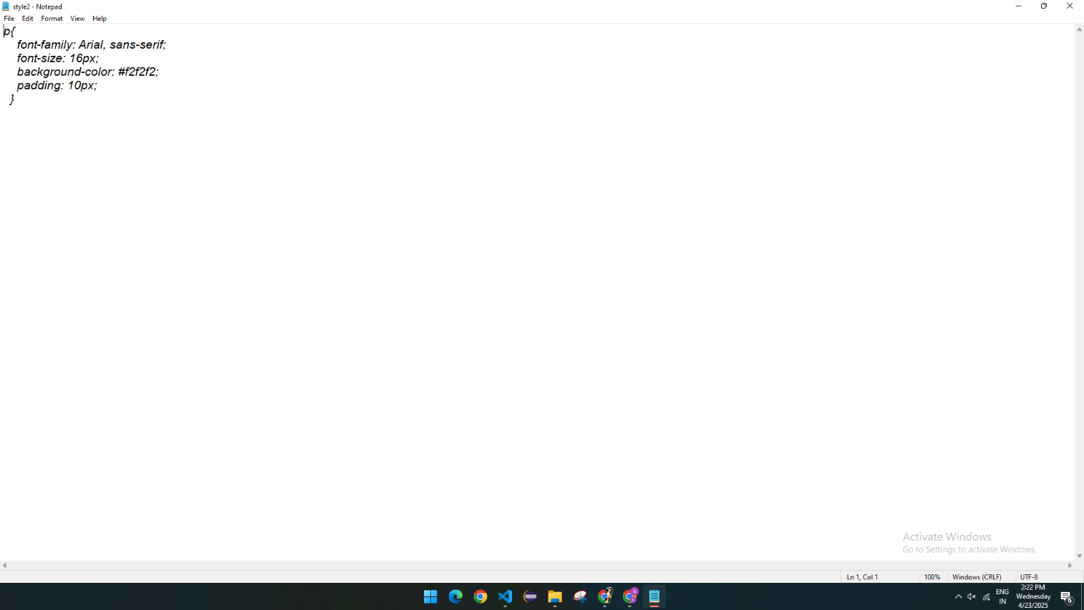

**OUTPUT:**

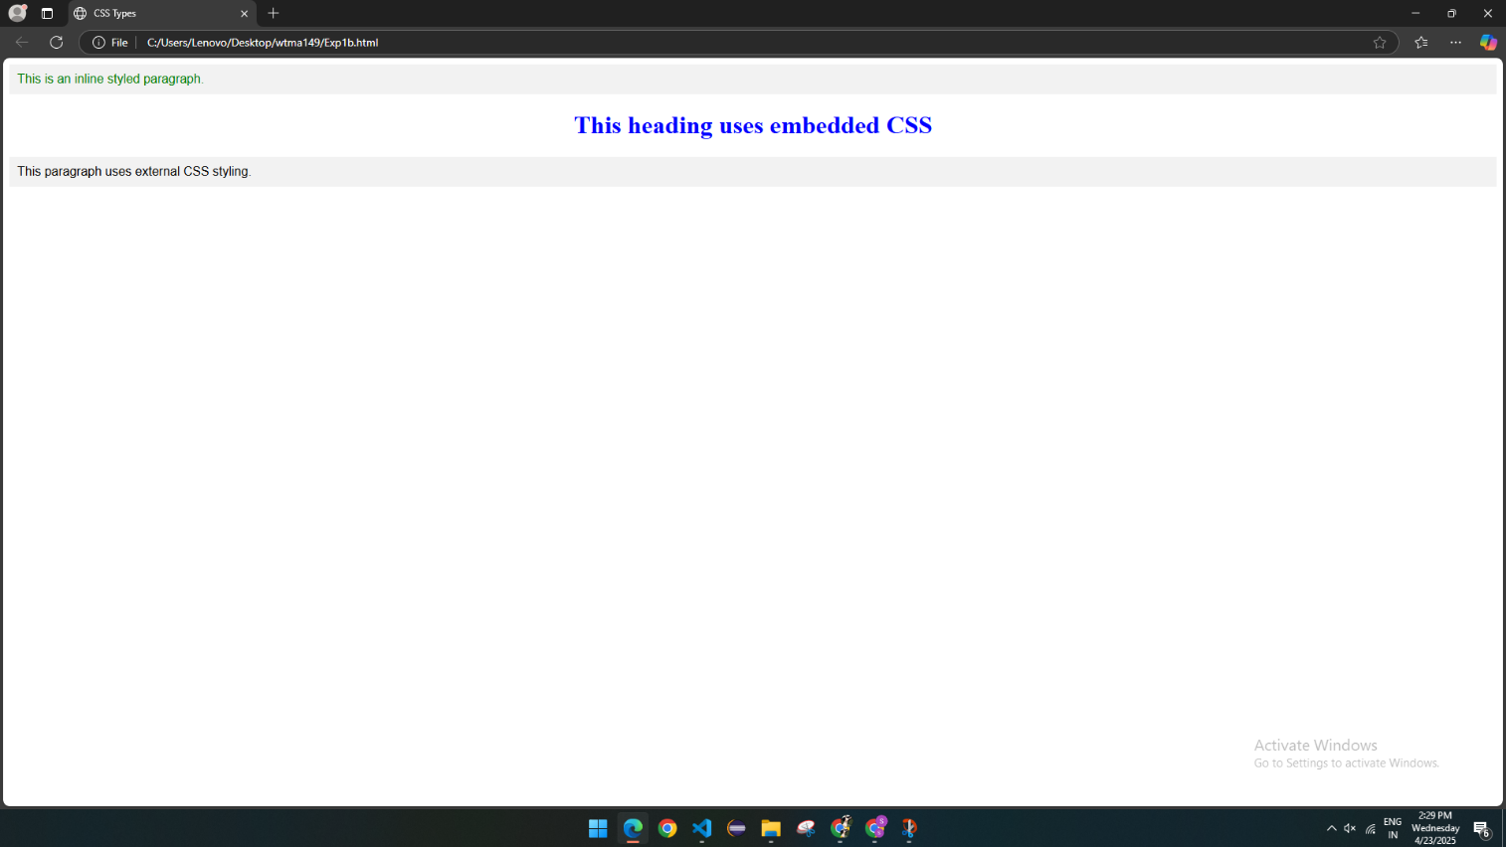

**RESULT:**

Successfully created:

* A webpage displaying a map with clickable hotspots inside frames, linking to information pages.
* A second webpage demonstrating styling with embedded (internal), inline, and external CSS.