|  |  |
| --- | --- |
| **Ex. No : 4**  **Date:** | **Creating a Web Form and Processing User Input Using Servlet** |

**AIM:**

To create a web form that accepts a user's name and age, and to write a Java Servlet that processes the submitted data and displays it back on the browser.

**PROGRAM:**

HTML:

<!DOCTYPE html>

<html>

<head>

<meta charset="ISO-8859-1">

<title>Insert title here</title>

</head>

<body>

<h1>Form Validation</h1>

<form name="RegForm" action="/sanjay_149/DisplayUser">

<p>

<label for="Username">Username:</label>

<input type="text" name="Username" placeholder="Enter your name" >

</p>

<p>

<label for="Age">Age:</label>

<input type="text" name="Age" placeholder="Enter your age" >

</p>

<input type="submit" value="Accept" name="Accept">

</form>

</body>

</html>

SERVLET:

package com.sanjay.servlet;

import java.io.IOException;

import java.io.PrintWriter;

import javax.servlet.ServletException;

import javax.servlet.annotation.WebServlet;

import javax.servlet.http.HttpServlet;

import javax.servlet.http.HttpServletRequest;

import javax.servlet.http.HttpServletResponse;

/**

* Servlet implementation class DisplayUser

*/

@WebServlet("/DisplayUser")

public class DisplayUser extends HttpServlet {

private static final long serialVersionUID = 1L;

/**

* @see HttpServlet#HttpServlet()

*/

public DisplayUser() {

super();

// TODO Auto-generated constructor stub

}

/**

* @see HttpServlet#doGet(HttpServletRequest request, HttpServletResponse response)

*/

protected void doGet(HttpServletRequest request, HttpServletResponse response) throws ServletException, IOException {

String a = request.getParameter("Username");

String b = request.getParameter("Age");

int c = Integer.parseInt(b);

PrintWriter P = response.getWriter();

if(!a.isEmpty() && c>0) {

P.println("UserName: "+a+"<br>");

P.println();

P.println("Age: "+c+"<br>");

}

else {

P.print("Login failed");

}

}

/**

* @see HttpServlet#doPost(HttpServletRequest request, HttpServletResponse response)

*/

protected void doPost(HttpServletRequest request, HttpServletResponse response) throws ServletException, IOException {

// TODO Auto-generated method stub

doGet(request, response);

}

}

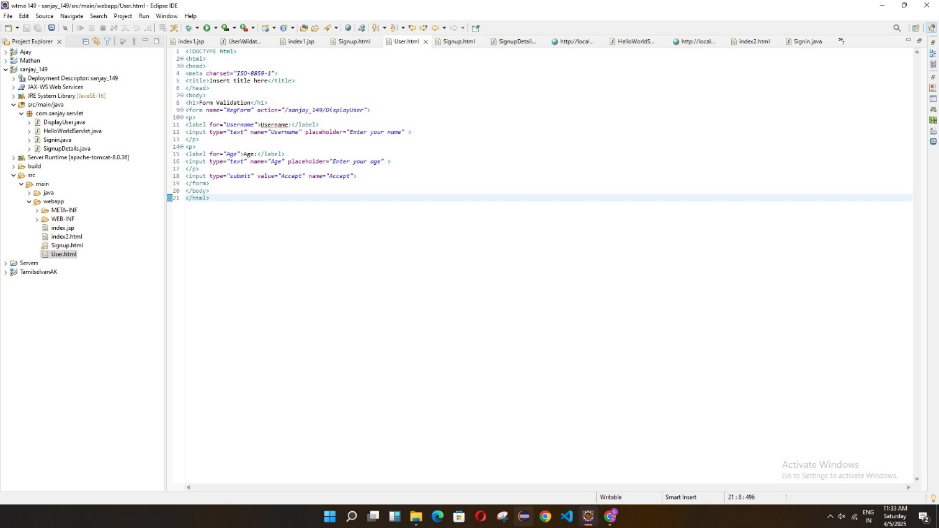

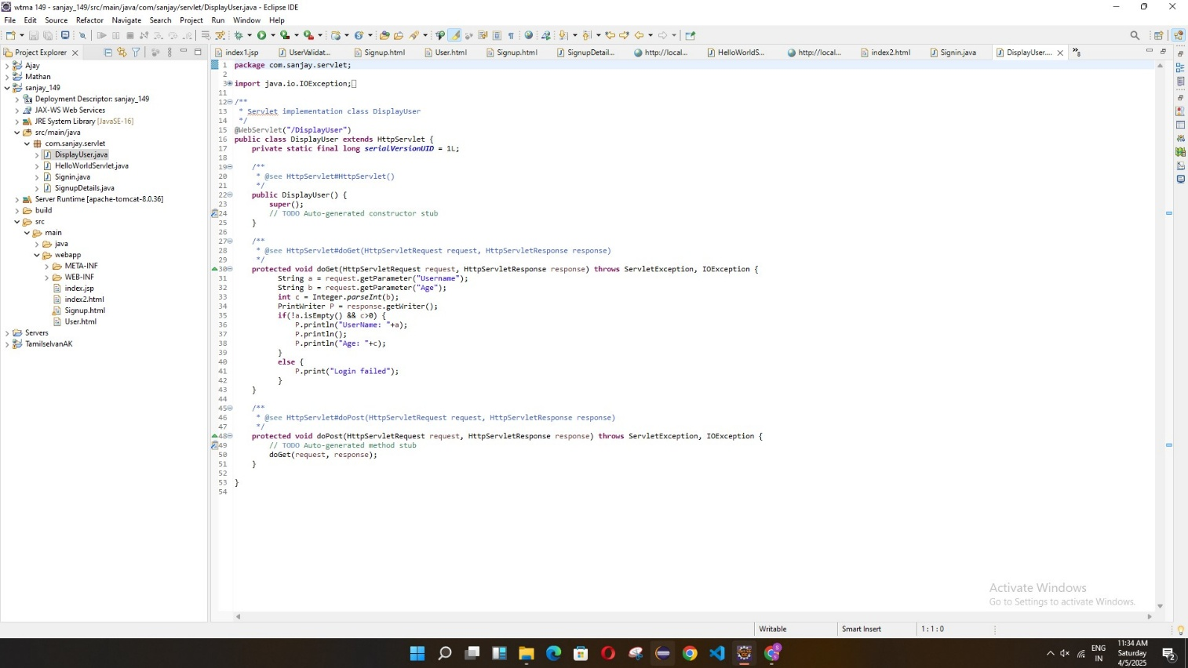

**OUTPUT:**

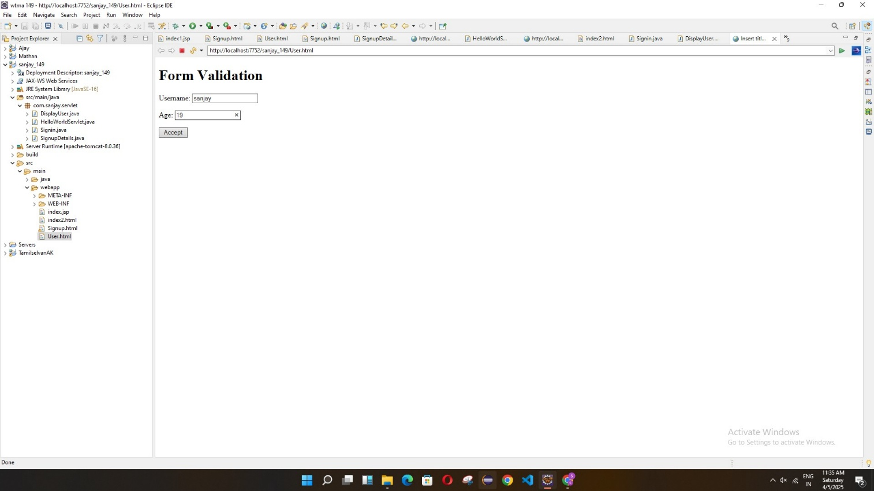

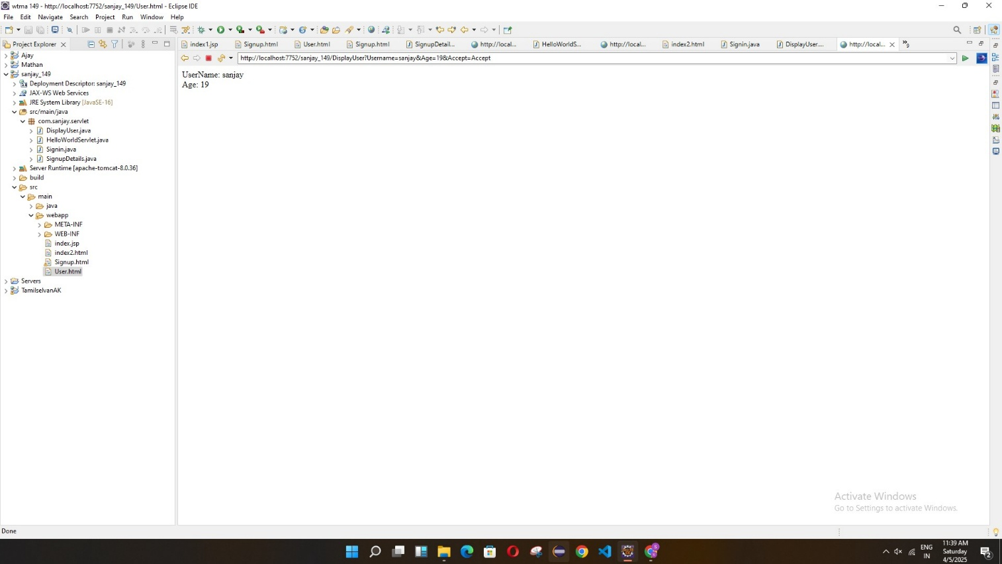

**RESULT:**

The web form was created successfully and the Servlet processed the user's input.  
When the user entered their name and age, the details were correctly displayed on the browser.