|  |  |
| --- | --- |
| **Ex. No : 5**  **Date:** | **Demonstration of HTTP GET and POST Methods Using Servlet** |

**AIM:**

To write a Java Servlet that demonstrates the difference between **HTTP GET** and **HTTP POST** methods by creating a web form and handling both types of requests accordingly.

**PROGRAM:**

HTML:

<!DOCTYPE html>

<html>

<head>

<meta charset="ISO-8859-1">

<title>Sign-Up Page</title>

</head>

<body>

<center>

<h1>Sign-Up Page</h1>

<form method="post" action="/sanjay_149/SignupDetails">

<p>

<label for="Firstname">First name :</label>

<input type="text" name="Firstname" placeholder="Enter your Firstname" >

</p>

<p>

<label for="Lastname">Last name :</label>

<input type="text" name="Lastname" placeholder="Enter your Lastname" >

</p>

<p>

<label for="dob">Date of Birth:</label>

<input type="date" id="dob" name="dob" required>

</p>

<p>

<label for="male">Gender : Male</label>

<input type="radio" id="male" name="gender" value="male">

<label for="female">Female</label>

<input type="radio" id="male" name="gender" value="female">

</p>

<p>

<label for="address">Address</label>

<textarea type="text" name="address"></textarea>

</p>

<input type="submit" value="SignUp">

</form>

</center>

</body>

</html>

SERVLET:

package com.sanjay.servlet;

import java.io.IOException;

import java.io.PrintWriter;

import javax.servlet.ServletException;

import javax.servlet.annotation.WebServlet;

import javax.servlet.http.HttpServlet;

import javax.servlet.http.HttpServletRequest;

import javax.servlet.http.HttpServletResponse;

/**

* Servlet implementation class SignupDetails

*/

@WebServlet("/SignupDetails")

public class SignupDetails extends HttpServlet {

private static final long serialVersionUID = 1L;

/**

* @see HttpServlet#HttpServlet()

*/

public SignupDetails() {

super();

// TODO Auto-generated constructor stub

}

/**

* @see HttpServlet#doGet(HttpServletRequest request, HttpServletResponse response)

*/

protected void doGet(HttpServletRequest request, HttpServletResponse response) throws ServletException, IOException {

// TODO Auto-generated method stub

response.getWriter().append("Served at: ").append(request.getContextPath());

}

/**

* @see HttpServlet#doPost(HttpServletRequest request, HttpServletResponse response)

*/

protected void doPost(HttpServletRequest request, HttpServletResponse response) throws ServletException, IOException {

String f_name=request.getParameter("Firstname");

String l_name=request.getParameter("Lastname");

String dob_v=request.getParameter("dob");

String gen=request.getParameter("gender");

String add=request.getParameter("address");

PrintWriter p = response.getWriter();

p.println("First Name: "+f_name+"<br>");

p.println("Last Name: "+l_name+"<br>");

p.print("Age: "+dob_v+"<br>");

p.print("Gender: "+gen+"<br>");

p.print("Address: "+add+"<br>");

}

}

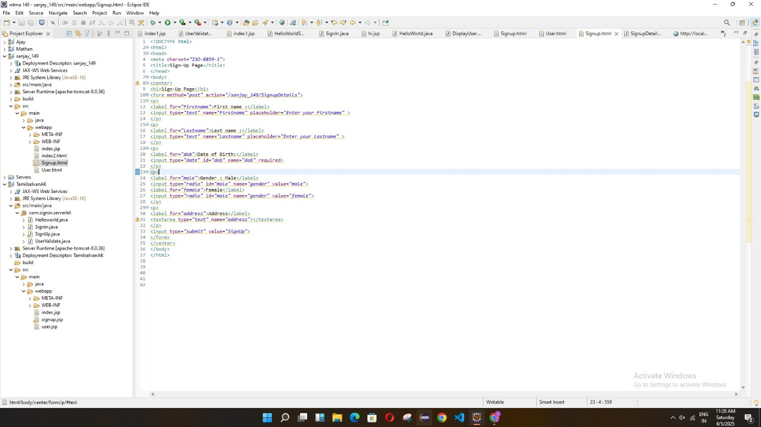

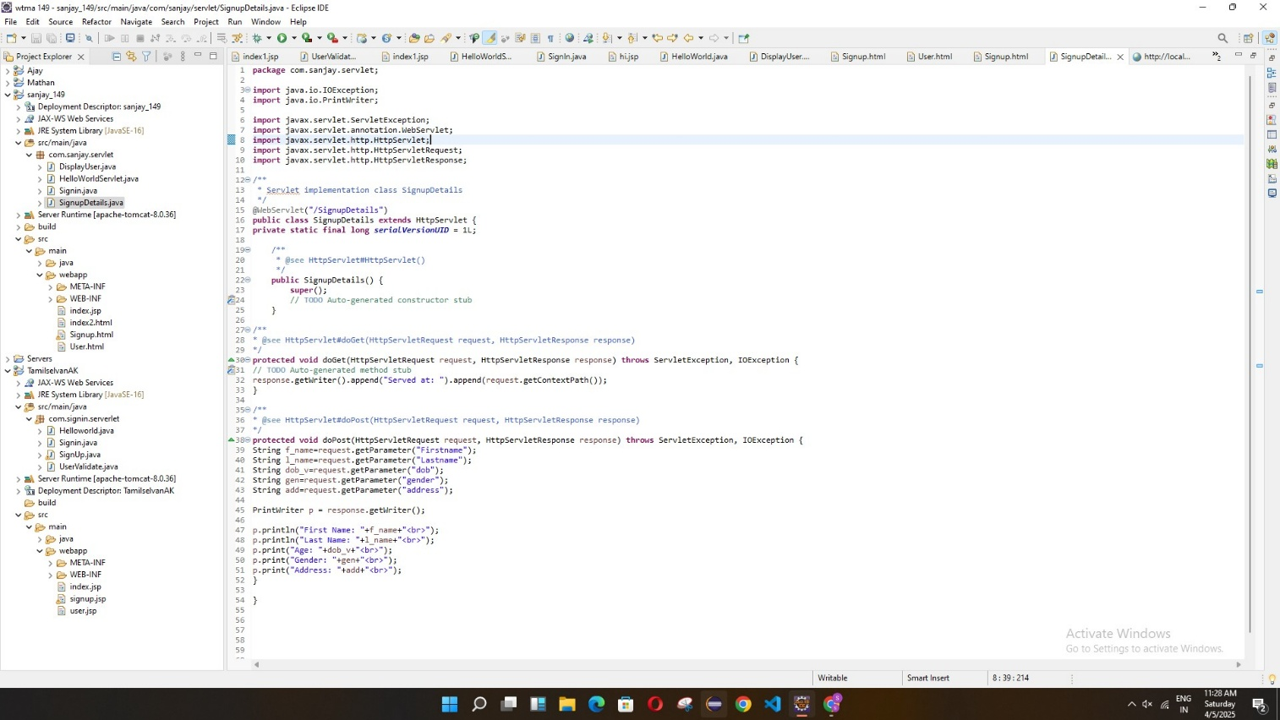

**OUTPUT:**

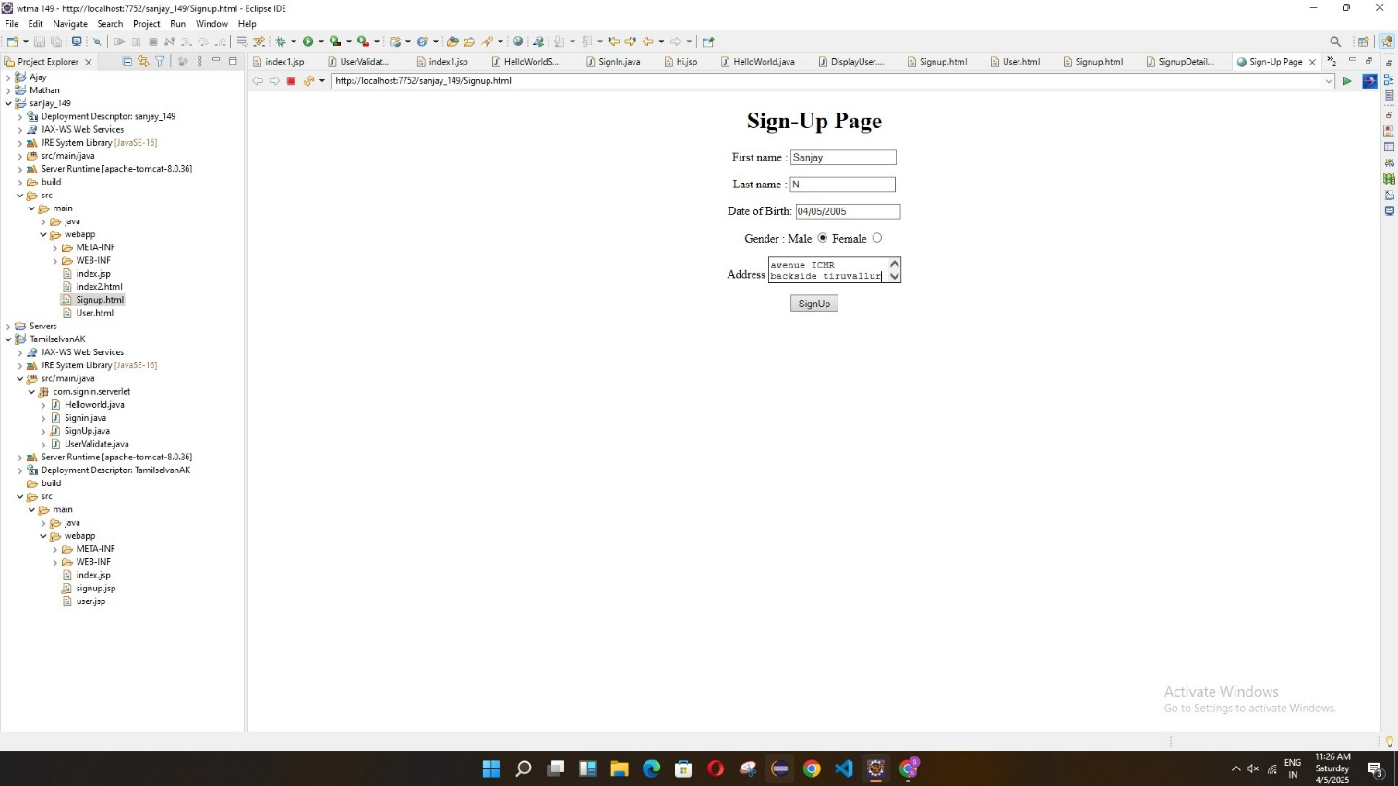

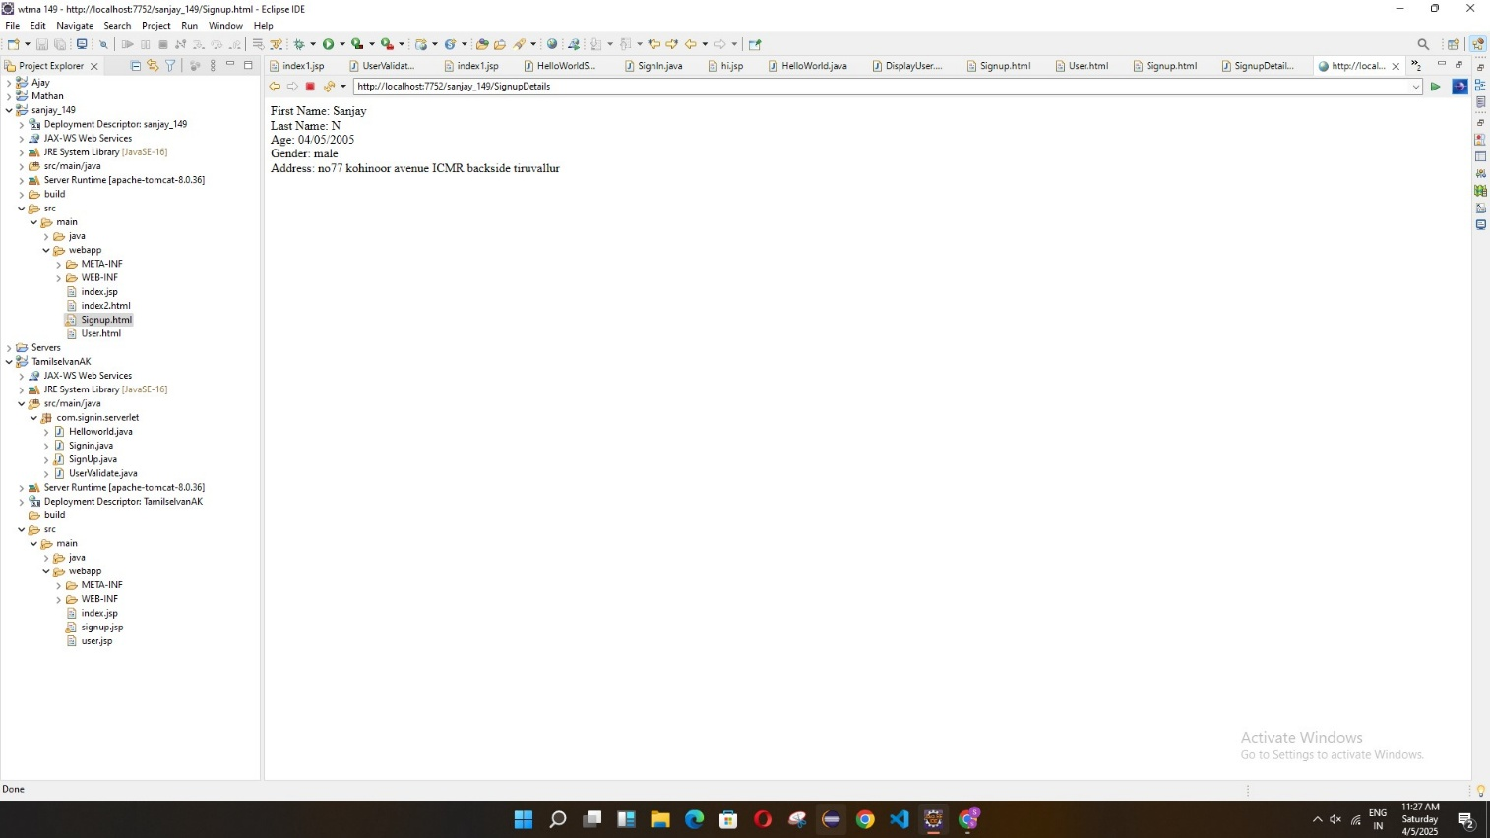

**RESULT:**

The web form and servlet were successfully created.  
The servlet correctly handled both GET and POST requests and displayed different outputs based on the request method, clearly demonstrating their differences.