|  |  |
| --- | --- |
| **Ex. No : 7**  **Date:** | **Storing and Retrieving User Preferences using Cookies in Servlet** |

**AIM:**

To create a Java Servlet application that saves a user’s preferences (like theme and language) using cookies, and retrieves and displays them on future visits.

**PROGRAM:**

HTML

<!DOCTYPE html>

<html>

<head>

<meta charset="ISO-8859-1">

<title>Cookies</title>

</head>

<body>

<form method="post" action="/sanjay_149/cookie">

<p>

<label>Theme: </label>

<input type="text" name="theme" required>

</p>

<p>

<label>Language: </label><br>

<input type="radio" name="language" value="English" required> English<br>

<input type="radio" name="language" value="Tamil"> Tamil<br>

<input type="radio" name="language" value="Hindi"> Hindi<br>

</p>

<button type="submit">Submit</button>

</form>

</body>

</html>

SERVLET

package com.sanjay.servlet;

import java.io.IOException;

import javax.servlet.ServletException;

import javax.servlet.annotation.WebServlet;

import javax.servlet.http.Cookie;

import javax.servlet.http.HttpServlet;

import javax.servlet.http.HttpServletRequest;

import javax.servlet.http.HttpServletResponse;

/**

* Servlet implementation class Cookie1

*/

@WebServlet("/cookie")

public class cookie extends HttpServlet {

private static final long serialVersionUID = 1L;

/**

* @see HttpServlet#HttpServlet()

*/

public cookie() {

super();

// TODO Auto-generated constructor stub

}

/**

* @see HttpServlet#doGet(HttpServletRequest request, HttpServletResponse response)

*/

protected void doGet(HttpServletRequest request, HttpServletResponse response) throws ServletException, IOException {

// TODO Auto-generated method stub

response.getWriter().append("Served at: ").append(request.getContextPath());

}

/**

* @see HttpServlet#doPost(HttpServletRequest request, HttpServletResponse response)

*/

protected void doPost(HttpServletRequest request, HttpServletResponse response) throws ServletException, IOException {

String them = request.getParameter("theme");

String lang = request.getParameter("language");

if ("Forest".equalsIgnoreCase(them) && "tamil".equalsIgnoreCase(lang)) {

Cookie themeCookie = new Cookie("theme", them);

Cookie languageCookie = new Cookie("language", lang);

themeCookie.setMaxAge(60 * 60);

languageCookie.setMaxAge(60 * 60);

themeCookie.setPath("/");

languageCookie.setPath("/");

response.addCookie(themeCookie);

response.addCookie(languageCookie);

response.sendRedirect("getCookie.jsp");

} else {

response.getWriter().println("Invalid login!");

}

}

}

JSP

<%@ page language="java" contentType="text/html; charset=ISO-8859-1" pageEncoding="ISO-8859-1"%>

<!DOCTYPE html>

<html>

<head>

<meta charset="ISO-8859-1">

<title>Get Cookie</title>

</head>

<body>

<%

Cookie[] cookies = request.getCookies();

String cookieName = "theme";

boolean found = false;

if (cookies != null) {

for (Cookie cookie : cookies) {

if (cookieName.equals(cookie.getName())) {

out.println("Hi " + cookie.getValue());

found = true;

break;

}

}

}

if (!found) {

out.println("No cookies found.");

}

%>

</body>

</html>

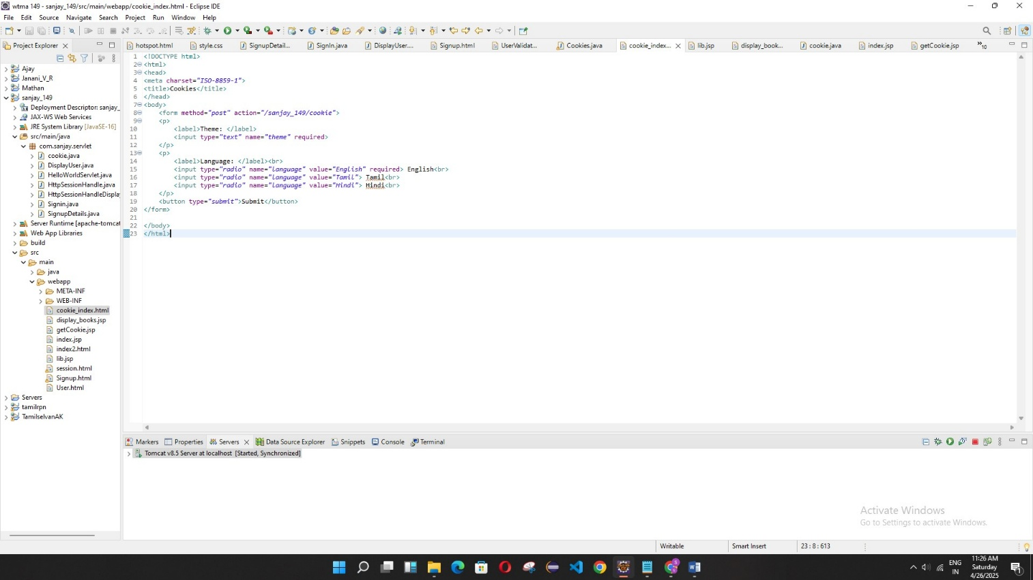

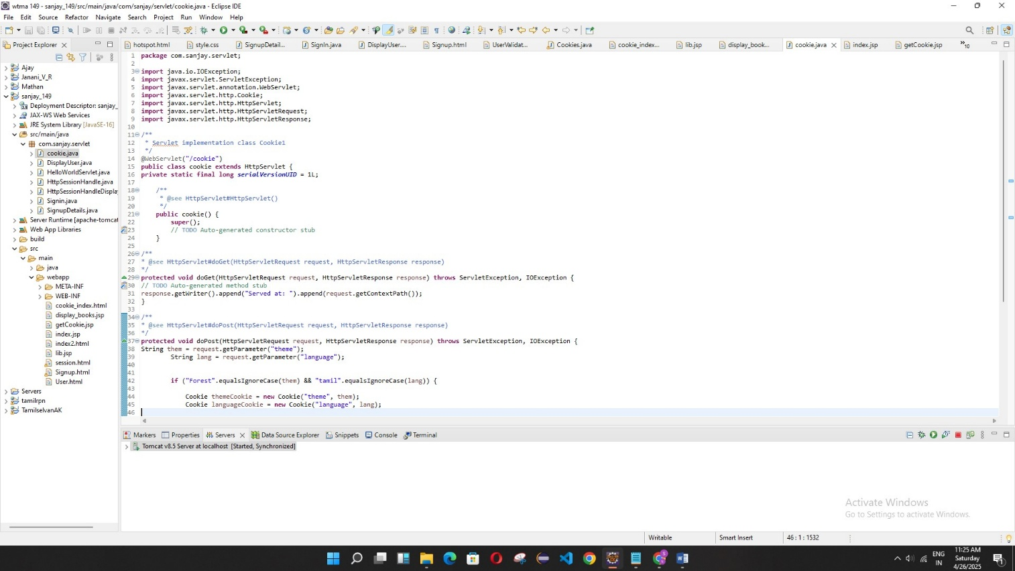

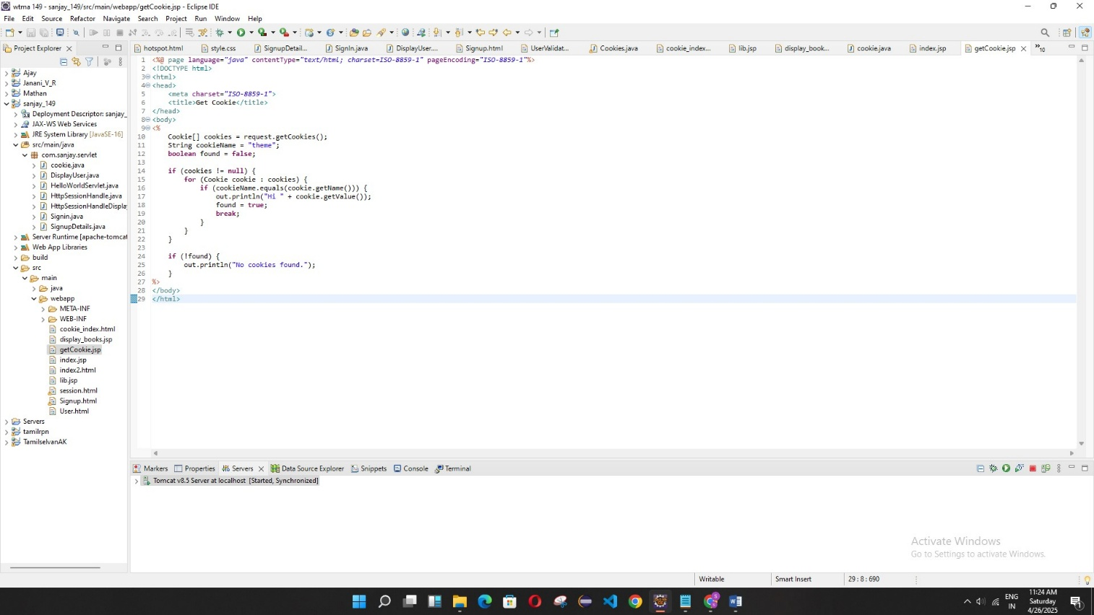

**OUTPUT:**

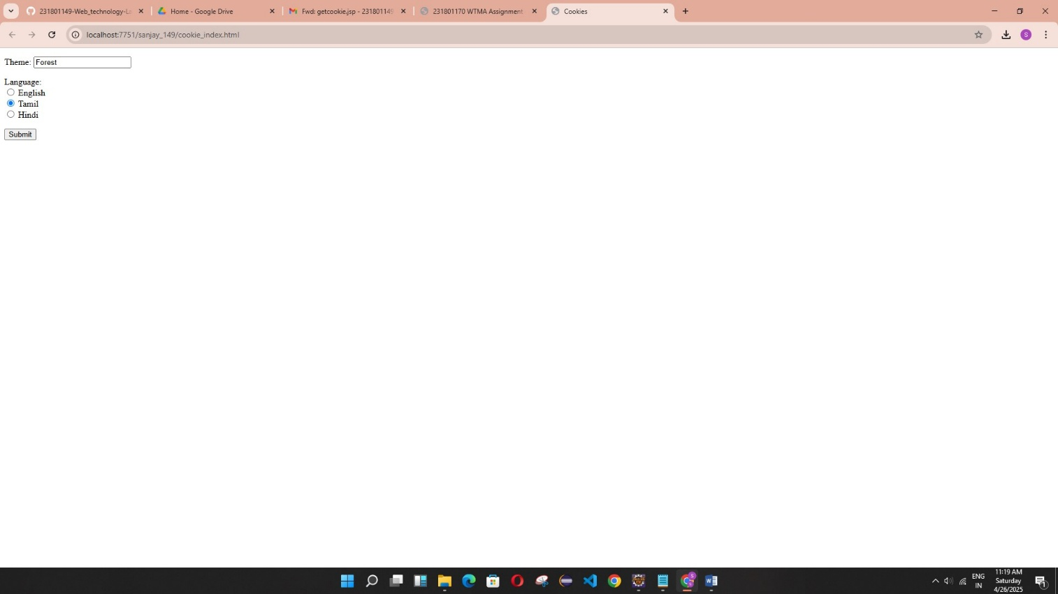



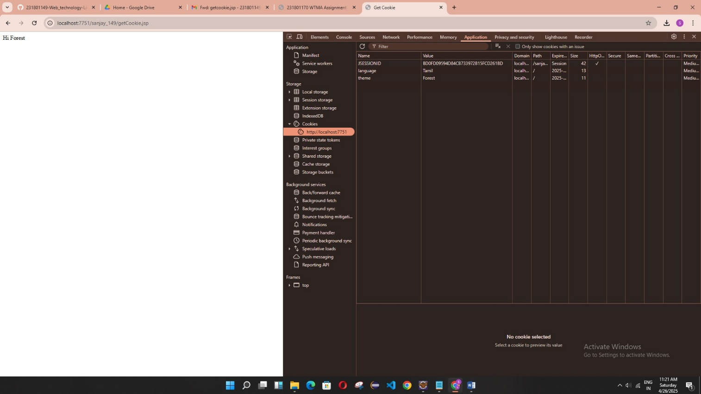

**RESULT:**

Successfully developed a Servlet that stores user preferences using cookies and retrieves them on subsequent requests, improving personalized user experience.