Market Research Agent

A practical competitor-research workflow for small enterprises
Document | Project overview
Intended users | Founders, product teams, consultants, analysts, and technical reviewers
Pilot scope | One target company, five candidates, three human-approved competitors, and one cited briefing
This document explains what we built, why we made the main design choices, and where the current implementation stops. Setup instructions are in SETUP.md, and the code-level architecture is documented in ARCHITECTURE.md.

Contents
- What the product does
- The problem we set out to solve
- How a research run works
- Who it is for
- Where automation stops
- Search and evidence ingestion
- Architecture
- Agent responsibilities and control flow
- State and audit history
- Technology choices
- Quality and safety controls
- What has been delivered and tested
- What we learned and what comes next

1. What the product does
The Market Research Agent turns a company name and a bounded research scope into a cited competitor briefing. It is aimed at a small team that needs a useful market scan but does not have a dedicated competitive-intelligence function.
A typical run answers four questions:
- Who are the most relevant competitors?
- What do they offer?
- What do they charge?
- What has changed recently?
The system does not send a single broad prompt to an LLM and hope for a good report. It separates the work into discovery, evidence collection, analysis, and report compilation. A person chooses the three competitors that deserve deeper research before the more expensive part of the run begins.
The four agent roles are:
- Competitor Discovery Agent: proposes and scores five candidates.
- Web Research Agent: gathers web and news evidence for each approved competitor. You.com is always used; Serper.dev can be added as a second provider.
- Analysis & Verification Agent: extracts claims, links them to evidence, and records uncertainty or conflicts.
- Orchestrator Agent: manages the run, approvals, retries, budgets, and final compilation.
PostgreSQL is the formal record of what happened. Pinecone retrieves relevant evidence during analysis, and LangSmith remains the primary development trace and evaluation workspace. Future AGI is an optional, separately enabled quality layer: it can trace the same LangChain/LangGraph activity and its evaluate() API scores dedicated discovery, analysis, and batch-scenario scripts. It does not participate in production routing or replace the audit trail. The final Markdown, CSV, and PDF exporters use the verified records already stored by the pipeline; they do not ask an LLM to rewrite the facts one more time.

What a completed run provides
Area | Result
Discovery | Five candidates scored as direct, indirect, or emerging competitors
Human review | Exactly three competitors selected for full research
Research | Current web and news evidence collected independently for each competitor
Analysis | Pricing, features, customers, positioning, differentiators, and recent changes
Trust | Evidence IDs, source URLs, confidence, conflicts, and explicit unknowns
Failure handling | A partial report when one branch cannot be completed
Output | Cited Markdown, CSV, and PDF briefings

2. The problem we set out to solve
Competitor research is usually assembled from browser tabs, copied snippets, and notes written at different times. That works for a quick conversation but breaks down when somebody asks where a price came from, whether a feature is still available, or why one company was classified as a direct competitor.
We focused on five recurring problems:
Problem | What it causes | How the MVP responds
Information becomes stale | Teams compare old prices or positioning | Every run performs fresh web and news searches
Notes use different formats | Comparisons become subjective | Pydantic schemas keep the same fields for every competitor
Sources disappear from the write-up | Claims are hard to defend | Claims retain evidence IDs that resolve to source URLs
One failed search stops the job | Useful work is discarded | Each competitor runs in an independent branch
Open-ended agents keep working | Cost and completion time are unclear | Budgets, retries, and completion rules are enforced in Python
This is a decision-support tool. It can shorten the collection and comparison work, but it is not intended to make a final strategy decision on behalf of a founder, consultant, or product manager.

3. How a research run works
Each run leaves a traceable chain from the original request to the final briefing. PostgreSQL stores the business records and events in that chain; Pinecone stores the searchable representation of the collected evidence.
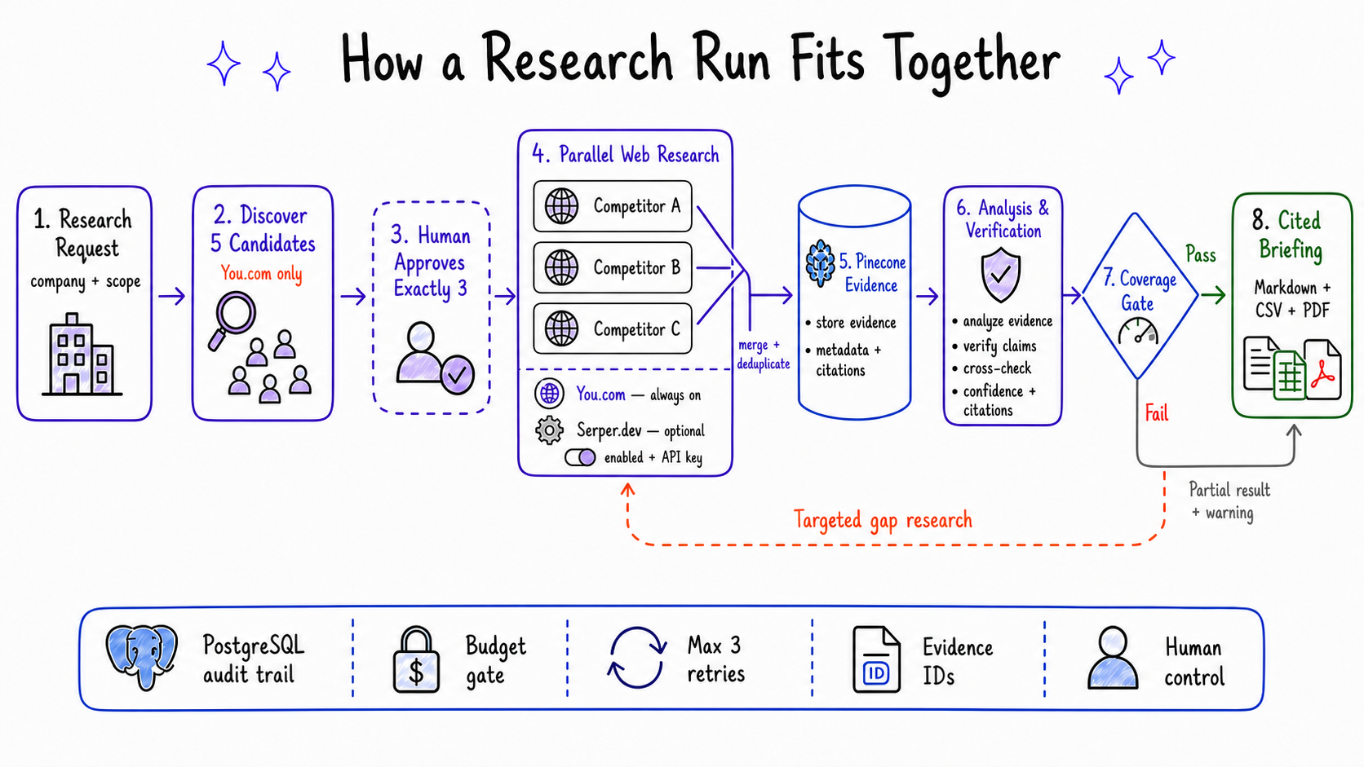
Research-run lifecycle: You.com-only discovery, human selection, concurrent multi-provider Web Research using You.com and optional Serper.dev, Analysis & Verification, a coverage gate that can loop into targeted gap research, and compilation into an exportable briefing
Future AGI is intentionally outside these numbered production stages. When enabled, it observes the LangChain/LangGraph activity; the separate eval and batch-scenario scripts exercise the same agents without changing this run sequence.
The sequence is straightforward:
- The user supplies the target company, industry, geography, customer segment, news window, and budget.
- Discovery queries You.com and returns five scored candidates.
- The user selects exactly three. The API validates this rule even if the interface is bypassed.
- Before full research starts, the graph estimates the cost. A higher budget requires approval.
- One Web Research branch runs for each competitor. Every active branch uses You.com and, when configured, Serper.dev.
- Search results are merged, validated, deduplicated, embedded, and stored.
- The Analysis & Verification branches retrieve evidence by competitor and category and produce typed claims.
- A coverage check accepts the profile, requests targeted gap research, or marks the branch incomplete.
- The exporters build the cited briefing from the stored profiles and evidence records.
Human approval happens before the three full research branches. If a branch still lacks enough evidence after its retry allowance is exhausted, the other branches continue and the briefing carries a visible warning.

One deliberate constraint
app/export/markdown_exporter.py formats verified data without another model call. We chose this because a final “make this sound better” prompt could add a claim that had never passed through evidence validation.

4. Who it is for
The MVP is most useful when the research question is bounded and the user can review the result before acting on it.
User | Likely use
Founder or small-business owner | Prepare a first market landscape without hiring an analyst
Product manager | Compare current features, pricing, and positioning
Sales or competitive-intelligence contributor | Create source-backed talking points
Consultant | Produce a repeatable starting point for client research
Analyst or student | Study a working multi-agent research and verification pipeline

Flagship use cases
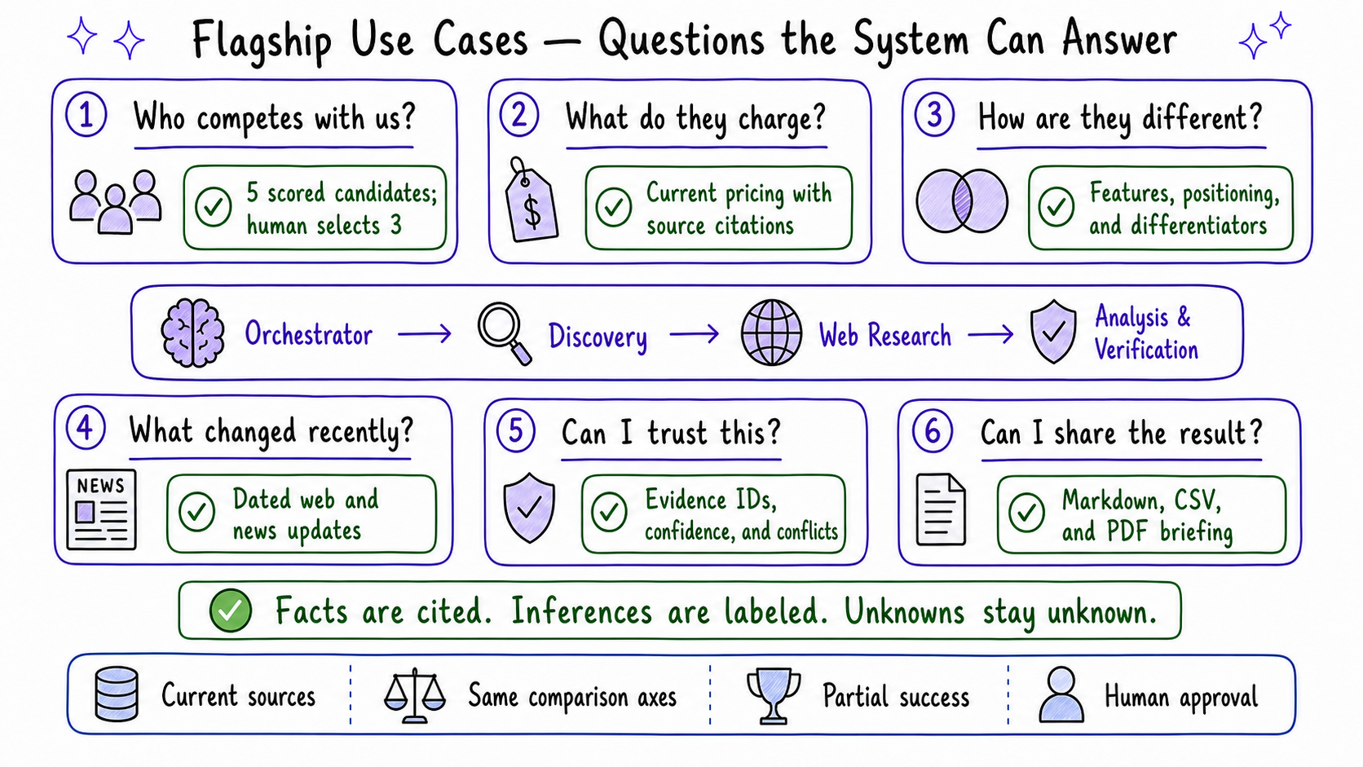
Flagship use cases: competitor discovery, pricing, differentiation, recent changes, evidence confidence, and exportable briefings
Question | What the system returns
Who competes with us? | Five scored candidates, followed by a human-selected shortlist of three
What do they charge? | Pricing details with currency, cadence, date, and source context when available
How are they different? | Comparable features, customers, positioning, and differentiators
What changed recently? | Dated web and news findings inside the requested time window
Can I trust this? | Source links, confidence, conflicts, and unknown values
Can I share it? | A cited Markdown, CSV, or PDF briefing
In a live RunPod research run, for example, the company-description claim in the exported briefing resolved to the actual source title and URL rather than showing an internal evidence UUID. That small detail matters: citations are only useful when a reader can follow them.

5. Where automation stops
We wanted the agents to handle repetitive research work without quietly crossing into business decisions. The split below is enforced by workflow and API rules, not just described in prompts.
The system can do on its own | A person must decide
Generate and refine search queries | Which three competitors receive full research
Retry transient provider failures | Whether to raise the approved budget
Deduplicate and categorize evidence | How to resolve a material conflict that cannot be reconciled safely
Run targeted research for missing categories | Whether a partial or low-confidence report is ready for external use
Preserve missing information as unknown | Whether to publish or write results into another business system
The current version deliberately does not include:
- unrestricted crawling or general-purpose page scraping;
- scheduled monitoring and alerts;
- enterprise SSO or multi-tenant SaaS administration;
- autonomous email, CRM, roadmap, or publishing actions;
- remote A2A agent services;
- conversational memory through Mem0 or another memory service; or
- any claim that the system replaces human strategic judgment.
Those features may be useful later, but adding them now would make a small deployment harder to operate without improving the core briefing.

6. Search and evidence ingestion
You.com is the required search provider. It is used for both candidate discovery and full competitor research. Serper.dev is optional and is used only by the Web Research Agent. When enabled, it gives the research branches a second search index without changing the rest of the ingestion pipeline.
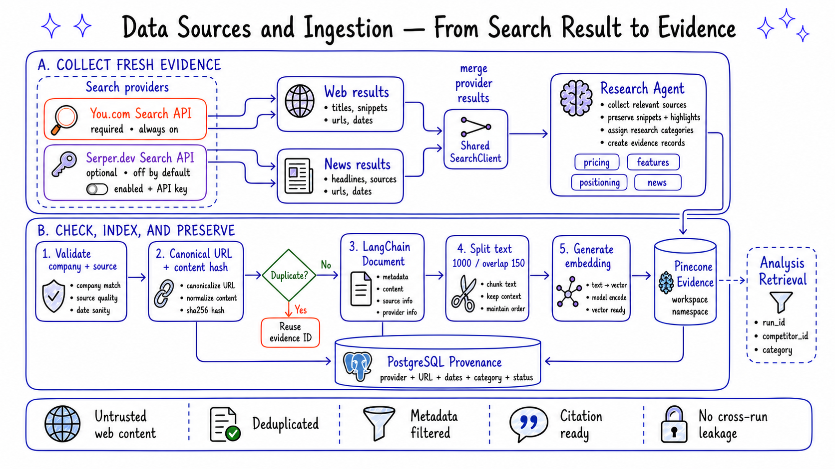
Data sources and ingestion: required You.com and optional Serper.dev web and news results merge through a shared search-client interface, then are validated, deduplicated, converted into LangChain documents, embedded into Pinecone, and preserved with PostgreSQL provider provenance

Provider behavior
Provider | Required? | Current behavior
You.com | Yes | Always queried; also powers competitor discovery
Serper.dev | No | Used alongside You.com only when SERPER_ENABLED=true and an API key is present
Both clients implement the SearchClient interface in app/clients/search_client.py. The Web Research Agent therefore receives the same result shape from either provider. Each accepted evidence record retains its provider name, URL, query, category, and dates.
Enabling Serper.dev adds one search request per research category and increases the pre-flight estimate accordingly. The implementation and mocked tests are in place, but this provider has not yet been exercised with a live Serper.dev account. Its per-call price in the cost table is also a placeholder and should be replaced before production billing is presented to users.

Research categories
Each competitor is researched across 11 categories. Company description is kept as context; the other ten contribute to the coverage score.
Category | Included in coverage?
Company description | No
Pricing | Yes
Core features | Yes
Target customers | Yes
Positioning | Yes
Differentiators | Yes
Announcements | Yes
Recent news | Yes
Free trial | Yes
Customer reviews | Yes
Notable customers | Yes

What happens to a search result
- The pipeline checks company relevance, source quality, and dates.
- Canonical URLs and content hashes prevent duplicates from inflating confidence, including duplicates returned by different providers.
- Results become LangChain documents and are split when necessary. The current chunk size is 1,000 characters with 150 characters of overlap.
- OpenAI embeddings are stored in a Pinecone workspace namespace.
- Vector IDs are derived from the evidence ID and chunk index, so retrying an upsert does not create new copies.
- Retrieval always filters on run_id, competitor_id, and category.
- PostgreSQL keeps the source record and its relationship to later claims.
All retrieved text is treated as untrusted content. It is evidence for the model to inspect, not a new set of instructions for the agent.

7. Architecture
The MVP runs as one Python application. The agent roles are separate in code, but they are not independently deployed services. This keeps local setup and debugging manageable while leaving client and graph boundaries that could be moved into services later.
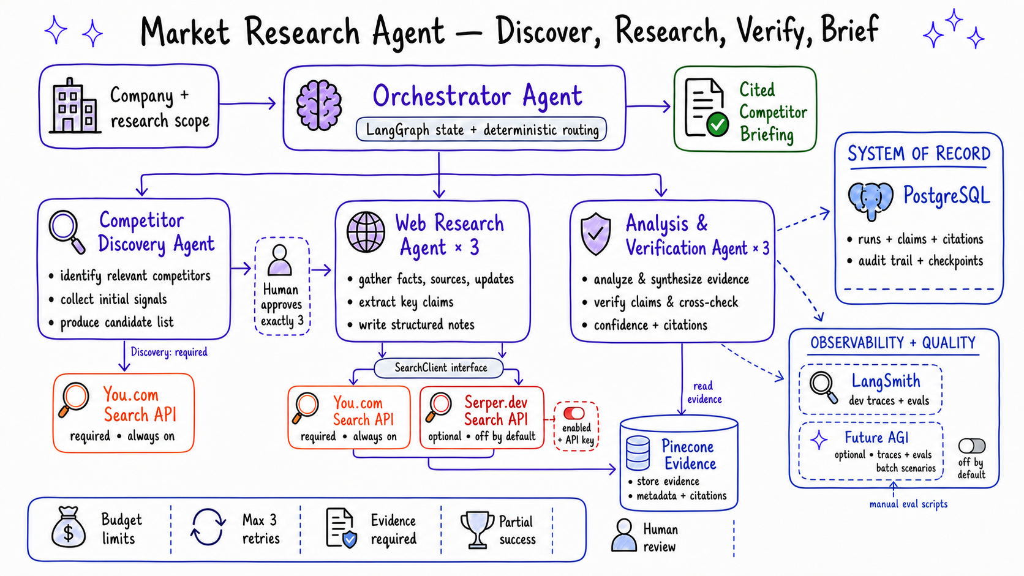
Market Research Agent architecture showing the Orchestrator, You.com-only competitor discovery, multi-provider Web Research, Analysis and Verification, human approval, Pinecone evidence, PostgreSQL as system of record, and separate LangSmith and optional Future AGI observability and quality paths
Future AGI and LangSmith receive diagnostic traces through dashed paths; neither platform approves competitors, changes budgets, or routes production work.

Main components
Component | Responsibility
Streamlit | Research form, competitor approval, progress, results, and downloads
FastAPI | Validation and endpoints for runs, approvals, status, and exports
LangGraph | Workflow state, fan-out, routing, retries, budgets, and coverage checks
LangChain | Prompts, structured model output, documents, embeddings, and retrieval interfaces
You.com | Required search and news data for discovery and research
Serper.dev | Optional second search and news provider for research
Pinecone | Scoped semantic retrieval over evidence chunks
PostgreSQL | Runs, selections, evidence, claims, costs, reports, events, and checkpoints
LangSmith | Development traces, evaluations, latency, and selected production diagnostics
Future AGI | Optional tracing through LangChainInstrumentor plus evaluate() scoring for dedicated eval scripts and the project-local batch scenario runner
The three competitor branches are concurrent instances of the same Web Research and Analysis definitions. We do not maintain six separate agents. That distinction reduces prompt drift and makes fixes apply consistently to every competitor.

8. Agent responsibilities and control flow
Each agent has a narrow job and a boundary it is not allowed to cross.
Agent | Receives | Produces | Does not do
Orchestrator | Research scope and graph state | Plans, routing decisions, and compiled briefing | Add new facts during report compilation
Competitor Discovery | Target company and scope | Five scored candidates | Choose the final three
Web Research | One competitor, categories, and active search clients | Deduplicated evidence IDs and coverage metadata | Write strategic conclusions
Analysis & Verification | Retrieved evidence for one competitor | Typed claims, confidence, conflicts, and coverage | Cite evidence it did not retrieve
The graph applies the following rules:
- external requests have timeouts and bounded retries;
- authentication and malformed requests are not treated as transient errors;
- a task is attempted no more than three times;
- projected search and model costs are checked before full research;
- missing categories can trigger a targeted research pass while budget remains;
- a failed branch stays visible in the report status; and
- only verified structured records reach the report compiler.
Provider-specific HTTP code lives in app/clients/. YouComClient and SerperClient implement the same search contract; PineconeClient owns vector operations; and the OpenAI, LangSmith, and Future AGI setup functions are isolated from agent logic. Future AGI imports are deferred, so the normal application still starts when its optional dependency group is absent. Tests can replace external clients with fakes rather than making paid requests.

9. State and audit history
There are four kinds of state in the application, and they are not equally authoritative.
Location | What it holds | Role
LangGraph state | Current branches, errors, coverage, retries, and approvals | Drives the active workflow
PostgreSQL | Business records and audit events | Formal system of record
Pinecone | Embedded evidence chunks and retrieval metadata | Search index, not business history
Streamlit session_state | Browser selections and navigation | Temporary UI convenience
The durable record follows this shape:
workspace
└── run
├── discovery candidates
├── approved competitor selections
├── research evidence
│ └── Pinecone chunks
├── competitor profiles
│ └── claims → evidence IDs
├── costs and audit events
└── briefing and exports
Pinecone can be rebuilt from the evidence records. PostgreSQL cannot be replaced by Pinecone because it stores the authoritative relationships among runs, approvals, sources, claims, and costs.
LangSmith and Future AGI hold diagnostic traces and evaluation results, not product state. A trace may be sampled, masked, disabled, or unavailable without changing the authoritative run recorded in PostgreSQL.

10. Technology choices
Area | Technology | Why it is here
Language | Python 3.12+ | Typed application and data-processing code
Workflow | LangGraph | Conditional routing and concurrent branches with explicit state
Agent/RAG utilities | LangChain | Structured outputs, documents, splitting, embeddings, and retrieval
Models | OpenAI | Query generation, candidate scoring, claim extraction, and embeddings
Search | You.com and optional Serper.dev | Fresh web and news evidence from one or two indexes
Vector search | Pinecone Serverless | Namespace and metadata-scoped evidence retrieval
Database | PostgreSQL | Durable workflow records and audit history
API | FastAPI | Typed asynchronous endpoints
Interface | Streamlit | A small multipage UI without a separate frontend stack
Schemas | Pydantic v2 | Validation at agent and API boundaries
Persistence | SQLAlchemy and Alembic | Relational data access and migrations
Primary engineering observability | LangSmith | Trace inspection and the existing development evaluation suite
Optional quality cross-check | Future AGI | Secondary traces, evaluate() scoring, and a project-local batch scenario harness; enabled only by explicit toggle and optional dependency group
Reports | ReportLab plus Markdown/CSV exporters | Shareable cited output
Tests | pytest | Credential-free behavior and integration checks
Packaging | uv | Locked dependencies and repeatable commands
We considered Mem0 and LlamaIndex earlier in the design. Neither solves a current gap: fresh evidence is more important than conversational memory, and LangChain already supplies the document and retrieval abstractions used here. Kafka, Kubernetes, remote A2A services, and a second vector database were left out for the same reason. They would raise the operating cost before the MVP has a workload that requires them.

11. Quality and safety controls
Several controls are structural rather than prompt-based:
- A supported claim without evidence IDs fails Pydantic validation.
- A single source cannot produce high confidence.
- Unknown information stays unknown instead of being filled with a guess.
- Conflicting values remain separate and retain their sources.
- Workspace namespaces and metadata filters prevent cross-run retrieval.
- Budget, retry, and coverage decisions are regular Python logic.
- Retrieved pages are delimited as untrusted content before model use.
The automated tests cover discovery scoring, deduplication, chunking, embedding failures, retrieval isolation, evidence-required claims, confidence downgrades, coverage, conflicts, retries, budgets, partial branches, exports, citations, audit events, migrations, prompt-injection boundaries, both search clients, and multi-provider provenance.
LangSmith is used to debug model calls, retrieval, node timing, token usage, and failures. It is not the customer-facing audit database. Production traces can be sampled, masked, or disabled for a privacy-sensitive workspace, while the required business events remain in PostgreSQL.

Future AGI quality loop
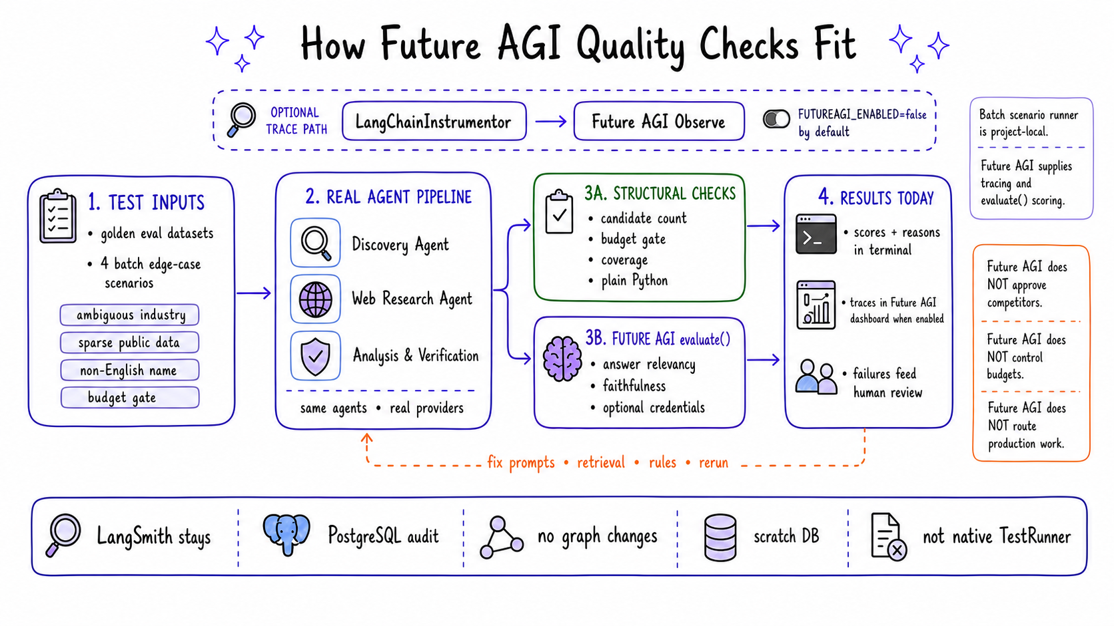
Future AGI quality loop showing golden datasets and four project-local batch scenarios running through the real agents, structural Python checks and Future AGI evaluate scoring, optional Future AGI Observe tracing, human review, and a feedback loop into prompts, retrieval, and deterministic rules
Future AGI is deliberately opt-in. FUTUREAGI_ENABLED=false is the default, and tracing starts only when both FI_API_KEY and FI_SECRET_KEY are present and the futureagi dependency group has been installed. FastAPI initializes the integration during application startup; a missing package, missing key, or setup failure degrades to no Future AGI tracing rather than preventing the application from starting.
Enable the optional integration with:
uv sync --group futureagi
FUTUREAGI_ENABLED=true
FI_API_KEY=...
FI_SECRET_KEY=...
FI_PROJECT_NAME=market-research-agent
Keep the toggle off when external tracing is not appropriate for the workspace. The evaluation scripts still require their own live provider credentials because they execute the underlying agents rather than evaluating static report text alone.
The delivered integration has three separate parts:
Part | Implementation | Current status
Observe tracing | app/clients/futureagi_client.py registers ProjectType.OBSERVE and instruments LangChain/LangGraph through LangChainInstrumentor | Live-verified against a real Future AGI account
Agent evaluation | eval/run_discovery_eval_futureagi.py scores answer relevancy; eval/run_analysis_eval_futureagi.py scores claim faithfulness | Implemented, but not yet run end-to-end with live Future AGI evaluation credentials
Batch edge-case checks | eval/simulation/run_simulation.py drives four synthetic requests through the real agents, performs structural Python checks, and calls Future AGI evaluate() | Project-local harness; not Future AGI’s native multi-turn TestRunner
The distinction in the last row matters. This application is a bounded research workflow rather than a conversational or voice agent. Its scenario runner therefore tests the real Discovery, Web Research, and Analysis agents directly instead of forcing them behind a chat-persona callback. The runner writes real records and must point at a scratch database.
Future AGI does not approve competitors, raise budgets, modify graph state, or compile the briefing. It provides traces and quality signals for a person to review. Standalone evaluate() results currently print to the terminal; they are not yet attached to trace spans for display as dashboard evaluation scores.
Because enabling both observability platforms can send the same prompt, retrieval, and model content to two external services, production use should apply the same sampling, masking, retention, and workspace-privacy decisions to both. Neither integration changes the credential-free tests/ suite.

12. What has been delivered and tested
The repository includes:
- application configuration, logging, and locked dependencies;
- SQLAlchemy models and reversible Alembic migrations;
- Pydantic schemas for evidence, claims, confidence, and graph state;
- You.com, Serper.dev, OpenAI, Pinecone, LangSmith, and Future AGI client boundaries;
- the four agent roles and two LangGraph workflows;
- PostgreSQL-backed services and FastAPI endpoints;
- a multipage Streamlit interface;
- Markdown, CSV, and PDF exporters;
- automated tests plus a separate optional LLM evaluation suite; and
- an optional Future AGI tracing layer, two Future AGI evaluation scripts, and a project-local batch scenario runner that uses Future AGI scoring.

Validation record
Check | Result
Automated suite | 49/49 test functions passed without live provider credentials
Database lifecycle | Alembic upgrade → downgrade → upgrade completed against local PostgreSQL, including the serper provider migration
Discovery | A live OpenAI + You.com run produced five classified Oracle competitors
Research and analysis | Live OpenAI + You.com + Pinecone runs produced evidence-backed RunPod and Salesforce profiles
Citations | Stored evidence IDs resolved to real source titles and URLs in exported reports
LangSmith | Per-node timing and per-model token usage were visible in live traces
Serper.dev | Mock-tested and migration-verified, but not yet called with a live account
Future AGI tracing | Live-verified: a real LangChain call was traced with a real FI_API_KEY/FI_SECRET_KEY and force-flushed to Future AGI’s collector, and confirmed visible in the Future AGI dashboard
Future AGI evaluation and batch scenarios | Structurally implemented; the tracing no-op path is unit-tested, but eval/run_*_futureagi.py and the project-local eval/simulation/ runner have not yet been executed end-to-end against a live Future AGI evaluation account
The core workflow is therefore live-validated with You.com. Serper.dev should still be treated as a tested integration candidate until its request shape, freshness behavior, quotas, and real cost have been checked with an account. Future AGI’s tracing path has cleared that same bar. Its evaluate() metric identifiers and batch scenarios have not, and should be treated as integration candidates until they have been exercised against a live evaluation account.

13. What we learned and what comes next
The main lesson from the build is that the useful part of a multi-agent system is not the number of agents. It is the handoff contract between them. Evidence IDs, typed outputs, deterministic routing, and clear failure states did more for reliability than adding another autonomous role would have done.
A few choices became clearer during implementation:
- Keeping discovery separate from full research creates a natural approval and cost boundary.
- A final LLM rewriting pass is unnecessary when the structured profile is already good enough to export.
- Search snippets are often shorter than the configured chunk size, but the splitter is still needed for occasional longer results.
- Pinecone is useful for retrieval, but source relationships and audit events belong in PostgreSQL.
- A second search provider may improve coverage, but it also makes provider provenance, deduplication, and cost accounting more important.

Known gaps
- Serper.dev needs a live integration run and verified pricing.
- Future AGI’s evaluate() metric identifiers and the project-local batch scenarios are implemented but not yet run end-to-end against a live account (tracing alone has been).
- Future AGI eval scores from eval/run_*_futureagi.py and eval/simulation/ are currently local-only: standalone evaluate() calls are not attached to a trace/span, so they print to the terminal but do not yet appear in the Future AGI dashboard.
- Cost projection still uses estimates rather than actual model usage metadata.
- Per-competitor progress could be clearer in the interface.
- The product has been exercised on a small number of companies and needs repeated use across industries before its confidence rules can be tuned.
- Authentication, container deployment, and background workers are not part of the current local MVP.

Recommended next steps
- Live-test Serper.dev and replace its placeholder price.
- Run eval/run_discovery_eval_futureagi.py, eval/run_analysis_eval_futureagi.py, and eval/simulation/run_simulation.py against a live Future AGI evaluation account. Confirm that faithfulness and answer_relevancy remain the best metric identifiers for the installed SDK version.
- If dashboard-visible eval scores are wanted (not just terminal output), attach Future AGI eval calls to the run’s trace/span instead of calling evaluate() standalone.
- Record actual model usage and exact provider requests in the cost ledger.
- Add first-class progress events for each competitor branch.
- Run the LangSmith and Future AGI evaluation suites regularly, compare their results over time, and require human review when the two judges disagree.
- Pilot the workflow in several industries and review where coverage and confidence disagree with a human analyst.
- Add authentication or deployment infrastructure only when a real hosting requirement justifies it.
- Revisit A2A if an agent eventually becomes a separately deployed service or a customer-controlled integration boundary.
The MVP now completes the intended path from discovery to a cited briefing. The next useful work is operational learning: run it repeatedly, note where a person has to correct it, and improve those parts before expanding the stack.

Technology references
- FastAPI documentation
- Streamlit documentation
- LangGraph documentation
- LangChain documentation
- OpenAI API reference
- You.com API documentation
- Serper.dev documentation
- Pinecone documentation
- PostgreSQL documentation
- SQLAlchemy documentation
- Alembic documentation
- Pydantic documentation
- LangSmith documentation
- Future AGI documentation
- ReportLab user guide
- pytest documentation
- uv documentation

