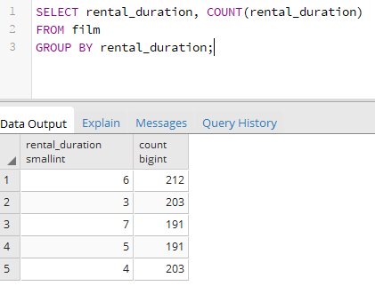

Now suppose you have to find MAX count from above result

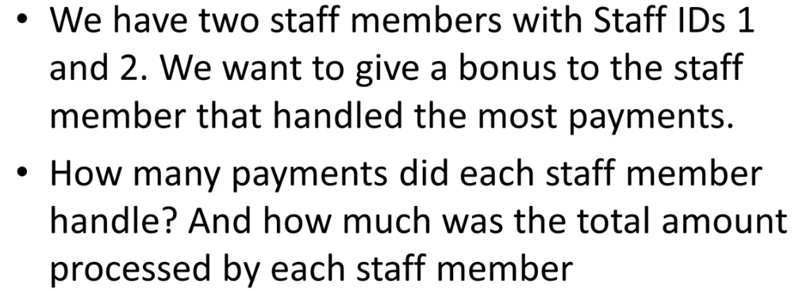

SELECT staff_id, COUNT(amount),SUM(amount) FROM payment GROUP BY staff_id;



SELECT rating, ROUND(AVG(replacement_cost),3) FROM film GROUP BY rating;

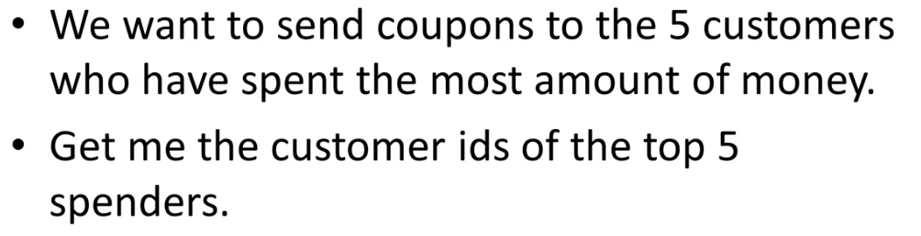

SELECT customer_id, SUM(amount) FROM payment GROUP BY customer_id

ORDER BY SUM(amount) DESC LIMIT 5;

WHERE and HAVING together

SELECT rating,ROUND(AVG(rental_rate),2)AS average_rental

FROM film

WHERE rating IN ('R','G','PG')

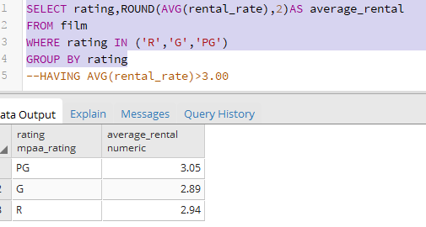

Based on where it has been filtered and we got records in group rows

Now to filter group rows we will use HAVING clause

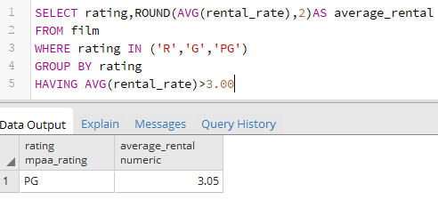

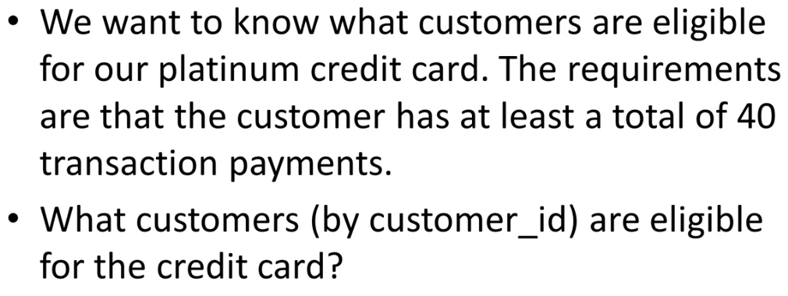

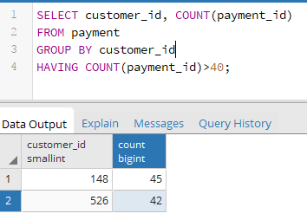

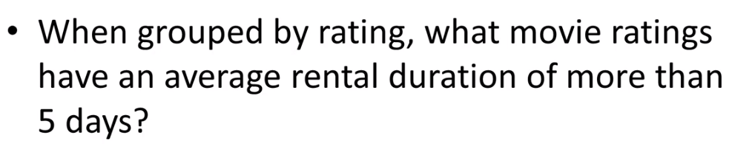

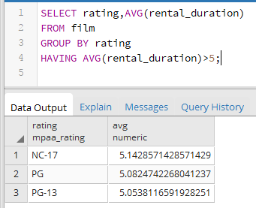

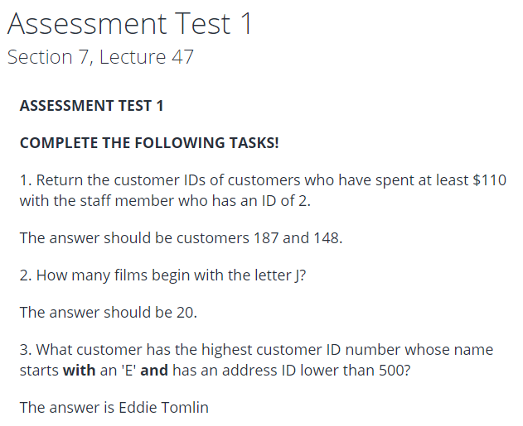

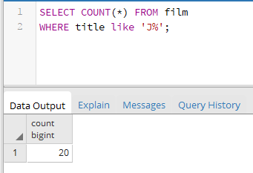

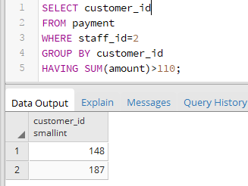

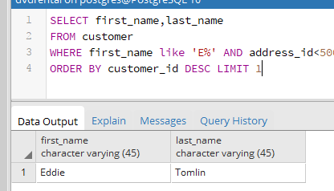

INNER JOIN

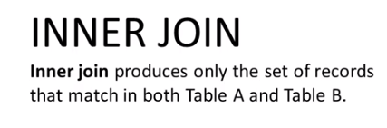

INNER JOIN and WHERE Together

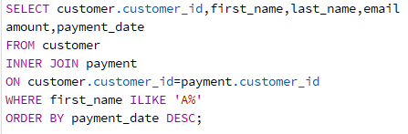

Note : in customer_id column we have specified table name because it is present in both the tables. If not specified ambiguity exception will be thrown. If column names are different in both the tables just column name is enough. Suppose two same columns are present in both the tables and we want to fetch both the columns then better to use AS clause.

JOIN, WHERE AND GROUP BY Together



FULL OUTER JOIN



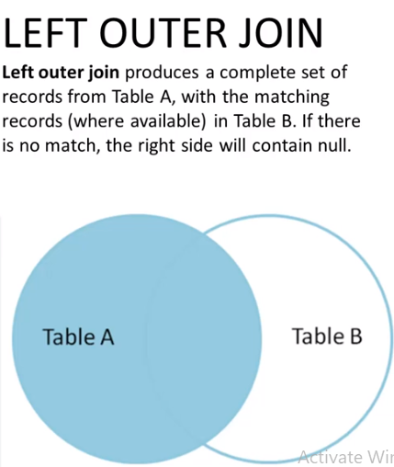

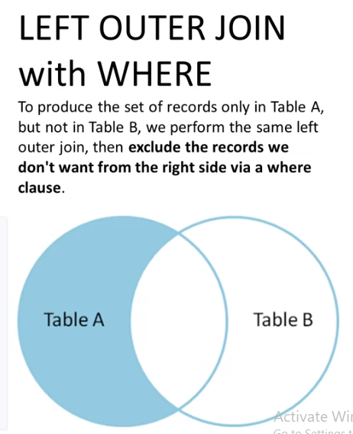

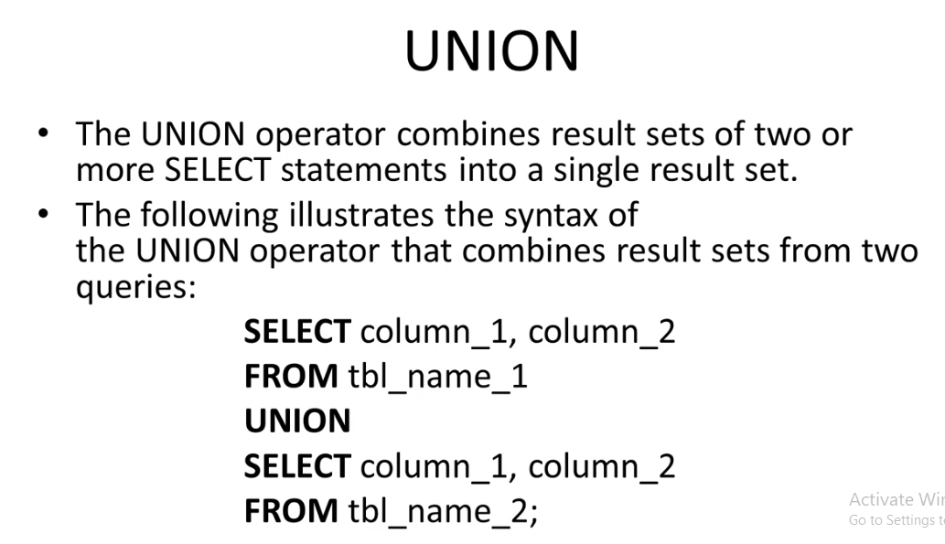

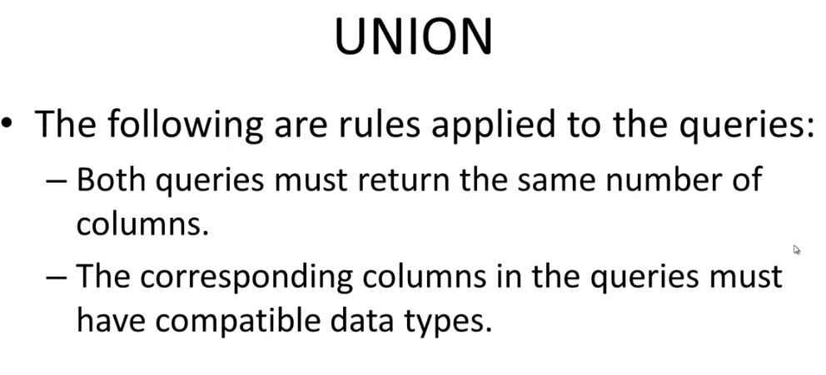

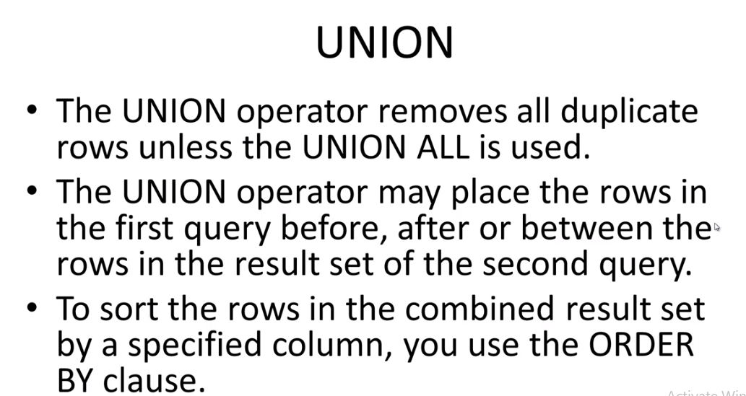

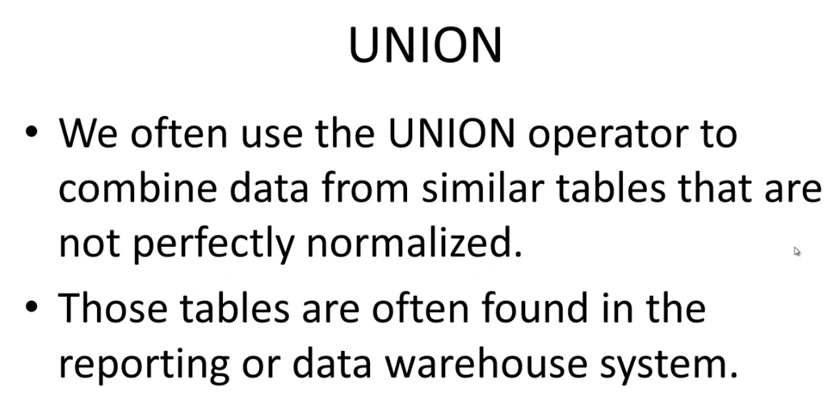

<http://www.sql-join.com/>

<https://blog.codinghorror.com/a-visual-explanation-of-sql-joins/>

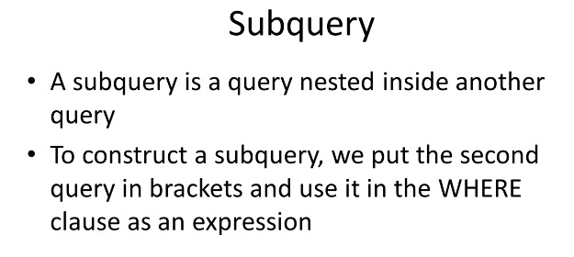





Postgres Data Types

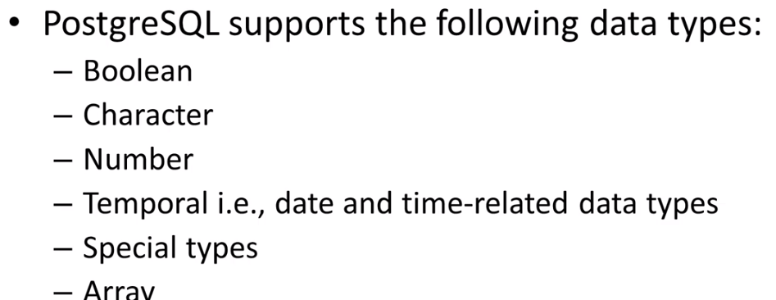

In postgressql serial is same as AUTO_INCREMENT in other databases.

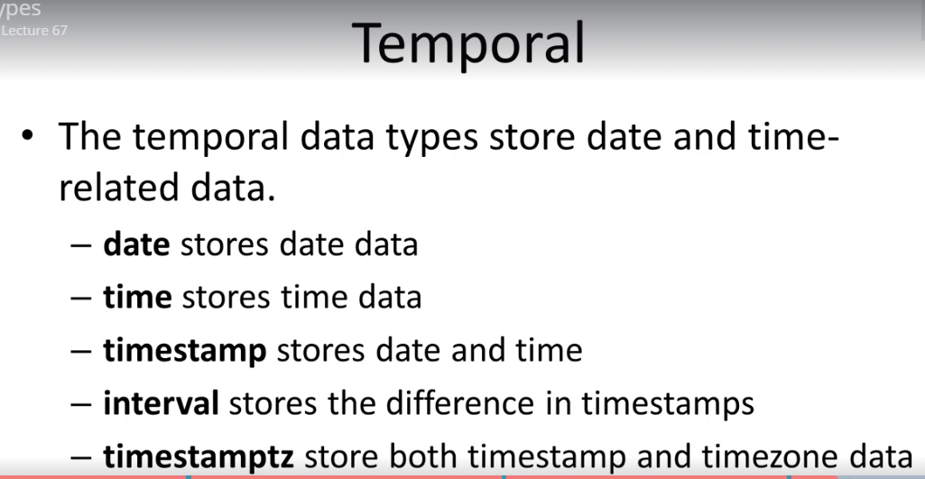



VIEW

Main use of view is store a Complex query as a view so that we don’t have to re-write.

--CREATING A VIEW--

SELECT first_name,last_name,email,address,phone

FROM customer

JOIN address

ON customer.address_id=address.address_id;

--Suppose it is a frequent requirement we will create

--a view for the above query and save it as a view

CREATE VIEW customer_info AS

SELECT first_name,last_name,email,address,phone

FROM customer

JOIN address

ON customer.address_id=address.address_id;

--Now use this view

SELECT *FROM customer_info;

--it is a virtual table it contains no data

--Here we saved this complex query as view

--Dropping

Drop VIEW IF EXISTS customer_info;

Important Queries-

https://www.postgresql.org/docs/9.1/static/functions-datetime.html

https://www.postgresql.org/docs/9.5/static/functions-math.html

select count(distinct amount) from payment;

-------------------------------------------------------------

select * from payment

where amount=4.99 limit 10;--returns top 10 rows

-------------------------------------------------------------------------

select first_name,last_name

from customer

order by first_name

DESC;

----------------------------------------------------------------

select first_name,last_name

from customer

order by first_name

ASC,last_name desc;

It will select first_name and last_name from customer table and result will be order by first_name ascending.

if there is more than one first_name there last_name name will be ordered by descending.

--------------------------------------------------------------------------------------------------------------------------------------------------

select first_name

from customer

order by last_name;

--we are selecting first_name and ordering by

--last name. Here order by column is not

--displyaed. it is unique in Postgres

--which is not allowed in other sql database

--default last_name order by Ascending.

in above query first_name whoose last_name starts with a will be selected first.

-------------------------------------------------------------------------------------------

select customer_id

from payment

order by amount desc limit 10;

----------------------------------------------------------

select count(*) from payment

where payment_date between

'2007-02-07' and '2007-02-15';

-------------------------------------------------------

select customer_id,rental_id,return_date

from rental

where customer_id not in(7,13,10)// here in statement equivalent to customer_id=7 or customer_id=13 or customer_id=10;

order by return_date desc;

----------------------------------------------------------------

SELECT first_name,last_name FROM customer where first_name like '%er%';

----------------------------------------------------------------------------------------------

SELECT first_name,last_name FROM customer where first_name like '_her%';--in result _ will be replaced by any character

-----------------------------------------------------------------------------------------------------------------------------------------------------------

SELECT first_name,last_name FROM customer where first_name not like 'Jen%'

----------------------------------------------------------------------------------------------------------------------------------------------

Challenges Solution

-----------------------------------------------------------------

select count(amount) from payment where amount>5.00;

select count(first_name) from actor where first_name like 'P%';

SELECT COUNT(DISTINCT district) FROM address;

SELECT DISTINCT district FROM address;

SELECT COUNT(*) FROM film WHERE rating='R' AND replacement_cost BETWEEN 5 AND 15;

---------------------------------------------------------------------------------------------------------------------------------

SELECT ROUND (AVG(amount),3) FROM payment;--round the average to 3 decimal

SELECT ROUND (MIN(amount),3) FROM payment;--round the minimum to 3 decimal

SELECT ROUND (MAX(amount),2) FROM payment;--round the average to 3 decimal

--------------------------------------------------------------------------------------------------------------------------

GROUP BY

---------------------------------------------------------

The GROUP by clause divides the rows returned from the select statement into groups.

for each group we can apply aggregate functions.

SELECT customer_id FROM payment GROUP BY customer_id;--gives unique id's

SELECT MAX(amount),customer_id FROM payment GROUP BY customer_id order by customer_id desc;--

SELECT SUM(amount) FROM payment GROUP BY customer_id;

please note in other sql engines we have to include group by column in select

SELECT customer_id,SUM(amount) FROM payment GROUP BY customer_id;

SELECT customer_id,SUM(amount) FROM payment GROUP BY customer_id ORDER BY SUM(amount) DESC;

SELECT staff_id,COUNT(*) FROM payment GROUP BY staff_id;--number of transactions made by staffs

SELECT rating,COUNT(*) FROM film GROUP BY rating;

-------------------------------------------------------------------------------------------------

GROUP BY challange

-----------------------------------------------------------------------------------------------

HAVING

-------------------------------------------------------------------

We often use the HAVING clause in conjunction with the group by clause to filter group rows that do not satisfy a specified condition.

Difference between HAVING and WHERE

----------------------------------------------------------------------------------------------

--The HAVING clause sets the condition for group rows created by the GROUP BY clause

--after the GROUP BY clause applies

--While

----the WHERE clause sets the condition for the individual rows before GROUP BY clause applies

SELECT customer_id, SUM(amount)

FROM payment

GROUP BY customer_id

HAVING SUM(amount)>200;

------------

SELECT customer_id, SUM(amount)

FROM payment

GROUP BY customer_id

HAVING customer_id<100;

-------

----------WHERE AND HAVING TOGETHER------

-----------------------------------------------------

INNER JOIN

---------------------------------------------------------

SELECT payment_id,first_name,last_name

FROM payment

INNER JOIN staff ON payment.staff_id=staff.staff_id;

--------

SELECT film.film_id,film.title,inventory_id

FROM film

LEFT OUTER JOIN inventory ON inventory.film_id=film.film_id

WHERE inventory_id IS NULL

ORDER BY film.film_id

--These films are not in inventory

-------------------------------------------------------------

select customer_id,extract ( day from payment_date) from payment;--all dates

select SUM(amount),extract (month from payment_date) AS month_wise

FROM payment

GROUP BY month_wise

ORDER BY SUM(amount) DESC

LIMIT 1;--Highest payment for a month

----------------------------------------------------------

Mathematical functions

select customer_id+rental_id as

new_id from payment; (creating new id from existing value)

round function already covered

String Functoins

------------------------------------------------------

select first_name, char_length(first_name)

from customer;--returns length of first_name

--SUB QUERY--

--Want to find films whose rental rate is higher than average rental rate

-----

--FIRST WAY---

SELECT round(AVG(rental_rate),2) from film;

---result is 2.98

SELECT title,rental_rate from film

where rental_rate>2.98

------------------------------------

second way using sub query

SELECT title,rental_rate

FROM film

WHERE rental_rate>(SELECT AVG(rental_rate) FROM film);

---------------------------------------------------------

--SUBQUERY WITH JOINING A TABLE---

SELECT film_id,title FROM film WHERE film_id IN

(SELECT inventory.film_id

FROM rental

INNER JOIN inventory ON inventory.inventory_id=rental.inventory_id

WHERE

return_date BETWEEN '2005-05-29' AND '2005-05-30');

------------------

--Here

SELECT inventory.film_id

FROM rental

INNER JOIN inventory ON inventory.inventory_id=rental.inventory_id

WHERE

return_date BETWEEN '2005-05-29' AND '2005-05-30

--returns multiple values so IN is used in subQuery

-------------------------------------

SELF JOIN

ALL QUERIES HERE GIVES SAME RESULT

--USING SUBQUERY--

SELECT customer_id,first_name,last_name

FROM customer

WHERE first_name IN

(SELECT last_name from customer);

-----------------------------------------------

--USING SELF JOIN--

--------------------------------

SELECT a.customer_id,a.first_name,a.last_name,b.customer_id,b.first_name,b.last_name

FROM customer AS a, customer AS b

WHERE a.first_name=b.last_name

-----------------------------------

--USING JOIN---

SELECT a.customer_id,a.first_name,a.last_name,b.customer_id,b.first_name,b.last_name

FROM customer AS a JOIN customer AS b

ON a.first_name=b.last_name

--------------------------------------------------

CREATE TABLE account(

user_id serial PRIMARY KEY,

username VARCHAR (50) UNIQUE NOT NULL,

password VARCHAR (50) NOT NULL,

email VARCHAR (355) UNIQUE NOT NULL,

created_on TIMESTAMP NOT NULL,

last_login TIMESTAMP

);

-------------------------------------

CREATE TABLE role(

role_id serial PRIMARY KEY,

role_name VARCHAR (255) UNIQUE NOT NULL

);

-----------------------------

CREATE TABLE account_role

(

user_id integer NOT NULL,

role_id integer NOT NULL,

grant_date timestamp without time zone,

PRIMARY KEY (user_id, role_id),

CONSTRAINT account_role_role_id_fkey FOREIGN KEY (role_id)

REFERENCES role (role_id) MATCH SIMPLE

ON UPDATE NO ACTION ON DELETE NO ACTION,

CONSTRAINT account_role_user_id_fkey FOREIGN KEY (user_id)

REFERENCES account (user_id) MATCH SIMPLE

ON UPDATE NO ACTION ON DELETE NO ACTION

)

----------------------------------------------