Create a New EC2 Instance
Name : websrv1
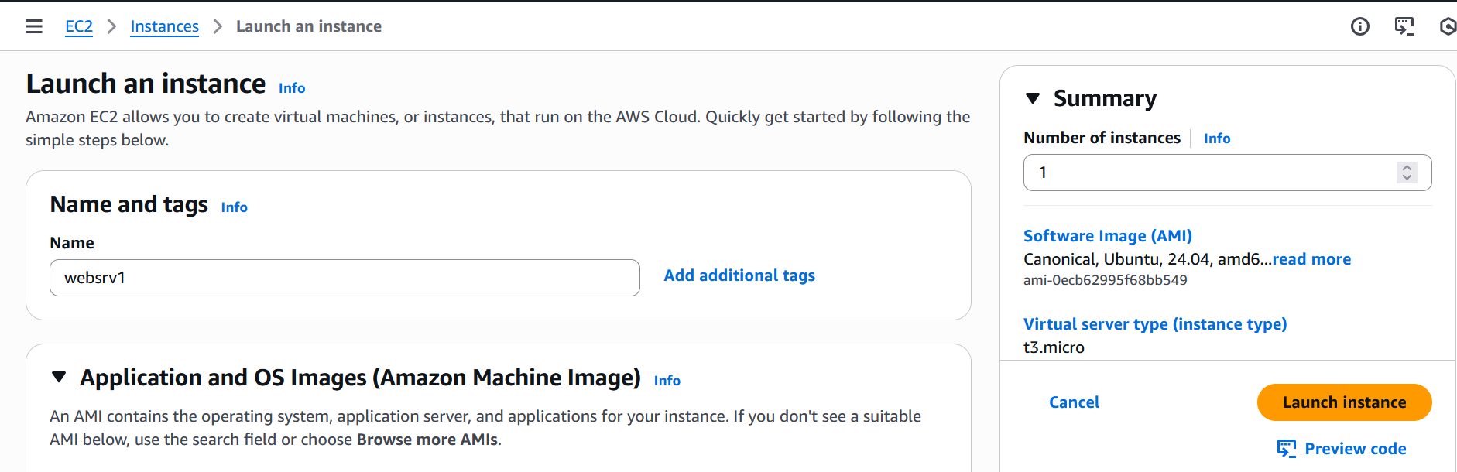

Select Image (Ubuntu)
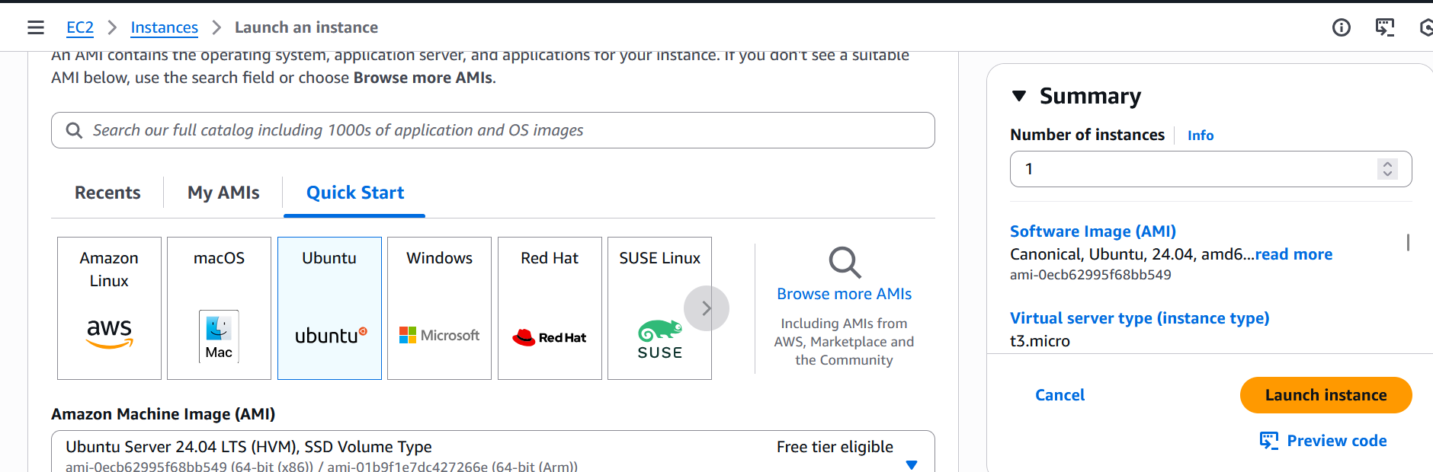

Select Instance Type (t3.micro)
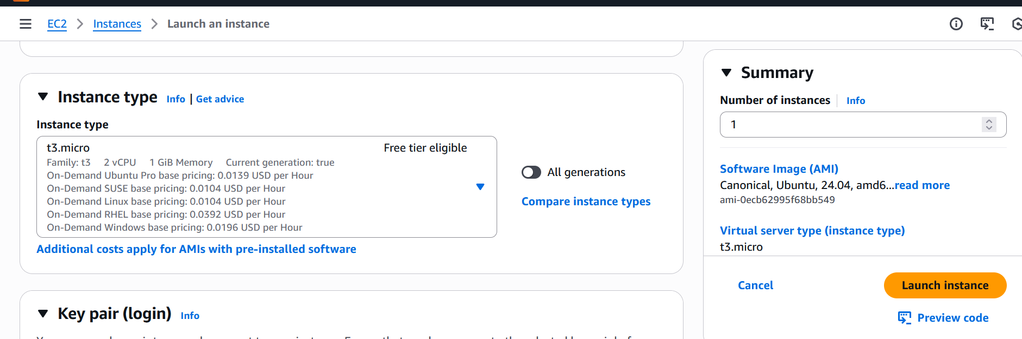
Select Key Pair for the SSH

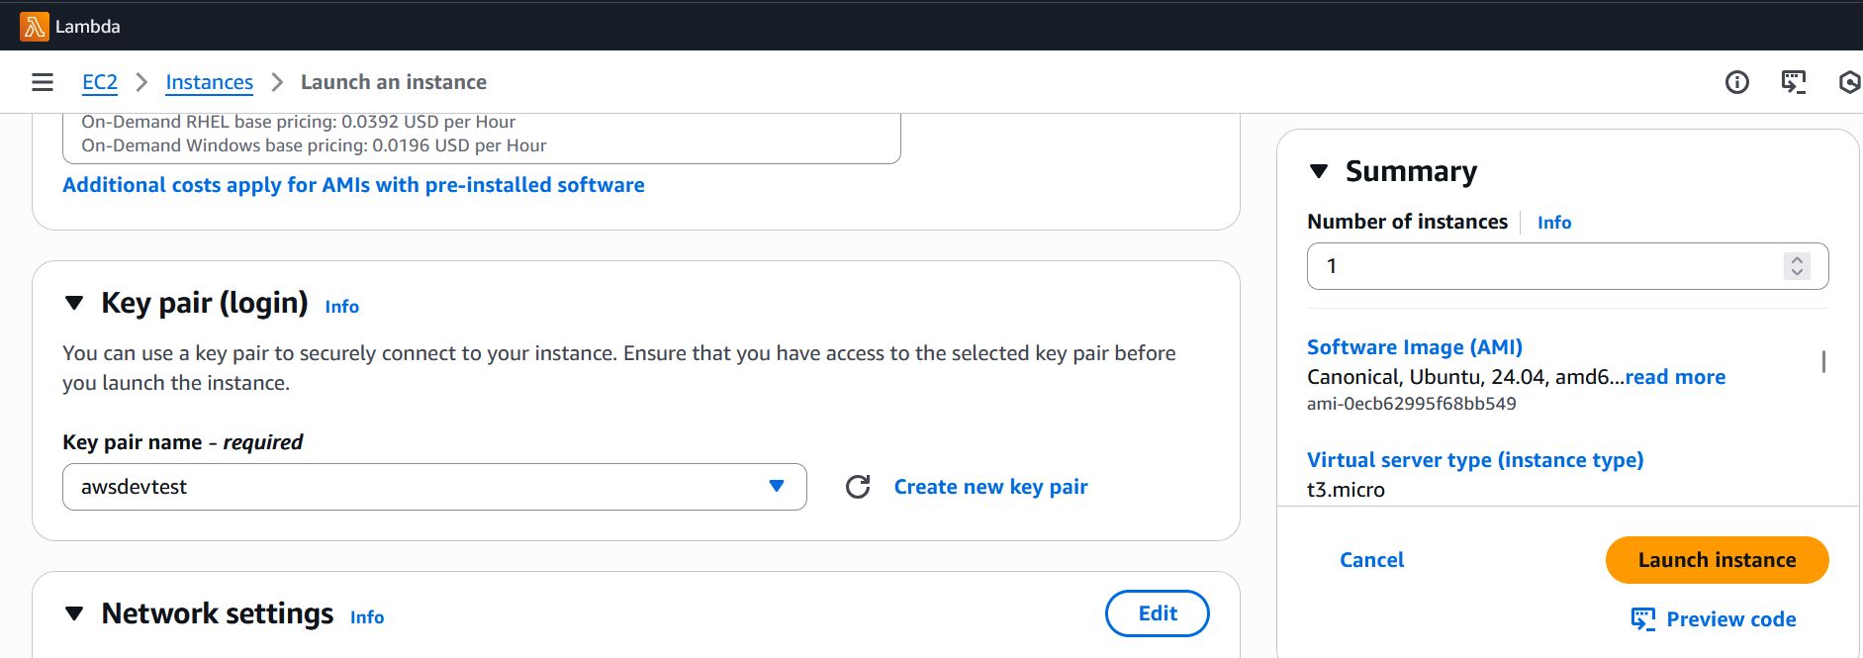

Configure network settings
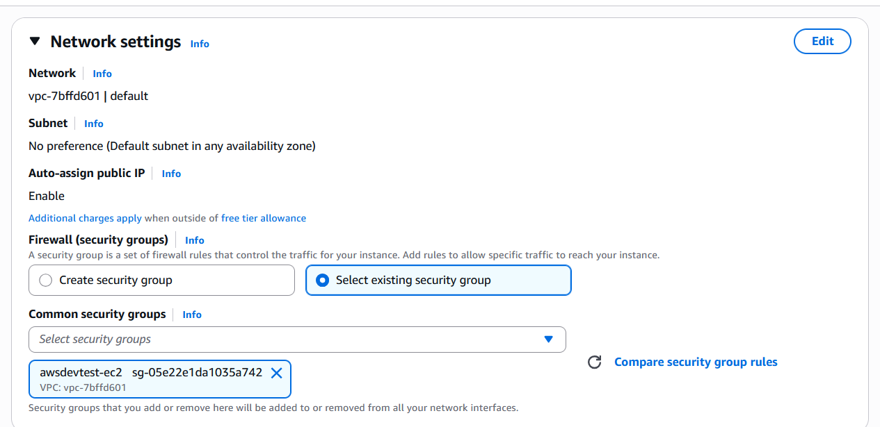
Public IP enabled
Security Group for SSH and HTTP

Select the Volume for EC2 Instance:
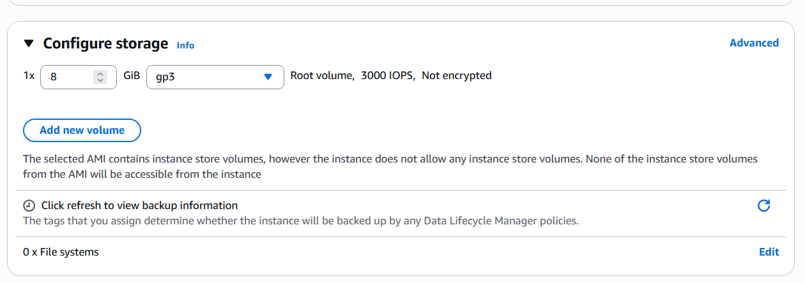

Summary of the instance before start

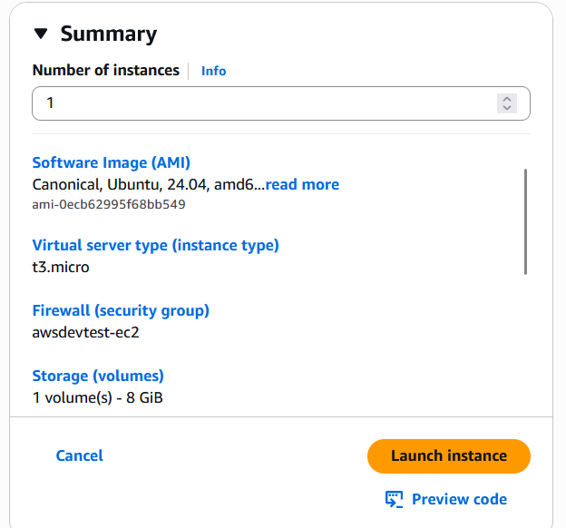

Verify the status of the instance
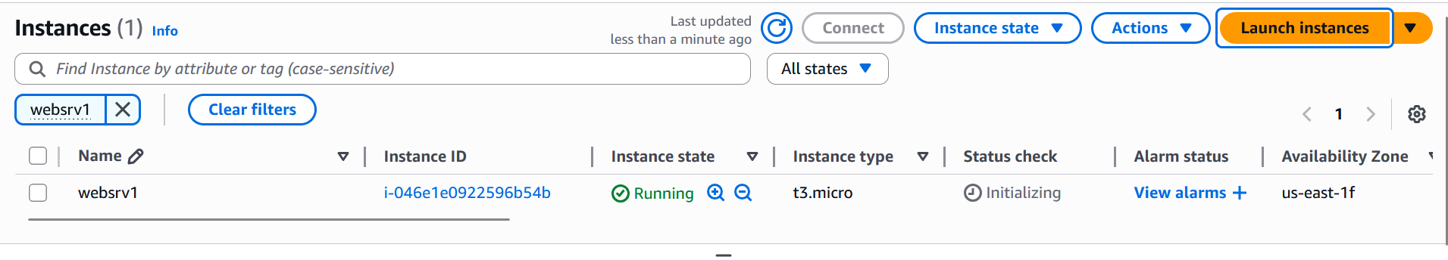
Get the public IP address of the instance:
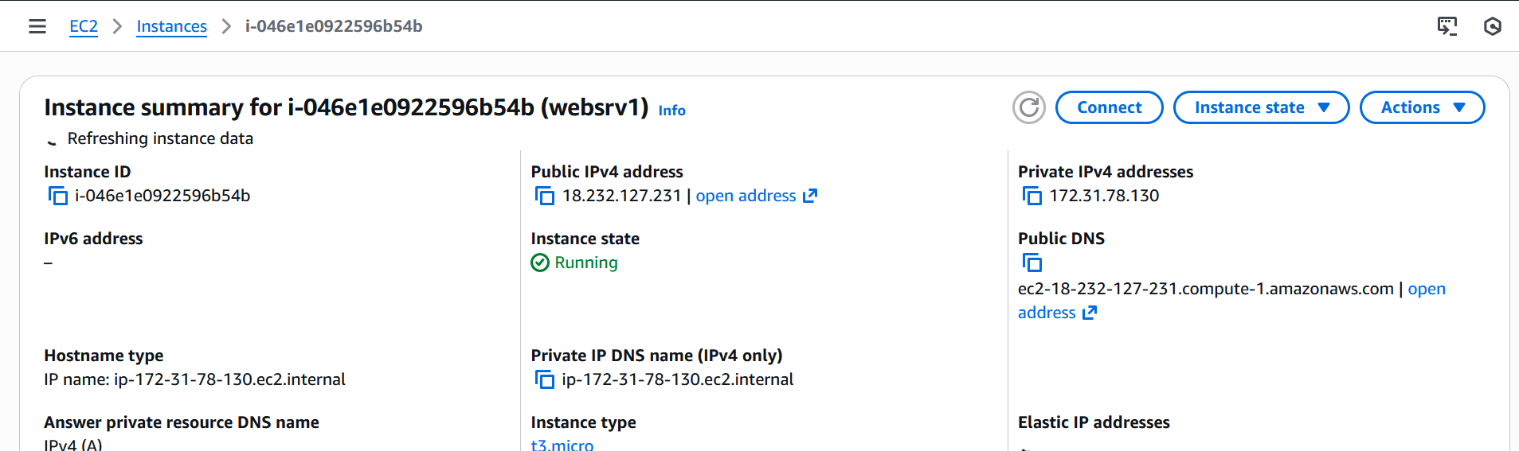

Launch the instance using the configured shared key:

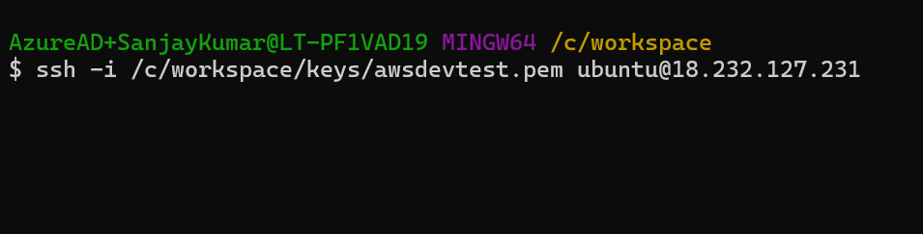

Instance login successful
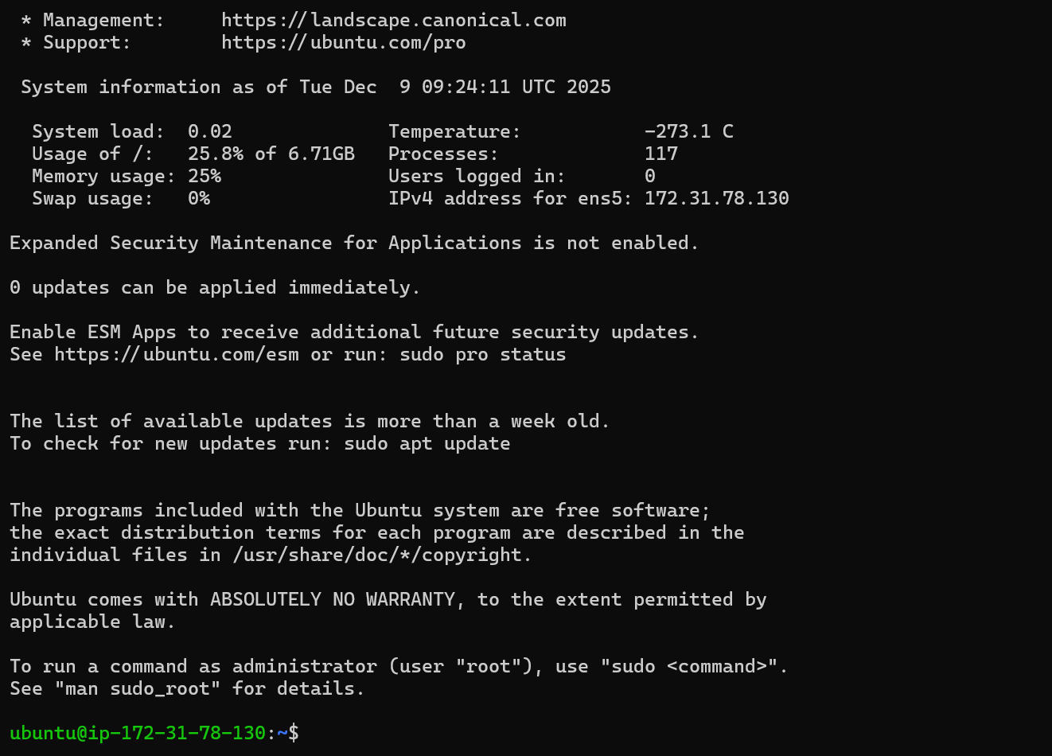

Update and Upgrade
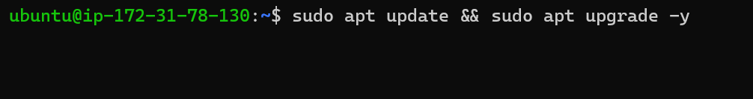

Generate SSH Keys for the github account integration:
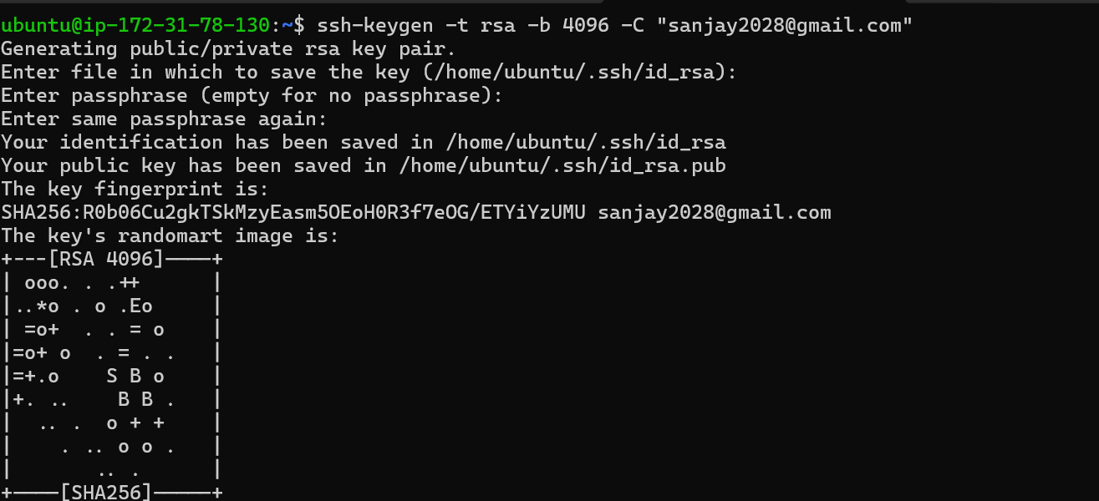

Added the private key in ssh-agent
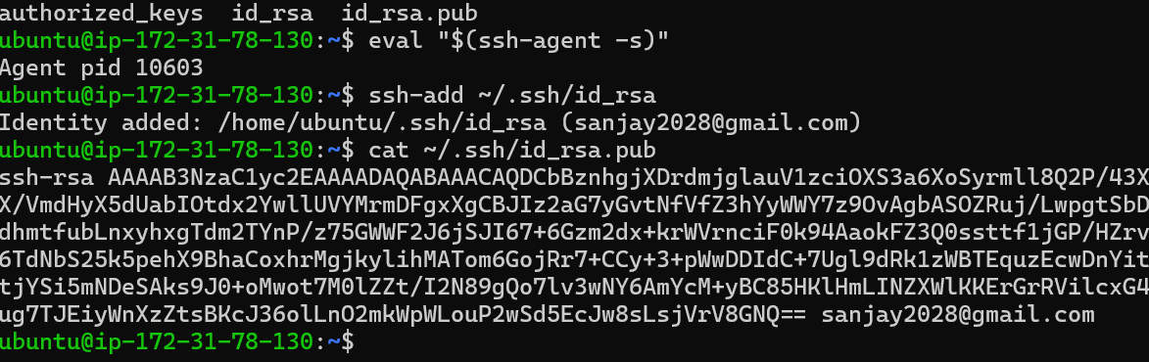

Extracted the public key for github integration and updated in the branch security settings:
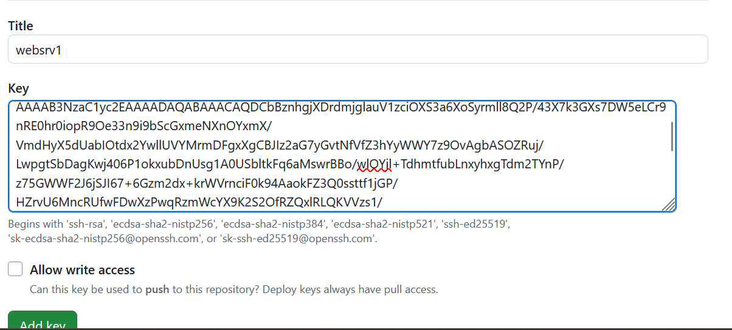
Install GIT and verify version:
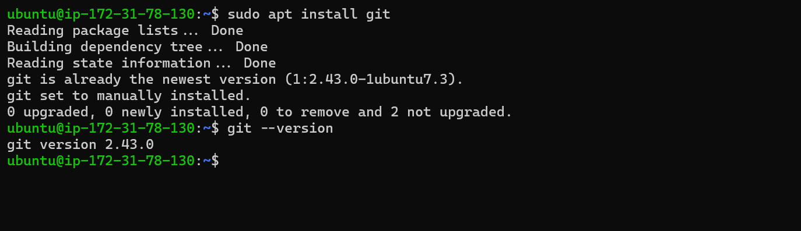

Clone repository:
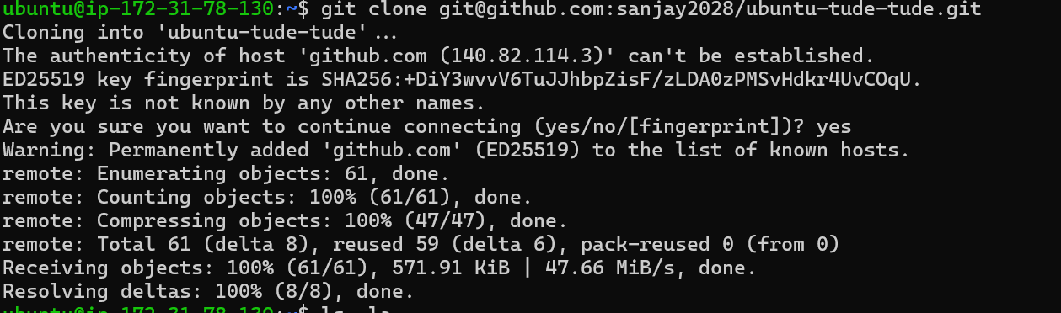

Switched to desired branch after cloning
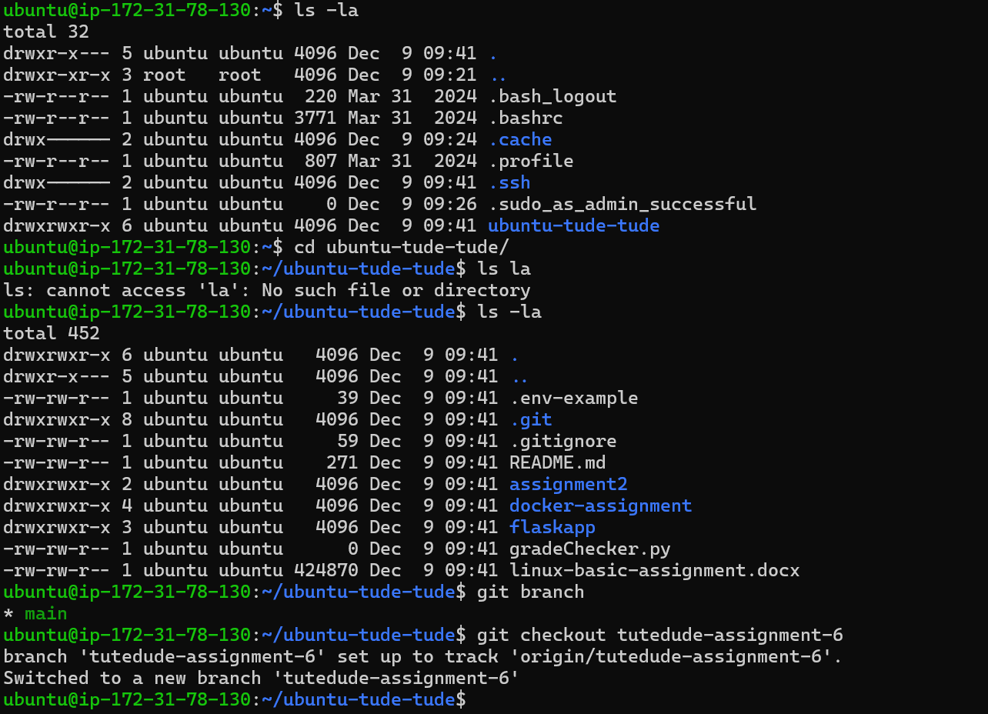

Setup Back end
- Installed Python
- Install virtual environment
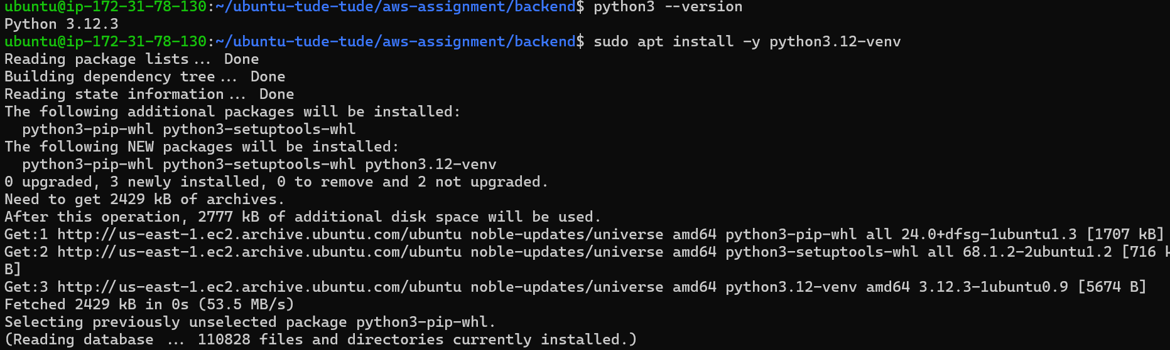
- Create Virtual Environment inside backend directory
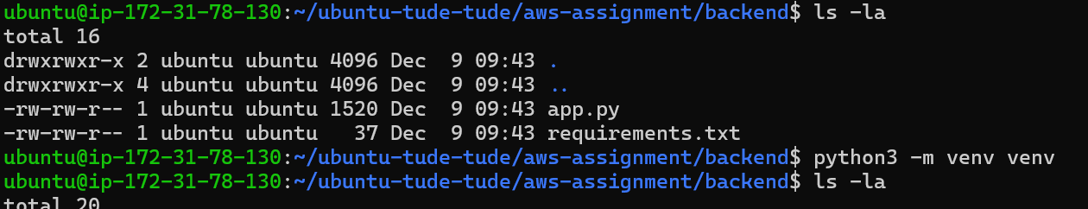

- Install dependencies for python app using requirements.txt
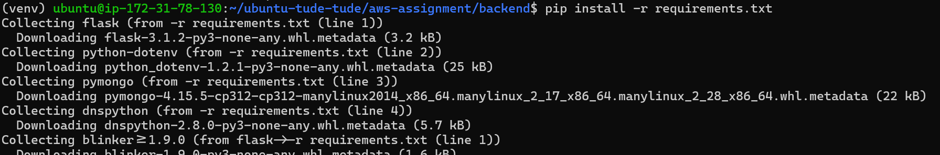
- Create .env file for the backend
- Run the app using nohup python app.py app.log 2>&1 &

Check the status of the backend using heartbeat endpoint

Backend is up successfully

Front End Setup
- Install nodejs and npm
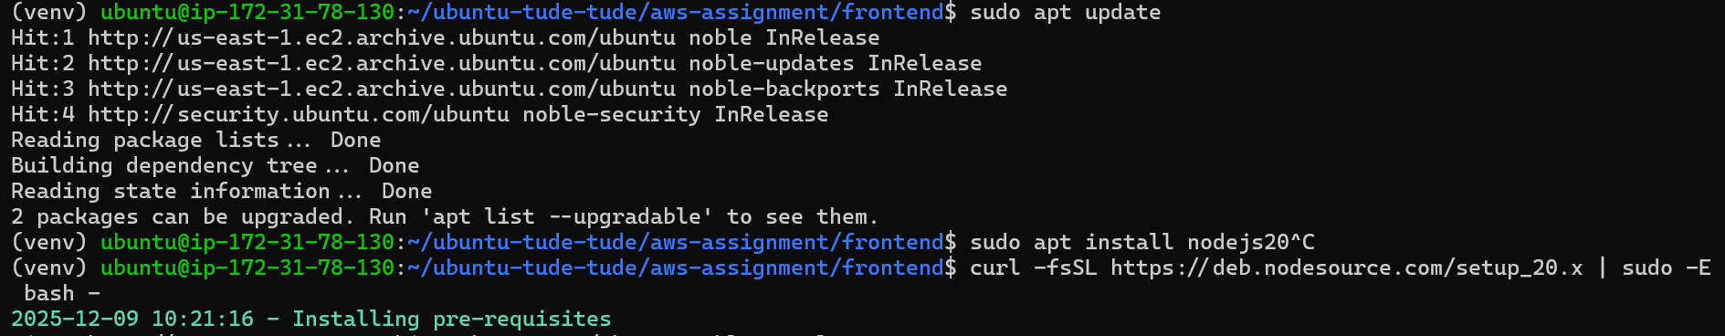
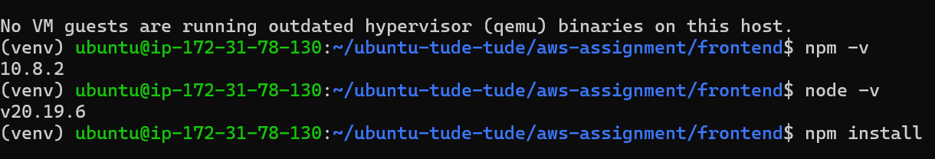

Start the front end app:

App is up and running. See the next page for the front end app

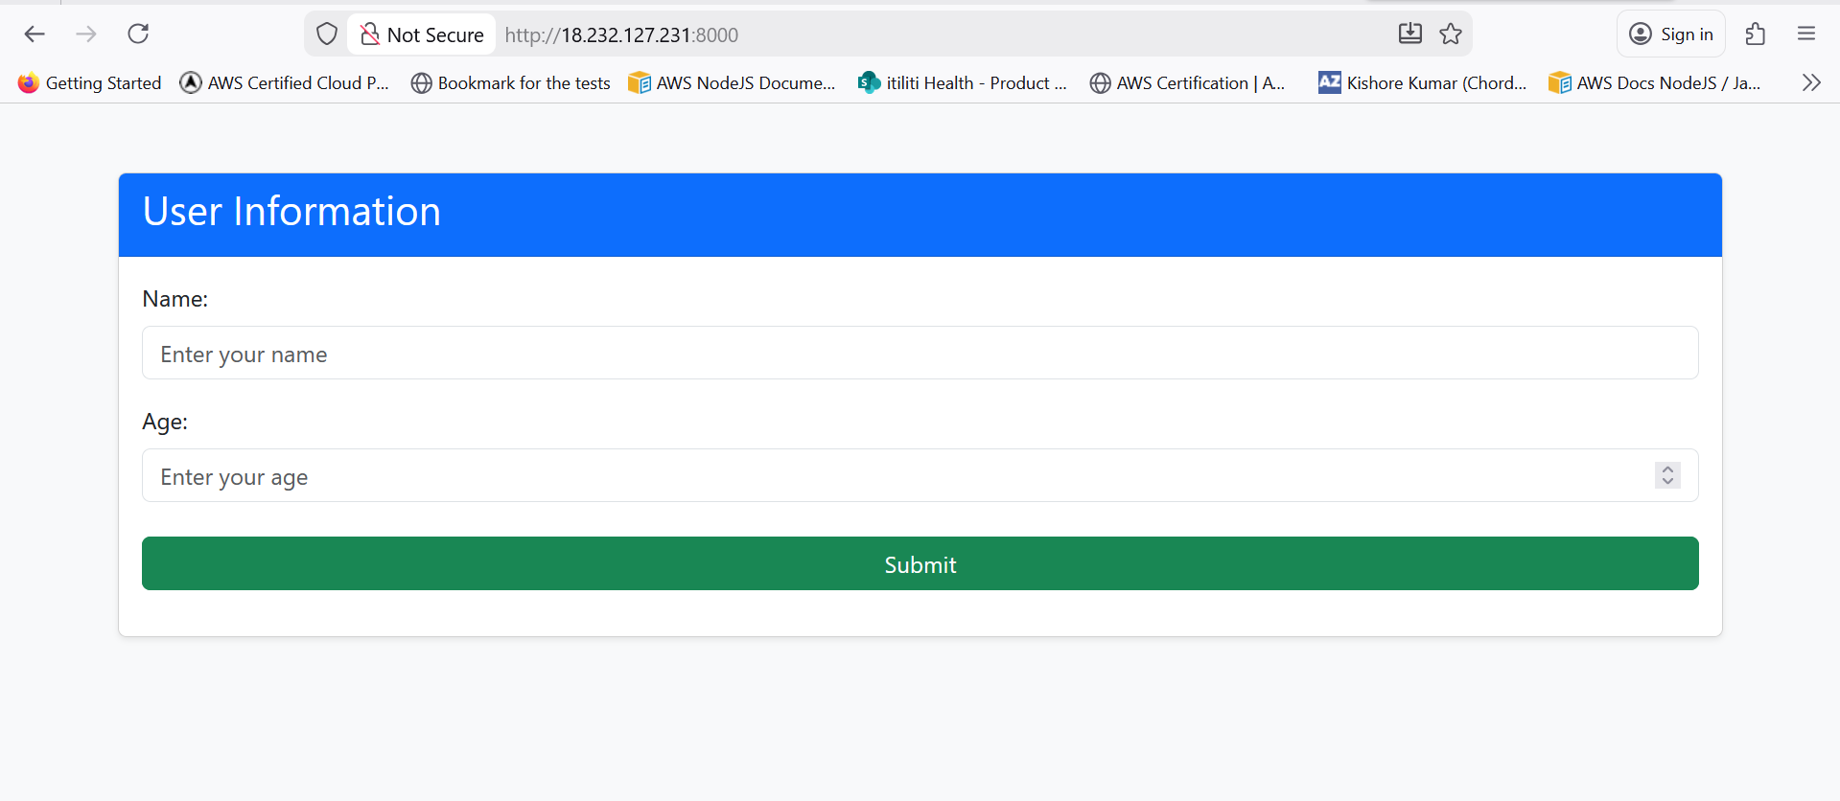

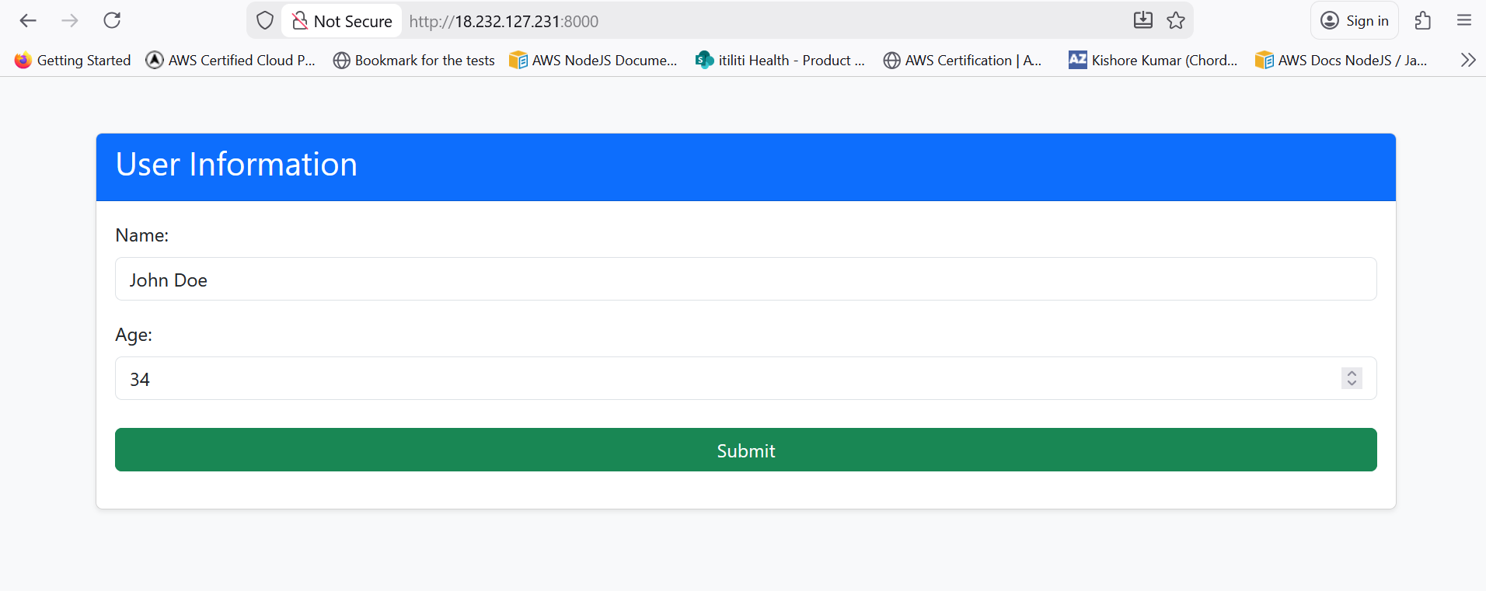
Submission successful to back end.
PS :- Please be patient. It takes a while to process the data.
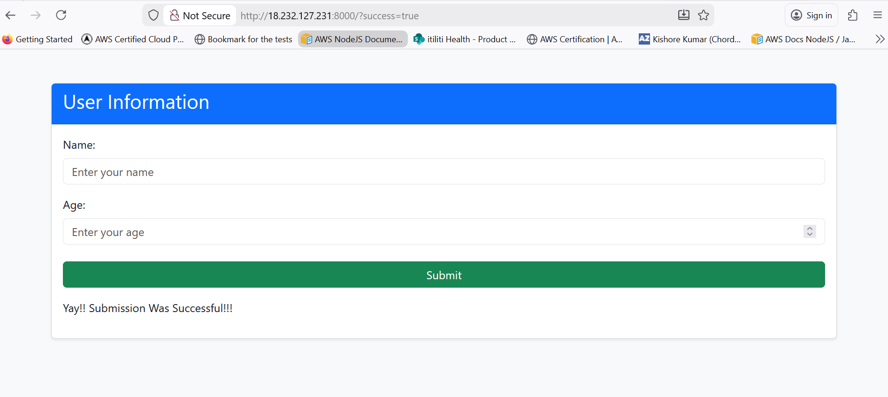

Refer to the screenshot given below for the data storage confirmation in MongoDB Atlas

